THE USE OF MOLECULAR MARKERS METALOTHIONEIN PROTEIN FOR MONITORING MARINE POLLUTION DUE TO HEAVY METALS MERCURY IN Apogon beauforti IN AMBON BAY

Dominggus Rumahlatu*, Fredy Leiwakabessy
Biology Education, Faculty of Teacher Training and Education Science,
Pattimura University, Ambon, Indonesia
e-mail:* dominggus_amq@yahoo.co.id

Abstract. The heavy metal Hg is a global issue because it is toxic to living organisms. Therefore, monitoring levels of Hg in Ambon Bay is important to do. This is a study about monitoring the levels of heavy metals Hg in the waters of Ambon Bay in 2013 and 2014 by using Apogon beauforti as bio-indicators and Metalothionein-1 (MT-1) as a biomarker to determine the accumulation of Hg in relation to the concentration and expression of MT-1 in the tissue of A. beauforti. The samples used were 50 fish of A. beauforti taken at four different stations with purposive sampling procedure. The analysis of Hg content used AAS method, the expression of MT-1 was determined by western blotting method, and MT-1 concentrations were determined by using ELISA method in the laboratory of Brawijaya University. On the average, the results of the analysis of Hg content indicated that the accumulation of heavy metal Hg varied in four different stations. The levels of Hg in the tissue of A. beauforti in 2014 at station 1 increased, while the levels of Hg at stations 2, 3, and 4 decreased. However, the calculation results of MT-1 concentration by ELISA showed an increase in the concentration of MT-1 in 2014 compared to that in 2013. This result was supported with the fact that the protein tape expressed on the test results of western blotting was very thick. It indicated that the longer the organism exposed to heavy metals Hg, the more increased the accumulation of Hg. Thus, the expression and the concentration of MT-1 would also increase.
Key Words: Heavy metals Hg, MT-1 protein, Apogon beauforti.

- INTRODUCTION
Mercury (Hg) is known as one of the heavy metals that easily accumulates in soil, water, sediment, even in the tissue of living organisms, and are toxic. Mercury can cause serious health problems and even death to living organisms (Jakimska et al., 2011). Therefore, mercury is a heavy metal causing environmental pollution, so that mercury becomes one of the global problems because it can spread widely and is difficult to decompose (Seixasa et al., 2005; Ismawati et al., 2013).
Mercury in the environment can come from anthropogenic waste and industrial waste as well as transportation due to poor waste management (Lovett & Tear, 2008; UNEP, 2013). Each open sea also tends to contain mercury coming from global mercury intake (Chen et al., 2012). Sea waters is the creek of all sorts of pollutants including mercury. Mercury entering the ocean can accumulate in the tissues of marine life, especially fish which is also the source of nutrients for humans. The previous research results on the content of heavy metals in the water of Ambon Bay were so alarming that monitoring activity was essential to conduct (Rumahlatu, 2011).
For monitoring the pollution caused by heavy metals mercury, it needed a bio-indicator species, that was the Apogon beauforti. The reasons for selecting A. beauforti as the bio-indicator species were because it was easily found in the water of Ambon Bay, widely distributed, and had a high tolerance to pollutants (Bonardi et al., 2010). In addition, mercury was found in fish all over the world with alarming levels (UNEP, 2002).
The level of mercury in the body of the animal could be monitored using the molecular marker, that is, Methalothionein proteins (MT). MT was a protein that was expressed when heavy metals were present in the animal body and played a role in detoxification of excessive metal (Carpene et al., 2007). Stimulation of metal ions could activate MT-1 protein (Takahashi, 2012). Furthermore Kovarova et al (2009) stated that the higher the levels of the Cd metal in the tissue of gold fish, the higher the level of MT in the liver of the fish. It was also found a significant correlation between the concentrations of heavy metals Cd and the concentrations of MT in the liver and kidneys of green turtle Chelonia mydas (Andreani et al., 2008). Previously, Lambot et al. (1980) stated that it was always found that the patella Vulgate living in metal polluted water had Cd metal binding to MT on its tissue. Thus, although normal fish tissue contained MT-1 protein, but if the amount of MT-1 protein was increasing, it could be ascertained that the environment of the organism had been contaminated by pollutants and heavy metals that had accumulated in the organism's body.
Under these conditions, monitoring activity on sea pollution due to heavy metals mercury in the water of Ambon bay was essential to do. Monitoring activities were conducted in 2013 and 2014 by using A. beauforti as a bio-indicator species and MT-1 protein as a molecular marker to determine the effect of heavy metals mercury to the protein activation of MT-1 and the concentration and expression of MT-1 protein in A. beauforti.

- MATERIALS AND METHODS
The Measurement of Heavy Metals Hg levels in the body tissue of Apogon beauforti
The samples used in this study were Apogon beauforti. 2013 Sampling was carried out in April, May, June and July, while the 2014 sampling was carried out in August, September, October, and November. Sampling was conducted by purposive sampling at 4 stations. The first station was in the Yos Sudarso harbor; the second station was in the very Galala harbor; the third station was in the coastal water of deep Passo Village; and the fourth station was in coastal water of Waiyame village.
The data were the levels of heavy metals Hg in Apogon beauforti at the four stations. The data collection in the water of the bay in Ambon Island was carried out by picking out a small portion. The sampling of Apogon beauforti used nets with mesh 1 x 1 cm as many as 50 individuals. The samples were then burnt into ash, and then the levels of the metal were analyzed by using Atomic Absorbsion Spectrophotometer method (AAS) (Bielmyer, 2005) at the Chemical Laboratory of Brawijaya University.

The Determination of the expression of MT-1 protein using Western Bloting Method
The examination of the expression of MT-1 protein using western blotting method was performed at the Laboratory of Physiology Faculty of Medicine, University of Brawijaya with the procedures following Young & Hongbao (2010). The Examination of MT-1 protein expression was preceded by the examination of SDS-PAGE, namely by performing electrophoresis sample protein standard broad range (Biolab). The gel, the results of SDS PAGE, was soaked in dionize for 5 minutes. Then the gel, NC membrane, and a sponge were soaked in transfer buffer for 5 minutes. After that, it was arranged sequentially, blackable, sponge, two sheets of filter paper, gel, NC membrane, 3 pieces of filter paper, sponge, whiteable. Then it was put into the chamber, and electrified from the negative to the positive pole (100 volts, 120 minutes). Next, the NC membrane was rinsed with dionize three times, and immersed in blocking buffer (5% BSA), and incubated at 4° Celsius for overnight. NC membrane was washed with TBS Tween 0.2% 3 times 5 minutes, and added antibodies in TBS 1% BSA. It was incubated for 2 hours and shaken. After that, the gel was washed with TBS 0.2% Tween 3 times 5 minutes. Then it was added anti-rabbit biotin Igg in TBS, incubated for 1 hour and shaken. Then it was washed again with TBS 0.2% Tween 3 times 5 minutes, and added SAHRP in TBS, incubated for 1 hour and shaken. After that, it washed with TBS 0.2% Tween 3 times 5 minutes. TMB substrate was then added to the membrane for 15-30 minutes until the tape appeared on the membrane. And then the reaction was stopped with distilled water.

The Determination of the Concentration of MT-1 Protein using ELISA method (Enzyme Linked Imunoassay)

The measurement of the concentration MT-1 protein using the indirect method of ELISA (Enzyme Linked Imunoasssay) was conducted at the Laboratory of Physiology of the Faculty of Medicine, University of Brawijaya following Lequin (2005). The sample preparation was carried out by smoothing the liver organ of A. beauforti with thawing. After that, the process of testing with ELISA reader was done by making a plate sketch of ELISA and coating buffer based on the sample code and location of the sample. Then, Coating the Antigen with the Levels 1:40 diluted with buffer coating and incubated at a temperature of 4°C overnight. The next day the plate was washed with a solution of 0.2% Tween PBS 100ul and repeated for 6 times. After that, 100 ul of primary antibody anti MT-1 (1: 400) was added into the assay buffer. And then, the ELISA plate was incubated at temperature room for 2 hours while being dishakered with ELISA plate shaker. The next stage was washing with a solution of PBS Tween 0.2% as much as 200ul for 6 times, then adding 100 ul IGg biotin secondary antibody anti-rabbit (1: 800) into the assay buffer and incubated at temperature room for 1 hour while being dishakered. After that, the plate was washed again with PBS Tween 0.2% for 6 times. (10) After that, 100 ul of SAHRP solution (1: 800) was added into the assay buffer and incubated at temperature room for 1 hour while being dishakered. Next, the solution was washed with PBS Tween 0.2% 200ul for 6 times. Then it was added with 100 ul of each well substrate sure the blue TMB microwell, incubated for 20-30 minutes in a dark room. At this stage, if there was a reaction between the antigen and the antibody, the solution would turn blue. Next, 100 ul of 1N HCl was added to stop the reactio. At this stage the solution which was previously blue would turn into yellow. After that, the sample was read using an ELISA reader at a wavelength of 450 nm. The results of the absorbance were then converted to a standard curve that ultimately turned the levels of MT-1 per sample.

- RESULTS AND DISCUSSION
Monitoring Heavy Metal Content of Hg in the Body tissue of Apogon beauforti
The mean results of the analysis of Hg levels of heavy metals in body tissues of Apogon beauforti at four monitoring stations in 2013 and 2014 can be seen in the following table:

Table 1. Average results of the Analysis of Hg levels on the tissue of A. beauforti per station in 2013 and 2014

Collection stations | Year 2013 | Year 2014
St. 1. Yos Sudarso harbor | 16.1 ± 1.14 | 18.74 ± 1.02
St. 2. Very Galela harbor | 19.8 ± 0.94 | 14.01 ± 0.64
St. 3. Coastal water of Passo village | 35.1 ± 1:50 | 19.73 ± 1.13
St. 4. Coastal water of Waiyame village | 37.7 ± 1.50 | 18.67 ± 0.40

The analysis results of levels of heavy metals Hg in the sample A. beauforti of each collection station quite varied (Table 1). However, when compared with the collection in the year 2013, there was an increase in the levels of heavy metal Hg in body tissue of A. Beauforti in station 1 in the year 2014. While at the station 2, 3, and 4, there was a decrease in the levels of heavy metals Hg. Although there was a decrease in the levels of Hg at stations 2, 3, and 4, but the levels of Hg content in the water of Ambon bay was still quite high. It might have occurred because the levels of heavy metals Hg accumulated in body tissues Apogon beauforti were influenced by different structures of coastal areas and by different rates of transport activities at each station.
Ercal et al. (2001) stated that Hg induced lipid peroxidation that damaged antioxidant system action in the body that could damage the cell membrane. It might trigger the oxidative stress in A. beauforti as a result of the accumulation of high levels of metal Hg. However, if the condition was associated with Apogon beauforti which were capable of surviving in such conditions, there might be the role of MT-1 that regulated the homeostasis in the body of the fish. As what was stated by Davis & Cousins ​​(2000), that the MT expression was induced by stress and hormones so that MT expression related to the metal accumulation in certain organs. Furthermore, MT had a role in detoxification of the species by executing the metal ions which were present in high concentrations. In other words, MT acted as a scavenger to heavy metals in the body of living organisms (Suhy et al., 1999). In addition, Podhorska-Okolow et al. (2006) found that MT provided a protective effect in cells from oxidative stress and apoptosis.

Monitoring the Heavy Metals Pollution Mercury (Hg) in the Molecular Level Based on the Concentration and Expression of MT-1 protein of Apogon beauforti in 2013 and 2014 in the water of Ambon Island

- Activation of MT-1 Protein
The Results of imunohistokima smear on the body tissue of A. beauforti using rabit antibody anti MT-1 showed that the cells expressed with MT-1 had brown color, and the cells not expressed with MT-1 had blue color. The cells undergoing MT-1 protein expression seemed to spread and to form clusters of cells. It was observable that MT-1 occupied the cytoplasm and the nucleus of liver cells of A. Beauforti, and the accumulation of mercury tended to increase the expression of MT-1. These results were not very different in 2013 and 2014. MT protected the cells from oxidative damage of ROS (Reactive Oxygen Species), and ROS activated the transcription by affecting several signal transduction pathways, so that ROS activated MT transcription factor (MTF) through Peroxide lipid derivation 4- hidroxynonenal (HNE) (Braithwaite et al 2010). MT-1 response to heavy metals was not only caused by the MTF-1, but it required protein structure as a whole, including the intramolecular interaction in various areas (Otsuka, 2004).
A big concentration of mercury, based on the analysis of Hg levels, can cause changes in the structure of cells and is associated with a protective strategy of A. beauforti to combat stress due to mercury accumulation. According to Takahashi (2012), MT protein regulates the modulation of metal ions and free radicals through intracellular working, and MT also plays a role in the proliferation and differentiation of hematopoietic cells. MT plays role in maintaining homeostasis and physiological transportation for metals such as Zn, and Cu, metal detoxification Cd, and Hg, protecting from oxidative stress, maintaining the intracellular reduction and oxidation reactions, regulating cell proliferation and apoptosis (Sakulsak, 2012). Therefore, the longer the cells are exposed to mercury, the more increased the MT protein expression in its attemps for cell regulation.
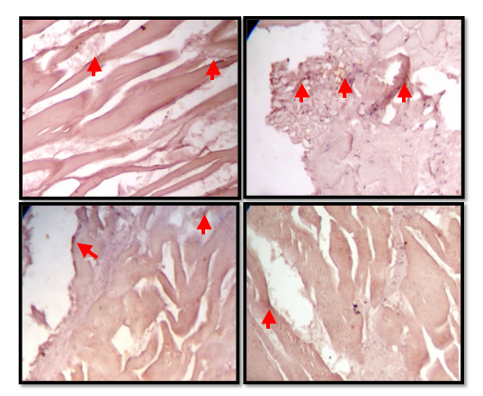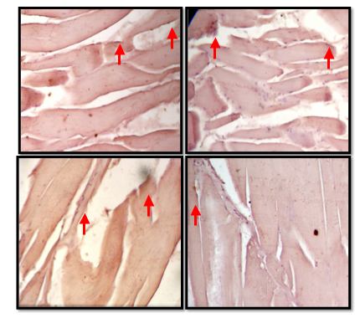
A B
Figure 1. The Results of Immunohistochemistry smear Using rabit antibody anti MT-1 Body tissue of A. beauforti. Observations using Olympus microscope for shooting a regular slide with 1000x magnification zoom. Observations was carried out ​​at 4 stations in 2013 (A) and 2014 (B). body cells expressing MT-1were brown and indicated by arrows.

- The Concentration and Expression of MT-1 Protein
The results of the calculation of the concentration of MT-1 protein using ELISA reader showed ​​varying concentrations in each A. beauforti data collection station. This is consistent with the results of the Hg level analysis using AAS which also showed varying results. The following data are the results of the calculation of mean concentrations of MT-1 protein using ELISA reader.

Table 2. The mean concentration of MT-1 Protein Apogon beauforti at 4 collection stations in 2013 and 2014

Data Collection Stations | Year 2013 | Year 2014
Data Collection Stations | The mean concentration  MT Protein-1 (ng/ml) | The mean concentration of MT Protein-1 (ng/ml)
St. 1. Yos Sudarso harbor | 2710 | 10180
St. 2. Very Galela harbor | 6595 | 12270
St. 3. Coastal water of Passo village | 4230 | 10250
St. 4. Coastal water of Waiyame village | 3265 | 12120
Although the concentration of MT-1 protein varied among each data collection station, the measurement in 2013 and 2014 as a whole showed an increase in the concentration of MT-1 protein in body tissues of Apogon beauforti. The increased concentrations might have a correlation with the role of MT-1 as a scavenger and detoxification of cells that have been contaminated by heavy metals Hg, so A. beauforti could still survive in the water with high levels of Hg. Therefore, the ELISA test showed that higher concentration of MT-1 protein in body tissue of A. beauforti which was also related to the accumulation of heavy metals mercury.
On the other hand, the expression of MT-1 based on the results of western blotting test showed that MT-1 protein colored with rabbit antibody anti MT-1, both in 2013 and in 2014. The results can be seen in the following figures.
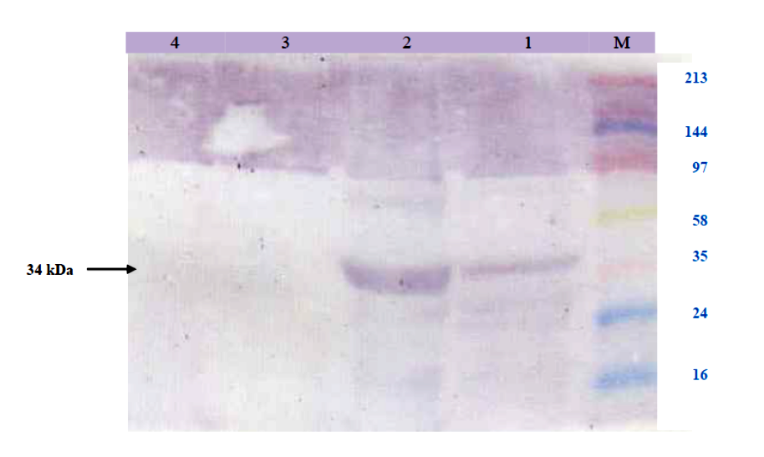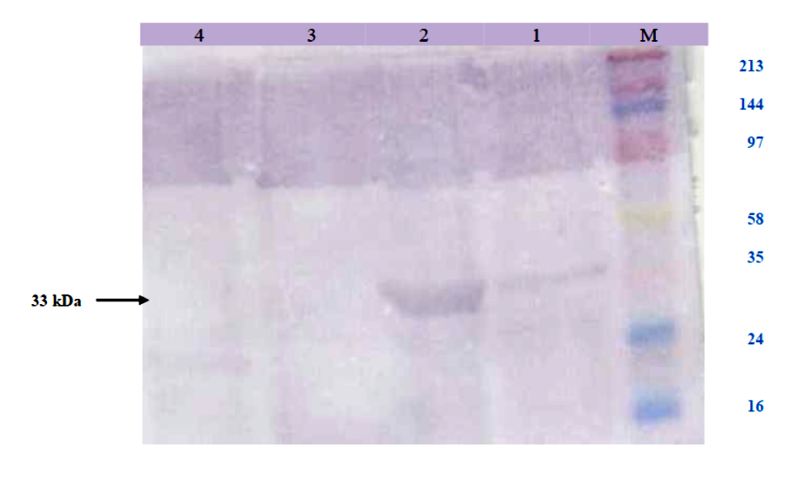
A B
Figure 2. The expression of MT-1 protein based on the results of Western Blotting test on A. beauforti at 4 collection data stations in 2013 (A) and 2014 (B). The Gel, the results of electrophoresis of SDS-PAGE, was performed western blotting test, that was, incubating it with secondary anti-rabbit IgG biotin. As that can be seen in the top row of 4 collection data stations, the purplish brown colored tape was MT-1 protein that was marked with arrows. M: Marker, 1 to 4: A. beauforti of 4 collection data stations.

Based on Figure 2, it was revealed that the high expression of MT-1 protein in body tissue of A. Beauforti had a correlation with the increased accumulation of heavy metals Hg in 2014, especially at Station 2 which was characterized by the thick protein tape. This means that the higher the concentration of MT-1 protein (ELISA test), the thicker the tape which showed the expression of MT-1 protein (western blotting test).
MT in the tissues of animals is commonly found in the brain, liver and kidneys, but the highest concentration of MT is found in the liver and kidneys (Henriques & Cozzolini, 2001; Florianzyk & Staroslawska, 2003). In addition, the MT in cells is found in the cytoplasm, lysosomes, mitochondria and nucleus of cells distributed in the liver, pancreas, intestine and kidney (Vasatkova et al. 2009). MT-1 expressed with a high concentration, and a thick tape in ELISA test and western blotting showed that there was a biomolecular response of A. beauforti against the accumulation of metal mercury. The existence of MT protein in cells undergoing physiological stress has the correlation with its function in protecting the heavy metal toxicity and the effects of oxidative stress.
The higher the concentration of mercury that accumulates in the body of A. Beauforti, the more increased the activation of MT-1 protein. The concentration and expression of MT-1 protein were also related with a defense mechanism by the cell to prevent damage to the cells, that is, the MT-1 binds with heavy metals. Therefore, MT-1 has the function as a biomarker (Wang et al., 2014). Furthermore, Barkhordar et al. (2013) stated that when undergoing stress, the fish responds by trying a number of ways to get back its homeostasis and important physiological process modulated in the form of biochemical effects, so that the biochemical effects are used as a biomarker that is quite important. In this case the MT-1 protein as a biomarker can be the answer to the measurement and monitoring of heavy metals mercury pollution in Ambon bay which showed an increased accumulation of mercury from 2013 to 2014.

- CONCLUSION
The use of molecular markers protein Metalothionein-1 (MT-1) for monitoring marine pollution due to heavy metals Hg at Apogon beauforti in Ambon bay in 2013 and 2014, showed an increase in the accumulation of heavy metals mercury characterized by an increased mean concentrations of MT-1 protein on the body of A. beauforti based on the ELISA tests and thick tape of MT-1 protein in western blotting test. This means that the longer the Apogon beauforti are exposed to heavy metals mercury, the more increased the concentration of MT-1 in the body of Apogon beauforti.

ACKNOWLEDGMENTS
The authors are very grateful to the Head of the Chemistry Laboratory and the Head of the Physiology Laboratory and Histology Faculty of medicine, University of Brawijaya that have provided the facilities for the author to conduct this research until the final stages of writing this article, and to DP2M Ministry of Education and Culture that has awarded the funding for the authors to conduct this research through a grant to compete with the contract number: 02/UN13.2/SP-HB/VII/2013.

REFERENCES
- Andreani, G., Santoro, M., Cottignoli, S., Fabri M., Carpene E., Isani, G. (2008). Metal Distribution and Metallothionein in Loggerhead (Carreta carreta) and Green (Chelonia mydas) Sea Turtles. Science of the Total Environment, 390: 287-294.
- Barkhordar, M., Valizadeh, R., Bagheri, T., Teherimirghaed, A., Hedayati, A. (2013). Detection of Heavy Metal Biomarkers for Study of Fishes. Journal of Novel Applied Sciences, 2(7): 180-187.
- Bielmyer, G.K., Brix K.V., Capo, T.R., Grosell. (2005). The effects of metals on embryo-larval and adult life stages of the sea urchin, Diadema antillarum. Aquatic Toxicol, 74: 254-263.
- Bonardi, A., Dimopoulos, P., Ficetola, F., Kallimanis, A., Labadessa, R., Mairota, P., Padoa-Schioppa, E. (2010). Selected Bio-indicators. BIO_SOS Biodiversity Multisource Monitoring System: from Space TO Species: 1-31.
- Braithwaite, E.K., Mattie, M.D., Freedman, J.H. (2010). Activation of Metallothionein Transcription by 4-Hydroxynonenal. J. Biochem. Mol. Toxicol, 24(5): 330-334.
- Carpene, E., Andreani, G., Isani, G. (2007). Metallothionein Functions and Structural Characteristic. Journal of Trace Elements in Medicine and Biology, 21: 35-39.
- Chen, C.Y., Driscoll, C.T., Lambert, K.F., Mason, R.P., Rardin, L.R., Schmitt, C.V., Serrel, N.S., Sunderland, E.M. (2012). Source to Seafood: Mercury Pollution in the Marine Environment. Hanover, NH: Toxic Metal Superfund Research Program, C-MERC: 1-28.
- Davis, S.R., Cousins, R.J. (2000). Metalothionein Expression in Animals: A Physiological Perspective on Fuction. The Journal of Nutrition: 1085-1088.
- Ercal, N., Gurer-Orhan, H., Aykin-Burns, N. (2001). Toxic metal Induced Oxidative Damage. Current Topics in Medicinal Chemistry, 1: 529-539.
- Florianczyk, B., Staroslawska, E. (2003). Metallothioneins in Rats Exposed to Barium Chloride. Bull. Vet. Inst. Pulawy, 47: 153-156.
- Henriques, G.S., Cozzolino S.M.F. (2001). Determination of Metallothionein Levels in Tissues of Young Rats Feed Zinc-Enriched Diets. Rev. Nutr., Campinas 14(3): 163-169.
- Ismawati, Y., Petrlik, J., DiGangi, J. (2013). Mercury Hotspot In Indonesia. Balifokus (Indonesia); Arnika Association (Czech Republik); IPEN Heavy Metals Working Groups: 1-18.
- Jakimska, A., Konieczka, P., Skora, K., Namiesnik, J. (2011). Bioaccumulation of metals in Tissues of Marine Animals, Part I: The Role and Impact of Heavy metals on Organisms. Pol. J. Environ, 20(5): 1117-1125.
- Kovarova, J., Kizek, R., Adam, V., Harustiakova, D., Celechovska, O., Svobodova, Z. (2009). Effect of Cadmium Chloride on Metallothionein Levels in Carp. Sensor, 9: 4787-4803.
- Lambot, F.N., Bouquegneau, J.M., Frankenne, F., Disteche, A. (1980). Cadmium, Zinc, and Copper Accumulation in Limpets (Patela vulgata) from the Bristol Channel with Special References to Metallothioneins. Marine Ecology – Progress Series, 2: 81-89.
- Lequin, R.M. (2005). Enzyme Immunoassay (EIA)/Enzyme-Linked Immunosorbent Assay (ELISA). Clinical Chemistry, 51(12): 2415–2418.
- Lovett, G.M., Tear, T. (2008). Air Pollution Impacts on Ecosystem and Biological Diversity in the Eastern United States. The Nature Conservancy and The Cary Institute of Ecosystem Studies: 1-17.
- Otsuka, F. (2004) Transcriptional Regulation of the Metallothionein Genes. Journal of Health Science, 50(4): 332-335.
- Podhorska-Okolow, M., Dziegiel, P., Dolinska-Kajewska, B., Dumanska, M., Cegielski, M., Jethon, Z., Rossini, K., Carraro, U., Zabel, M. (2006). Expression of Metallothionein in Renal Tubules of Rats Exposed to Acute and Endurance Exercise. Folia Histochemica Et Cytobiologica, 44(3): 195-200.
- Rumahlatu D. (2011). [Concentrations of Heavy Metals in Sediments, Water and Diadema setosum (Echinoidea, Echinodermata) in the water of Ambon Island]. Indonesian Journal of Marine Science, 16(2): 78-85.
- Sakulsak, N. (2012). Metallothionein: An Overview on Its metal Homeostatic Ragulation in Mamals. Int. J. Morphol, 30(3): 1007-1012.
- Seixasa, S., Bustamanteb, P., Piercec, G. (2005). Accumulation of mercury in the tissues of the common octopus Octopus vulgaris (L.) in two localities on the Portuguese coast. Science of the Total Environment, 340: 113–122.
- Suhy, D.A., Simon, K.D., Linzer, O.I.H., O’Halloran, T.V. (1999). Metallothionein is Part of a Zinc-Scavenging Mechanism for Cell Survival Under Conditions of Extreme Zinc Deprivation. The Journal of Biological Chemistry, 274(14): 9183-9192.
- Takahashi, S. (2012). Molecular Functions of metallothionein and Its Role in Hematological Malignancies. Journal of Hematology & Oncology, 5(41): 1-8.
- United Nations Environment Program (UNEP) Chemicals. (2002). Global Mercury Assessment. Inter-organization Programme fot the Sound Management of Chemicals, Geneva, Switzerland: 1-270.
- United Nations Environment Program (UNEP). (2013). Global Mercury Assessment: Sources, Emissions, Releases and Environmental Transport. UNEP Chemicals Branch, Geneva, Switzerland: 1-44.
- Vasatkova, A., Krizova, S., Adam, V., Zeman, L., Kizek, R. (2009). Changes in Metallothionein Level in Rat Hepatic Tissue After Administration of Natural Mouldy Wheat. International Journal of Molecular Sciences, 10: 1138-1160.
- Wang, W.C., Mao, H., Ma, D.D., Yang, W.X. (2014). Characteristic, Functions, and Aplications ao Metallothionein in Aquatic Vertebrates. Frontiers in marine Science (Review Article) vol 1(34): 1-12.
- Young, J and Hongbao, M. (2010). Practical Technique of Western Blotting. The Journal of American Science 4(2). http://www.americanscience.org.

