Lampiran Output Data
User
2022-07-15
#Script and output data of stock price determinant analysis
#handling missing data
any(is.na(stock_price))
## [1] TRUE
sum(is.na(stock_price))
## [1] 204
colSums(is.na(stock_price))
## no sector sub_industry_code sub_industry
## 0 0 0 0
## code stock_name harga_saham Assets_bIDR
## 0 0 0 0
## Liabilities_bIDR Equity_bIDR EPS_IDR PER
## 0 0 1 8
## DER ROA ROE NPM
## 5 82 82 26
stock_price_clean <- na.omit(stock_price)
any(is.na(stock_price_clean))
## [1] FALSE
head(stock_price_clean)
## # A tibble: 6 × 16
## no sector sub_industry_co… sub_industry code stock_name harga_saham
## <dbl> <chr> <chr> <chr> <chr> <chr> <dbl>
## 1 1 Consumer Non… D232 Plantations… AALI Astra Agr… 9500
## 2 3 Financials G412 General Ins… ABDA Asuransi … 5850
## 3 4 Industrials C311 Multi-secto… ABMM ABM Inves… 1420
## 4 5 Consumer Cyc… E743 Home Improv… ACES Ace Hardw… 1280
## 5 6 Infrastructu… J211 Heavy Const… ACST PT Acset … 210
## 6 7 Consumer Non… D212 Soft Drinks ADES Akasha Wi… 3290
## # … with 9 more variables: Assets_bIDR <dbl>, Liabilities_bIDR <dbl>,
## # Equity_bIDR <dbl>, EPS_IDR <dbl>, PER <dbl>, DER <dbl>, ROA <dbl>,
## # ROE <dbl>, NPM <dbl>
#sample distribution by sector
sector_count <- table(stock_price_clean$sector)
sector_count
##
## Basic Materials Consumer Cyclicals Consumer Non-Cyclicals
## 81 108 88
## Energy Financials Healthcare
## 56 71 21
## Industrials Infrastructures Properties & Real Estate
## 49 44 63
## Technology Transportation & Logistic
## 27 22
ggplot(data = stock_price_clean) + geom_bar(mapping = aes(x = sector, fill = sector)) + labs(title= "Jumlah observasi menurut sektor", x= "Sektor", y="Jumlah Observasi")+theme(text=element_text(size=8),axis.text.x = element_text(angle=45, hjust=1))
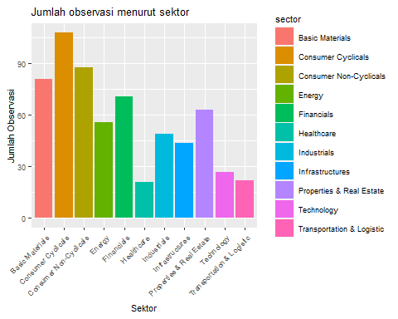
sector_percent <-sector_count / length(stock_price_clean$sector)
sector_percent
##
## Basic Materials Consumer Cyclicals Consumer Non-Cyclicals
## 0.12857143 0.17142857 0.13968254
## Energy Financials Healthcare
## 0.08888889 0.11269841 0.03333333
## Industrials Infrastructures Properties & Real Estate
## 0.07777778 0.06984127 0.10000000
## Technology Transportation & Logistic
## 0.04285714 0.03492063
#summary statistic
summary(reg_data)
## harga_saham EPS_IDR PER DER
## Min. : 36.0 Min. : 0.12 Min. : 0.540 Min. : 0.010
## 1st Qu.: 182.2 1st Qu.: 8.17 1st Qu.: 8.835 1st Qu.: 0.360
## Median : 489.0 Median : 28.78 Median : 19.245 Median : 0.815
## Mean : 1805.7 Mean : 184.17 Mean : 156.078 Mean : 2.068
## 3rd Qu.: 1492.5 3rd Qu.: 95.32 3rd Qu.: 46.350 3rd Qu.: 1.670
## Max. :49000.0 Max. :37407.13 Max. :28119.340 Max. :142.690
## ROA ROE NPM Assets_bIDR
## Min. :0.01000 Min. : 0.0100 Min. : 0.010 Min. : 14.7
## 1st Qu.:0.02000 1st Qu.: 0.0400 1st Qu.: 0.060 1st Qu.: 562.8
## Median :0.04000 Median : 0.0900 Median : 0.150 Median : 1991.8
## Mean :0.07192 Mean : 0.2059 Mean : 2.314 Mean : 20939.2
## 3rd Qu.:0.09000 3rd Qu.: 0.1700 3rd Qu.: 0.360 3rd Qu.: 7570.3
## Max. :1.41000 Max. :12.8600 Max. :853.070 Max. :1637950.2
## Liabilities_bIDR Equity_bIDR Ln_Liab
## Min. : 0.3 Min. : 6.37 Min. :-1.308
## 1st Qu.: 196.9 1st Qu.: 285.86 1st Qu.: 5.283
## Median : 782.5 Median : 998.58 Median : 6.662
## Mean : 14390.8 Mean : 6197.83 Mean : 6.657
## 3rd Qu.: 3585.5 3rd Qu.: 3960.52 3rd Qu.: 8.185
## Max. :1339489.5 Max. :280282.77 Max. :14.108
#regression
regresion_model1 <- lm(formula = harga_saham ~ EPS_IDR + PER + DER + ROA + ROE + NPM + Assets_bIDR + Ln_Liab + Equity_bIDR, data = reg_data)
summary(regresion_model1)
##
## Call:
## lm(formula = harga_saham ~ EPS_IDR + PER + DER + ROA + ROE +
## NPM + Assets_bIDR + Ln_Liab + Equity_bIDR, data = reg_data)
##
## Residuals:
## Min 1Q Median 3Q Max
## -10210 -1279 -728 59 44371
##
## Coefficients:
## Estimate Std. Error t value Pr(>|t|)
## (Intercept) -7.010e+02 5.176e+02 -1.354 0.176130
## EPS_IDR 1.010e+00 9.874e-02 10.232 < 2e-16 ***
## PER 4.823e-02 1.113e-01 0.433 0.664914
## DER -2.371e+01 3.687e+01 -0.643 0.520359
## ROA 3.623e+03 1.759e+03 2.060 0.039816 *
## ROE -7.030e+00 4.422e+02 -0.016 0.987322
## NPM -3.320e-01 4.387e+00 -0.076 0.939694
## Assets_bIDR -8.635e-03 2.892e-03 -2.986 0.002938 **
## Ln_Liab 2.811e+02 7.434e+01 3.782 0.000171 ***
## Equity_bIDR 6.664e-02 1.629e-02 4.092 4.84e-05 ***
## ---
## Signif. codes: 0 '***' 0.001 '**' 0.01 '*' 0.05 '.' 0.1 ' ' 1
##
## Residual standard error: 3759 on 620 degrees of freedom
## Multiple R-squared: 0.2262, Adjusted R-squared: 0.215
## F-statistic: 20.14 on 9 and 620 DF, p-value: < 2.2e-16
regresion_model2 <- lm(formula = harga_saham ~ EPS_IDR + PER + DER + ROA + ROE + NPM , data = reg_data)
summary(regresion_model2)
##
## Call:
## lm(formula = harga_saham ~ EPS_IDR + PER + DER + ROA + ROE +
## NPM, data = reg_data)
##
## Residuals:
## Min 1Q Median 3Q Max
## -12417 -1395 -1130 -271 46300
##
## Coefficients:
## Estimate Std. Error t value Pr(>|t|)
## (Intercept) 1.461e+03 2.028e+02 7.203 1.7e-12 ***
## EPS_IDR 1.062e+00 1.027e-01 10.338 < 2e-16 ***
## PER -3.311e-03 1.157e-01 -0.029 0.977
## DER -6.013e+00 3.773e+01 -0.159 0.873
## ROA 2.816e+03 1.828e+03 1.541 0.124
## ROE -1.611e+02 4.577e+02 -0.352 0.725
## NPM -3.180e+00 4.524e+00 -0.703 0.482
## ---
## Signif. codes: 0 '***' 0.001 '**' 0.01 '*' 0.05 '.' 0.1 ' ' 1
##
## Residual standard error: 3921 on 623 degrees of freedom
## Multiple R-squared: 0.1542, Adjusted R-squared: 0.1461
## F-statistic: 18.93 on 6 and 623 DF, p-value: < 2.2e-16
#classic asumption
#Normalitas
ks.test(regresion_model1$residuals, ecdf(regresion_model1$residuals))
##
## Asymptotic one-sample Kolmogorov-Smirnov test
##
## data: regresion_model1$residuals
## D = 0.0015873, p-value = 1
## alternative hypothesis: two-sided
ks.test(regresion_model2$residuals, ecdf(regresion_model2$residuals))
##
## Asymptotic one-sample Kolmogorov-Smirnov test
##
## data: regresion_model2$residuals
## D = 0.0015873, p-value = 1
## alternative hypothesis: two-sided
#Multikolinieritas
ols_vif_tol(regresion_model1)
## Variables Tolerance VIF
## 1 EPS_IDR 0.9907492 1.009337
## 2 PER 0.9912957 1.008781
## 3 DER 0.2572945 3.886597
## 4 ROA 0.7300526 1.369764
## 5 ROE 0.2429449 4.116159
## 6 NPM 0.9711008 1.029759
## 7 Assets_bIDR 0.2070973 4.828648
## 8 Ln_Liab 0.7079079 1.412613
## 9 Equity_bIDR 0.1887976 5.296677
ols_vif_tol(regresion_model2)
## Variables Tolerance VIF
## 1 EPS_IDR 0.9956605 1.004358
## 2 PER 0.9974540 1.002552
## 3 DER 0.2672780 3.741423
## 4 ROA 0.7355348 1.359555
## 5 ROE 0.2466976 4.053545
## 6 NPM 0.9932974 1.006748
#Heteroskedastisitas
bptest(regresion_model1)
##
## studentized Breusch-Pagan test
##
## data: regresion_model1
## BP = 14.836, df = 9, p-value = 0.09553
bptest(regresion_model2)
##
## studentized Breusch-Pagan test
##
## data: regresion_model2
## BP = 8.4636, df = 6, p-value = 0.2061
#regression in outlier treatment
#identifying outliers
ggplot(data = reg_data, mapping=aes(x=EPS_IDR, y=harga_saham))+geom_point(position = "jitter")+ geom_smooth()
## `geom_smooth()` using method = 'loess' and formula 'y ~ x'
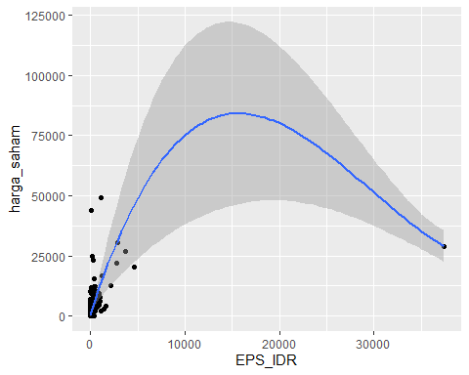
ggplot(data = reg_data, mapping=aes(x=PER, y=harga_saham))+geom_point(position = "jitter")+ geom_smooth()
## `geom_smooth()` using method = 'loess' and formula 'y ~ x'
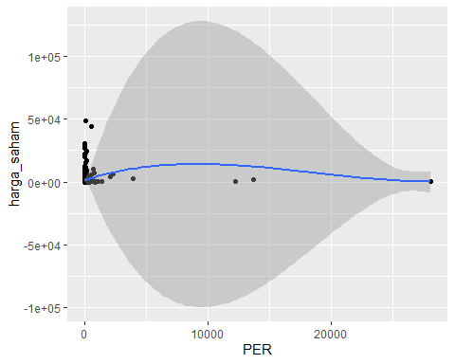
ggplot(data = reg_data, mapping=aes(x=DER, y=harga_saham))+geom_point(position = "jitter")+ geom_smooth()
## `geom_smooth()` using method = 'loess' and formula 'y ~ x'
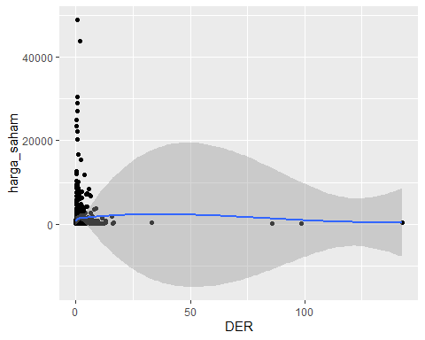
ggplot(data = reg_data, mapping=aes(x=ROA, y=harga_saham))+geom_point(position = "jitter")+ geom_smooth()
## `geom_smooth()` using method = 'loess' and formula 'y ~ x'
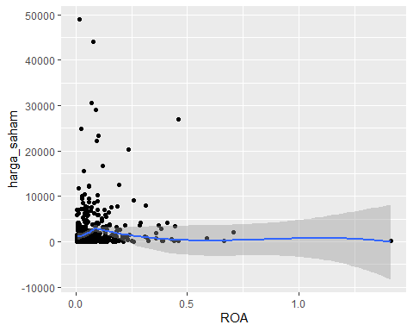
ggplot(data = reg_data, mapping=aes(x=ROE, y=harga_saham))+geom_point(position = "jitter")+ geom_smooth()
## `geom_smooth()` using method = 'loess' and formula 'y ~ x'
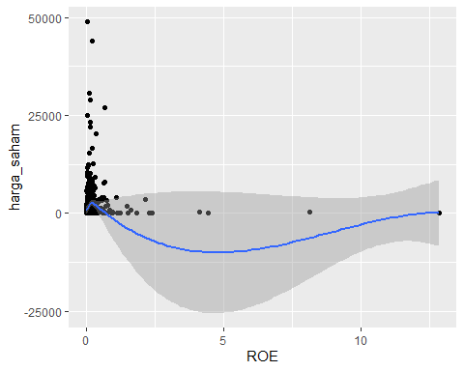
ggplot(data = reg_data, mapping=aes(x=NPM, y=harga_saham))+geom_point(position = "jitter")+ geom_smooth()
## `geom_smooth()` using method = 'loess' and formula 'y ~ x'
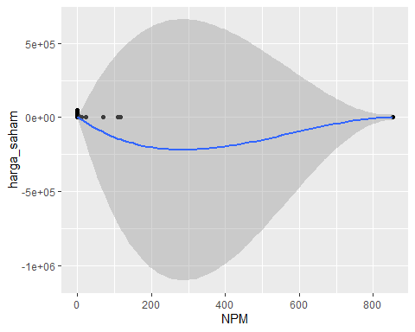
#import data without outlier, outliers have been eliminated
regression_data2 <- mutate(data_nonoutlier, Ln_Liab = Liabilities_bIDR)
str(regression_data2)
#regression
regresion_model3 <- lm(formula = harga_saham ~ EPS_IDR + PER + DER + ROA + ROE + NPM + Assets_bIDR + Ln_Liab + Equity_bIDR, data = regression_data2)
summary(regresion_model3)
##
## Call:
## lm(formula = harga_saham ~ EPS_IDR + PER + DER + ROA + ROE +
## NPM + Assets_bIDR + Ln_Liab + Equity_bIDR, data = regression_data2)
##
## Residuals:
## Min 1Q Median 3Q Max
## -11376 -1067 -813 -197 44847
##
## Coefficients:
## Estimate Std. Error t value Pr(>|t|)
## (Intercept) 766.85359 264.28799 2.902 0.00385 **
## EPS_IDR 1.03403 0.09975 10.367 < 2e-16 ***
## PER 4.29583 1.40609 3.055 0.00235 **
## DER 19.44702 95.05732 0.205 0.83797
## ROA 4252.82397 2262.91747 1.879 0.06067 .
## ROE -389.09371 861.57246 -0.452 0.65171
## NPM -2.63472 4.38392 -0.601 0.54807
## Assets_bIDR 0.02189 0.02763 0.792 0.42861
## Ln_Liab -0.03417 0.02950 -1.158 0.24718
## Equity_bIDR 0.06164 0.02854 2.159 0.03121 *
## ---
## Signif. codes: 0 '***' 0.001 '**' 0.01 '*' 0.05 '.' 0.1 ' ' 1
##
## Residual standard error: 3797 on 608 degrees of freedom
## Multiple R-squared: 0.2225, Adjusted R-squared: 0.211
## F-statistic: 19.33 on 9 and 608 DF, p-value: < 2.2e-16
regresion_model4 <- lm(formula = harga_saham ~ EPS_IDR + PER + DER + ROA + ROE + NPM , data = regression_data2)
summary(regresion_model4)
##
## Call:
## lm(formula = harga_saham ~ EPS_IDR + PER + DER + ROA + ROE +
## NPM, data = regression_data2)
##
## Residuals:
## Min 1Q Median 3Q Max
## -12574 -1310 -1051 -325 46400
##
## Coefficients:
## Estimate Std. Error t value Pr(>|t|)
## (Intercept) 1235.8232 261.0934 4.733 2.75e-06 ***
## EPS_IDR 1.0707 0.1031 10.386 < 2e-16 ***
## PER 3.4992 1.4502 2.413 0.0161 *
## DER -8.9257 92.4713 -0.097 0.9231
## ROA 3948.1602 2329.5401 1.695 0.0906 .
## ROE -470.7790 876.5195 -0.537 0.5914
## NPM -3.0947 4.5370 -0.682 0.4954
## ---
## Signif. codes: 0 '***' 0.001 '**' 0.01 '*' 0.05 '.' 0.1 ' ' 1
##
## Residual standard error: 3930 on 611 degrees of freedom
## Multiple R-squared: 0.163, Adjusted R-squared: 0.1547
## F-statistic: 19.82 on 6 and 611 DF, p-value: < 2.2e-16
#classic asumption
#Normalitas
ks.test(regresion_model3$residuals, ecdf(regresion_model3$residuals))
##
## Asymptotic one-sample Kolmogorov-Smirnov test
##
## data: regresion_model3$residuals
## D = 0.0016181, p-value = 1
## alternative hypothesis: two-sided
ks.test(regresion_model4$residuals, ecdf(regresion_model4$residuals))
##
## Asymptotic one-sample Kolmogorov-Smirnov test
##
## data: regresion_model4$residuals
## D = 0.0016181, p-value = 1
## alternative hypothesis: two-sided
#Multikolinieritas
ols_vif_tol(regresion_model3)
## Variables Tolerance VIF
## 1 EPS_IDR 0.990759885 1.009326
## 2 PER 0.957916864 1.043932
## 3 DER 0.519311695 1.925626
## 4 ROA 0.453474296 2.205197
## 5 ROE 0.361097958 2.769332
## 6 NPM 0.992067452 1.007996
## 7 Assets_bIDR 0.002315297 431.910074
## 8 Ln_Liab 0.003141853 318.283516
## 9 Equity_bIDR 0.062771561 15.930781
ols_vif_tol(regresion_model4)
## Variables Tolerance VIF
## 1 EPS_IDR 0.9937327 1.006307
## 2 PER 0.9647413 1.036547
## 3 DER 0.5878970 1.700978
## 4 ROA 0.4584225 2.181394
## 5 ROE 0.3737677 2.675459
## 6 NPM 0.9923039 1.007756
#Heteroskedastisitas
bptest(regresion_model3)
##
## studentized Breusch-Pagan test
##
## data: regresion_model3
## BP = 23.507, df = 9, p-value = 0.005154
bptest(regresion_model4)
##
## studentized Breusch-Pagan test
##
## data: regresion_model4
## BP = 14.134, df = 6, p-value = 0.02817
##### terima kasih #####

