**GeoPlanning**

Journal of Geomatics and Planning Vol. x, No. x, year



e-ISSN: 2355-6544

Received: ..........;

Accepted: ..........;

Published: ..........

**Keywords:**

Modelling, prediction, land cover change, cellular automata

*Corresponding author(s) email: [dirahariyanto23@student](mailto:author@geoplanning.ac.id).ub.ac.id

*Original Research*

Land Cover Change Prediction Based on Cellular Automata Approach for Kedungkandang Disctrict, Malang City: Comparison of Three Models

Annisa Dira Hariyanto 1*, Adipandang Yudono 2, Agus Dwi Wicaksono 2

1. *Master Degree of Urban and Regional Planning Department, Brawijaya University, Indonesia*
2. *Department of Urban and Regional Planning, Brawijaya University, Indonesia*

DOI: [10.14710/geoplanning.8.1.pp-](https://doi.org/10.14710/geoplanning.8.1.61-74)pp

**Abstract**

The infrastructure development of Malang City is being concentrated towards the eastern and southeastern parts, Kedungkandang District. Infrastructure plays an important role in the aspect of land cover change, which raises the complexity of the emergence of urban forms and dynamics. The Cellular Automata (CA) approach is used because this study aims to observe the behavior (local rules) that underlie the emergence of development patterns and land dynamics in Kedungkandang District. In CA, a transition probability model is built with several variables that are assumed to drive land change. The transition probability model can be analyzed with several techniques that will produce different validity values or prediction accuracy levels. This study tries to compare the results of land cover change predictions using three models, namely Artificial Neural Network (ANN), Logistic Regression (LR), and Multi-Criteria Evaluation (MCE). The prediction results show that the ANN and MCE model has the highest Kappa overall (prediction accuracy level), while the ANN and LR models have the highest Kappa location values. Based on this research, it can be concluded that the model run by machine learning is more accurate, especially in predicting land growth in Kedungkandang District, compared to the existing model with human intervention.

*Copyright © 2021 GJGP-Undip  
This open access article is distributed under a   
Creative Commons Attribution (CC-BY-NC-SA) 4.0 International license*

1. **Introduction**

Cellular Automata (CA) is a land cover change modeling approach that explicitly calculates urban drivers and influences from the surrounding environment (Wahyudi and Liu, 2016; Campos, Almeida and Queiroz, 2018). Historically, CA has long been used to capture the complex dynamics of land cover change processes created by John von Neumann (1903–1957) during the 1950s. CA is considered the simplest type of dynamic spatial model (White and Engelen, 2000; Sfa, Nemiche and Raydo, 2020) and is a grid-based modeling approach where each cell is in a specific state, in this case, specific land use or cover. Five important components prepared and determined in the CA process, including cell space, cell state, neighborhood, transition rules, and iteration time (Feng et al., 2019). Time runs in discrete time steps. At each time step, all cells update their state simultaneously based on the previous cell state, environment, and transition rules (Delden et al., 2011; Qian et al., 2020). The core of the CA-based model is the transition rule, where the appropriate transition rule is the main determinant for the ability of a good predictive model (Xing et al., 2020). This transition rule requires several spatial factors of land change to model the transition potential. Many techniques are used to model transition potential and map transition potential (Roodposhti, Aryal and Bryan, 2019; Sfa, Nemiche and Raydo, 2020; Xing et al., 2020), including Weight of Evidence (Campos et al., 2018), Logistic Regression (Mustafa et al., 2018; Campos et al., 2018; Wang et al., 2019; Cao et al., 2020), Multi Criteria Evaluation (Fu et al., 2018; Campos et al., 2018; Mohamed & Worku, 2020; A. A. Gharaibeh et al., 2020; SIPAHIOGLU & CAGDAS, 2022), Artificial Neural Network (Li & Yeh, 2001; Campos et al., 2018; A. Gharaibeh et al., 2020; SIPAHIOGLU & CAGDAS, 2022), Support Vector Machine (Campos et al., 2018), and other techniques. Each of these analytical techniques uses structurally different formulations, which will affect the accuracy of the results of modeling land cover changes in CA (Roodposhti et al., 2019). This study tries to compare the predictions of land cover change in Kedungkandang District, Malang City and use three transition potential model techniques, including Artificial Neural Network (ANN), Logistic Regression (LR), and Multi-Criteria Evaluation (MCE).

ANN is considered the best model that relies on artificial intelligence (A. Gharaibeh et al., 2020) and has a large enough capacity to recognize and classify patterns through the training or learning process (Yeh & Li, 2002). Non-linear relationship between land change factors and the process of understanding complex patterns such as urban growth can be captured by the ANN model very well (A. Gharaibeh et al., 2020). ANN can be designed to estimate the likelihood of land change and development in each iteration of the simulation in CA based on past trends (Yeh & Li, 2002). However, ANN has major drawbacks, one of which is that it is difficult to understand its internal computation process (Park et al., 2011; Shafizadeh-Moghadam, Tayyebi and Helbich, 2017). In contrast to ANN, the use of LR is quite popular because of its ability to analyze the relationship between land cover changes and the factors that occur quantitatively. In addition, the LR model can also identify the extent to which these factors influence land cover change, thereby enabling researchers to clearly understand the role of various land change factors in the future (Cao et al., 2020). The ANN and LR models in this study are specifically based on machine learning, where there is no researcher intervention in the modeling process. To compare the results between the model generated by machine learning and the model with human intervention, the researchers also considered using MCE. This MCE model substantially relies on expert knowledge and judgment in making the weighting of its spatial factors (Yeh & Li, 2002). Based on this, it can be understood that MCE integrates spatial conditions and human decisions, thereby demonstrating a great ability to measure the comprehensive effects of various factors of resulting land cover change (Zadbagher, Becek and Berberoglu, 2018; Yao et al., 2022). One of the weaknesses of MCE is that the transition potential model can change linearly and thus will produce predictions with a linear trend (Shafizadeh-Moghadam et al., 2017).

As a sub-district that has developed rapidly over the last ten years and supported by various infrastructure developments, the changes in the spatial dynamics of Kedungkandang District in the future need to be identified. It is in line with the statement Shafizadeh-Moghadam et al. (2017), that in carrying out efficient monitoring and management of land cover, knowledge of previous land dynamics, current trends, and predictions of future developments are required. Three techniques in modeling the transition potential in this study are utilized to formulate the best model that can capture the dynamics of change in Kedungkandang District in the future.

1. **Data and Methods**
   1. ***Study Area Description***

Malang City, as the second-largest city in East Java Province, continues to experience very rapid urban development, in terms of population and land development, as well as the growth of primary and regional activities. This caused settlement development to be pushed towards the outskirts of the city due to the saturation that occurs in the city center (Adrianto et al., 2017). One of the potential areas for settlement development is Kedungkandang District, where the area of ​​non-developed land is the highest in Malang City currently (55% of the total area of ​​undeveloped land). In line with this, historically, Kedungkandang District has also experienced the conversion of non-built land into the highest built-up land in Malang City from 2009 to 2019 (Table 1). It can be indicated that the conversion of non-built land into built-up land in Kedungkandang District has the potential to occur again in the future.

Administratively, Kedungkandang District has 12 sub-districts (Fig. 1), most of them adjacent to Malang Regency. Previous research (Rofii, 2021) showed an urban sprawl phenomenon in Malang City in 2014 with a type of land spread, ribbon development that leads to outside Malang City, one of which is around the city limits in Kedungkandang District. Based on these conditions, the researcher considers the Kedungkandang District area to have a high urgency to be modelled the dynamics and patterns of land cover changes, so that the Regional Government can take the right policy.

**Table 1.** Land Cover Change of Non-Built Land to Built-up Land per District in Malang City

|  |  |  |  |  |  |  |  |
| --- | --- | --- | --- | --- | --- | --- | --- |
| **District** | **2009 Land Cover (hectares)** | | | **2019 Land Cover (hectares)** | | | **Land Cover Change (hectares)** |
| **Wet Land Paddy** | **Non-Wet Land Paddy** | **Non-Agricultural Land** | **Wet Land Paddy** | **Non-Wet Land Paddy** | **Non-Agricultural Land** |
| Kedungkandang | 619 | 1,505.31 | 1,864.69 | 511 | 1,207 | 2,271 | 406.31 |
| Sukun | 322 | 396.80 | 1,378.20 | 181 | 452 | 1,464 | 85.80 |
| Klojen | 0 | 0 | 883 | 0 | 1 | 882 | 0 |
| Blimbing | 142 | 7 | 1,628 | 75 | 10 | 1,692 | 64 |
| Lowokwaru | 311.62 | 102.44 | 1,944.10 | 247 | 78 | 1,935 | 40.18 |

*Source: Malang City Central Bureau of Statistics 2010 and 2020*

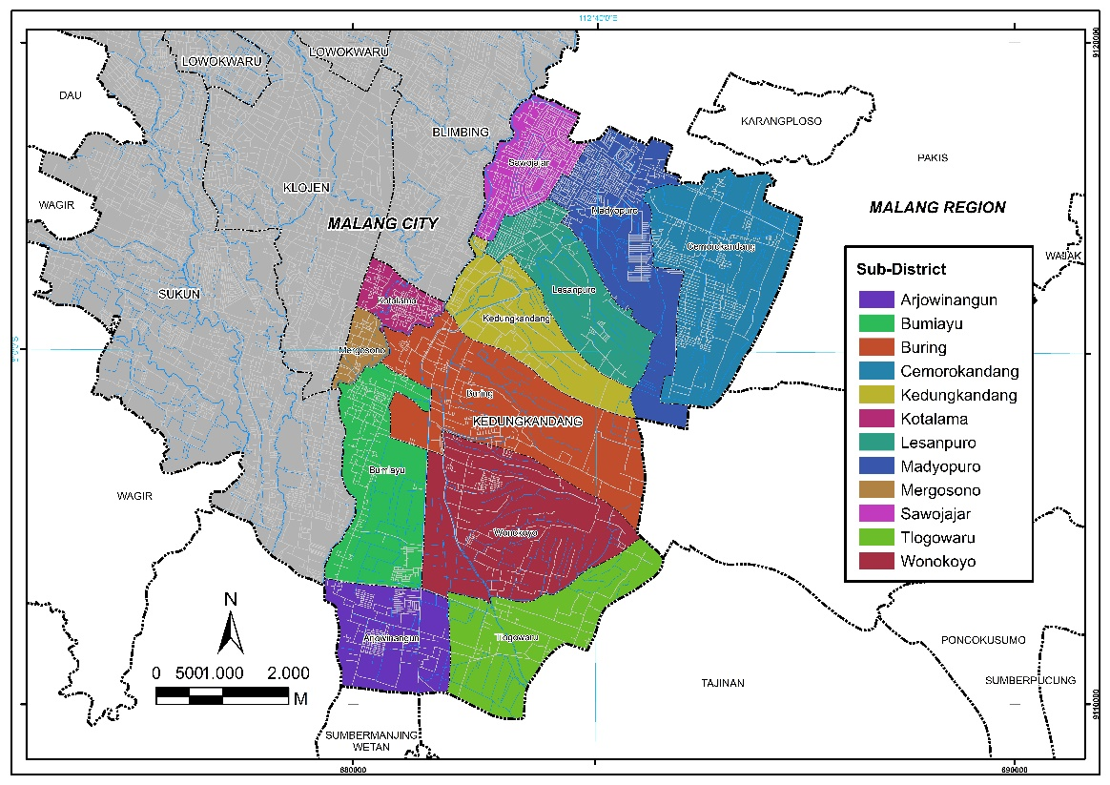

*Source: Author, 2022*

**Figure 1**. Location of Study

* 1. ***Data Source***

This section describes in detail the preparation of the data used in this study. It includes land cover data for three different years and several spatial factors that can stimulate urban growth and land cover changes in Kedungkandang District. These data are obtained from open source platforms and processed using QGIS software. The results of which can be analized in the simulation process. A detailed explanation of the data source is in Table 2.

**Table 2.** List of the used datasets in this study

|  |  |  |  |
| --- | --- | --- | --- |
| **Varıabel** | **Metadata** | **Processing** | **Source** |
| 2012 land cover map | * Satellite portrait dated 04-28-2012 * Cloud <10% * Resolusi of 30m | Pansharpening process to a resolution of 15m | Landsat 7 image |
| 2016 land cover map | * Satellite portrait dated 05-08-2016 * Cloud <10% * Resolution of 30m | Pansharpening process to a resolution of 15m | Landsat 8 image |
| 2020 land cover map | * Satellite portrait dated 22-12-2020 * Cloud <10% * Resolution of 30m | Pansharpening process to a resolution of 15m | Landsat 8 image |
| Distance to road | Malang city road base map | Rasterized with a pixel size of 15x15 meters | * OpenStreetMap * RTRW Kota Malang tahun 2020-2030 |
| Distance to existing settlement | 2020 land cover map | Rasterized with a pixel size of 15x15 meters | Citra Landsat 8 |
| Distance to electricity network | POI of electrical substation | Rasterized with a pixel size of 15x15 meters | PT. PLN (State Electricity Company) |
| Distance to educational facilities | POI of school building | Rasterized with a pixel size of 15x15 meters | Data Scrapping |
| Distance to commercial facilities | POI of trade and service buildings | Rasterized with a pixel size of 15x15 meters | Data Scrapping |

* 1. ***Methodological Framework***

There are three scopes in the research framework presented in Figure 2. The first scope is land cover map using Landsat 7 and Landsat 8 data. This map is to identify the dynamics of previous land change in Kedungkandang District, namely in 2012, 2016 and 2020. The second scope is the transition potential model from three techniques or models, including ANN, LR and MCE. The last scope is the simulation of prediction of future land cover changes, which is until 2036. This study will use MOLUSCE (Modules for Land Use Change Evaluation) and LanduseSim as CA-based modeling tools. MOLUSCE is used in the prediction simulation process using the ANN and LR techniques. The prediction simulation process using the MCE technique is using the LanduseSim software. It is due to the limitations and difficulties in using MOLUSCE for the MCE model simulation process. Modeling with the MCE technique used in this study only uses the weights generated from previous studies. So, MOLUSCE is harder to run because it must include a pairwise comparison matrix. Then, by using the MCE model, MOLUSCE can only represent the transition from one class in one simulation process, while LanduseSim makes it easier for researchers to perform simulations by representing all transition classes. The following are the steps for processing CA in this study:

1. Preparation of land cover maps

The study area is divided into cells as the basis of analysis in modeling. Landsat image was generated using the USGS Earth Explorer with a resolution of 30 meters. Pansharpening process is carried out to get a smaller image resolution of 15 meters. It is because the study area only covers the administration of the sub-districts. The land cover map in this study was produced through a land cover classification process based on the appearance of Landsat image using the supervised classification technique. The Semi-Automatic Classification Plugin (SCP), which is an open source plugin in QGIS, is used in the supervised classification process. Land classification uses the five land cover categories described in Table 3. Furthermore, the classification results need to be validated and tested for accuracy, where the validation of the land cover classification is processed with the THRASE plugin with references to GoogleEarth images in 2012, 2016, and 2020. Then, test the classification accuracy of land cover is done using the AcATAMa (Accuracy Assessment of Thematic Maps) plugin, so it can generate Kappa values.

**Table 3.** Land Cover Categories

| **No.** | **Land classification** | **Keterangan** |
| --- | --- | --- |
| 1 | Built-up areas | Areas undergoing changes or conversions from natural or semi-natural land cover to impermeable and permanent land cover such as buildings, roads, and other pavements |
| 2 | Vegetation | Areas that are not cultivated for agricultural activities are generally dry land overgrown with natural vegetation such as forests, shrubs, grass, reeds, and others. |
| 3 | Agricultural Areas | Areas that are cultivated for agricultural activities |
| 4 | Water body | All water features such as rivers, swamps and others |
| 5 | Bare land | Areas that are not covered are either artificial, natural or semi-natural |

*Source: Author, 2022*

1. Modeling the transition potential

The spatial factors of land cover changes used in the simulation process must be converted into raster units based on proximity measurements. Proximity is a measurement based on the distance between two objects as points in geographic space. Two of the most commonly used proximity metrics are Euclidean Distance and Manhattan Distance (Nkweteyim, 2018). Measurement of proximity in this study was carried out using the Euclidean distance. Euclidean distance is a commonly used technique, it can recognize distances and calculate the proximity of each factor to land cover changes based on the distance (Liang et al., 2018). The Euclidean distance in this research is processed in QGIS using the Proximity tool and is measured based on the grid/cell distance that is per 15 meters. Figure 3 shows various spatial factors of land cover change in Kedungkandang District that have gone through the Euclidean distance process. Then, the transition area along with the driving and limiting factors that have been in the euclidean distance, was analyzed in the MOLUSCE plugin with several techniques (ANN, LR and MCE) to produce a potential model for land cover change transitions.

1. Simulation of Land Cover Change Prediction

The simulation of land cover change uses the Cellular Automata approach, based on the transition potential model implemented in the previous stage. This study performs five iterations of the simulation starting from 2016 to 2036. The simulation results, the generated predictions, need to be validated to test the accuracy of the results. One of the most frequently used techniques to test simulation results is Kappa statistics. The CA process in the MOLUSCE plugin also provides tools to validate simulation results, especially with Kappa statistics. The Kappa statistical process is to compare the simulated map with the actual map in the same year, in order to valuate the accuracy of the model using the % truth and the Kappa validation coefficient (Mienmany, 2018).

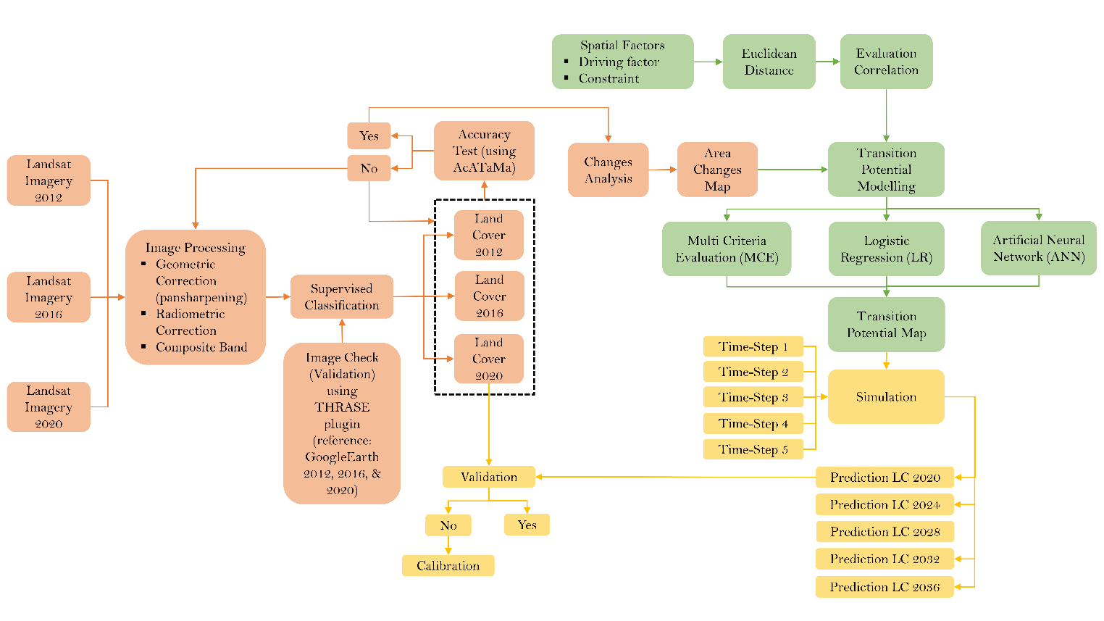

*Source: Author, 2022*

**Figure 2**. Research Framework

**1**

**Distance to**

**Electricity Network**

**5**

**4**

**3**

**2**

**Distance to Commercial Facilities**

**Distance to**

**Existing Settlement**

**Distance to Educational Facilities**

**Distance to Road**

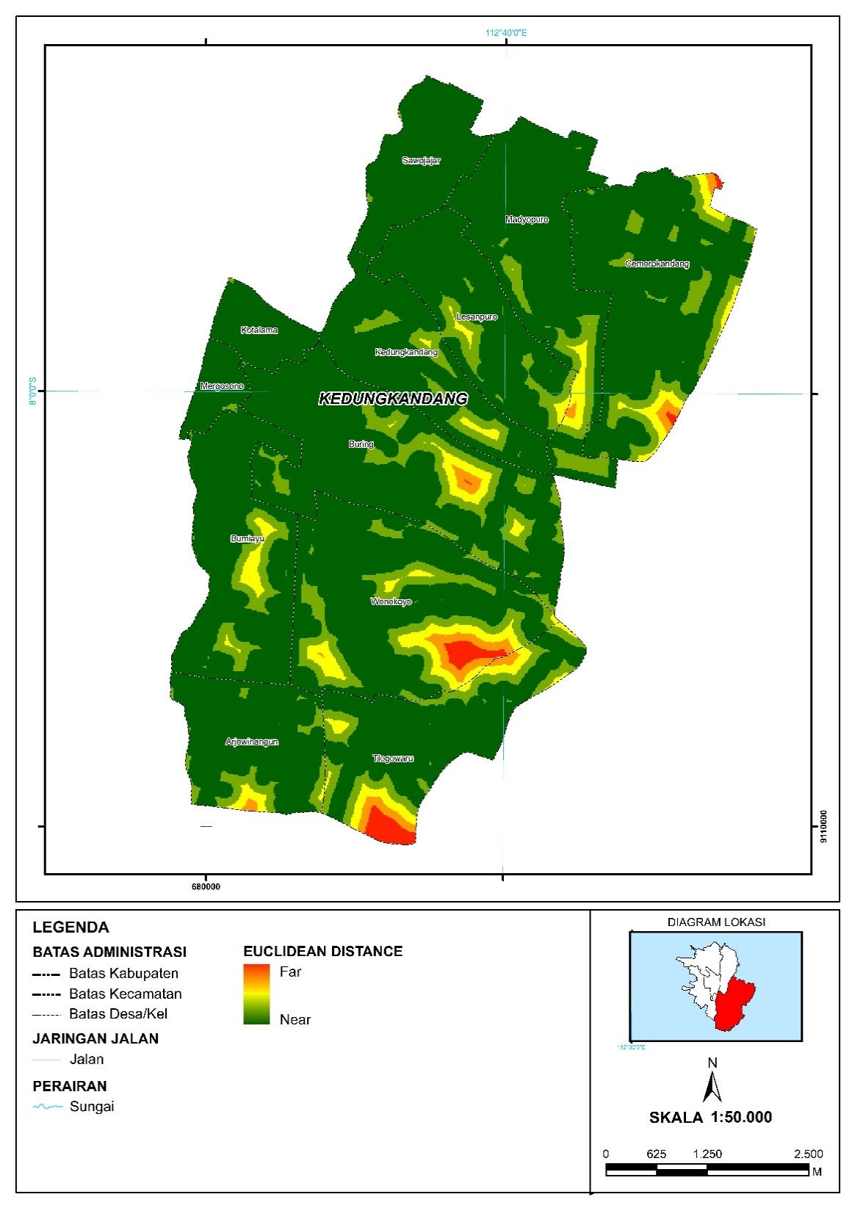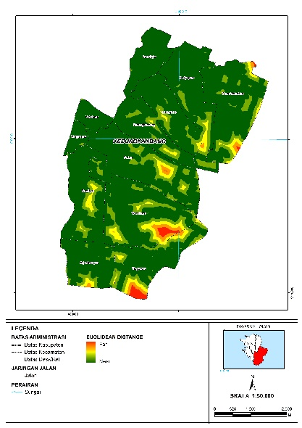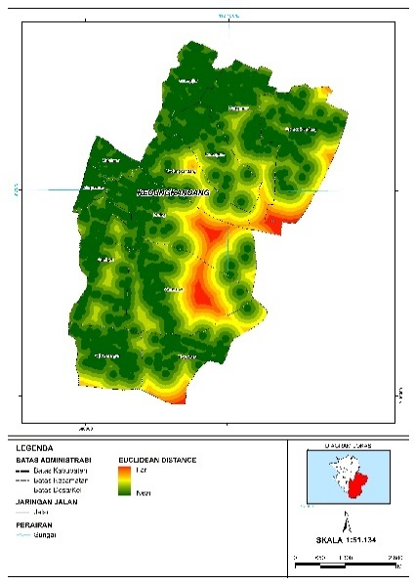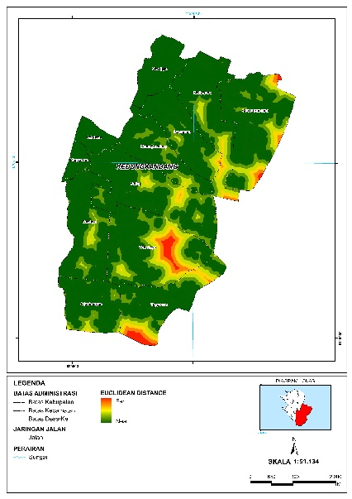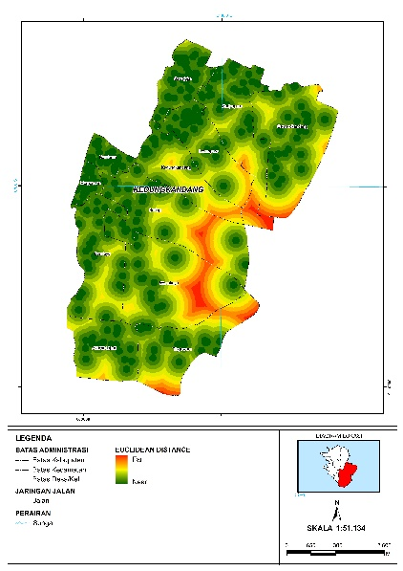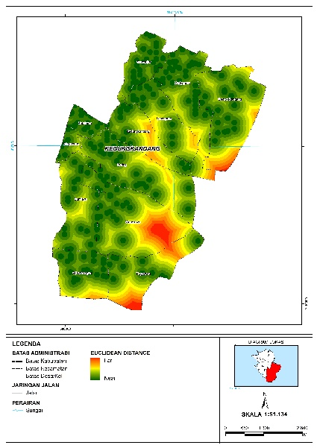

*Source: Author, 2022*

**Figure 3**. Euclıdean Distance Map of Spatial Factors of Land Cover Change

1. **Result and Discussion**
   1. ***Land Cover Change***

Land cover change is calculated through the MOLUSCE plugin as a power input, especially in 2012 – 2016 and 2016 – 2020, resulting in a land cover change transition map (Figure 4) and a land cover change transition matrix (Table 4). The largest change in land cover from 2012 to 2020 in Kedungkandang District occurred due to the addition of 335.53 hectares of built-up land and a reduction of 297.90 hectares of vegetation. Agricultural areas have decreased, but not as significant as vegetation. In line with the built-up land, bare land also experienced an increase, indicated by the initiation of new development, resulting in the opening and preparation of open land.

**Table 4.** Land Cover Change Transition Matrix

|  |  |  |  |  |
| --- | --- | --- | --- | --- |
| **Land Classification** | **Areas (Hectares)** | | | **Land Cover Change (Hectares)** |
| **2012** | **2016** | **2020** |
| Built-up Areas | 955.03 | 1,117.53 | 1,290.56 | 335.53 |
| Vegetation | 2,244.17 | 2,150.13 | 1,946.27 | -297.90 |
| Agricultural Areas | 553.61 | 544.07 | 470.30 | -83.31 |
| Water Bodies | 26.10 | 26.10 | 26.10 | 0.00 |
| Bare Land | 211.81 | 152.89 | 257.49 | 45.68 |

*Source: Analysis, 2022*

**2**

**Transition: 2016 - 2020**

**Transition: 2012 - 2016**

**1**

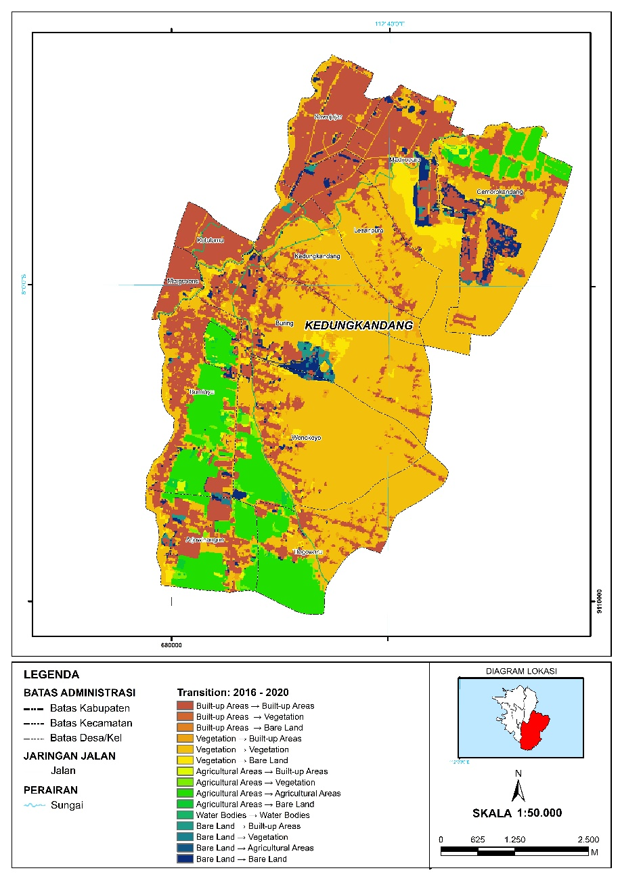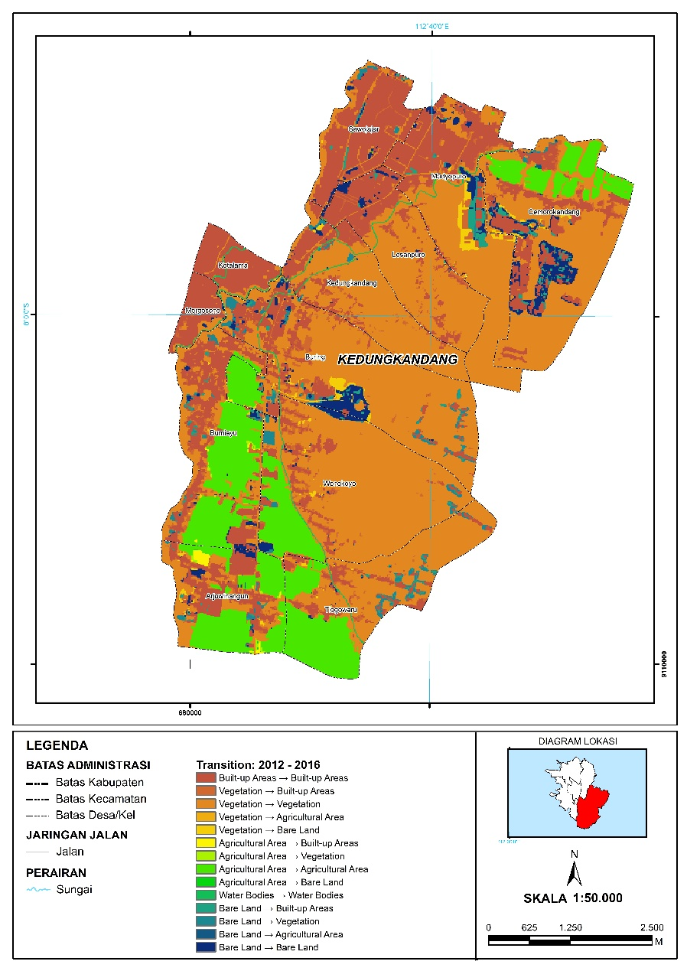

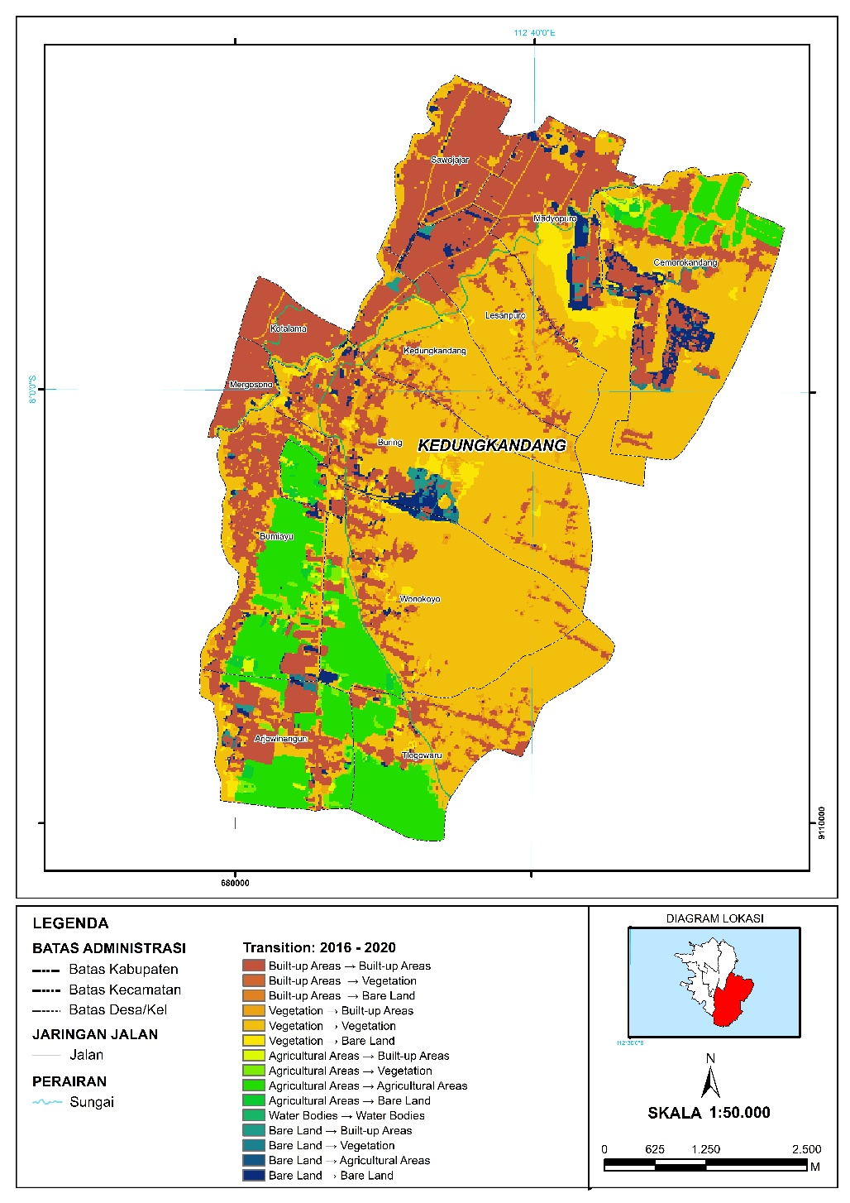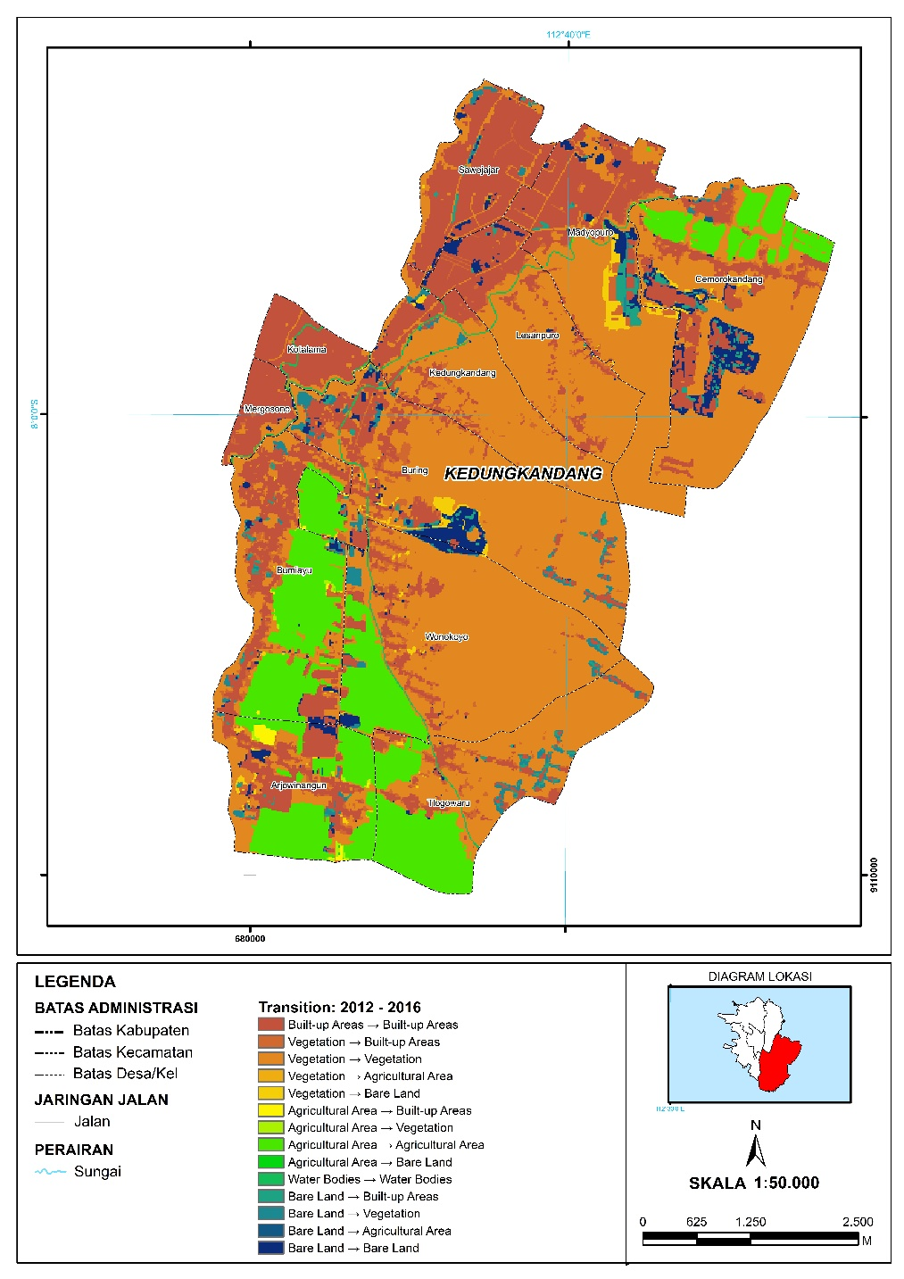

*Source: Analysis, 2022*

**Figure 4**. Land Cover Change Transition Map

* 1. ***Transition Potential Model***

The transition potential model of land cover change in Kedungkandang District will use Artificial Neural Network, Logistic Regression and Multi Criteria Evaluation analysis techniques. When running the ANN model, a learning process is needed using the ANN model parameters (Table 5). With these model parameters, the resulting accuracy level with the best Kappa value is 90%, so that this ANN model can be used to simulate land cover change predictions. Similar to the ANN transition potential model, the LR transition potential model also needs to define several parameters as described in Table 6. With these parameters, a pseudo r-square value of 99.1% is generated, which indicates that the logistic regression model is good. The independent variable can explain the dependent variable with a percentage that is almost 100%.

The third transition potential model is MCE. The MCE in the transition potential model of land cover change requires the weight of each land change factor. The weights in this study use the results of previous research by Rofii (2021) generated through the AHP process. The study resulted in five spatial factors in land cover change in Malang City, where the four spatial factors were the same as the spatial factors used in this study. The weight of the spatial factors in this study is described in Table 7. The three models also produce a transition probability map (Table 8) to be further used in the simulation process for predicting land cover changes. The transition potential map represents the possibility of land change with a potential value range of 0 to 100. A value of 0 indicates a low potential for transitional change, while a value of 100 indicates a high transition potential.

**Table 5.** Parameters of Artificial Neural Network Learning Process Model

| **Parameter** | **Value** |
| --- | --- |
| Neighbourhood | 1px |
| Sampel | 1000 |
| Learning rate | 0,08 |
| Maximum iteration | 100 |
| Hidden layer | 5 |
| Momentum | 0,05 |

*Source: Analysis, 2022*

**Table 6.** Parameter Model Logistic Regression

| **Parameter** | **Value** |
| --- | --- |
| Neighbourhood | 1px |
| Sampel | 1000 |
| Maximum iteration | 100 |

*Source: Analysis, 2022*

**Table 7.** Spatial Factor Weighting Land Cover Change

| **Spatial Factor** | **Weight** |
| --- | --- |
| Existing built-up areas | 0,404 |
| Roads | 0,263 |
| Education facilities | 0,125 |
| Commercial facilities | 0,121 |
| Electricity network | 0,087 |

*Source:* (Rofii, 2021)*, processed 2022*

**Table 7.** Transition Potential Model Map

| **Model** | **Transition Potential Model Map** | | |
| --- | --- | --- | --- |
| ANN | Vegetation → Built-up Areas | Agricultural Areas → Built-up Areas | Bare Land → Built-up Areas |
|  |  |  |
| LR | Vegetation → Built-up Areas | Agricultural Areas → Built-up Areas | Bare Land → Built-up Areas |
|  |  |  |
| MCE |  | | |

*Source: Analysis, 2022*

* 1. ***Land Cover Change Prediction Simulation***

The simulation of land cover change prediction is then processed based on the results of the previous transition potential model. The results of the prediction of cover change using the ANN model are in Figure 5, the LR model in Figure 6 and the MCE model in Figure 7, and Table 8 describes maps of land development directions based on the predicted results of land cover changes.

*Source: Analysis, 2022*

**Figure 5**. Land Cover Change Prediction with ANN Model

*Source: Analysis, 2022*

**Figure 6**. Land Cover Change Prediction with LR Model

*Source: Analysis, 2022*

**Figure 7**. Land Cover Change Prediction with MCE Model

**Table 9.** Prediction Map of Land Cover Change and Direction of Development of Built-up Land

| **Model** | **Prediction Map** | | |
| --- | --- | --- | --- |
| **Y2020** | **Y2028** | **Y2036** |
| ANN |  |  |  |
| LR |  |  |  |
| MCE |  |  |  |

*Source: Analysis, 2022*

The simulation of prediction of land cover change results that the MCE model predicts a very high increase in built-up land according to the development of built-up land in actual conditions, while ANN and MCE predicts a development of built-up land, but not too significantly. The results of the prediction of land use change using the MCE model have a linear trend. This is indicated due to the intervention of researchers in the transition potential modeling process. While the ANN and LR models in this study are entirely run by machine learning, so researchers cannot make limits or judgments in the models. The MCE model is the only model that can predict the development of large built-up land around the Malang – Pasuruan toll gate, especially in 2020 which is in line with developments in the existing conditions in 2020.

To validate the prediction results, a comparison is made between the actual 2020 land cover map and the 2020 land cover prediction simulation map. Kappa statistics are used in the validation process with the results in the form of Kappa Histogram, Kappa Location and Kappa Overall (Table 10). Judging from the overall value of Kappa, the highest model accuracy is generated by the ANN and MCE models. Then the highest Kappa location value is generated by the ANN and LR models. It indicates that the ANN and LR models have the simulation ability to determine the location of the development of built-up land very well compared to the MCE model. Based on the validation results, it is known that ANN is the best predictive model of land cover change in Kedungkandang District, because it has the highest Kappa overall and Kappa location values.

**Table 10.** Validation of Land Cover Prediction Simulation Results from Three Types of Models

| **Model** | **% of *Correctness*** | **Kappa (*Overall*)** | **Kappa (Histo)** | **Kappa (Loc)** |
| --- | --- | --- | --- | --- |
| ANN | 90.77% | 0.85 | 0.91 | 0.93 |
| LR | 90.10% | 0.84 | 0.91 | 0.93 |
| MCE | 90.33% | 0.85 | 0.94 | 0.90 |

*Source: Analysis, 2022*

1. **Conclusion**

This research has compared three potential transition models in predicting land cover change based on the Cellular Automata approach. Overall, the ANN transition potential model is the best model in predicting land cover changes in Kedungkandang District. Based on this, it can be concluded that the model run by machine learning is more accurate, especially in predicting land growth in Kedungkandang District, compared to the existing model with human intervention.

1. **Acknowledgments**

We are very grateful for the support given by the Department of Urban and Regional Planning, Universitas Brawijaya as well as members of the Editorial Board and anonymous reviewers for their comments and for the improvement of this research.

1. **References**

Adrianto, D. W., Hasyim, A. W., Dinanti, D., Dwi, J., & Sandy, H. (2017). *Valuasi Sumber Daya Lahan di Pinggiran Kota Malang (Studi Kasus : Wilayah Pinggiran Kota Malang , Kelurahan Tunggulwulung Kecamatan*. 335–342.

Campos, P. B. R., Almeida, C. M. de, & Queiroz, A. P. de. (2018). Educational infrastructure and its impact on urban land use change in a peri-urban area: a cellular-automata based approach. *Land Use Policy*, *79*(August), 774–788. https://doi.org/10.1016/j.landusepol.2018.08.036

Cao, Y., Zhang, X., Fu, Y., Lu, Z., & Shen, X. (2020). Urban spatial growth modeling using logistic regression and cellular automata: A case study of Hangzhou. *Ecological Indicators*, *113*(December 2019), 106200. https://doi.org/10.1016/j.ecolind.2020.106200

Delden, H. Van, Mcdonald, G., Shi, Y., Hurkens, J., Vliet, J. Van, & Belt, M. Van Den. (2011). Integrating socio-economic and land-use models to support urban and regional planning. *Agile*, *November*, 1–10.

Feng, Y., Wang, J., Tong, X., Shafizadeh-Moghadam, H., Cai, Z., Chen, S., Lei, Z., & Gao, C. (2019). Urban expansion simulation and scenario prediction using cellular automata: comparison between individual and multiple influencing factors. *Environmental Monitoring and Assessment*, *191*(5). https://doi.org/10.1007/s10661-019-7451-y

Fu, X., Wang, X., & Yang, Y. J. (2018). Deriving suitability factors for CA-Markov land use simulation model based on local historical data. *Journal of Environmental Management*, *206*, 10–19. https://doi.org/10.1016/j.jenvman.2017.10.012

Gharaibeh, A. A., Shaamala, A. H., & Ali, M. H. (2020). Multi-Criteria Evaluation for Sustainable Urban Growth in An-Nuayyimah, Jordan; Post War Study. *Procedia Manufacturing*, *44*(2019), 156–163. https://doi.org/10.1016/j.promfg.2020.02.217

Gharaibeh, A., Shaamala, A., Obeidat, R., & Al-Kofahi, S. (2020). Improving land-use change modeling by integrating ANN with Cellular Automata-Markov Chain model. *Heliyon*, *6*(9), e05092. https://doi.org/10.1016/j.heliyon.2020.e05092

Li, X., & Yeh, A. G. (2001). Calibration of cellular automata by using neural networks for the simulation of complex urban systems. *Environment and Planning A*, *33*(8), 1445–1462. https://doi.org/10.1068/a33210

Liang, X., Liu, X., Li, X., Chen, Y., Tian, H., & Yao, Y. (2018). Delineating multi-scenario urban growth boundaries with a CA-based FLUS model and morphological method. *Landscape and Urban Planning*, *177*(September 2017), 47–63. https://doi.org/10.1016/j.landurbplan.2018.04.016

Mienmany, B. (2018). *Analysis of land use and land cover changes and the driving forces: A case study in Kaysone Phomvihan District, Laos*. University of Porto.

Mohamed, A., & Worku, H. (2020). Simulating urban land use and cover dynamics using cellular automata and Markov chain approach in Addis Ababa and the surrounding. *Urban Climate*, *31*(May 2019), 100545. https://doi.org/10.1016/j.uclim.2019.100545

Mustafa, A., Heppenstall, A., Omrani, H., Saadi, I., Cools, M., & Teller, J. (2018). Modelling built-up expansion and densification with multinomial logistic regression, cellular automata and genetic algorithm. *Computers, Environment and Urban Systems*, *67*, 147–156. https://doi.org/10.1016/j.compenvurbsys.2017.09.009

Nkweteyim, D. L. (2018). Clustering by partitioning around medoids using distance-based similarity measures on interval-scaled variables. *Nigerian Journal of Technological Development*, *15*(1), 1. https://doi.org/10.4314/njtd.v15i1.1

Park, S., Jeon, S., Kim, S., & Choi, C. (2011). Prediction and comparison of urban growth by land suitability index mapping using GIS and RS in South Korea. *Landscape and Urban Planning*, *99*(2), 104–114. https://doi.org/10.1016/j.landurbplan.2010.09.001

Qian, Y., Xing, W., Guan, X., Yang, T., & Wu, H. (2020). Coupling cellular automata with area partitioning and spatiotemporal convolution for dynamic land use change simulation. *Science of the Total Environment*, *722*, 137738. https://doi.org/10.1016/j.scitotenv.2020.137738

Rofii, I. (2021). Model Perubahan Penggunaan Lahan Di Wilayah Peri Urban Kota Malang. *Indonesian Journal of Spatial Planning*, *2*(1), 28. https://doi.org/10.26623/ijsp.v2i1.3153

Roodposhti, M. S., Aryal, J., & Bryan, B. A. (2019). A novel algorithm for calculating transition potential in cellular automata models of land-use/cover change. *Environmental Modelling and Software*, *112*(October), 70–81. https://doi.org/10.1016/j.envsoft.2018.10.006

Sfa, F. E., Nemiche, M., & Raydo, H. (2020). A generic macroscopic cellular automata model for land use change: The case of the Drâa valley. *Ecological Complexity*, *43*(July), 100851. https://doi.org/10.1016/j.ecocom.2020.100851

Shafizadeh-Moghadam, H., Tayyebi, A., & Helbich, M. (2017). Transition index maps for urban growth simulation: application of artificial neural networks, weight of evidence and fuzzy multi-criteria evaluation. *Environmental Monitoring and Assessment*, *189*(6). https://doi.org/10.1007/s10661-017-5986-3

SIPAHIOGLU, N., & CAGDAS, G. (2022). Scenario-Based Cellular Automata and Artificial Neural Networks in Urban Growth Modeling. *Gazi University Journal of Science*, *36*(2). https://doi.org/10.35378/gujs.998073

Wahyudi, A., & Liu, Y. (2016). Cellular Automata for Urban Growth Modelling: *International Review for Spatial Planning and Sustainable Development*, *4*(2), 60–75. https://doi.org/10.14246/irspsd.4.2_60

Wang, M., Cai, L., Xu, H., & Zhao, S. (2019). Predicting land use changes in northern China using logistic regression, cellular automata, and a Markov model. *Arabian Journal of Geosciences*, *12*(24). https://doi.org/10.1007/s12517-019-4985-9

White, R., & Engelen, G. (2000). High-resolution integrated modelling of the spatial dynamics of urban and regional systems. *Computers, Environment and Urban Systems*, *24*(5), 383–400. https://doi.org/10.1016/S0198-9715(00)00012-0

Xing, W., Qian, Y., Guan, X., Yang, T., & Wu, H. (2020). A novel cellular automata model integrated with deep learning for dynamic spatio-temporal land use change simulation. *Computers and Geosciences*, *137*(January), 104430. https://doi.org/10.1016/j.cageo.2020.104430

Yao, S., Chen, C., Chen, Q., Zhang, J., Li, Y., & Zeng, Y. (2022). An integrated hydrodynamic and multicriteria evaluation Cellular Automata–Markov model to assess the effects of a water resource project on waterbird habitat in wetlands. *Journal of Hydrology*, *607*(January), 127561. https://doi.org/10.1016/j.jhydrol.2022.127561

Yeh, A. G., & Li, X. (2002). Urban Simulation Using Neural Networks and Cellular Automata for Land Use Planning. *Symposium on Geospatial Theory, Processing and Applications*.

Zadbagher, E., Becek, K., & Berberoglu, S. (2018). Modeling land use/land cover change using remote sensing and geographic information systems: case study of the Seyhan Basin, Turkey. *Environmental Monitoring and Assessment*, *190*(8), 494. https://doi.org/10.1007/s10661-018-6877-y