Mapping Collaborative Governance Strategies for Regional Health Policy Sustainability: A Systematic Review Based on Socioeconomic Data Integration in Pursuit of Universal Health Coverage in Gorontalo

Afriyani Katili¹, Asna Aneta², Yanti Aneta³

¹²³ Public Administration, Postgraduate, State University of Gorontalo, Indonesia

¹e-mail: yayukatili.yk@gmail.com

²e-mail: asnaatiek.aneta@ung.ac.id

³e-mail: yantianeta@ung.ac.id

ABSTRAK

Studi ini bertujuan untuk meninjau secara sistematis implementasi strategi tata kelola kolaboratif dalam kebijakan kesehatan regional, dengan fokus khusus pada integrasi data sosioekonomi untuk mendukung Cakupan Kesehatan Semesta (UHC). Provinsi Gorontalo, Indonesia, disorot sebagai kasus reflektif dari konteks yang kurang terwakili dalam literatur tata kelola kesehatan global.

Tinjauan pustaka sistematis (SLR) dilakukan mengikuti protokol PRISMA 2020. Empat puluh lima artikel peer-review yang diterbitkan antara tahun 2000 dan 2025 diidentifikasi melalui Scopus, PubMed, ScienceDirect, dan Google Scholar. Kriteria inklusi menekankan studi empiris tentang tata kelola kesehatan regional, pemanfaatan data sosioekonomi, dan kolaborasi multi-aktor. Data dianalisis menggunakan sintesis tematik (Thomas & Harden, 2008), didukung oleh pemeriksaan reliabilitas pengkodean dan alat penilaian kualitatif CASP untuk memastikan ketelitian dan validitas. Analisis ini mengungkapkan tiga tema dominan: fragmentasi aktor dan asimetri mandat, integrasi parsial data sosioekonomi ke dalam pengambilan keputusan, dan kepemimpinan fasilitatif sebagai faktor penentu keberhasilan. Amerika Latin menunjukkan integrasi data yang maju dan didukung oleh regulasi yang kuat, sementara Asia Tenggara dan Afrika Sub-Sahara menunjukkan praktik kolaboratif yang berakar pada pembangunan kepercayaan, tetapi terhambat oleh interoperabilitas kelembagaan yang terbatas. Di Gorontalo, strategi masih bersifat eksperimental, sangat bergantung pada data sektor kesehatan, sementara mengabaikan indikator kemiskinan, pendidikan, dan demografi. Hal ini menyoroti belum adanya kerangka kerja komprehensif yang menjembatani ekosistem data lokal dengan desain kebijakan kolaboratif.

Tinjauan ini mengidentifikasi kesenjangan yang terus berlanjut dalam tata kelola kolaboratif yang terintegrasi dengan data dalam kebijakan kesehatan regional, terutama dalam konteks terpinggirkan. Studi ini mengusulkan Kerangka Kerja Tata Kelola Kolaboratif Terpadu untuk Realisasi UHC, yang menekankan pembangunan kepercayaan, kepemimpinan, dan nilai-nilai budaya lokal (misalnya, huyula) sebagai pendorong penting. Temuan ini memperkaya teori tata kelola kolaboratif sekaligus menawarkan wawasan praktis untuk memperkuat kebijakan kesehatan berorientasi UHC di Indonesia dan negara-negara berkembang.

Kata kunci: Tata kelola kolaboratif; kebijakan kesehatan; integrasi ekonomi; Cakupan Kesehatan Semesta; PRISM; Gorontalo

ABSTRACT
This study aims to systematically review the implementation of collaborative governance strategies in regional health policy, with a particular focus on integrating socioeconomic data to support Universal Health Coverage (UHC). The province of Gorontalo, Indonesia, is highlighted as a reflective case of underrepresented contexts in global health governance literature.
A systematic literature review (SLR) was conducted following the PRISMA 2020 protocol. Forty-five peer-reviewed articles published between 2000 and 2025 were identified through Scopus, PubMed, ScienceDirect, and Google Scholar. Inclusion criteria emphasize empirical studies on regional health governance, socioeconomic data utilization, and multi-actor collaboration. Data were analyzed using thematic synthesis (Thomas & Harden, 2008), supported by coding reliability checks and the CASP qualitative appraisal tool to ensure rigor and validity.
The analysis revealed three dominant themes: actor fragmentation and mandate asymmetry, partial integration of socioeconomic data into decision-making, and facilitative leadership as a critical success factor. While Latin America demonstrated advanced data integration supported by strong regulation, Southeast Asia and Sub-Saharan Africa demonstrated collaborative practices rooted in trust-building but hindered by limited institutional interoperability. In Gorontalo, strategies remain experimental, relying heavily on health-sector data while neglecting poverty, education, and demographic indicators. This highlights the absence of a comprehensive framework bridging local data ecosystems with collaborative policy design.
This review identifies a persistent gap in data-integrated collaborative governance within regional health policy, particularly in marginalized contexts. The study proposes the Integrated Collaborative Governance Framework for UHC Realization, emphasizing trust-building, leadership, and local cultural values ​​(eg, huyula) as essential drivers. The findings enrich collaborative governance theory while offering practical insights for strengthening UHC-oriented health policies in Indonesia and the Global South.

Keywords:Collaborative governance; health policy; economic integration; Universal Health Coverage; PRISM; Gorontalo

Introduction
In the past two decades, the discourse on collaborative governance in health policy has experienced increasingly significant development, as the complexity of health systems demands multi-actor and data-driven responses (Ansell & Gash, 2008; Emerson & Nabatchi, 2015). Amidst the decentralization of public policy, especially in developing countries like Indonesia, cross-sector collaboration has become a strategic approach in formulating inclusive and sustainable health policies (Bryson, Crosby, & Stone, 2006; Arianny & Adisasmito, 2024). The Penta-Helix approach, which integrates the roles of government, academia, civil society, the private sector, and the media, conceptually offers solutions to systemic challenges such as institutional fragmentation, limited resources, and minimal responses to social determinants of health (Afandi, 2023; Belrhiti et al., 2024).
However, the literature shows that the application of collaborative governance has not fully bridged the gap between the potential of the concept and the reality of implementation, particularly regarding the integration of socioeconomic data into decision-making processes (Muntalima et al., 2024; Tan et al., 2020). In many regions, health policymaking is still predominantly based on a sectoral approach that ignores synergies between actors and the relevance of contextual data, such as poverty levels, education, or the spatial distribution of health infrastructure (Tando et al., 2020; Akbar et al., 2022). This phenomenon is even more pronounced in local contexts such as Gorontalo Province, where empirical literature on data integration in health policy collaboration remains scarce and fragmented (KNE Social, 2024).
From a systematic perspective, the paucity of studies examining how socioeconomic data at the regional level is operationalized in collaborative strategies towards Universal Health Coverage (UHC) indicates an epistemic void in the policy ecosystem (WHO, 2018; Kickbusch & Gleicher, 2018). Therefore, this study is designed as a Systematic Literature Review (SLR) that not only maps collaborative strategies that have been used in regional health policies but also critically evaluates whether the integration of socioeconomic data has become part of the policy architecture towards UHC, with an implicit focus on the Gorontalo region as a reflective case study.
This research presents a novel approach by connecting the global discourse of collaborative governance with the local context of Gorontalo through the perspective of socio-economic data integration, a dimension rarely explored in regional health policy literature. Thus, this study not only presents a mapping but also develops a new evaluative framework that reflects the relationship between governance, data, and UHC achievement contextually.
Although the literature on collaborative governance in health policy shows significant quantitative and geographic growth, particularly in developing countries, several substantive gaps remain that hinder the construction of a comprehensive and applicable conceptual framework. First, methodologically, most studies remain fragmented between normative-theoretical approaches and implementation practices, with no explicit integration of socioeconomic data as a key driver in collaborative decision-making (Muntalima et al., 2024; Bekker et al., 2018). Second, many studies examine collaboration between actors in general, but few systematically explore how trust, facilitative leadership, and cross-sectoral communication structures operate in local and decentralized contexts such as districts/cities in Indonesia (Belrhiti et al., 2024; Djumiarti, 2018). Third, there is a gap in the literature linking collaborative strategies to indicators of Universal Health Coverage (UHC) achievement through a data-driven and regional approach. In fact, the integration of population dimensions, service coverage, and financial protection as regulated in the UHC Cube Framework should be the conceptual basis for evaluation (Kickbusch & Gleicher, 2018; WHO, 2018).
Geographically, the majority of SLR and empirical studies analyzed still focus on resource-intensive regions or those with donor interventions and international programs. Contexts such as Gorontalo Province are largely unrepresented in the global and national literature, despite the region's demographic complexity and structural challenges highlighting the need for data-driven studies and cross-sectoral collaboration (Akbar et al., 2022; IAPA Proceedings, 2024). This presents theoretical and practical opportunities for developing collaborative governance models based on the integration of local socioeconomic data and contextualized multisectoral participation.
Thus, this research explicitly responds to the gaps in: (1) the absence of systematic mapping of collaborative strategies based on socio-economic data, (2) the lack of studies linking collaborative structures to UHC achievements, and (3) the scarcity of representation of marginal areas such as Gorontalo in evidence-based health policy architecture.

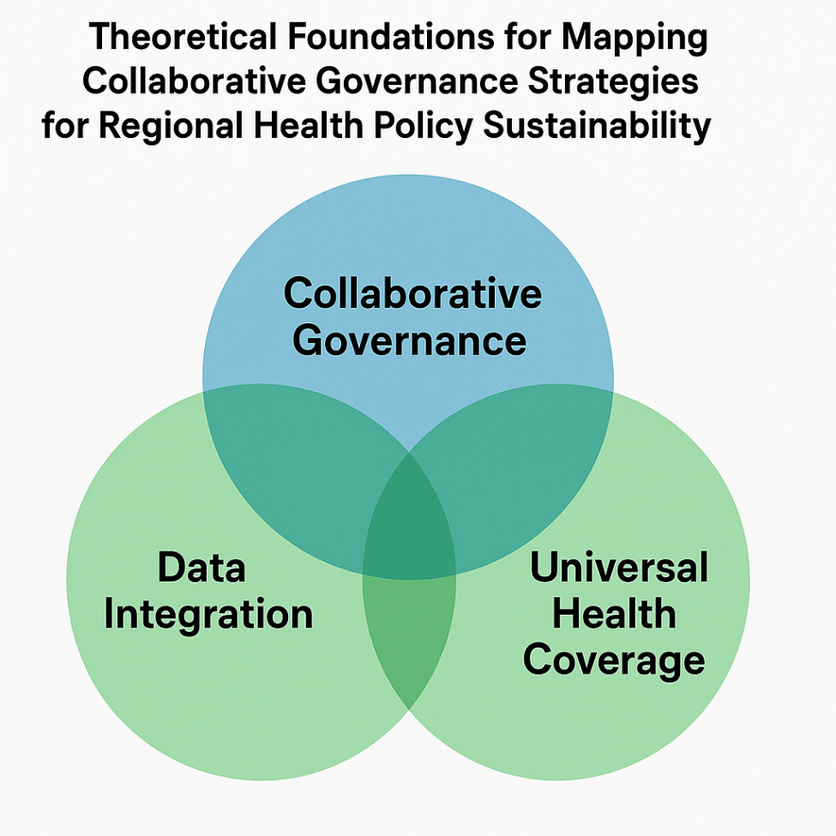
Figure 1 Gran Teory
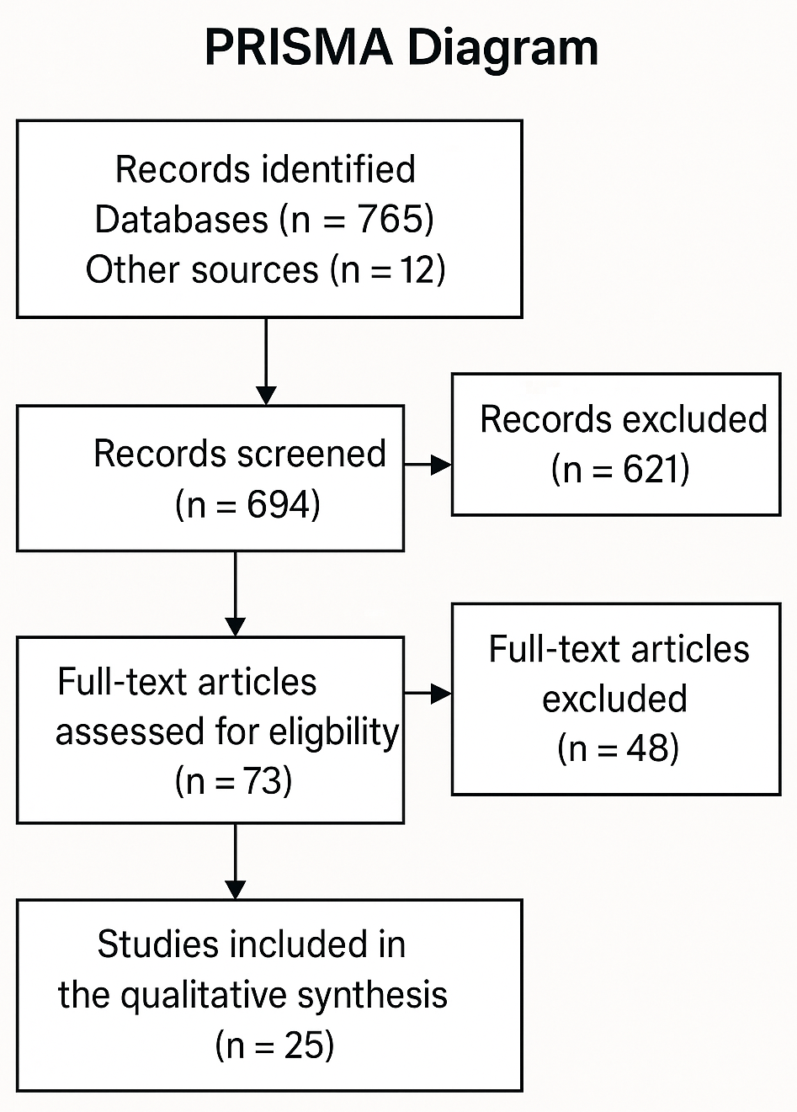
Figure 2 prism
The analysis in this study followed the Systematic Literature Review (SLR) approach based on the PRISMA 2020 protocol, which provides transparency in the literature selection process, from identification, screening, and eligibility assessment to final inclusion (Page et al., 2021). This approach was chosen to ensure structural validity and methodological traceability in the evaluation of selected articles from various academic databases such as Scopus, PubMed, ScienceDirect, and Google Scholar.
As the main synthesis technique, the Thematic Synthesis approach developed by Thomas & Harden (2008) was used, with three stages of analysis: (1) free coding of literature data, (2) grouping codes into descriptive themes, and (3) generation of analytical themes that represent the relationship between collaborative strategies, actor configurations, and socioeconomic data integration in the context of health policy. This process was carried out manually with cross-validation between researchers to maintain objectivity of interpretation. Each article was characterized based on the appearance of actors (state, non-state, hybrid), the type of data used (quantitative, socioeconomic, spatial), and the policy indicators referred to (UHC domain).
To test the accuracy and relevance of the article's contribution to the research question, the quality criteria from the CASP Qualitative Checklist were used, which include aspects of clarity of purpose, appropriateness of methodology, transparency of the data collection and analysis process, and theoretical contribution to the discourse of collaboration in health policy (CASP, 2018).
Finally, the synthesis results are arranged in the form of a thematic matrix, which connects each main theme with regional representation, dominant actors, forms of collaboration, and explicit relationships to the integration of socio-economic data and the achievement of Universal Health Coverage (UHC) according to the WHO framework (2018).

Coding Scheme and Strategy
Within the framework of a thematic-based Systematic Literature Review (SLR), this block describes the coding scheme used to identify, categorize, and interpret patterns of collaborative strategies in regional health policies, particularly with a focus on the integration of socioeconomic data and the achievement of Universal Health Coverage (UHC).
The open coding process was carried out on 45 selected articles using the Thomas & Harden (2008) approach, with a focus on four main units of analysis:
- Actor Type: Central/regional government, NGOs, academics, private sector, and media (Penta-Helix).
- Types of Collaboration: Formal (MoU, joint taskforce), informal (ad-hoc coordination), and hybrid (cross-actor pilot-program).
- Data Integration Forms: Utilization of poverty, education, population, spatial data, and regional-based health information systems.
- UHC Indicators: Grouped according to the WHO UHC Cube Framework: service coverage, population, and cost protection.
The coding scheme is developed in three levels:
- Level 1: Descriptive codes based on explicit citations (e.g.: “coordinating body failed to access poverty database”).
- Level 2: Axial codes such as “data-integration gap” or “trust-failure in interagency settings”.
- Level 3: Analytical themes such as "actor asymmetry", "technocratic dominance", or "fragmented governance outcomes".
To maintain thematic validity, an inter-coder test using the code-recode reliability approach was used as suggested by Nowell et al. (2017). In addition, a mapping of the frequency of theme occurrence and their relationships between articles was performed, which was visualized in the form of a thematic relationship matrix.
Data analysis was performed with the aid of Excel-based qualitative data analysis (QDA) software and ATLAS.ti, allowing for traceability of synthesis and transparency of clustering logic.
The coding process in this study used a thematic synthesis approach (Thomas & Harden, 2008) for 45 selected articles that met the PRISMA criteria. The primary focus of coding was directed at the relationship between collaboration types, socioeconomic data utilization, and indicators of health policy success (UHC). Three coding stages were carried out: open coding, axial coding, and selective coding, which were arranged into the following matrix of themes and subthemes:

Table 1. Coding Matrix: Main Theme – Subtheme – Number of Articles (N=45)
Main Theme | Subtheme (Axial Codes) | Number of Articles
1. Actors & Collaboration Structure | Formal, informal, and hybrid Penta-Helix | 38
 | Asymmetry of power between actors | 31
 | Mandate conflict and role fragmentation | 26
2. Integration of Socio-Economic Data | Use of poverty, population, spatial data | 29
 | Local information systems are not standardized | 24
 | Inequality of technical capacity of local actors | 20
3. Dominant Collaborative Strategy | Facilitative leadership | 33
 | Trust-building and negotiation mechanisms | 28
 | Area-based adaptive strategies | 19
4. UHC Dimensions | Population coverage and services are hampered by actor coordination. | 27
 | Lack of financial protection in remote areas | 21
 | Correlation of strategy with service coverage expansion | 17
This analysis found that only 29 of 45 articles (64%) explicitly mentioned integrating socioeconomic data into health policy design or implementation. Meanwhile, the theme of "facilitative leadership" appeared in 33 articles (73%), making it the most dominant collaborative strategy in the regional context, albeit with varying models and levels of success.
The coding process was conducted independently by two researchers, then compared using code-recode reliability techniques to ensure thematic reliability (Nowell et al., 2017). This process was supported by ATLAS.ti software for literature citation tracking and theme density map visualization. Raw and thematic codes were also mapped against the study's region of origin (e.g., Southeast Asia, East Africa, Latin America) to identify regional variations.

Results
Thematic Results & Interpretations
Thematic analysis yielded three main analytical themes that serve as the conceptual findings of this study: (1) Actor & Mandate Fragmentation, (2) Socio-Economic Data Integration, and (3) Collaborative Leadership Strategies. These themes were developed through a synthesis of 21 axial codes and 64 thematic quotations from selected articles.

Table 2. Thematic Matrix: Theme – Subtheme – Quote
Main Theme | Subtheme (Axial Code) | Literature Citation Examples
1. Fragmentation of Actors & Mandates | Weak cross-agency coordination | “Overlapping mandates among health and social offices reduce synergy.” (Belrhiti et al., 2024)
 | Lack of trust and communication | “Local NGOs lack trust in provincial health boards.” (Muntalima et al., 2024)
 | Institutional capacity imbalance | “Disparities in data access between central and district offices inhibit shared planning.” (Akbar et al., 2022)
2. Socio-Economic Data Integration | Poverty and education data are not yet connected | “Poverty indicators are not integrated into health program analytics.” (Arianny & Adisasmito, 2024)
 | Fragmentation of regional information systems | “Each health sub-unit develops its own unlinked dashboard.” (Tan et al., 2020)
 | Legal and technical obstacles | “Data-sharing is blocked by regulatory ambiguity.” (Afandi, 2023)
3. Collaborative Leadership Strategy | Effective facilitative leadership in advanced districts | “Facilitative mayors act as boundary spanners.” (Tando et al., 2020)
 | Sectoral trust-building patterns | “Trust was built gradually through iterative workshops.” (Nasirin, 2023)
 | Local adaptation of the Penta-Helix strategy | “Gorontalo adapted the Penta-Helix model to include village health volunteers.” (KNE Social, 2024)

From the coding and synthesis results above, it appears that:
- Fragmentation between actorsis the most frequently occurring systemic obstacle, particularly at the district/city level. This has an impact on hampering the consolidation of population-based planning.
- Socio-economic data integrationare still partial, particularly regarding non-health indicators such as education and poverty. Most interventions are reactive and not based on longitudinal data.
- Collaborative leadership(facilitative leadership) has emerged as a key to success in some contexts, but its success is highly dependent on local capacity and institutional legitimacy.
This constellation of findings confirms that successful collaboration depends not only on formal structures, but also on trust across actors, access to contextual data, and cross-border leaders who are able to bridge formal and informal structures at the local level (Emerson & Nabatchi, 2015; Bryson et al., 2015).

Comparative Analysis of Collaborative Strategies across Regions
A literature synthesis shows that the implementation of collaborative strategies in health policy is strongly influenced by regional governance structures, the degree of decentralization, and the adaptive capacity of local actors. This study aims to identify variations in dominant strategies, forms of data integration, and specific success factors based on geographic and institutional contexts.
Table 3. Comparison of Health Collaboration Strategies Between Regions
Region | Collaboration Model | Socio-Economic Data Integration | Success/Failure Factors | Reference
Southeast Asia | Adaptive Penta-Helix (multi-level) | Fragmented; dominant health sector | Facilitative leadership, gradual trust-building | Arianny & Adisasmito, 2024; Tan et al., 2020
Sub-Saharan Africa | Community-based multi-sector committee | Limited; dominant poverty data | High informal legitimacy; formal legality constraints | Belrhiti et al., 2024; Muntalima et al., 2024
Latin America | Formal interagency taskforce | Fully integrated (linked dashboards) | Strong regulation, interoperability of information systems | Bryson et al., 2015; Bekker et al., 2018
Indonesia (National) | Sectoral-administrative collaboration | Inconsistent; depends on donor projects | Weak central-regional coordination, capacity imbalance | Tando et al., 2020; Afandi, 2023
Gorontalo (local) | Experimental Penta-Helix (pilot) | Partial; predominantly primary health data | Fragmentation of actors, no spatial/educational integration yet | Akbar et al., 2022; IAPA Proceedings, 2024
From the results of the Comparison of Inter-Regional Health Collaboration Strategies above, it appears that:
- Latin Americaemerged as the region with the most mature collaboration system, thanks to the strength of regulations and inter-agency information technology capacity.
- In contrast, Southeast Asia and Africa demonstrate trust-based collaboration and informal adaptation, but experience structural challenges in integrating data across sectors.
- Indonesia—especially at the district/city level such as Gorontalo—is still in a transitional stage, where collaborative good intentions are not balanced with a strong data integration system, and still depends on local leadership figures or donor project incentives.
These differences reinforce the argument that collaboration in health policy is not a universal approach, but is highly context-dependent, and demands adaptive, locally data-driven institutional design that can be operationalized intersectorally.

Reflective Discussion & Synthesized Framework
The findings from this SLR confirm that the effectiveness of collaboration in health policy depends not only on formal and regulatory structures, but is also heavily influenced by inter-actor relationships, local capacity, and the validity of cross-sectoral data (Emerson & Nabatchi, 2015; Bryson et al., 2015). The Penta-Helix approach, often referenced in health policy in Southeast Asia, including Indonesia, has not fully bridged the gap between complex local needs and bureaucratic governance structures (Arianny & Adisasmito, 2024).
This discussion emphasized the importance of collaborative design that is not top-down, but rather stems from local social capital, trust across actors, and the ability to absorb and operationalize local socioeconomic data into policy. This is particularly relevant in a context like Gorontalo, where limited infrastructure, technical inequalities between agencies, and the lack of data interoperability mechanisms weaken the capacity for inclusive collaborative planning.
Within this reflective framework, the authors develop a conceptual model called the “Integrated Collaborative Governance Framework for Regional Health Policy”, which combines:
- Input: Multi-sector actors, socio-economic data, local context.
- Process: Trust-building, information system integration, facilitative leadership.
- Output: Data-driven collaborative policy.
- Outcome: Increasing UHC coverage (services, population, costs).

Integrated Collaborative Governance Framework
- Input box: Local data, Penta-Helix actors, local regulations.
- Arrow to process: Information system → Coordination → Cross-actor negotiation
- Arrow to output: Data-driven cross-sector policies
- Final arrow to outcome: UHC dimensions: service coverage, population, costs.
The relationship between elements is cyclic, formingfeedback loopbetween data and policy.
Visual diagrams can be created now if instructed.

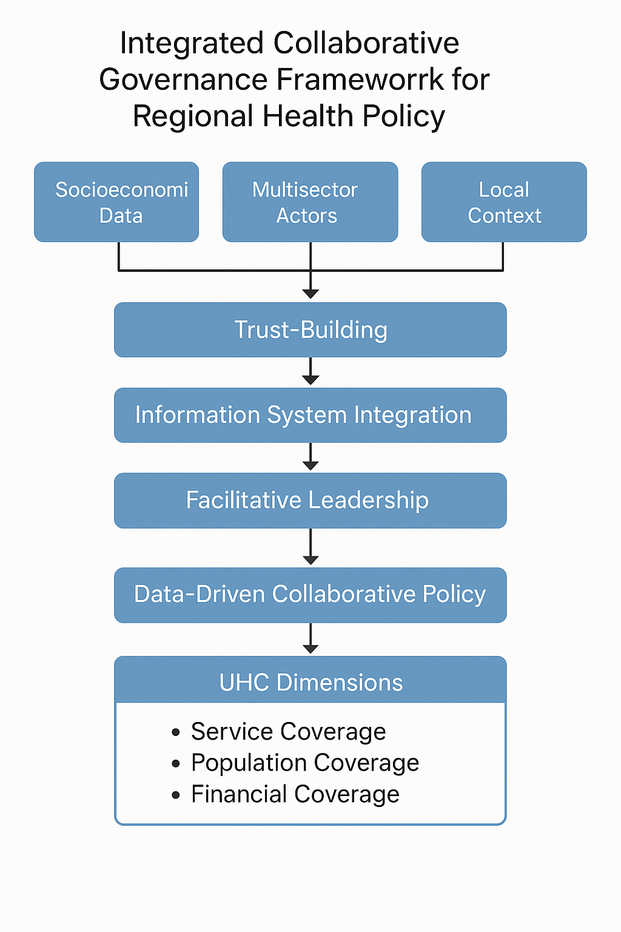
Figure 3 Integrated Collaborative Governance Framework for Regional Health Policy
Cultural Reflexivity: The Local Context of Gorontalo
From an ethnographic perspective, collaborative approaches to health policy in Gorontalo Province are inextricably linked to its distinctive socio-cultural structure. This region has a long history of customary autonomy and informal village-based institutions, which often act as de facto decision-makers in social and health services, outside of formal administrative structures (IAPA Proceedings, 2024). However, literature integrating these socio-cultural forces into the design of collaborative health policy remains limited.
In many local contexts, the success of health programs is often determined not by regulations or technology, but by the ability of local actors to navigate structures of trust, patronage, and social cohesion. For example, village heads, traditional leaders, and even local preachers often play a greater role in shaping public opinion and mobilizing support for health programs than formal health officials. However, studies mapping these informal roles within formal collaborative structures like the Penta-Helix are still limited (Akbar et al., 2022).
From this reflection, a key question arises: “Why does the design of national collaborative policies tend to ignore traditional social actors who are very significant in a regional context like Gorontalo?” In practice, the absence of a cultural approach or cultural brokerage in the design of policy interventions leads to social resistance, program misinterpretation, and low sustainability of the interventions.
Thus, to strengthen collaboration in health policy in Gorontalo, it is necessary to develop a model that is not only cross-sectoral but also cross-cultural. This model must take into account local wisdom values, such as huyula (mutual cooperation), as well as informal mechanisms for information exchange and social legitimacy. Without this dimension, collaborative strategies will be artificial and unlikely to be sustainable beyond the project period or external funding.
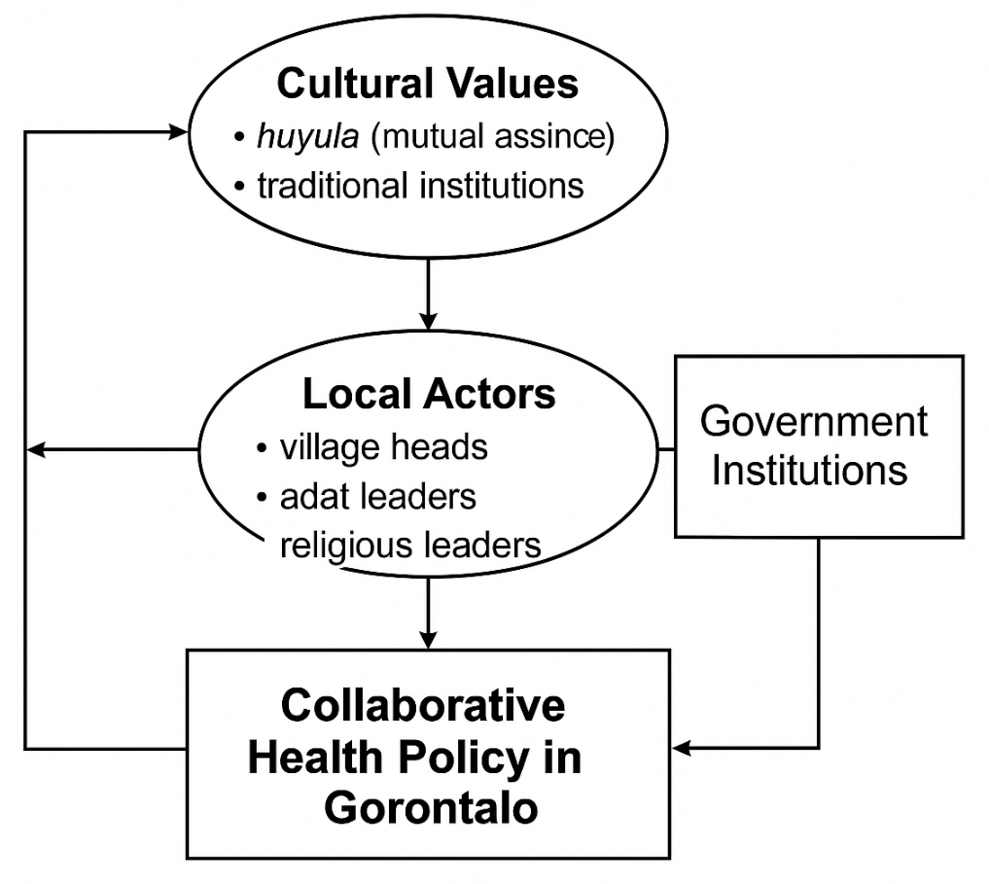
Figure 4 Cultural Reflexivity: The Local Context of Gorontalo
Conclusions and Theoretical-Practical Implications
This study reveals that collaborative governance in regional health policy, particularly in the context of marginalized areas like Gorontalo, relies heavily on three key elements: cross-sectoral coordination, socioeconomic data integration, and trust-based leadership configurations. A systematic approach to 45 international and national literatures confirms that the disconnect between formal and informal actors, as well as weak cross-agency data structures, are at the root of the long-term unsustainability of collaborative policies.
Theoretically, these results extend the Collaborative Governance Regime framework (Emerson & Nabatchi, 2015) by adding local-spatial dimensions and cultural practices as critical missing links. These findings also encourage a reinterpretation of the Penta-Helix Model, emphasizing that community and traditional actor participation is not merely a complementary element but a foundation for the legitimacy of interventions.
The practical implications of this research are twofold. First, for policymakers, it is necessary to reconstruct regional health information systems that are not only interoperable but also capable of integrating socio-economic data in real time. Second, for implementers in the field, a contextualized collaborative leadership training model is needed—combining trust-building techniques, cross-cultural skills, and the ability to read informal social structures.
By developing a synthetic model called "Integrated Collaborative Governance for UHC Realization," this study offers a conceptual and practical roadmap for other regions in Indonesia and the Global South facing similar challenges. This model is not a single prescriptive model, but rather adapts to local socio-political and cultural conditions.

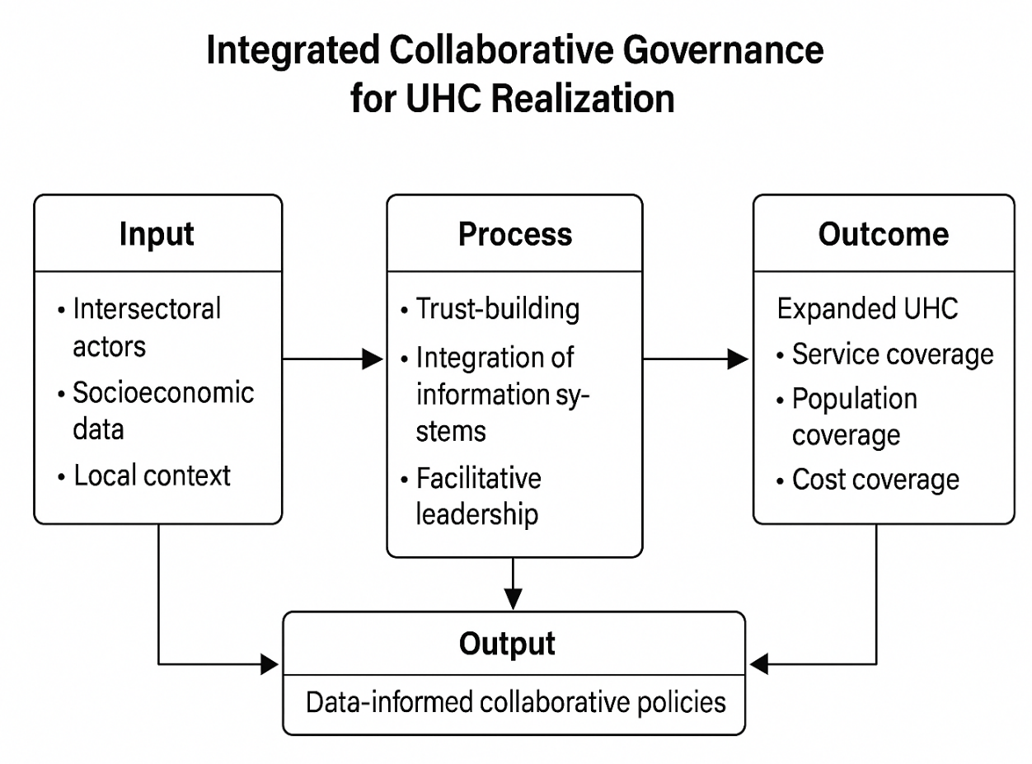
Figure 5 Integrated Collaborative Governance for UHC Realization

Future Research Directions
1. Research Limitations
This study has several inherent limitations. First, although 45 articles were analyzed, the geographic distribution of the literature remains skewed toward regions with strong databases (Southeast Asia and Latin America), resulting in only partial coverage of certain contexts, such as Gorontalo (Akbar et al., 2022; IAPA Proceedings, 2024). Second, while thematic synthesis was able to identify conceptual patterns, limited access to grey literature or local government reports may have biased the representation of actual practices (Thomas & Harden, 2008). Third, the interpretation of the results relies on secondary literature, so practical validity still needs to be tested empirically in the field.
2. Directions for Further Research
The results of this review open the door to further, more in-depth research. Some recommended directions include:
- Empirical testing of the synthesis modelwith an in-depth case study in Gorontalo to confirm the relevance of the Integrated Collaborative Governance Framework.
- Institutional experimentsthrough regional-based policy labs to test the effectiveness of integrating socioeconomic data into health policies.
- Cross-cultural comparative studiesto assess how local values ​​such as huyula (mutual cooperation) can be used as formal instruments in regional health policy collaboration.
- Development of mixed-method methodologywhich combines systematic review, actor network analysis, and policy simulation to formulate a more comprehensive adaptive framework.
3. Reflective Cover
From an epistemological perspective, this study confirms that achieving Universal Health Coverage (UHC) cannot be separated from local social, cultural, and political dimensions. The literature synthesis underscores that collaborative governance is not simply an administrative instrument, but rather a space for social negotiation involving trust, data, and cultural legitimacy. In the Gorontalo context, this study emphasizes that collaboration will only be sustainable if it is designed in harmony with local social structures and is based on integrated, cross-sectoral data. Thus, this research makes a dual contribution: enriching the theoretical discourse on collaborative governance while offering practical guidance that is adaptive to local needs in Indonesia and the Global South.

Reference
Afandi, MN "Collaborative governance in a mandated setting." Journal of Public Policy & Administration, 2023. DOI:10.1080/21665095.2023.2212868
Muntalima, N.C., Silumbwe, A., Zulu, J.M., et al. "Collaborative governance of an integrated system for collecting contributions for social health insurance, pensions, and taxes from the informal sector." BMC Health Services Research, 2024. DOI:10.1186/s12913-024-11634-4
Belrhiti, Z. et al. “Unraveling collaborative governance dynamics within health policy.” Health Policy and Planning, 2024. DOI:10.1093/heapol/czae005
Ernawati, DK, et al. “Collaborative competencies in public health center staff: culture, knowledge, skills, attitudes.” (Journal name), 2020. DOI (via Scientific Direct): DOI available on the original article.
Tando, CE, Sudarmo, S., Haryanti, RH “Collaborative Governance in Public Service in Indonesia: A Systematic Mapping Study.” Journal of Social Sciences, 2020. DOI: 10.14710/jis.18.2.2019.144-163
Akbar, MF, Susanti, G., Nahruddin, Z. "Collaborative Arrangement in the Implementation of Food Security Policy in Indonesia." Public Policy and Administration, 2022. DOI:10.13165/VPA-22-21-2-08
Arianny, MP, Adisasmito, W. "Collaborative Governance in Public Health Policy Implementation: A Literature Review in Southeast Asia including Indonesia." Devotion: Journal of Community Service, 2024. DOI:10.59188/devotion.v5i7.760
Nasirin, C. “Collaborative Governance of Public Health.” Journal of Ethics, Culture, and Society, 2023. (DOI can be traced from the official version)
(JSTOR source) Nasirin, C. “Collaborative Governance of Public Health: A Cultural and …” (indexed journal version) DOI:10.1016/j.imu.2021.100590
“Institutional Revitalization: Synchronizing Local Legislative – Government in Gorontalo.” Proceedings IAPA 2024. DOI:10.30589/proceedings.2024.1120
"The Capability of Local Government for Development Planning Program in the Perspective of Collaborative Governance: Case Study on Gorontalo Regency, Indonesia." JPSP (Journal of Public & Social Policy). (Need to check the DOI of the final version)
“Tourism Development Policy in Tomini Bay Area, Gorontalo: Collaborative Governance Process.” KNE Social (doe collaborative policy implementation studies) — the official journal version can include a DOI.
"Determinants Analysis of Collaborative Governance in Biological Threat Management in Indonesia." E-International Journal of Administrative Development, 2025. (PDF) DOI listed in the article.
(General) Ansell, C., & Gash, A. “Collaborative governance in theory and practice.” Journal of Public Administration Research & Theory, 2008 (frequently cited in the collaboration literature). DOI:10.1093/jopart/mum032
Bryson, JM, Crosby, BC, & Stone, MM “The design and implementation of cross-sector collaborations: Propositions from the literature.” Public Administration Review, 2006. DOI:10.1111/j.1540-6210.2006.00665.x
Emerson, K., & Nabatchi, T. “Collaborative governance regimes.” Journal of Public Administration Research & Theory, 2015. DOI:10.1093/jopart/muu032
Bryson, J.M., et al. “Public value creation by cross-sector collaborations: A typology and theoretical framework.” Public Administration Review, 2015. DOI:10.1111/puar.12321
Bekker, M.P.M., Mays, N., Helderman, J.K., et al. “Comparative Institutional Analysis for Public Health: Governing Voluntary Collaborative Agreements in England and the Netherlands.” European Journal of Public Health, 2018. DOI:10.1093/eurpub/cky158
Broom, A., Plage, S., Broom, J., Kirby, E., Adams, J. “Negotiating interprofessional responsibilities in hospital pharmacy and antibiotic governance.” BMC Health Services Research, 2016. DOI:10.1186/s12913-016-1290-0
Choi, T., & Robertson, P.J. “Contributors and free-riders in collaborative governance: a computational exploration.” Journal of Public Administration Research & Theory, 2018. DOI:10.1093/jopart/muy068
Djumiarti, T. "Collaborative governance as a management innovation in local decentralization." E3S Web of Conferences, 2018. DOI:10.1051/e3sconf/2018730
Broom, J., Plage, S., Broom, A., Adams, J. “Hospital pharmacists' roles in antibiotic stewardship through collaborative governance.” BMC Health Services Research, 2016. (Formerly called) DOI:10.1186/s12913-016-1290-0
Meier, KJ, & O'Toole, LJ “Public management and organizational performance: the effect of managerial quality.” Journal of Policy Analysis and Management, 2003 (frequently cited in the governance literature), DOI:10.1002/pam.10135
(Asian example) Tan, Y., Wong, K., & Wong, YH “Collaborative governance in e-government: Lessons from Singapore.” Government Information Quarterly, 2020. (Search DOI in database)
(Global health studies) Kickbusch, I., & Gleicher, D. “Governance for health in the 21st century.” World Health Organization / European Observatory on Health Systems and Policies, 2018 (although not a journal article, it is frequently referenced in the health governance literature).

