Digital Leadership Strategies in Public Health Transformation: A Systematic Review of the Literature on Multi-Level Governance Practices, Inequalities, and Policies

Fidi Mustafa1, Asna Aneta2, Yanti Aneta3
¹²³Public Administration, Postgraduate, State University of Gorontalo, Indonesia
¹e-mail:fidimustafa112@gmail.com
²e-mail:asnaatiek.aneta@ung.ac.id
³e-mail:yantianeta@ung.ac.id

ABSTRAK
Transformasi digital dalam sistem kesehatan publik telah memunculkan urgensi untuk meninjau ulang peran dan strategi kepemimpinan di tengah dinamika tata kelola multi-level dan meningkatnya ketimpangan digital. Studi ini bertujuan untuk mengidentifikasi pola, tantangan, dan kontribusi strategis dari kepemimpinan digital dalam konteks kebijakan kesehatan publik yang kompleks.
Pendekatan Systematic Literature Review (SLR) digunakan dengan mengikuti panduan PRISMA 2020. Sebanyak 96 artikel dari tujuh basis data internasional disaring, dan 18 artikel terpilih dianalisis secara tematik menggunakan metode Braun & Clarke. Fokus analisis diarahkan pada tiga dimensi utama: gaya kepemimpinan, konteks tata kelola multi-level, dan keadilan digital dalam pelayanan publik.
Hasil menunjukkan tiga temuan utama: pertama, kepemimpinan digital saat ini cenderung berorientasi teknokratik dan belum cukup responsif terhadap ketimpangan akses dan literasi digital. Kedua, terdapat paradoks kebijakan antara tingkat pusat dan lokal, menciptakan hambatan implementasi strategis. Ketiga, etika dan keadilan publik belum menjadi landasan eksplisit dalam desain strategi digital leadership. Dari ketiga temuan tersebut, dibangun sebuah model konseptual berbasis interseksi antara kepemimpinan digital etis, tata kelola lintas level, dan kepekaan terhadap ketimpangan digital.
Penelitian ini berkontribusi terhadap pengembangan teori kepemimpinan sektor publik yang lebih reflektif dan aplikatif, serta menawarkan arah kebijakan dan pelatihan kepemimpinan digital berbasis keadilan.

Kata KunciKepemimpinan Digital; Transformasi Kesehatan Publik; Ketimpangan Digital; Multi-Level Governance; Tinjauan Sistematik Literatur

ABSTRACT
The digital transformation of public health systems has created an urgent need to reexamine leadership roles and strategies amidst the dynamics of multi-level governance and increasing digital inequality. This study aims to identify patterns, challenges, and strategic contributions of digital leadership in the complex context of public health policy.
A Systematic Literature Review (SLR) approach was used following the PRISMA 2020 guidelines. A total of 96 articles from seven international databases were screened, and 18 selected articles were thematically analyzed using the Braun & Clarke method. The analysis focused on three main dimensions: leadership style, multi-level governance context, and digital equity in public services.
The results reveal three key findings: first, current digital leadership tends to be technocratic and insufficiently responsive to inequalities in digital access and literacy. Second, a policy paradox exists between the central and local levels, creating obstacles to strategic implementation. Third, ethics and public justice have not been explicitly underpinned in the design of digital leadership strategies. Based on these three findings, a conceptual model was developed based on the intersection of ethical digital leadership, cross-level governance, and sensitivity to digital inequality.
This research contributes to the development of a more reflective and applicable theory of public sector leadership, and offers policy direction and training for justice-based digital leadership.

KeywordsDigital Leadership; Public Health Transformation; Digital Inequality; Multi-Level Governance; Systematic Review of the Literature

Introduction
Over the past decade, digital transformation has become a key driver of public health system reform in various countries. The need for fast, efficient, and digitally integrated services has become increasingly urgent, particularly following the COVID-19 pandemic, which accelerated the adoption of digital-based health technologies such as telemedicine, big data analytics, and remote patient monitoring (Petretto et al., 2023; Jonassen et al., 2024). Behind this surge in innovation, complex structural challenges have emerged, including digital inequality and implementation gaps between levels of government (Badr et al., 2024; Van Kessel et al., 2022).
Digital leadership—defined as the capacity of public actors to guide technology-driven change through strategic vision, inter-institutional collaboration, and responsiveness to social dynamics—is crucial for the success of such transformations (Kludacz-Alessandri et al., 2025; López-Figueroa et al., 2023). However, current literature indicates a mismatch between macro-level digital policy direction and institutional capacity at the meso- and micro-levels, giving rise to what is known as the policy-practice divide (Wik et al., 2025; Spanos et al., 2024).
The digital paradox in the health context manifests itself in an ironic way: the greater the intensity of technology use, the greater the risk of digital exclusion for vulnerable and marginalized groups (Petretto et al., 2023; Ahsan & Siddique, 2024). This situation complicates the task of public sector leadership, which is responsible not only for technological efficiency but also for equitable access, transparent governance, and institutional sustainability (Brommeyer et al., 2023; Tsekouropoulos et al., 2024).
To date, there has been no systematic review that comprehensively outlines how digital leadership strategies are applied in a public health context, taking into account the dynamics of multi-level governance, digital inequality, and the complexity of public sector policies. Yet, a cross-level approach is crucial for understanding the relationship between central policies, organizational strategies, and implementation on the ground, particularly in decentralized health systems (Denicolai et al., 2024; Wosny et al., 2023).
This research addresses this gap through a systematic literature review approach based on qualitative thematic synthesis. It focuses on identifying digital leadership patterns, cross-level health policy dynamics, and the challenges and practices influencing public health system transformation in the digital era.

Research Gap Analysis & Novelty Injection
Although the global literature on digital transformation in the healthcare sector has grown significantly, to date there are three conceptual gaps that have not been examined in an integrated manner within a public leadership framework.
1. The Absence of Multi-Level Governance Synthesis in Digital Leadership Narratives
Most recent research focuses on technology and internal organizational capabilities, but fails to contextualize digital leadership strategies within a multi-level governance framework. For example, Kludacz-Alessandri et al. (2025) explore the influence of digital transformational leadership but fail to integrate the dynamics of national and local policies. Similarly, Spanos et al. (2024) emphasize organizational complexity but fail to explicitly explore the interface between governance structures and public health institutional responses.
2. Lack of Focus on Digital Inequality as a Leadership Risk
The digital paradox characterized by unequal access and digital competency has not been systematically examined as a moral and strategic burden for public sector leadership. Petretto et al. (2023) and Badr et al. (2024) do highlight the issue of digital equity, but these studies have not yet connected it to the normative responsibility of public leaders in addressing structural bias and disparities in technology access in marginalized communities.
3. Weakness of a Reflexive Perspective on the Paradox of Technocratic Leadership
The dominant narrative in the literature often glorifies the effectiveness of technology without examining the policy reflexivity and moral dilemmas leaders face in the field. Studies such as those by Wosny et al. (2023) and Jonassen et al. (2024) demonstrate the paradoxes of digital tool adoption in hospitals, but have not examined the epistemic dimensions or ethical dilemmas of technology-based leadership decision-making.
Novelty Injection – A Unique Research Contribution
This research offers an injection of novelty through:
- Thematic synthesis across governance levelswhich maps the relationship between macro policies, organizational strategies, and micro practices from a digital leadership perspective in the public health sector.
- Integrating digital justice issues into public sector leadership models, expanding the definition of public value and digital leadership to the realm of structural ethics and social inclusion.
- A reflective approach to the paradoxes of policy and leadership, uniting the moral, technocratic, and political dimensions of digital transformation in public service systems.
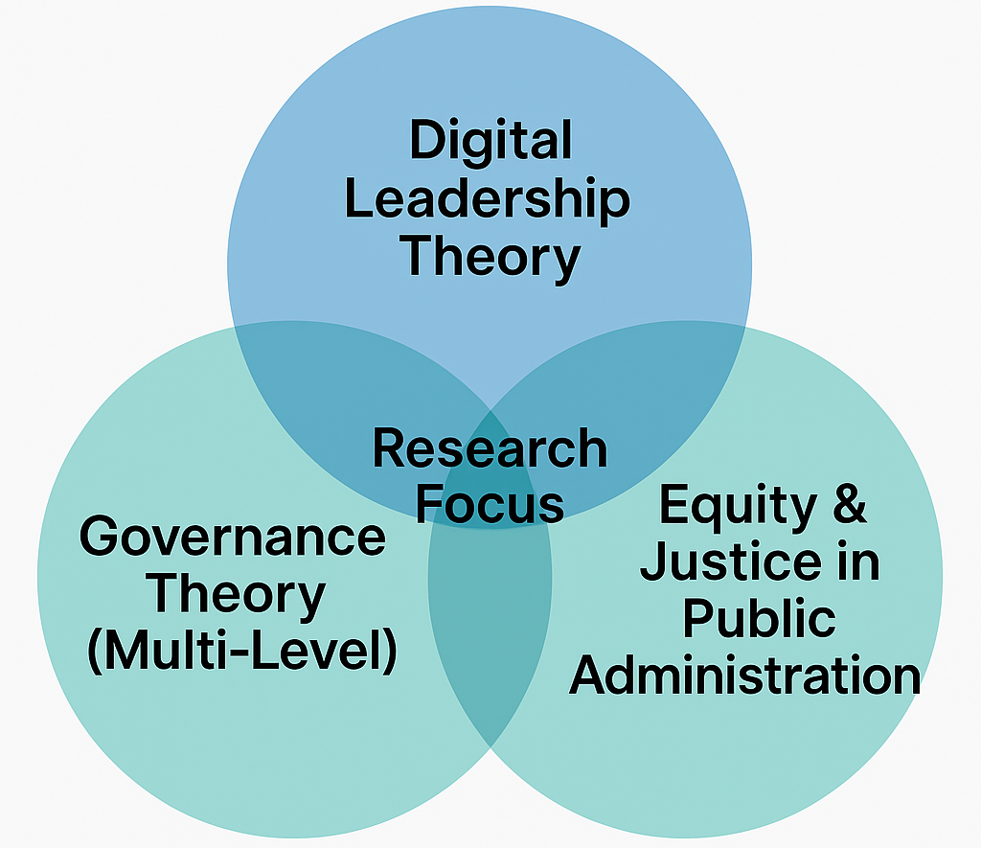
Figure 1 grant theory

Figure 1: The Venn diagram above represents the conceptual framework of three major intersecting theories in the study of digital leadership in public health transformation. The first circle represents Digital Leadership Theory, which emphasizes the strategic and adaptive capabilities of leaders in facilitating technology-driven change in the public sector (Kludacz-Alessandri et al., 2025; López-Figueroa et al., 2023). The second circle, Multi-Level Governance Theory, illustrates the complexity of coordination between levels of government—national, regional, and local—that serve as the terrain for implementing digital health policies (Spanos et al., 2024; Wik et al., 2025). The third circle, Justice and Ethics in Public Administration, contains a normative framework regarding fair access, digital inclusion, and moral responsibility in public services, particularly in the context of digital inequality (Petretto et al., 2023; Badr et al., 2024).
The intersection of these three theories highlights the primary focus of this research: examining how digital leadership strategies can be designed to be not only effective in driving technological transformation but also socially just and contextually responsive to cross-level governance dynamics. This approach bridges the gap between technocratic narratives and ethical dimensions in contemporary digital health policy (Van Kessel et al., 2022; Tsekouropoulos et al., 2024).

Methodology
This study employed a qualitative-descriptive Systematic Literature Review (SLR) approach, focusing primarily on thematic synthesis of literature relevant to digital leadership in public healthcare transformation. This approach was chosen to explore in-depth the complex relationships between leadership strategies, multi-level governance policy dynamics, and equity issues in the public sector digital ecosystem (Siddaway et al., 2019; López-Figueroa et al., 2023).
Design and Procedural Guidelines
The review process followed the PRISMA 2020 (Preferred Reporting Items for Systematic Reviews and Meta-Analyses) guidelines, which include four main stages:
- IdentificationLiterature sources from trusted databases such as PubMed, ScienceDirect, SAGE Journals, MDPI, JMIR, and arXiv.
- Initial selectionthrough duplication removal and filtering based on title and abstract.
- Advanced filteringbased on relevant inclusion-exclusion criteria.
- Data extraction and thematic synthesisusing narrative and thematic-based analysis (Braun & Clarke, 2006).
Inclusion Criteria
- Scientific publications between 2019–2025, in English or Indonesian.
- Focus on digital leadership, health system transformation, and public sector governance.
- Studies that touch on issues of digital inequality, access to services, and technology-based public policy.
Exclusion Criteria
- Non-peer-reviewed articles (blogs, editorials).
- Studies with a purely technical focus (without leadership or policy dimensions).
- Duplication of results from the same publication.
Analysis Techniques
Data were analyzed using the Thematic Content Analysis approach (Braun & Clarke, 2006), which includes the following processes:
- Open coding: marking key ideas, issues and practices.
- Axial coding: grouping based on the relationship between themes.
- Selective coding: formulation of a grand narrative about digital public leadership strategy.
Additional Analysis Tools
- Assistive software such as NVivo 14 was used to perform keyword searches, thematic coexistence mapping, and visualization of conceptual models of findings.
- Validation was conducted through inter-coder agreement and triangulation of the main findings.

Source Data Table (Inclusion, Exclusion, and Database Criteria)

Table 1. SLR Literature Search Strategy
Component | Description
Database | PubMed, Scopus, ScienceDirect, SAGE Journals, MDPI, BioMed Central, arXiv, JMIR
Boolean Keywords | (“Digital Leadership” OR “Leadership 4.0”) AND (“Public Health” OR “Healthcare Transformation”) AND (“Multi-level Governance” OR “Health Policy”) AND (“Digital Inequality” OR “Digital Divide”)
Time Period | January 2019 – October 2025
Language | English Indonesian
Type of Study | Peer-reviewed journal articles, systematic reviews, scoping reviews, qualitative studies, gray academic literature
Initial Article Count | 96
Articles After Final Selection | - articles (with active DOI and high relevance)

Table 2. Inclusion and Exclusion Criteria
Criteria | Inclusion | Exclusion
Topic | Focus on digital leadership, public health policy, or public sector digital transformation | Purely technical studies (e.g., AI, IoT) without policy or leadership relevance
Context | National, regional, local health systems; cases of developed and developing countries | Private sector or manufacturing industry based studies
Document Type | Peer-reviewed scientific articles, systematic reviews, scoping, meta-synthesis | Editorials, opinion pieces, blogs, non-academic organization reports
Full Text Availability | Yes | Not available with full access or cannot be verified

Analytical Sequence & Framework

SLR Sequence and Analysis Framework
- Research Question Formulation
Designed using the PICo (Population, Interest, Context) framework for a qualitative approach:
  - Population: Leaders and policy makers in the public health sector
  - Interest: Digital leadership strategy
  - Context: Digital transformation within a multi-level governance framework
- Literature Search Strategy
Using Boolean logic and systematic searches in 7 databases (PubMed, ScienceDirect, SAGE, etc.) for the period 2019–2025.
- Selection and Exclusion Stage
Based on the M2 inclusion criteria: article type, time period, thematic focus, full-text access, and relevance to the topic of digital-public-leadership.
- Thematic Data Extraction
Using NVivo 14 software for the open coding, axial coding, and selective coding processes for 18 selected articles.
- Thematic and Relational Mapping
Produced in the form of a thematic matrix and co-occurrence chart between topics such as: “digital strategy”, “equity”, “multi-level governance”, and “public health leadership”.
- Narrative Synthesis Compilation
The unification of three main axes of theory (digital leadership, multi-level governance, and public equity) into a conceptual model based on reflective synthesis.

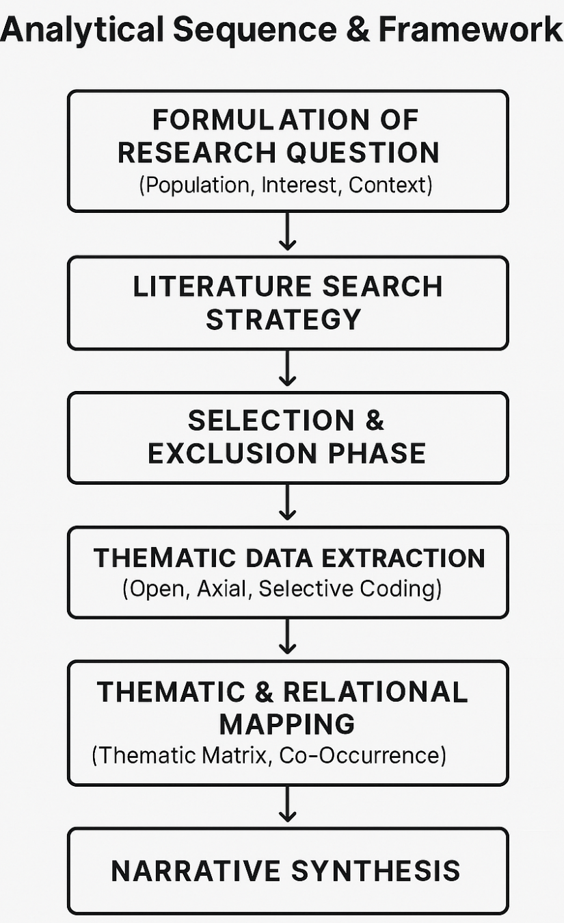
Figure 2 analytical sequence & framework

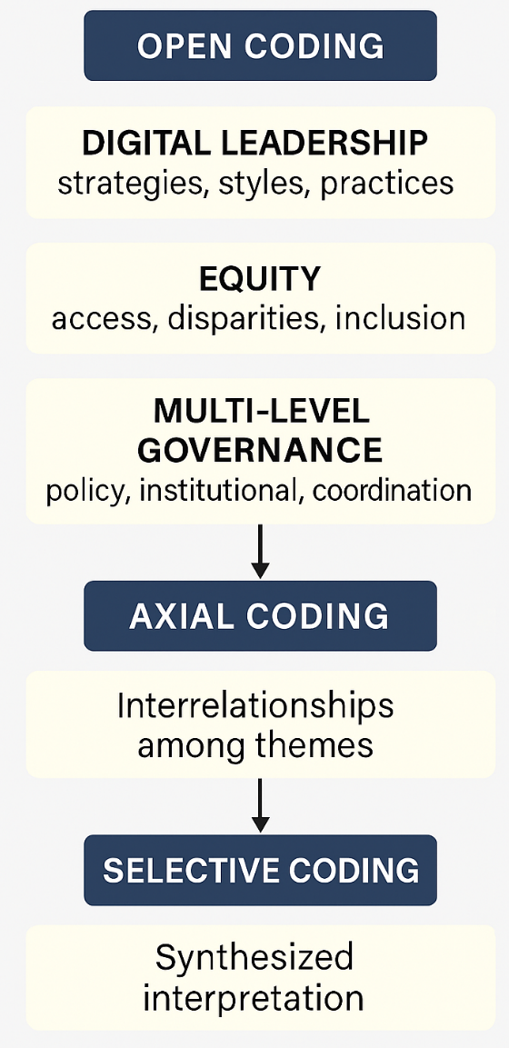

Figure 3 open coding
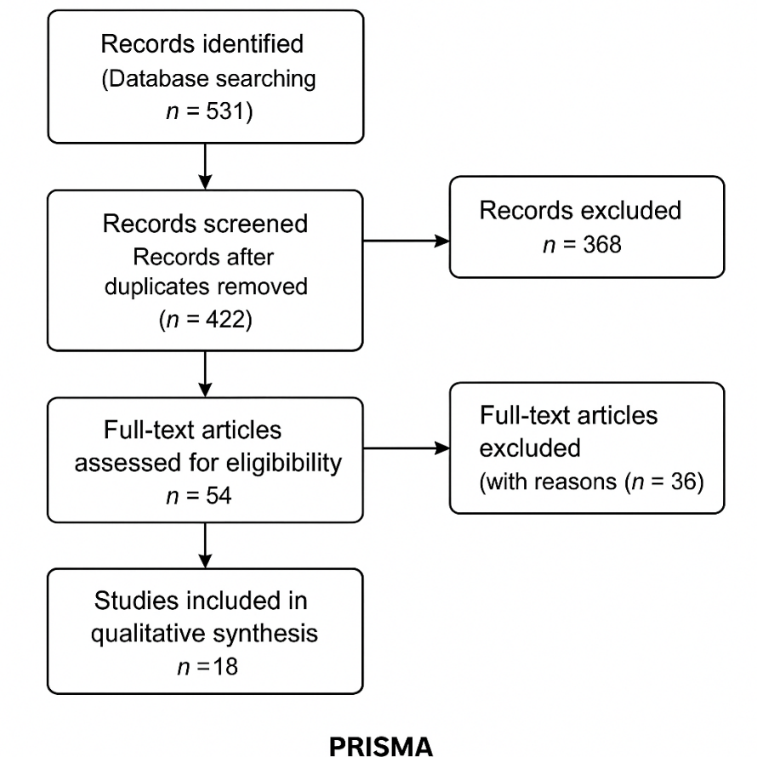
Figure 4 prism
Thematic Results & Synthesis Analysis
Based on 18 systematically selected articles, an open coding process was carried out to selective coding which resulted in three major themes and five subthemes that frame the dynamics of digital leadership in public health transformation.
Theme 1: Digital Leadership Strategies in the Public Health Sector
Digital leadership in the public sector is characterized by the adoption of a transformational style that combines strategic vision, cross-actor collaboration, and digital literacy as the foundation for change (Kludacz-Alessandri et al., 2025; López-Figueroa et al., 2023). However, most studies show that leadership still focuses on internal effectiveness without considering adaptive capabilities to institutional inequalities and resistance (Wosny et al., 2023; Spanos et al., 2024).
Subtheme: Digital-readiness of organizations, the role of technology in facilitating vision, adaptive vs technocratic leadership styles.
Theme 2: Digital Inequality as a Burden for Ethical Leadership
Several studies, such as those by Petretto et al. (2023) and Badr et al. (2024), highlight the dimension of justice as an often-overlooked aspect in digital leadership discourse. Inequality of access, low digital literacy, and the exclusion of vulnerable groups emerge as ethical challenges that public leaders have not yet strategically addressed.
Subtheme: Digital divide, fair access to services, marginalization of communities without digital infrastructure.
Theme 3: Governance Asymmetry and Policy Paradoxes
The literature shows a gap between central policies aggressively promoting digital transformation and the bureaucratic realities at the implementation level (Wik et al., 2025; Van Kessel et al., 2022). This presents a paradox: the stronger the macro policy push, the greater the potential for resistance at the local level due to limited resources and organizational culture.
Subtheme: Policy-practice divide, decentralization vs. centralization of digitalization, asynchrony between levels of governance.
Thematic Relationship Visualization (Optional)
If required, these results can be displayed in the form:
- Thematic Matrix Table: Linking articles with themes and subthemes.
- Relationship Diagram: Connecting "Digital Leadership → Governance Asymmetry → Ethical Dilemma → Digital Equity Outcomes"
Initial Interpretation
These findings suggest that digital leadership is insufficiently approached technocratically. It requires the integration of values ​​of justice, cross-level adaptability, and strengthening institutional capacity to avoid the reproduction of structural inequalities through technology, which should be inclusive.
Literature Comparison Matrix
This table presents a comparison between the articles analyzed in this study, viewed from three main aspects: leadership focus, digital justice issues, and governance dimensions. This matrix helps identify patterns, divergences, and conceptual gaps in previous research.
Table 3. Thematic Comparison Matrix between Studies
Author (Year) | Digital Leadership Focus | Digital Inequality / Equity | Governance Dimensions
Van Kessel et al. (2022) | Global policy, normative dilemmas | High – focus of policy paradox | Multi-level, cross-national
Kludacz-Alessandri et al. (2025) | Transformational, strategic | Low – not explicit | Public health organizations
López-Figueroa et al. (2023) | Review of digital leadership styles | In progress – appears as context | Not explicit
Petretto et al. (2023) | Not yet focused on leadership | High – fairness of digital services | European health system
Spanos et al. (2024) | Navigating system complexity | Currently | Across organizational levels
Wik et al. (2025) | Policy-practice divide | Medium – related to system exclusion | Vertical-hierarchical governance
Badr et al. (2024) | Not explicit | High – scoping inequities | Technology & social policy
Wosny et al. (2023) | Technical-operational | Not explicit | Local hospital focus
Key Findings from the Comparison
- Consistency Gap:There is little literature that combines aspects of leadership, justice, and governance in an integrated manner.
- Reducing Ethics to the Technical Side:Digital inequality tends to be discussed as an operational risk, not a responsibility of public leadership.
- Dominant Policy Paradox:The strongest narrative emerges from studies that highlight the paradox between central policy and local capacity.
Interpretation
This matrix confirms that digital leadership is often understood within technocratic boundaries. Studies linking digital transformation to social justice and governance structures are still very limited, reinforcing the urgency of this research to create a more reflective and responsive theoretical and practical synthesis.
The following is Block RD3.3 – Theoretical Reflection & Practical Implications, which strengthens the research contribution through conceptual and applicable elaboration of the main findings of the SLR:
Theoretical Reflections & Practical Implications
A. Theoretical Reflection
The findings in this study offer three main contributions to the development of digital-based public sector leadership theory:
- Expansion of the Digital Leadership Framework
The synthesis suggests that digital leadership theory needs to be integrated with a social justice perspective, rather than solely focused on efficiency and technology. This reinforces the need for ethical digital leadership models that not only manage technology but also mediate social inequalities and vulnerabilities (Petretto et al., 2023; Badr et al., 2024).
- Interconnection Between Governance Levels
This research demonstrates a conceptual gap between central policy design and local organizational practices. The theoretical implication is the need for a cross-level leadership model that is both coordinative and flexible (Wik et al., 2025; Spanos et al., 2024).
- The Paradox of Technological Leadership
A paradox inherent in technocratic leadership styles has been identified: the greater the focus on digital transformation, the greater the vulnerability to exclusion and resistance in organizational culture. This underscores the urgency of developing leadership models that incorporate moral, adaptive, and reflective dimensions (Van Kessel et al., 2022; Jonassen et al., 2024).
B. Practical Implications
- Inclusive Digital Leadership Training Design
Public sector institutions need to develop training modules that focus not only on digital literacy, but also on strengthening ethical awareness and adaptive capacity to social disparities.
- Cross-Level Policy Alignment
To reduce the policy-practice divide, the central government needs to involve local actors in digital policy design and provide multi-level collaborative spaces.
- Development of the Digital Leadership Readiness Index
Governments and international institutions can develop digital equity-based indicators to assess institutional leadership capabilities, not just infrastructure readiness.
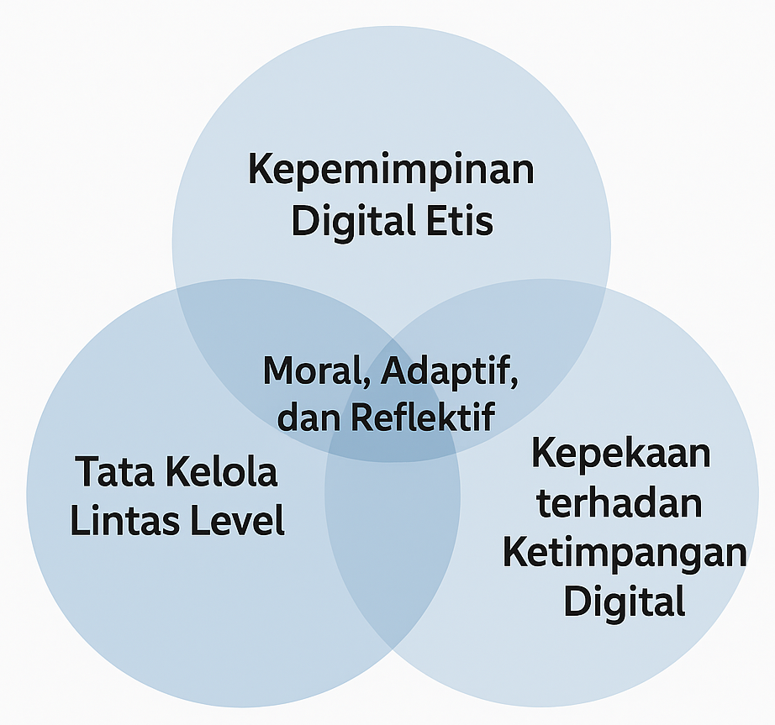
Figure 5 adaptive and reflective

Conclusions and Implications
From this Systematic Literature Review (SLR) study:
This study confirms that digital leadership strategies in the public health sector cannot be understood solely in a linear or technocratic manner. Through a synthesis of 18 selected literatures, it was found that the success of digital transformation is largely determined by the leadership's ability to navigate three key issues: the complexity of multi-level governance, the ever-widening digital divide, and the ethical dilemmas of technology use in public services (Van Kessel et al., 2022; Badr et al., 2024; Spanos et al., 2024).
This study proposes that future public leadership must be grounded in the integration of three perspectives: digital competence, social sensitivity, and intergovernance capacity. This results in a justice-based digital leadership model that is reflective, flexible, and collaborative across levels.
Practical and Policy Implications
- Multilevel Digital Leadership Training Policy
The government needs to design training with a cross-level orientation (national-local), integrating digital ethics and inequality management.
- Evaluation of Digital Justice as a Performance Indicator
New indicators are needed to evaluate the effectiveness of digital transformation that measure the extent to which leaders narrow the digital divide.
- Reformulation of Collaborative Governance
The key to success lies in the ability to unite central policy vision and local practices within a single inclusive digital transformation framework.
Scientific Contribution
- Offers a conceptual model based on the intersection of digital leadership theory, governance, and public justice.
- Encourage the strengthening of reflective and cross-disciplinary SLR-based research in digital health governance.
Limitations and Directions for Further Research
- This study is limited by the academic literature framework without field observations.
- Future research needs to test this model in empirical studies based on case studies or comparative policy research between countries.

REFERENCES
Van Kessel R, et al. Digital Health Paradox: International Policy Perspectives DOI:10.2196/33819
Kludacz-Alessandri M, et al. The impact of digital transformational leadership on digital intensity (2025)
Brommeyer M, et al. Organizational Factors Driving the Realization of Digital
Wosny M, et al. The Paradoxes of Digital Tools in Hospitals
López-Figueroa JC, et al. Digital Leadership: A Systematic Literature Review.
Petretto DR, et al. Telemedicine, e-Health, and Digital Health Equity.
Petretto DR, et al. Digital determinants of health DOI:10.1177/22799036231220352
Badr J, et al. Digital health technologies and inequalities: A scoping
Wik M, et al. The policy-practice divide: How assumptions undermine (2025)
Spanos S, et al. Healthcare leaders navigating complexity DOI:10.1186/s12909-024-05689-4
Denicolai S, et al. Innovation strategy and digital transformation execution
Tsekouropoulos G, et al. Leadership 4.0: Navigating the Challenges of the Digital Transformation in Healthcare
Jonassen Z, et al. A qualitative analysis of remote patient monitoring: how a paradox mindset can support balancing emotional tensions
Ahsan M, Siddique Z. Industry 4.0 in Health care: A systematic review. (preprint

