LAMPIRAN 1 : KUISIONER PENELITIAN
Judul: Pengaruh Keberadaan Mal Pelayanan Publik (MPP) terhadap Tingkat Kepuasan Masyarakat di Kota Mataram
Petunjuk Pengisian:
- Angket ini bertujuan untuk mengukur pengaruh keberadaan Mal Pelayanan Publik (MPP) terhadap tingkat kepuasan masyarakat di Kota Mataram.
- Bagian pertama berisi pertanyaan identitas dan pertanyaan penyaring (screening question).
- Bagian kedua berisi pernyataan mengenai kualitas pelayanan dan kepuasan masyarakat.
- Semua jawaban bersifat rahasia dan hanya digunakan untuk kepentingan penelitian.
- Jawablah dengan jujur sesuai pengalaman Anda saat menggunakan layanan di MPP Kota Mataram.
A. Data Diri Responden
Pertanyaan |  | Jawaban
Nama |  | .....................................................
Jenis Kelamin | ☐ Laki-laki ☐ Perempuan
Usia | .....................................................
Domisili/Kecamatan |  | .....................................................
No. Telepon/WA |  | .....................................................
B. Pertanyaan Penyaring (Screening Question)
        - Apakah Anda pernah menggunakan layanan di Mal Pelayanan Publik (MPP) Kota Mataram dalam 1 tahun terakhir?
Ya → Lanjut ke kuesioner
Tidak → Kuesioner selesai (tidak termasuk kriteria responden)
C. Instrumen Penelitian
Berikan penilaian sesuai pengalaman Anda di MPP Kota Mataram.
Skala penilaian menggunakan Likert 5 poin:
1 = Sangat Tidak Setuju
2 = Tidak Setuju
3 = Ragu-ragu
4 = Setuju
5 = Sangat Setuju
BAGIAN I — Variabel X: Kualitas Pelayanan (SERVQUAL)
No | Pernyataan | Jawaban
No | Pernyataan | 1 | 2 | 3 | 4 | 5
Dimensi Tangible (Bukti Fisik)
1 | Fasilitas pelayanan MPP bersih, tertata, dan nyaman digunakan masyarakat.
2 | Peralatan dan teknologi pelayanan di MPP berfungsi baik dan membantu proses pelayanan.
3 | Petugas tampil rapi dan profesional saat memberikan layanan
Dimensi Reliability (Keandalan)
4 | Petugas melayani sesuai prosedur standar yang telah ditetapkan.
5 | Hasil pelayanan yang saya terima sesuai kebutuhan dan permohonan saya.
6 | Petugas menunjukkan ketelitian dalam memeriksa dan memproses berkas pelayanan.
Dimensi Responsiveness (Ketanggapan/Respon)
7 | Petugas cepat merespons setiap permintaan layanan dari masyarakat.
8 | Keluhan masyarakat ditindaklanjuti dengan cepat dan jelas oleh petugas.
9 | Petugas sigap membantu ketika terjadi kendala dalam proses pelayanan.
Dimensi Assurance (Jaminan)
10 | Petugas memberikan penjelasan yang jelas mengenai waktu penyelesaian pelayanan
11 | Informasi mengenai biaya dan prosedur pelayanan mudah dipahami.
12 | Saya merasa aman dan percaya terhadap keabsahan hasil layanan MPP
Dimensi Empathy (Empati)
1 | Petugas melayani masyarakat dengan ramah dan menghargai setiap pemohon
2 | Petugas menunjukkan kepedulian terhadap kebutuhan masing-masing pemohon
3 | Semua masyarakat diperlakukan dengan adil tanpa membedakan latar belakang
Bagian II. Instrumen Variabel Y — Kepuasan Masyarakat (SKM PermenPANRB 2017)
No | Pernyataan | 1 | 2 | 3 | 4 | 5
1 | Proses dan alur pelayanan MPP mudah dipahami oleh masyarakat.
2 | Persyaratan pelayanan jelas dan mudah dipenuhi.
3 | Waktu penyelesaian pelayanan sesuai dengan yang dijanjikan.
4 | Biaya pelayanan disampaikan secara transparan dan sesuai ketentuan.
5 | Hasil pelayanan sesuai dengan yang saya harapkan.
6 | Petugas memiliki kemampuan teknis yang baik dalam memberikan pelayanan.
7 | Petugas bersikap sopan dan profesional saat melayani masyarakat.
8 | Keluhan masyarakat ditangani secara cepat dan jelas.
9 | Sarana dan prasarana pelayanan memadai dan mendukung kenyamanan pengguna.

LAMPIRAN 2 : HASIL TABULASI DATA PENELITIAN
No | Jenis Kelamin | Usia  (Tahun) | Kecamatan | X  1 | X  2 | X  3 | X  4 | X  5 | X  6 | X  7 | X  8 | X  9 | X  10 | X  11 | X  12 | X  13 | X  14 | X  15 | Total  X | Y  1 | Y  2 | Y  3 | Y  4 | Y  5 | Y  6 | Y  7 | Y  8 | Y  9 | Total  Y
1 | Laki-Laki | 38 | Ampenan | 4 | 5 | 4 | 4 | 5 | 5 | 5 | 5 | 5 | 5 | 5 | 5 | 5 | 5 | 5 | 72 | 5 | 5 | 5 | 5 | 5 | 5 | 5 | 5 | 4 | 44
2 | Laki-Laki | 48 | Ampenan | 4 | 4 | 4 | 4 | 5 | 4 | 5 | 4 | 5 | 4 | 4 | 5 | 4 | 5 | 4 | 65 | 4 | 4 | 4 | 4 | 4 | 5 | 5 | 4 | 4 | 38
3 | Laki-Laki | 19 | Cakranegara | 4 | 4 | 4 | 4 | 4 | 4 | 4 | 4 | 4 | 4 | 4 | 4 | 4 | 4 | 4 | 60 | 4 | 4 | 4 | 4 | 4 | 4 | 4 | 4 | 4 | 36
4 | Laki-Laki | 40 | Ampenan | 5 | 4 | 5 | 5 | 4 | 5 | 4 | 5 | 4 | 4 | 4 | 4 | 5 | 4 | 5 | 67 | 4 | 4 | 4 | 5 | 4 | 4 | 5 | 4 | 5 | 39
5 | Laki-Laki | 54 | Ampenan | 4 | 4 | 4 | 4 | 4 | 4 | 4 | 4 | 4 | 4 | 4 | 4 | 5 | 4 | 5 | 62 | 4 | 4 | 4 | 4 | 4 | 4 | 4 | 4 | 4 | 36
6 | Laki-Laki | 26 | Cakranegara | 4 | 4 | 5 | 4 | 4 | 4 | 4 | 4 | 4 | 4 | 4 | 4 | 4 | 4 | 4 | 61 | 4 | 4 | 4 | 4 | 4 | 4 | 4 | 4 | 4 | 36
7 | Laki-Laki | 26 | Cakranegara | 5 | 5 | 5 | 5 | 5 | 5 | 5 | 5 | 5 | 5 | 5 | 5 | 4 | 5 | 5 | 74 | 5 | 4 | 4 | 5 | 5 | 5 | 5 | 4 | 5 | 42
8 | Laki-Laki | 39 | Cakranegara | 1 | 1 | 1 | 5 | 5 | 5 | 5 | 5 | 5 | 5 | 5 | 5 | 5 | 5 | 5 | 63 | 5 | 5 | 5 | 5 | 5 | 5 | 5 | 5 | 5 | 45
9 | Laki-Laki | 29 | Cakranegara | 5 | 5 | 5 | 5 | 5 | 5 | 5 | 5 | 5 | 5 | 5 | 5 | 5 | 5 | 5 | 75 | 5 | 5 | 5 | 5 | 5 | 5 | 5 | 5 | 5 | 45
10 | Laki-Laki | 33 | Cakranegara | 4 | 4 | 4 | 4 | 4 | 4 | 4 | 4 | 4 | 4 | 4 | 4 | 4 | 4 | 4 | 60 | 4 | 4 | 4 | 4 | 4 | 4 | 4 | 4 | 4 | 36
11 | Laki-Laki | 17 | Cakranegara | 4 | 4 | 4 | 4 | 4 | 4 | 4 | 4 | 4 | 4 | 4 | 4 | 4 | 4 | 4 | 60 | 4 | 4 | 4 | 4 | 4 | 4 | 4 | 4 | 4 | 36
12 | Laki-Laki | 47 | Cakranegara | 4 | 4 | 4 | 4 | 4 | 4 | 4 | 4 | 4 | 4 | 4 | 4 | 4 | 4 | 5 | 61 | 4 | 4 | 4 | 4 | 4 | 4 | 5 | 4 | 4 | 37
13 | Laki-Laki | 40 | Cakranegara | 4 | 4 | 4 | 4 | 4 | 4 | 4 | 5 | 4 | 4 | 5 | 5 | 5 | 5 | 5 | 66 | 5 | 5 | 5 | 5 | 5 | 5 | 4 | 5 | 5 | 44
14 | Laki-Laki | 33 | Mataram | 4 | 3 | 3 | 3 | 3 | 3 | 3 | 3 | 3 | 3 | 3 | 3 | 3 | 3 | 3 | 46 | 3 | 3 | 3 | 3 | 3 | 3 | 3 | 3 | 3 | 27
15 | Laki-Laki | 22 | Mataram | 5 | 5 | 5 | 4 | 4 | 4 | 4 | 4 | 4 | 4 | 4 | 4 | 4 | 4 | 4 | 63 | 4 | 4 | 4 | 4 | 4 | 4 | 4 | 4 | 4 | 36
16 | Laki-Laki | 33 | Cakranegara | 4 | 4 | 4 | 4 | 4 | 4 | 4 | 4 | 4 | 4 | 4 | 4 | 4 | 4 | 4 | 60 | 4 | 4 | 4 | 4 | 4 | 4 | 4 | 4 | 4 | 36
17 | Laki-Laki | 21 | Mataram | 4 | 4 | 4 | 4 | 4 | 4 | 4 | 4 | 4 | 4 | 4 | 4 | 4 | 4 | 4 | 60 | 4 | 4 | 4 | 4 | 4 | 1 | 1 | 2 | 2 | 26
18 | Laki-Laki | 36 | Selaparang | 4 | 4 | 4 | 4 | 4 | 4 | 4 | 4 | 4 | 4 | 4 | 4 | 4 | 4 | 4 | 60 | 4 | 4 | 4 | 4 | 4 | 4 | 4 | 4 | 4 | 36
19 | Laki-Laki | 32 | Cakranegara | 5 | 5 | 5 | 5 | 5 | 5 | 5 | 5 | 5 | 5 | 5 | 5 | 5 | 5 | 5 | 75 | 5 | 5 | 5 | 5 | 5 | 5 | 5 | 5 | 5 | 45
20 | Laki-Laki | 28 | Ampenan | 1 | 1 | 1 | 1 | 1 | 1 | 1 | 1 | 1 | 1 | 1 | 1 | 1 | 1 | 1 | 15 | 1 | 1 | 1 | 1 | 1 | 1 | 1 | 1 | 1 | 9
21 | Laki-Laki | 22 | Mataram | 3 | 4 | 4 | 4 | 4 | 3 | 3 | 3 | 3 | 4 | 4 | 4 | 4 | 4 | 4 | 55 | 3 | 3 | 3 | 4 | 4 | 4 | 4 | 3 | 4 | 32
22 | Laki-Laki | 29 | Sandubaya | 4 | 4 | 4 | 4 | 4 | 4 | 4 | 4 | 4 | 4 | 4 | 4 | 4 | 4 | 4 | 60 | 4 | 4 | 4 | 4 | 4 | 4 | 4 | 4 | 4 | 36
23 | Laki-Laki | 19 | Sandubaya | 2 | 2 | 3 | 3 | 1 | 2 | 3 | 3 | 2 | 2 | 3 | 3 | 3 | 2 | 1 | 35 | 2 | 3 | 1 | 3 | 1 | 4 | 3 | 1 | 3 | 21
24 | Laki-Laki | 32 | Sandubaya | 5 | 5 | 5 | 5 | 5 | 5 | 5 | 5 | 5 | 5 | 5 | 3 | 3 | 4 | 3 | 68 | 5 | 5 | 5 | 5 | 5 | 5 | 5 | 5 | 5 | 45
25 | Laki-Laki | 29 | Sandubaya | 5 | 5 | 5 | 5 | 5 | 5 | 5 | 5 | 5 | 5 | 5 | 5 | 5 | 5 | 5 | 75 | 5 | 5 | 5 | 5 | 5 | 5 | 5 | 5 | 5 | 45
26 | Laki-Laki | 36 | Sandubaya | 4 | 5 | 5 | 5 | 5 | 5 | 5 | 5 | 5 | 5 | 5 | 5 | 5 | 5 | 5 | 74 | 5 | 5 | 5 | 5 | 5 | 5 | 5 | 5 | 5 | 45
27 | Laki-Laki | 18 | Sandubaya | 4 | 4 | 4 | 4 | 4 | 4 | 4 | 4 | 4 | 4 | 4 | 4 | 4 | 4 | 4 | 60 | 4 | 4 | 4 | 4 | 4 | 4 | 4 | 4 | 4 | 36
28 | Laki-Laki | 45 | Sandubaya | 5 | 5 | 5 | 5 | 4 | 5 | 5 | 5 | 5 | 4 | 4 | 5 | 5 | 5 | 5 | 72 | 5 | 5 | 4 | 5 | 4 | 5 | 5 | 4 | 5 | 42
29 | Laki-Laki | 33 | Sandubaya | 5 | 5 | 5 | 5 | 5 | 5 | 5 | 5 | 5 | 5 | 5 | 5 | 5 | 5 | 5 | 75 | 5 | 5 | 5 | 3 | 5 | 4 | 5 | 5 | 5 | 42
30 | Laki-Laki | 55 | Sandubaya | 5 | 4 | 5 | 5 | 5 | 5 | 5 | 5 | 5 | 5 | 5 | 5 | 5 | 5 | 5 | 74 | 5 | 5 | 5 | 5 | 5 | 5 | 5 | 5 | 5 | 45
31 | Laki-Laki | 42 | Sekarbela | 4 | 3 | 3 | 3 | 3 | 3 | 4 | 3 | 4 | 3 | 4 | 4 | 4 | 4 | 4 | 53 | 4 | 4 | 4 | 3 | 4 | 3 | 4 | 4 | 4 | 34
32 | Laki-Laki | 37 | Sekarbela | 4 | 4 | 5 | 5 | 5 | 4 | 4 | 4 | 5 | 4 | 4 | 4 | 4 | 5 | 5 | 66 | 4 | 4 | 5 | 5 | 5 | 4 | 5 | 4 | 4 | 40
33 | Laki-Laki | 40 | Sekarbela | 1 | 1 | 1 | 3 | 3 | 4 | 2 | 3 | 4 | 5 | 1 | 3 | 2 | 4 | 4 | 41 | 1 | 2 | 3 | 3 | 4 | 5 | 1 | 2 | 3 | 24
34 | Laki-Laki | 41 | Sekarbela | 2 | 2 | 2 | 2 | 1 | 4 | 4 | 3 | 4 | 4 | 4 | 4 | 4 | 3 | 3 | 46 | 5 | 5 | 4 | 4 | 4 | 4 | 4 | 4 | 4 | 38
35 | Laki-Laki | 20 | Selaparang | 4 | 3 | 3 | 4 | 3 | 3 | 3 | 4 | 3 | 4 | 3 | 3 | 3 | 4 | 3 | 50 | 4 | 3 | 3 | 4 | 3 | 4 | 3 | 4 | 3 | 31
36 | Laki-Laki | 33 | Selaparang | 5 | 5 | 4 | 4 | 4 | 4 | 4 | 4 | 4 | 4 | 4 | 4 | 4 | 4 | 4 | 62 | 4 | 4 | 4 | 4 | 4 | 4 | 4 | 4 | 4 | 36
37 | Laki-Laki | 42 | Selaparang | 4 | 4 | 4 | 4 | 4 | 4 | 4 | 4 | 5 | 5 | 5 | 5 | 5 | 5 | 5 | 67 | 5 | 5 | 5 | 5 | 5 | 5 | 5 | 5 | 5 | 45
38 | Laki-Laki | 17 | Selaparang | 5 | 1 | 5 | 4 | 3 | 3 | 4 | 2 | 3 | 4 | 3 | 4 | 3 | 3 | 4 | 51 | 1 | 5 | 5 | 5 | 5 | 5 | 5 | 5 | 5 | 41
39 | Laki-Laki | 20 | Selaparang | 5 | 5 | 4 | 3 | 4 | 3 | 4 | 5 | 2 | 3 | 3 | 2 | 5 | 2 | 3 | 53 | 3 | 1 | 3 | 4 | 4 | 5 | 5 | 5 | 5 | 35
40 | Laki-Laki | 44 | Selaparang | 4 | 4 | 4 | 4 | 4 | 4 | 4 | 4 | 4 | 4 | 4 | 4 | 4 | 4 | 4 | 60 | 4 | 4 | 4 | 4 | 4 | 4 | 4 | 4 | 4 | 36
41 | Laki-Laki | 39 | Selaparang | 4 | 4 | 4 | 4 | 4 | 4 | 4 | 4 | 4 | 4 | 4 | 4 | 4 | 4 | 4 | 60 | 4 | 5 | 5 | 4 | 4 | 5 | 4 | 4 | 4 | 39
42 | Perempuan | 40 | Ampenan | 4 | 4 | 5 | 4 | 4 | 4 | 4 | 4 | 4 | 4 | 4 | 4 | 4 | 5 | 4 | 62 | 5 | 4 | 4 | 4 | 4 | 4 | 4 | 4 | 4 | 37
43 | Perempuan | 39 | Cakranegara | 5 | 3 | 4 | 4 | 2 | 5 | 5 | 5 | 5 | 5 | 5 | 5 | 5 | 5 | 5 | 68 | 3 | 3 | 5 | 3 | 5 | 5 | 5 | 1 | 4 | 34
44 | Perempuan | 42 | cakranegara | 5 | 5 | 5 | 5 | 5 | 5 | 5 | 5 | 5 | 5 | 5 | 5 | 5 | 5 | 5 | 75 | 5 | 5 | 5 | 5 | 5 | 5 | 5 | 5 | 5 | 45
45 | Perempuan | 32 | Cakranegara | 3 | 4 | 4 | 4 | 4 | 4 | 4 | 4 | 4 | 4 | 3 | 4 | 4 | 4 | 4 | 58 | 5 | 4 | 4 | 4 | 4 | 4 | 4 | 4 | 4 | 37
46 | Perempuan | 38 | cakranegara | 4 | 4 | 4 | 5 | 4 | 4 | 4 | 4 | 4 | 4 | 4 | 4 | 5 | 4 | 4 | 62 | 4 | 4 | 4 | 4 | 4 | 4 | 5 | 4 | 4 | 37
47 | Perempuan | 39 | Cakranegara | 5 | 4 | 5 | 3 | 5 | 4 | 5 | 4 | 5 | 4 | 3 | 4 | 4 | 5 | 4 | 64 | 3 | 4 | 4 | 4 | 4 | 5 | 5 | 5 | 4 | 38
48 | Perempuan | 42 | Cakranegara | 4 | 4 | 4 | 3 | 4 | 4 | 4 | 3 | 4 | 4 | 4 | 3 | 3 | 3 | 4 | 55 | 3 | 3 | 3 | 3 | 3 | 4 | 4 | 4 | 4 | 31
49 | Perempuan | 22 | Cakranegara | 4 | 4 | 5 | 5 | 5 | 5 | 5 | 5 | 5 | 5 | 5 | 5 | 5 | 5 | 5 | 73 | 5 | 5 | 5 | 5 | 5 | 5 | 5 | 5 | 5 | 45
50 | Perempuan | 40 | Cakranegara | 5 | 4 | 4 | 4 | 4 | 5 | 4 | 4 | 4 | 5 | 5 | 5 | 5 | 5 | 4 | 67 | 4 | 5 | 4 | 5 | 4 | 4 | 5 | 4 | 5 | 40
51 | Perempuan | 17 | Cakranegara | 5 | 4 | 4 | 4 | 5 | 4 | 4 | 5 | 4 | 4 | 4 | 4 | 4 | 4 | 5 | 64 | 5 | 5 | 5 | 5 | 4 | 4 | 4 | 5 | 4 | 41
52 | Perempuan | 37 | Cakranegara | 4 | 4 | 4 | 4 | 4 | 4 | 4 | 4 | 4 | 4 | 4 | 4 | 4 | 4 | 4 | 60 | 4 | 4 | 4 | 4 | 4 | 4 | 4 | 4 | 4 | 36
53 | Perempuan | 32 | Cakranegara | 4 | 4 | 4 | 4 | 4 | 4 | 4 | 4 | 4 | 4 | 4 | 4 | 4 | 4 | 4 | 60 | 4 | 4 | 4 | 4 | 4 | 4 | 4 | 4 | 4 | 36
54 | Perempuan | 39 | Sandubaya | 3 | 3 | 3 | 3 | 3 | 3 | 3 | 3 | 3 | 3 | 3 | 3 | 3 | 3 | 3 | 45 | 4 | 4 | 4 | 4 | 4 | 4 | 4 | 4 | 4 | 36
55 | Perempuan | 50 | Cakranegara | 5 | 5 | 5 | 5 | 4 | 4 | 5 | 4 | 4 | 4 | 4 | 4 | 5 | 4 | 5 | 67 | 3 | 3 | 3 | 4 | 3 | 3 | 4 | 4 | 4 | 31
56 | Perempuan | 45 | Cakranegara | 5 | 4 | 4 | 4 | 4 | 4 | 5 | 5 | 5 | 4 | 5 | 4 | 4 | 4 | 5 | 66 | 5 | 4 | 4 | 5 | 4 | 5 | 5 | 5 | 5 | 42
57 | Perempuan | 50 | Cakranegara | 4 | 4 | 4 | 4 | 4 | 4 | 4 | 4 | 4 | 4 | 4 | 4 | 4 | 4 | 4 | 60 | 4 | 4 | 4 | 4 | 4 | 4 | 4 | 4 | 4 | 36
58 | Perempuan | 23 | Cakranegara | 4 | 5 | 5 | 5 | 5 | 5 | 5 | 5 | 5 | 5 | 5 | 5 | 5 | 5 | 5 | 74 | 5 | 5 | 5 | 5 | 5 | 5 | 5 | 5 | 5 | 45
59 | Perempuan | 35 | Cakranegara | 5 | 4 | 4 | 4 | 4 | 5 | 4 | 4 | 5 | 5 | 4 | 4 | 4 | 4 | 4 | 64 | 4 | 4 | 4 | 4 | 4 | 4 | 5 | 4 | 4 | 37
60 | Perempuan | 19 | Cakranegara | 5 | 5 | 5 | 5 | 5 | 5 | 5 | 5 | 5 | 5 | 5 | 5 | 5 | 5 | 5 | 75 | 5 | 5 | 5 | 5 | 5 | 5 | 5 | 5 | 5 | 45
61 | Perempuan | 35 | Cakranegara | 4 | 3 | 4 | 4 | 4 | 4 | 4 | 4 | 4 | 4 | 4 | 4 | 3 | 3 | 4 | 57 | 3 | 4 | 4 | 3 | 3 | 3 | 3 | 3 | 4 | 30
62 | Perempuan | 37 | Selaparang | 4 | 4 | 4 | 3 | 4 | 4 | 5 | 4 | 4 | 4 | 4 | 4 | 5 | 4 | 5 | 62 | 5 | 4 | 4 | 4 | 4 | 4 | 5 | 3 | 4 | 37
63 | Perempuan | 24 | Mataram | 4 | 4 | 4 | 4 | 4 | 4 | 4 | 4 | 4 | 4 | 4 | 4 | 4 | 4 | 4 | 60 | 4 | 4 | 4 | 4 | 4 | 4 | 4 | 4 | 4 | 36
64 | Perempuan | 30 | Mataram | 1 | 5 | 5 | 5 | 5 | 5 | 5 | 5 | 5 | 4 | 5 | 5 | 5 | 5 | 5 | 70 | 5 | 5 | 5 | 5 | 5 | 5 | 5 | 5 | 5 | 45
65 | Perempuan | 22 | Mataram | 4 | 4 | 5 | 4 | 4 | 4 | 3 | 3 | 4 | 2 | 4 | 4 | 4 | 4 | 4 | 57 | 4 | 4 | 3 | 3 | 4 | 4 | 4 | 4 | 5 | 35
66 | Perempuan | 21 | Mataram | 3 | 4 | 4 | 3 | 5 | 4 | 4 | 2 | 4 | 3 | 4 | 2 | 5 | 2 | 3 | 52 | 4 | 4 | 4 | 3 | 4 | 5 | 4 | 3 | 4 | 35
67 | Perempuan | 18 | Cakranegara | 5 | 5 | 5 | 5 | 5 | 5 | 5 | 5 | 5 | 5 | 5 | 5 | 5 | 5 | 5 | 75 | 5 | 5 | 5 | 5 | 5 | 5 | 5 | 5 | 5 | 45
68 | Perempuan | 33 | Mataram | 3 | 4 | 3 | 3 | 3 | 4 | 4 | 3 | 4 | 4 | 3 | 4 | 4 | 3 | 3 | 52 | 4 | 3 | 4 | 3 | 4 | 3 | 4 | 4 | 2 | 31
69 | Perempuan | 22 | Sandubaya | 4 | 4 | 4 | 3 | 5 | 4 | 3 | 4 | 3 | 3 | 3 | 3 | 4 | 4 | 4 | 55 | 4 | 4 | 4 | 3 | 3 | 4 | 3 | 3 | 5 | 33
70 | Perempuan | 24 | Cakranegara | 5 | 4 | 5 | 4 | 5 | 4 | 5 | 5 | 5 | 5 | 4 | 4 | 4 | 4 | 5 | 68 | 5 | 5 | 5 | 4 | 5 | 5 | 5 | 5 | 5 | 44
71 | Perempuan | 20 | Cakranegara | 4 | 4 | 4 | 4 | 4 | 4 | 4 | 4 | 4 | 4 | 4 | 4 | 4 | 4 | 4 | 60 | 4 | 4 | 4 | 4 | 4 | 4 | 4 | 4 | 4 | 36
72 | Perempuan | 45 | Mataram | 5 | 5 | 5 | 4 | 1 | 4 | 5 | 5 | 4 | 4 | 4 | 4 | 4 | 4 | 5 | 63 | 5 | 5 | 4 | 5 | 5 | 4 | 5 | 4 | 4 | 41
73 | Perempuan | 27 | Mataram | 4 | 4 | 4 | 4 | 4 | 4 | 4 | 4 | 4 | 4 | 5 | 4 | 4 | 4 | 5 | 62 | 4 | 4 | 4 | 5 | 4 | 4 | 4 | 4 | 4 | 37
74 | Perempuan | 35 | Cakranegara | 5 | 5 | 5 | 5 | 5 | 5 | 5 | 5 | 5 | 5 | 5 | 5 | 5 | 5 | 5 | 75 | 4 | 4 | 4 | 4 | 4 | 4 | 4 | 4 | 4 | 36
75 | Perempuan | 48 | Mataram | 1 | 5 | 5 | 5 | 5 | 5 | 5 | 5 | 5 | 5 | 5 | 5 | 5 | 5 | 5 | 71 | 5 | 5 | 5 | 5 | 5 | 5 | 5 | 5 | 5 | 45
76 | Perempuan | 32 | Mataram | 4 | 4 | 5 | 4 | 4 | 4 | 4 | 4 | 4 | 4 | 4 | 4 | 4 | 3 | 4 | 60 | 4 | 4 | 4 | 4 | 4 | 4 | 4 | 4 | 4 | 36
77 | Perempuan | 45 | Mataram | 4 | 4 | 4 | 4 | 4 | 3 | 3 | 3 | 4 | 3 | 3 | 4 | 4 | 3 | 4 | 54 | 4 | 4 | 3 | 3 | 3 | 4 | 3 | 3 | 4 | 31
78 | Perempuan | 17 | Mataram | 4 | 4 | 4 | 4 | 4 | 4 | 4 | 4 | 4 | 4 | 4 | 4 | 4 | 4 | 4 | 60 | 4 | 4 | 4 | 4 | 4 | 4 | 4 | 4 | 4 | 36
79 | Perempuan | 18 | Sandubaya | 5 | 4 | 4 | 4 | 3 | 4 | 3 | 3 | 3 | 3 | 4 | 4 | 4 | 4 | 5 | 57 | 4 | 4 | 3 | 3 | 3 | 4 | 5 | 5 | 5 | 36
80 | Perempuan | 22 | Sandubaya | 5 | 5 | 5 | 5 | 5 | 4 | 4 | 3 | 5 | 5 | 4 | 5 | 5 | 5 | 5 | 70 | 5 | 5 | 5 | 5 | 5 | 5 | 5 | 5 | 4 | 44
81 | Perempuan | 38 | Sandubaya | 5 | 5 | 5 | 5 | 5 | 5 | 5 | 5 | 5 | 5 | 5 | 5 | 5 | 5 | 5 | 75 | 5 | 5 | 5 | 5 | 5 | 5 | 5 | 5 | 5 | 45
82 | Perempuan | 29 | Sandubaya | 4 | 4 | 4 | 4 | 4 | 4 | 4 | 4 | 4 | 4 | 4 | 4 | 4 | 4 | 4 | 60 | 4 | 4 | 4 | 4 | 4 | 4 | 4 | 4 | 4 | 36
83 | Perempuan | 39 | Sandubaya | 4 | 4 | 4 | 4 | 4 | 4 | 4 | 4 | 4 | 4 | 4 | 4 | 4 | 4 | 4 | 60 | 4 | 4 | 4 | 4 | 4 | 4 | 4 | 4 | 4 | 36
84 | Perempuan | 44 | Sandubaya | 4 | 4 | 3 | 4 | 2 | 4 | 3 | 4 | 4 | 4 | 5 | 4 | 5 | 4 | 5 | 59 | 4 | 5 | 2 | 3 | 5 | 4 | 5 | 5 | 2 | 35
85 | Perempuan | 40 | Sandubaya | 4 | 4 | 4 | 5 | 4 | 5 | 4 | 5 | 5 | 4 | 5 | 4 | 5 | 5 | 5 | 68 | 4 | 5 | 4 | 5 | 5 | 4 | 4 | 4 | 5 | 40
86 | Perempuan | 46 | Sandubaya | 4 | 4 | 4 | 4 | 4 | 4 | 4 | 4 | 4 | 4 | 4 | 4 | 4 | 4 | 4 | 60 | 4 | 4 | 4 | 4 | 4 | 4 | 4 | 4 | 4 | 36
87 | Perempuan | 40 | Sandubaya | 5 | 3 | 4 | 4 | 4 | 5 | 3 | 5 | 3 | 4 | 4 | 4 | 3 | 4 | 3 | 58 | 4 | 3 | 4 | 3 | 5 | 5 | 5 | 5 | 4 | 38
88 | Perempuan | 27 | Sandubaya | 5 | 5 | 5 | 5 | 3 | 5 | 5 | 4 | 5 | 5 | 5 | 5 | 5 | 5 | 5 | 72 | 5 | 5 | 5 | 5 | 5 | 5 | 5 | 5 | 5 | 45
89 | Perempuan | 17 | Sandubaya | 5 | 5 | 5 | 5 | 5 | 5 | 5 | 5 | 5 | 5 | 5 | 5 | 5 | 5 | 5 | 75 | 5 | 5 | 5 | 5 | 5 | 5 | 5 | 5 | 5 | 45
90 | Perempuan | 23 | Sandubaya | 4 | 4 | 3 | 3 | 4 | 4 | 4 | 3 | 4 | 3 | 4 | 4 | 4 | 4 | 4 | 56 | 3 | 4 | 3 | 4 | 4 | 4 | 4 | 4 | 3 | 33
91 | Perempuan | 39 | Sandubaya | 5 | 5 | 5 | 5 | 5 | 5 | 5 | 5 | 5 | 5 | 5 | 5 | 5 | 5 | 5 | 75 | 5 | 5 | 5 | 5 | 5 | 5 | 5 | 5 | 5 | 45
92 | Perempuan | 18 | Sekarbela | 4 | 4 | 3 | 4 | 4 | 5 | 3 | 3 | 3 | 4 | 4 | 3 | 4 | 4 | 2 | 54 | 5 | 4 | 4 | 5 | 4 | 5 | 3 | 4 | 3 | 37
93 | Perempuan | 29 | Sekarbela | 4 | 4 | 4 | 5 | 5 | 5 | 5 | 5 | 5 | 5 | 5 | 5 | 4 | 5 | 5 | 71 | 5 | 5 | 5 | 5 | 4 | 4 | 5 | 4 | 5 | 42
94 | Perempuan | 18 | Sekarbela | 4 | 4 | 4 | 4 | 4 | 4 | 4 | 4 | 4 | 4 | 4 | 4 | 4 | 4 | 4 | 60 | 4 | 4 | 4 | 4 | 4 | 4 | 4 | 4 | 4 | 36
95 | Perempuan | 30 | Sekarbela | 4 | 4 | 4 | 4 | 4 | 4 | 4 | 4 | 4 | 4 | 4 | 4 | 5 | 4 | 4 | 61 | 4 | 4 | 4 | 4 | 4 | 4 | 4 | 4 | 4 | 36
96 | Perempuan | 29 | Selaparang | 3 | 4 | 1 | 5 | 1 | 4 | 4 | 4 | 2 | 5 | 2 | 3 | 5 | 2 | 4 | 49 | 2 | 4 | 2 | 3 | 4 | 3 | 1 | 3 | 4 | 26
97 | Perempuan | 38 | Selaparang | 5 | 5 | 5 | 5 | 5 | 5 | 5 | 5 | 5 | 5 | 5 | 5 | 5 | 5 | 5 | 75 | 5 | 5 | 5 | 5 | 5 | 5 | 5 | 5 | 5 | 45
98 | Perempuan | 40 | Selaparang | 4 | 5 | 4 | 4 | 5 | 5 | 4 | 4 | 4 | 4 | 4 | 4 | 3 | 4 | 4 | 62 | 4 | 4 | 2 | 4 | 3 | 4 | 4 | 3 | 4 | 32
99 | Perempuan | 43 | Selaparang | 4 | 4 | 5 | 5 | 4 | 4 | 4 | 4 | 4 | 4 | 4 | 4 | 4 | 4 | 4 | 62 | 4 | 4 | 4 | 4 | 4 | 4 | 4 | 4 | 4 | 36
100 | Perempuan | 18 | Selaparang | 4 | 4 | 4 | 4 | 4 | 4 | 4 | 4 | 5 | 4 | 4 | 4 | 4 | 4 | 5 | 62 | 4 | 5 | 4 | 4 | 4 | 4 | 4 | 4 | 4 | 37

LAMPIRAN 3 HASIL UJI VALIDITAS DAN RELIABILITAS
- Validitas Variabel X (Keberadaan MPP – Kualitas Pelayanan)
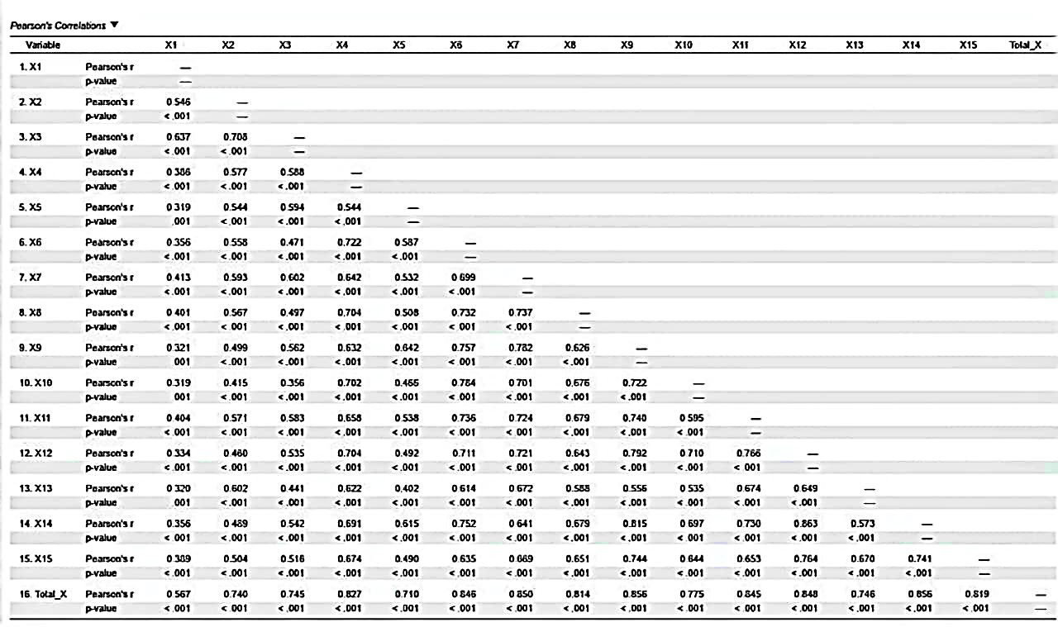
- Validitas Variabel Y (Kepuasan Masyarakat)
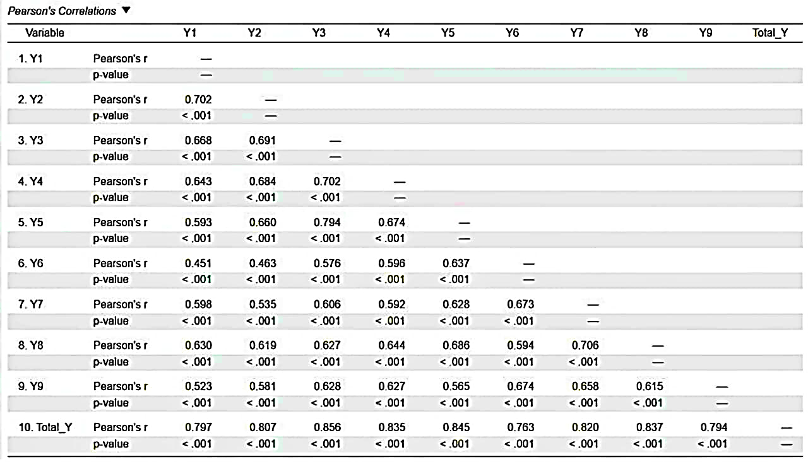
- Reliability Variabel X (Keberadaan MPP – Kualitas Pelayanan)

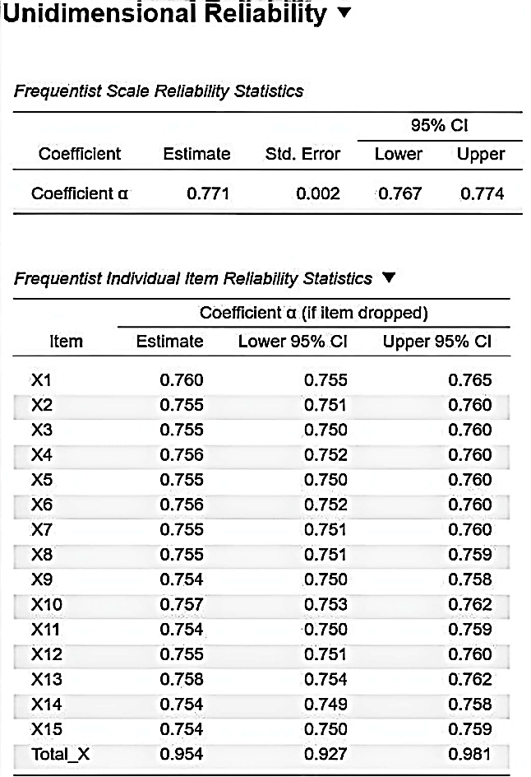

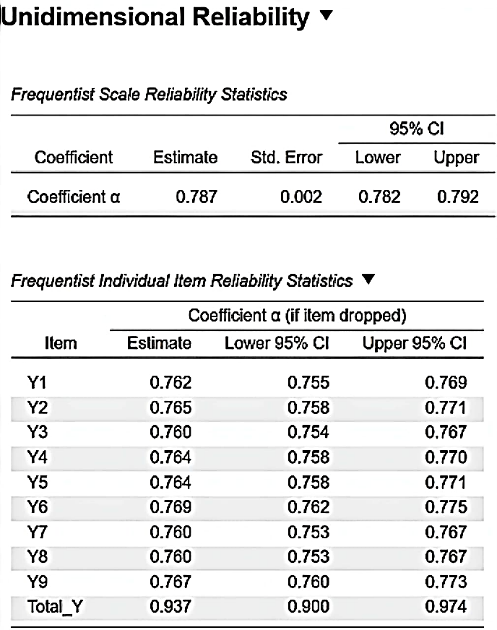
- Reliability Variabel Y (Kepuasan Masyarakat)

LAMPIRAN 4 : HASIL GAMBAR LINEARITAS
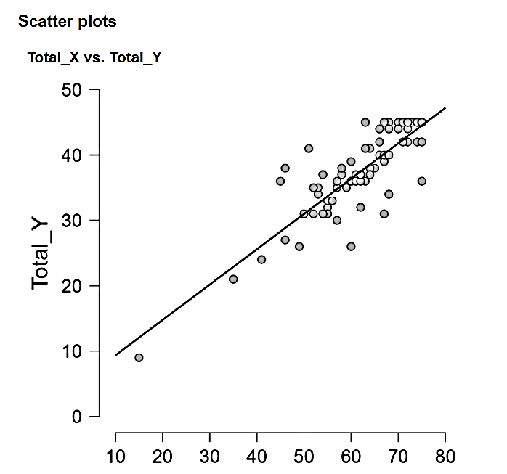

LAMPIRAN 5 : HASIL UJI KORELASI

Correlation
Spearman's Correlations
 |  |  | n | Spearman's rho | p | Effect size (Fisher's z) | SE Effect size
Total_X | - | Total_Y | 100 | 0.806 | < .001 | 1.115 | 0.110
Assumption checks
Shapiro-Wilk Test for Bivariate Normality
 |  |  | Shapiro-Wilk | p
Total_X | - | Total_Y | 0.935 | < .001

LAMPIRAN 6 : HASIL UJI REGRESI LINEAR
Linear Regression
Model Summary - Total_Y
Model | R | R² | Adjusted R² | RMSE | AIC | BIC | R² Change | df1 | df2 | p
M₀ | 0.000 | 0.000 | 0.000 | 6.014 | 645.600 | 650.811 | 0.000 | 0 | 99
M₁ | 0.863 | 0.745 | 0.742 | 3.055 | 511.121 | 518.937 | 0.745 | 1 | 98 | < .001
Note. M₁ includes Total_X

ANOVA
Model |  | Sum of Squares | df | Mean Square | F | p
M₁ | Regression | 2666.0 | 1 | 2666.025 | 285.7 | < .001
 | Residual | 914.6 | 98 | 9.333
 | Total | 3580.6 | 99
Note. M₁ includes Total_X
Note. The intercept model is omitted, as no meaningful information can be shown.

Coefficients
 |  |  |  |  |  |  | 95% CI
Model |  | Unstandardized | Standard Error | Standardized | t | p | Lower | Upper
M₀ | (Intercept) | 37.560 | 0.601 |  | 62.454 | < .001 | 36.367 | 38.753
M₁ | (Intercept) | 3.955 | 2.012 |  | 1.966 | .052 | -0.037 | 7.947
 | Total_X | 0.541 | 0.032 | 0.863 | 16.902 | < .001 | 0.477 | 0.604

Descriptives
 | N | Mean | SD | SE
Total_Y | 100 | 37.56 | 6.014 | 0.601
Total_X | 100 | 62.15 | 9.597 | 0.960

Residuals Statistics
 | Minimum | Maximum | Mean | SD | N
Predicted Value | 12.066 | 44.508 | 37.560 | 5.189 | 100
Residual | -10.397 | 9.469 | 8.557×10⁻¹⁷ | 3.039 | 100
Std. Predicted Value | -4.913 | 1.339 | 5.718×10⁻¹⁷ | 1.000 | 100
Std. Residual | -3.421 | 3.137 | -0.001 | 1.007 | 100

LAMPIRAN 7 : FOTO KEGIATAN PENGUMPULAN DATA DAN
PENGISIAN ANGKET RESPONDEN
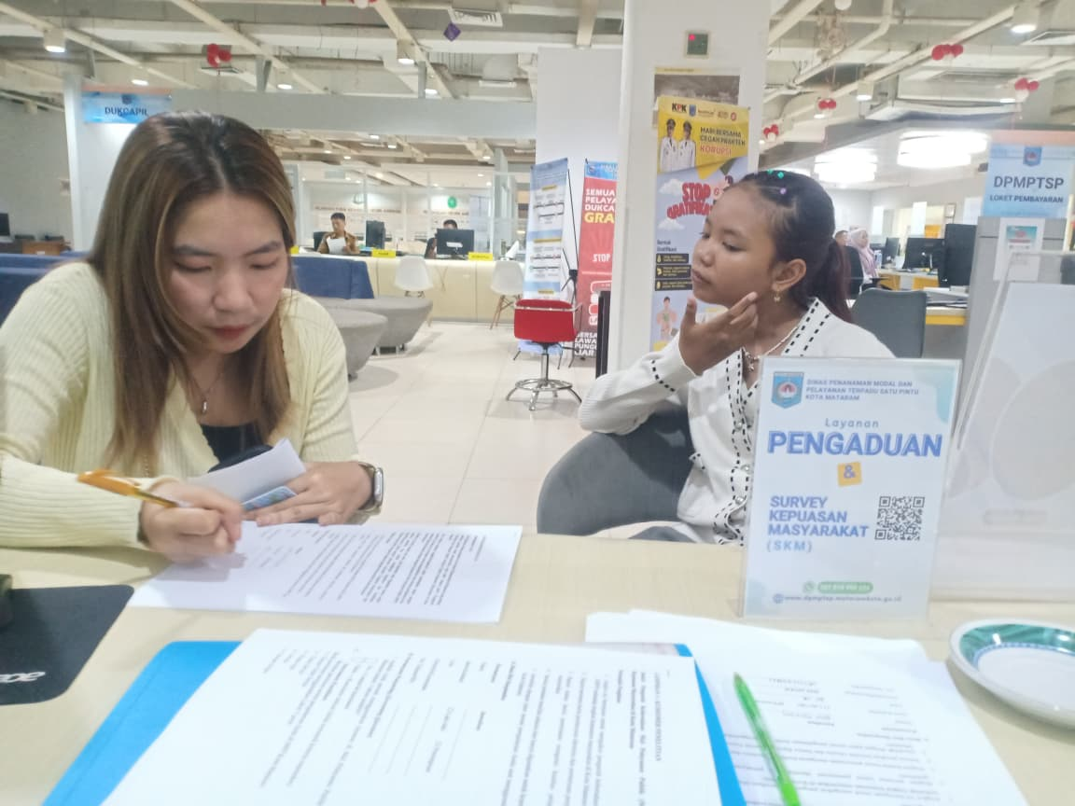
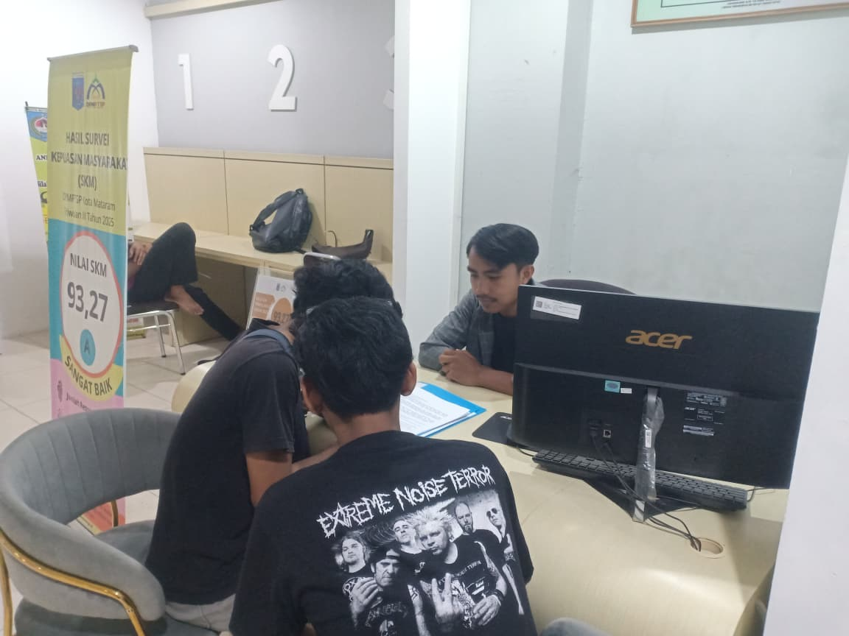

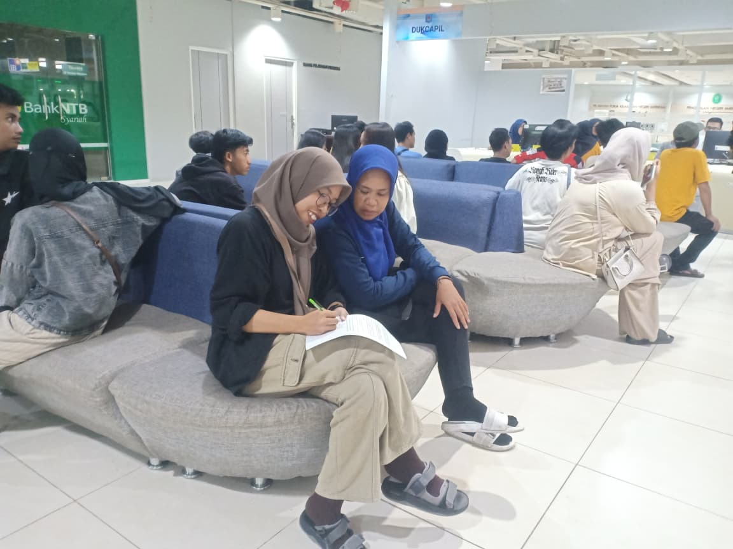
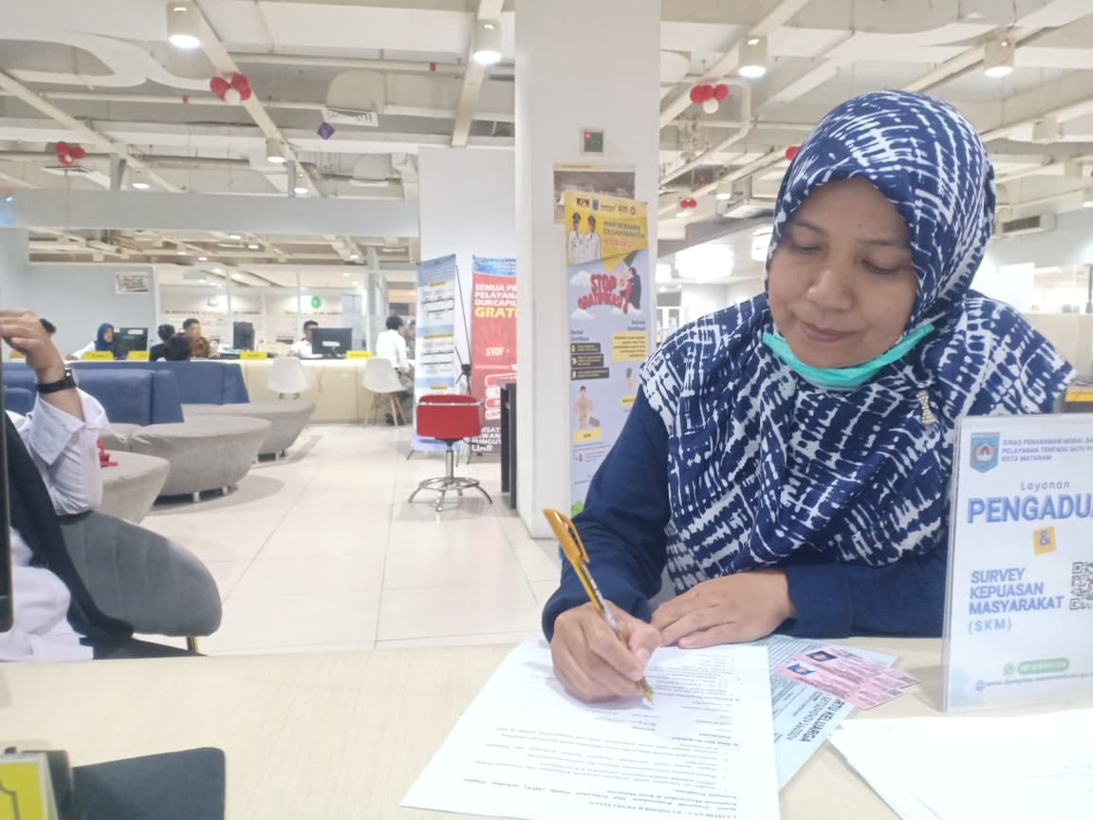

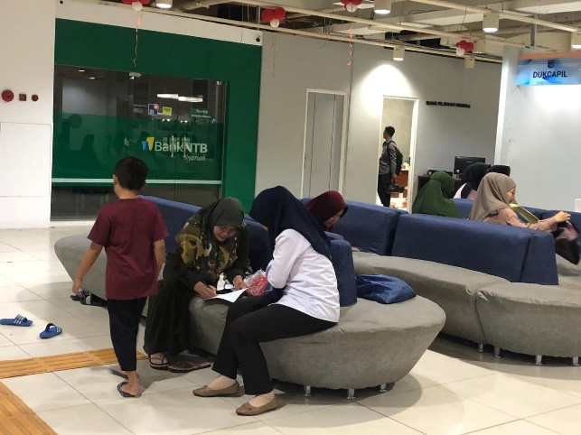
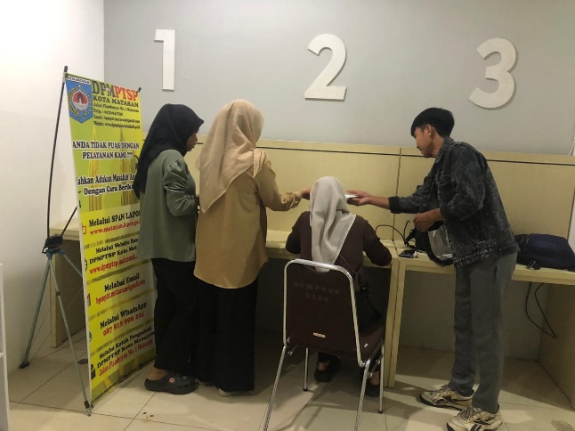

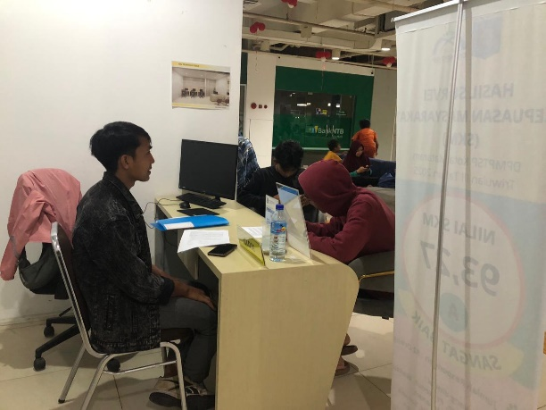
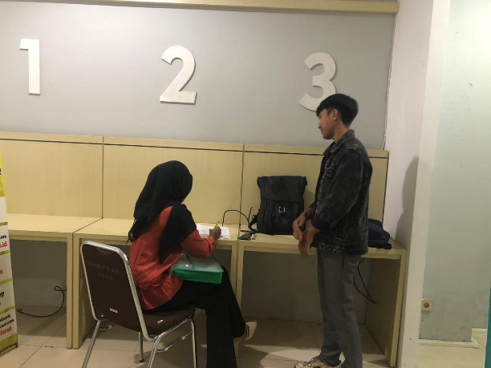

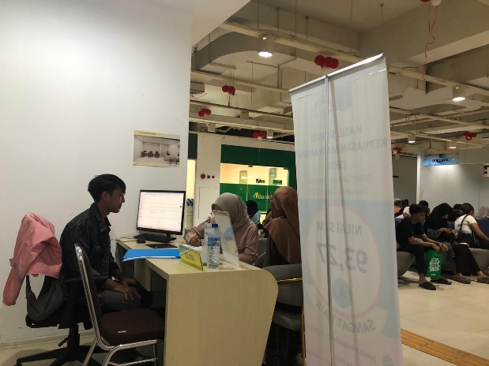

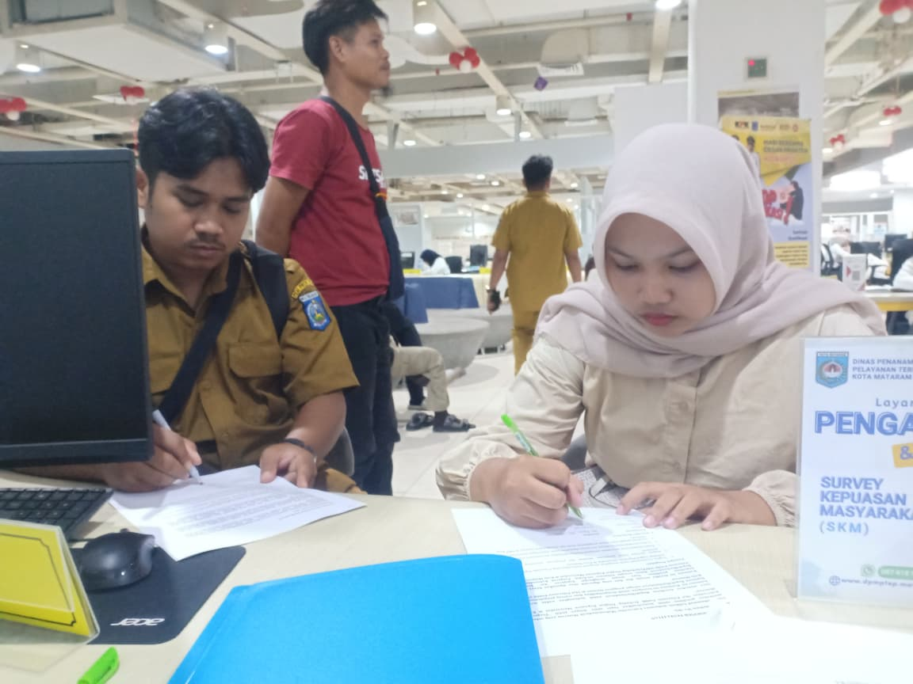
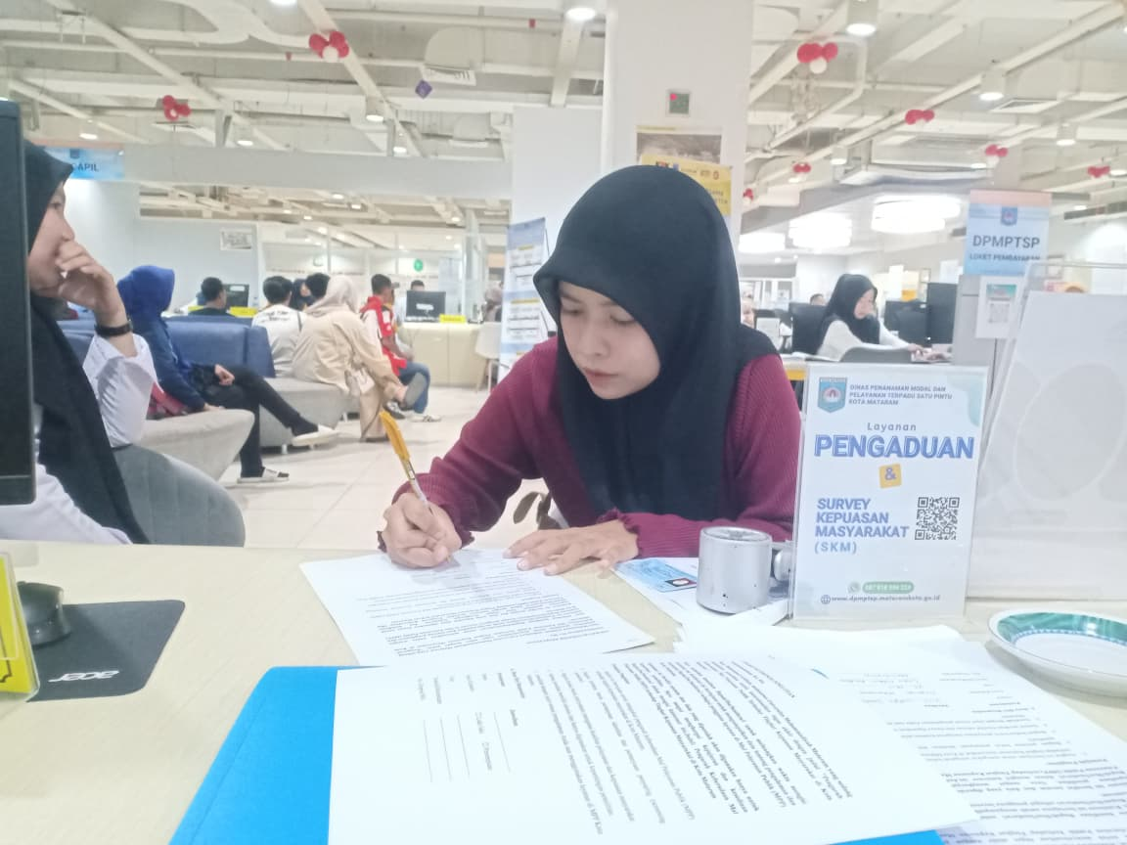

LAMPIRAN 8 BARCODE ANGKET VIA GOOGLE FORM
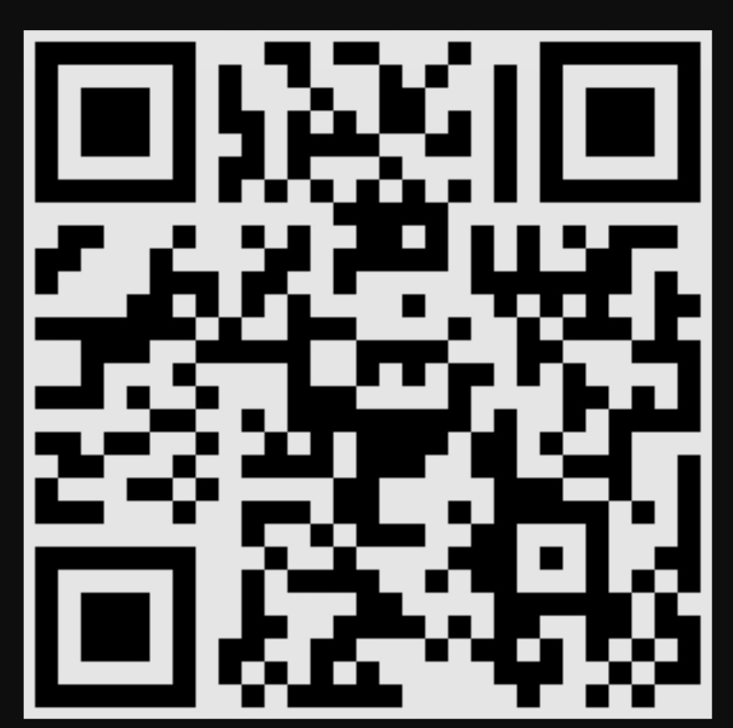

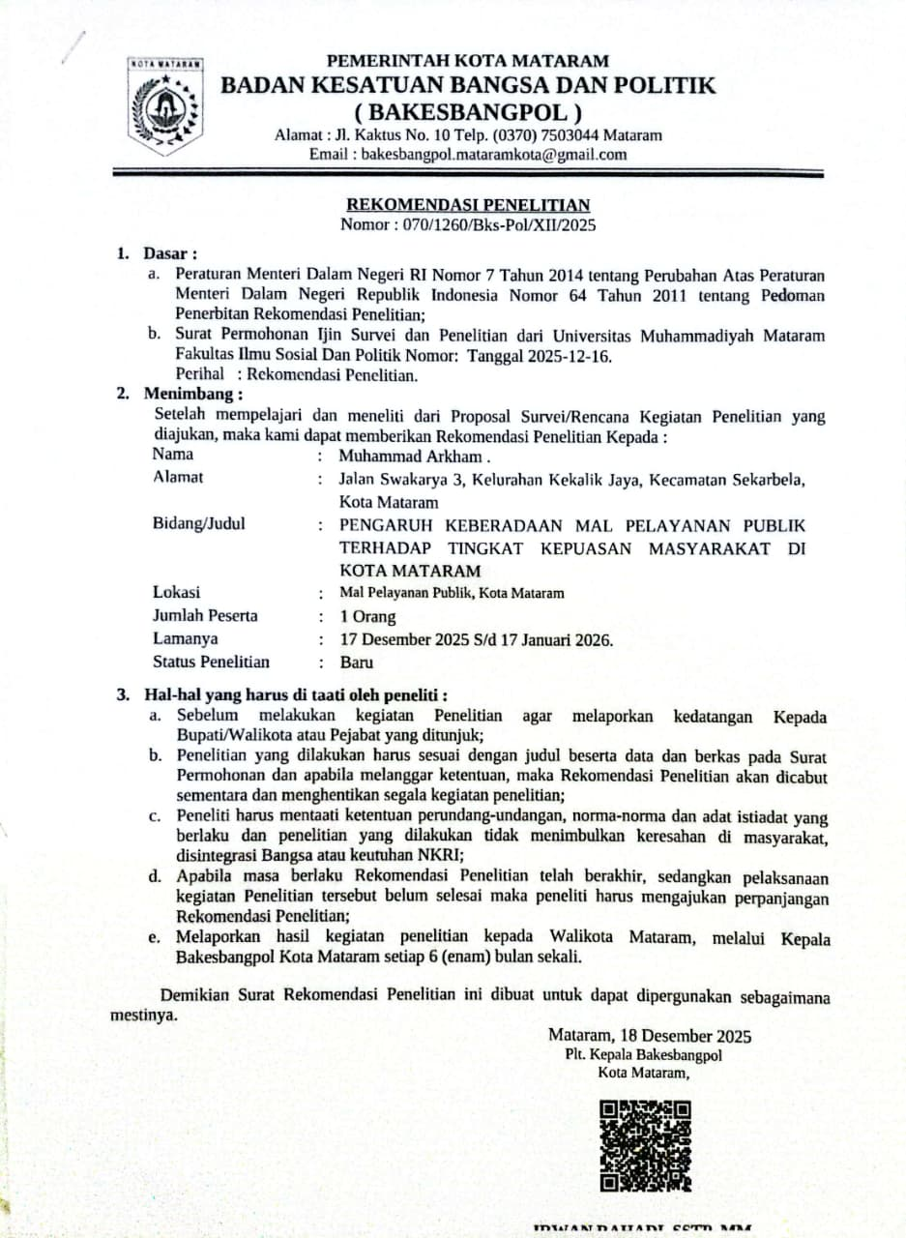
LAMPIRAN 9 : SURAT REKOMENDASI BAKESBANGPOL



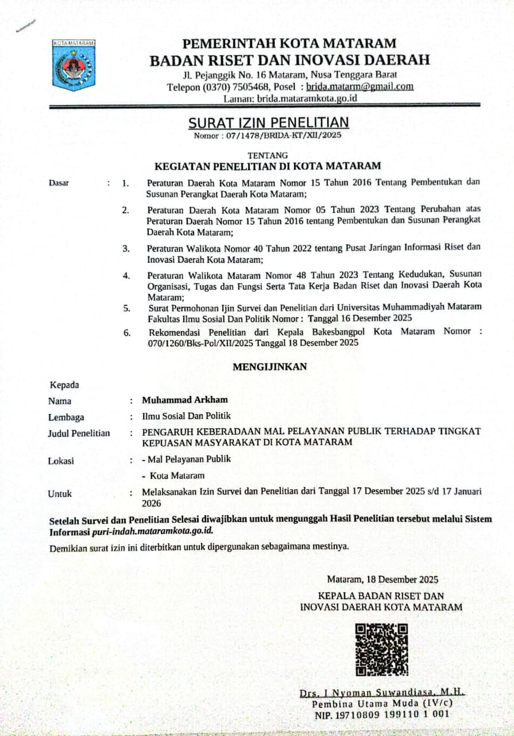
LAMPIRAN 10 : SURAT IZIN BRIDA



