Trace Metals (Pb, Cu, Zn, Ni, As and Fe) Distribution in Sediment Fractions of Karimata Strait, Indonesian

Duaitd Kolibongso^{1*}, Tri Prartono², Ali Arman³

^{1,2}Department of Marine Science, Bogor Agricultural University, Indonesia
Jl. Agatis, Kampus IPB Dramaga Bogor, West Java, 16680 Indonesia
³Center for the Application of Isotopes and Radiation (PAIR), National Nuclear Energy Agency
Jl. Raya Lebak Bulus, South Jakarta, 12440 Indonesia
Email: duaitd91kolibongso@gmail.com

Abstract

The profile concentration of heavy metals (Pb, Cu, Zn, Ni, As, and Fe), organic matter and the composition of the grain sizes is determined in two sediment cores from Karimata Strait. This study aimed to estimate the distribution of sediment grain sizes and distribution of heavy metals (Pb, Cu, Zn, Ni, As, and Fe) in the three sediment fractions (> 250 μm, 63-250 μm and <63 m) of the Strait Karimata. Sampling was conducted using box core. Graining size analysis was carried out through sieving and the digestion and heavy metals concentration analysis used Inductively Coupled Plasma-Optical Emission Spectrometry (ICP-OES). Results of the study show that the sediment grain size distribution is strongly influenced by the water hydrodynamic condition (currents), it can be seen by the dominance of finding coarse grain size in the research areas. The highest concentration of the heavy metals are found in the finest grain size (<63 m) due to the larger surface area and higher adsorption capacity. Distribution of heavy metals Cu, Pb, Zn and Ni in the upper layer of sediments is higher than in the bottom layer. Furthermore, the As and Fe concentration in the surface were lower than in the bottom layer. Statistical analysis shows an association and a source of heavy metals mainly coming from the surrounding areas. It is supported by the enrichment factor values ​​of finding heavy metals generally has been undergone enrichment.

Keyword: Grain sizes, Karimata strait, Sediment, Trace metals

Introduction

Karimata Strait is a part of the Sunda shelf. Geological characteristic of the strait is a long process of tectonically movements. The strait belongs to the neritic shallow water (<85 m) and has deposits and enriched small quartzes of volcanic ashes that consists of deposits coming from mainland, terrestrial areas and rivers, deltas koluvial, marshes, and the kaolin clays coming from weathering and volcanoes muds that contain a lot of mineral deposits such as gold, copper, lead and zinc, bauxite, and kaolinite (Situmorang et al, 1993; Situmorang & Andi 1999). Moreover, the strait water connects the South China Sea and Java Sea with different directions of current patterns movement in every season dues to be affected by monsoon. The other interesting characteristic of the strait is being located in both big island, Borneo and Sumatra. Hydrological complexities, human activities around the water and many rivers that flow into this strait contribute certainly to the environmental condition change. One of them is an increasing amount of materials that enter to the strait through raining’s and depositing atmospherics.
Geochemical studies in a sediment can be used as a 'tool' to delve environmental changes within a certain time. Marine sediment attribute is an output of land and sea interaction recording. Sea is affected by two sources such as recording land influences come from transported materials through rivers and runoffs and recording chemical and physical reactions in the sediments (Segar, 2012).
The grain sizes is an important indicator that can illustrate spatial changes, deposition process, and environmental characteristics of the sediment; and identifies the sediment sources (Ujevic, 2000; Purkait, 2010). It affects heavy metals concentration in a sediment. Heavy metal is highly associated with grain sizes of fine sediment especially silt / clay fraction. In other side, heavy metals have significant ecological influences relating to the accumulating process in sediments and biotas (Yao et al., 2015). However, some recent researches show that coarse grain sizes especially sand fraction has high heavy metal concentration and even more concentration than finest particles (Parizanganeh, 2008).
To understand environmental changes by related grain sizes and heavy metals approaches can interpret environment condition and identify their sources therefore we can predict the Karimata strait evolution process in the future. This research aimed to analyze distributing and depositing sediments based on their grain sizes and contained heavy metals. This research is supposed can illustrate heavy metals property in the sediments and their sources which contributes to provide environmental change information of the strait.

Materials and Method

Sediment Sampling

The collected sediment core samples were taken using a core box with dimension 50x50x75 cm at two stations in Karimata Strait. First location was on B3 that represented offshore area with high average current speed. The second location was on St 9 representing an area that close to the mainland (Borneo) and the Karimata’s small chained islands (Figure 1). Those core sampling were conducted by Baruna Jaya VIII research vehicle cruise on June 2015 and stored in refrigator at -4^{O}C until further analysis in laboratory. They were analyzed in the Laboratory of Marine and Chemical Industry and the environment, Center for the Application Isotopes and Radiation (PAIR), National Nuclear Energy Agency (BATAN). Sampling coordinates location, water depth and sediment core length are shown in Table 1.

Tabel 1 Two Sampling Sediment Coring Property of Karimata Strait.
Station | Longitude | Latitude | Depth (m) | Core (cm)
B3 | 108º32’49.5” | 1º54’64.8” | 40 | 28
9 | 109º3’48.8” | 1º24’08.3” | 27 | 5

Size Fractionation

In the laboratory, sediment samples were slices with interval 1 cm using plastic knives to avoid heavy metal contamination. Those interval samples were weighted and dried at 105⁰C for 24 hours (IAEA-TECDOC, 2003). Thus, each of the interval was homogenized by mortar and pestle. The homogenized sediment samples were sieving used mesh size 70 mm and mesh size 230 mm for 15 minutes. These mesh sizes were aimed to fractionate grains from >250 mm, 63-250 mm and <63 mm based Wentworth scale (Boggs, 2006). Sediment retained on each sieve was carefully remove and weighed. All fractions were then analyzed for their heavy metals concentration (Pb, Cu, Zn, Ni and As). Organic matters were determined by the percentage of lost on ignition (Heiry et al, 2001 and Robertson, 2011).

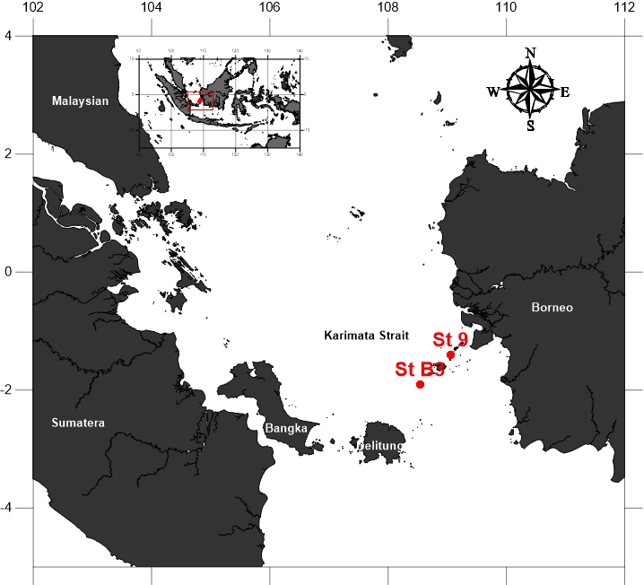

Figure 1. Research Map Location of Sampling at Karimata Strait

Heavy metals analysis

Digestion of sediment for hevay metals analysis using a closed vessel microwave-assited digestion method has now become common since it is very fast and also reduces the risk of external contamination (Frank and Arsenault, 1996; Adiyiah et al, 2014)). Each of interval and fractionation were weighted about 0.3 g and put into a vessel. Those samples were added with 9 ml HNO3 and 3 ml HCl (3: 1) and 1 ml of H₂O₂ was drop in slowly. The vessel were then sealed carefully with their respective corks and heated using a microwave at 150 °C with 700 Watts intensely for 30 minutes. Then those solvent samples were transferred into 50 mL volumetric flask and centrifuged at 3,000 rpm for 30 minutes to allow any suspended particles to settle. The solution was then decanted into a PPE plastic cup and diluted to 10 ml with distilled water (EPA 3015A, 2007). Measurement of the heavy metals were done using Inductively Coupled Plasma-Optical Emission Spectrometry (ICP-OES) on Thermo iCAP 6300. The accuracy of the analytical procedure was repeatedly checked by analyzing samples of reference material SRM 158 (marine sediment) provided by the International Atomic Energy Agency (IAEA). Those samples and the standard sediment were applied with the same manner. The compliance of obtained results with the reffered values is shown in Table 2. All result are reported on a dry weight basis. As a further quality assurance measure, method blanks were performed to check for the presence of contamination during the digestion and analytical procedures. The method blanks confirmed the absence of contamination for both procedures.

Enrichment Factor (EF)

Enrichment Factor (EF) was used to estimate the level of contaminating and assessing heavy metals source of anthropogenic or natural that was first suggested by Simex and Helz (Zhang et al, 2007). EF method normalized the measured data concentration of heavy metals in sediment with a reference sample. Normalizing heavy metals used a metal iron (Fe) functioning as a conservative elements (tracer) of metal natural-connected for coastal sediments and rivers and as one of the commonly used (Seshan et al, 2010; Sekabira et al, 2012). EF heavy metal was calculated by using the equation:

$EF=\frac{\left(\frac{E}{Fe}\right)sedimen}{\left(\frac{E}{Fe}\right)reference}$ (1)

Where, (E / Fe) is the concentration of metals in sediment samples and sediment reference (E / Fe) is metal concentrations of earth crust (Taylor, 1964). EF value > 1.5 indicates an enrichment of heavy metals in sediment.

. Tabel 2 Comparison of the certified and obtained values (mg/kg dry wt) for trace metal concentration in standard reference material SRM 158.
Element | Standard | Obtained | Recovery (%)
Pb | 39.6 ± 4.7 | 41 ± 3.4 | 103.3
Cu  Zn  Ni  As  Fe | 48.3 ± 4.2  140.6 ± 9.5  30.3 ± 2.9  11.5 ± 1.2  26300 ± 1.4 | 46.3 ± 7.5  134.9 ± 10  28.3 ± 2.2  11.1 ± 1  20100 ± 2.6 | 95.9  95.9  93.3  96.7  76.8

Results and Discussion

Grain sizes

Classification of sediment types based on grain size indicated by the composition of two sediment cores do not differ greatly (Figure 2 and 3). Generally, sediment at station B3 dominated coarser grain size (>250 μm) with a percentage of the core >60%. Meanwhile, stations 9 are dominated 2 two grain size, the size of 63-250 μm and> 250 μm with a percentage of each in a core of about 40%. Vertical distribution profile of grain size composition also differed between the two stations. At station B3 share coarse particles (>250 m) lower in the deeper layer and slowly increase in surface. Meanwhile, the composition of the grain size of stations 9 tend to be uniform between grain size >250 mm and 63-250 mm along the core. Differences dominance sediment grain size on both stations is the influence of environmental conditions that flows as a transport medium particles at both locations. Alkausar (2008) found that the speed of currents in the Strait Karimata decline approaching coastal waters and increasing offshore. Grain size distribution profile of the two cores also indicate the fine grain size (<63 mm) that goes to the Strait of Karimata transported towards the sea (station B3) continues to increase.

A
B
C
Figure 2. Grain size distribution at station B3; (A) >250 µm, (B) 63-250 µm, and (C) <63 µm.

C
Figure 3 Grain size distribution at station 9; (A) >250 µm, (B) 63-250 µm, and (C) <63 µm

Organic matter in marine sediments is usually derived from terrestrial environments, marine and anthropogenic sources. The total percentage of organic matter in the sediment station B3 about >20% and station 9 <20% (Figure 4). Distribution of total organic material indicates organic matter content is generally found to be high in the surface layer and decreased with increasing depth. However, the station B3 found little variation in the organic matter content of the sediment profile. This condition is thought to be the result by turns between grain size during the process of sediment deposition.

Figure 4. Organic matter distribution in core sediment

Distribution and concentration

The concentration of heavy metals in the three sediment fraction> 250 mm, 63-250 mm, and <63 mm displayed in Figure 5 and 6. The results show the heavy metal concentrations in each different fractions vary greatly. This indicates a different effect on each sediment grain size in binding heavy metals. Concentrations of heavy metals (Cu, Pb, Zn, Ni, As, and Fe) are found high in the fine fraction (particle size <63 m) where the value two times (2x) higher than the grain size >250 μm and 63-250 mm. But unlike other metals As and Fe metal concentrations in particular at the station B3 was found to increase the grain size of 63-250 mm. The concentration of heavy metals in the fine grain size is generally associated with a surface area and organic matter content is high in adsorbing metals (Horowitz, 1985; Krumgalz et al, 1991; Greaney, 2005; Adiyiah et al, 2014; Zaborska et al, 2014). High metal concentrations in the coarse grain size is generally associated with the formation of agglomeration of coarse particles, the content of carbonates, and metal characteristics (Krumgalz et al, 1989; Singh 1999: Parizanganeh, 2008).

Figure 5. Trace metal profile distribution at station B3
Note: 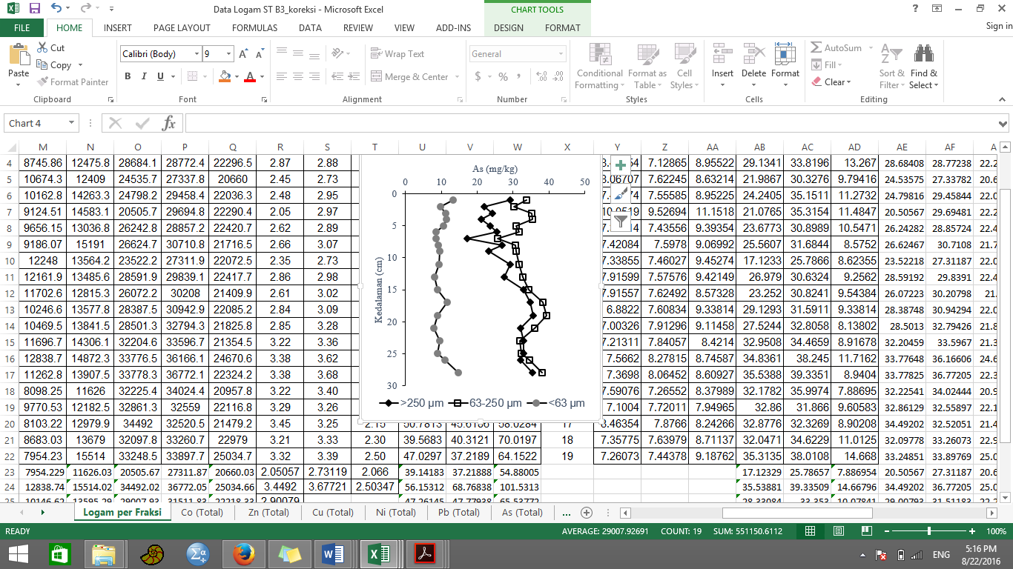

Heavy metals distribution profile in each grain size in both cores generally show the highest concentrations are found in the surface layer while heavy metals distribution profile As and Fe demonstrated low concentrations in the surface layer (especially the station B3) (Figure 5). It is suspected because of the input from the surrounding area and the influence of fine sediment grain size in the surface layer is higher than in the inner layer. Described vertical profiles characterized by elevated concentrations in upper layer of sediment are typical for process of sediment loading by input from the surrounding area (Ujevic et al, 2000). Meanwhile, the high As and Fe in the deeper layer relates to the size of coarse grains is high on the inner lining. As and Fe properties found in the station B3 expected to be more inclined to associate and form a bond with a coarse grain size. This is supported by observations made at the station 9 which shows the opposite where As concentrations at this station higher in fines grain size. Concentration and vertical distributions of heavy metals in sediment may be controlled by numerous factors such as: the mineral composition of the sediment, carrier substances (for example: hydroxides, carbonate, sulfide), and effects of Eh and pH (Zorana et al, 2008). But, the efficiency of the various above factors in influencing the binding and increased concentrations of heavy metals in sediments depend on the environmental conditions of sediment deposited, salinity, and water hydrodynamic conditions. Each grain size have different mobility in the marine environment, and the distribution of heavy metals in various grain sizes will also vary for different metals so that it can serve as a "fingerprint" the source of heavy metals in the water.

Figure 6. Trace metal profile distribution at station 9
Note:

Enrichment Factor (EF)

Comparison of metal concentrations in sediments with the reference value is generally used to estimate metal enrichment. Based on result, the highest EF value for heavy metals commonly found in the particle size of <63 mm in the second compare other particles. This indicates that a higher percentage of fine grain size in the sediment causing sediments are more susceptible to heavy metal contamination. Sequence enrichment of heavy metals in their respective grain sizes ranging from as low As>Pb>Zn>Cu>Ni at the station B3 while, sediments at station 9 shows the sequence from the lowest As>Pb>Cu>Zn>Ni.
EF value distribution profile for each grain size showed on the both cores, heavy metal enrichment As significant experience very high (20-40), Pb were enriched medium (2-5), Cu and Zn enrichment minimal (1.5-2 ) and Ni did not experience enrichment (<1.5) indicates where sediment conditions on both cores tend to have undergone any enrichment. According to Sutherland (2000) states that the higher the EF, the contribution of anthropogenic sources is also increasing. Meanwhile, EF values ​​in the range 0.5 to 1.5 indicates that all metals tend to come from the material crust (the crust) or the result of natural weathering Zhang et al (2007).

Figure 7. Distribution of Enrichment factor value of trace metal in core sediment station B3
Note: , dot line

Associations and sources

Results of statistical analysis using PCA on all metal concentration data for each grain size in two sediment cores used to infer the source of the metal in the second core (Ruiz-Fernandez et al, 2007) and the results of PCA shown in Table 3 and 4. The two main components with eigenvalues ​​more than one which explained 72% of the total variance in the particle size of >250 mm, 85% of the total variance in particle size of 63-250 mm and 80% of the total variance of particles <63 mm in stations B3 and the only one principal component with eigenvalue more than one, which explained 83% of the total variance in particle >250 mm, 89% of the total variance in the 63-250 mm particles and 47.4% of the total variance in particle <63 mm at the station 9.

Figure 8. Distribution of Enrichment factor value of trace metal in core sediment station 9
Note:

F1 explained 46.8% of the total variance in grain size> 250 μm in the station B3, therein including a group of Cu, Zn and Ni. This indicates that all three of these metals form an association in grain size> 250 μm and come from the same source, ie from the sea itself. This is supported by all three concentrations found to be low in the grain size and the value of EF who showed no enrichment. Fe is also included in this group. However, differences in loading components Fe showed a different distribution with other metals (low concentrations in the surface layer). F2 explained 25.4% of the total variance in grain size> 250 As metal therein. The grain size 63-250 therein As and Fe group metals. This condition indicates that these two metals originated from the same source. Fe is one of the main elements and its nature as a hydroxide will undergo a process of reduction of Fe³⁺ to Fe²⁺ which it would then affect the metal adsorption of As (Sanusi, 2006). And on the grain size <63 μm explain 55% of the total variance, which certainly includes Pb, Cu, Zn, Ni and As. This condition indicates that all of these metals form associations with particle size of <63 μm and come from sources of anthropogenic activities on land that enter waters through run-off and input from rivers. At station 9, F1 explain 83% of the total variance in grain size >250 mm including a group of Pb, Ni, As and Fe. This indicates the characteristics of Pb, Ni and As to form associations and binds with Fe-oxides. Cu is also included in this group but the difference in loading showed differences in the distribution of sediments (Figure 5). This condition is suspected due to changes in redox conditions that usually occur in this bond which led to the release of Cu. This can be seen from the EF value of Cu (EF <1.5) in these particles is relatively experienced compared to the enrichment of Pb and As.

Table 3. PCA result of trace metal concentration in grain size at station B3
St B3 | >250 mm |  | 63-250 mm |  | <63 mm
St B3 | F1 | F2 | F1 | F2 | F1 | F2
Cu | 0.817 | 0.356 | -0.886 | -0.181 | 0.833 | -0.235
Pb | -0.566 | 0.284 | 0.166 | 0.935 | 0.910 | -0.004
Zn | 0.673 | 0.528 | -0.879 | 0.228 | 0.835 | -0.353
Ni | 0.679 | 0.463 | -0.654 | 0.621 | 0.675 | -0.432
As | -0.487 | 0.726 | 0.924 | 0.090 | 0.678 | 0.650
Fe | -0.816 | 0.547 | 0.921 | 0.224 | 0.413 | 0.840
Eigenvalue | 2.808 | 1.529 | 3.718 | 1.403 | 3.302 | 1.496
%Value | 46.814 | 25.491 | 61.978 | 23.392 | 55.136 | 24.947
%Cumulative | 46.814 | 72.305 | 61.978 | 85.371 | 55.136 | 80.083

F1 explain 89% of the total variance in grain size 63-250 μm, and has a positive loading (> 0.8) for Pb, Cu, Zn, Ni, As, and Fe. This illustrates that the association of these metals tend to bind to the Fe-oxide and carbonate fraction high in this grain size. That is to say the higher the concentration of Fe in 63-250 μm particle it will be followed by the higher concentration of heavy metals. Sutherland et al (2012) found heavy metals commonly found associated and attached to the fraction of Fe/Mn oxides and carbonates in particular on the grain size class 63-250 mm. Generally the metals bind to the fraction of carbonate and Fe-Mn oxide is a metal that the highest mobility (most available form) because it is easiest to exchange (most exchangeable) and weakly adsorbed on a matrix of sediment so that the most easily separated and dissolved in the water column and therefore it is the fraction of the most available and potentially absorbed and can cause toxicity in aquatic organisms (Zimmerman and Weindorf, 2010; Sundaray et al, 2011). The main source of metals in these strong grain size thought to have come from the mainland around. And on the grain size <63 μm therein Cu, Fe and As which explain the source of these metals come from activities on land around the station as well as from distant areas or derived from anthropogenic inputs. Potential sources of heavy metals mostly from mainland such as port and industrial activities (Rochyatun and Razak, 2007 and Arifin and Fadhlina, 2009). Moreover, the existence of various industries, mining, plantation/agricultural areas near the mainland is estimated to dump wastes through rivers or drainage passing through the estuary towards the Strait Karimata.

Table 4. PCA result from trace metal concentrationl in grain size at station 9

St 9 | >250 mm | 63-250 mm | <63 mm
St 9 | F1 | F1 | F1
Cu | -0.988 | 0.973 | 0.142
Pb | 0.991 | 0.906 | 0.664
Zn | -0.636 | 0.935 | 0.487
Ni | 0.894 | 0.906 | 0.884
As | 0.952 | 0.955 | 0.377
Fe | 0.953 | 0.987 | 0.106
Eigen value | 4.979 | 5.353 | 2.848
% Varian | 82.993 | 89.232 | 27.272
% Cumulative | 82.992 | 89.232 | 47.468

Conclusion

Karimata Strait is shallow water with the composition of the grain size is not uniformly distributed. The highest concentrations of heavy metals found in the highest fine grain size (<63 m) with the distribution pattern of the metal in the surface layers higher than the deeper layer in which this is an indicates of the input coming from the mainland. Results of statistical analysis using all data (concentrations of heavy metals in each grain size) indicates the association of heavy metals were found to differ in which it describes the source of the metals are also different. At stastion B3, heavy metals Pb, Cu, Ni and Zn mainly found in the fine fraction where it illustrates that the main source of these metals come from activities on land which is distant enough and As and Fe in the coarse fraction in which it describes the main source this metal from both natural sources and the surrounding land. Meanwhile, at station 9 Pb, Cu, and As found in all of the grain size is an indication that the major source of heavy metals is derived from activities on land/antropogenic and natural, and metals Zn and Ni that shows the main source of both metals primarily from the natural source because it is found only in the coarse fraction.

Acknowledgements This study was supported by Center for Applications of Isotopes and Radiation, National Nuclear Energy Agency, Jakarta-Indonesia.

References

Adiyiah J, Acheampong MA, Ebenezer D, Anza O, Kelderman P. 2014. Grain-size Analysis and Heavy Metals distribution in sediment fraction of Lake Markermeer in the Netherland. J. Environ Sci and Toxi Res. 2 (8): 160-167.
Alkausar H. 2008. Model hidrodinamika pasang surut di Perairan Selat Karimata. Bandung: Institut Teknologi Bandung.
Arifin Z dan Fadhlina D. 2009. Fraksinasi logam berat Pb, Cd, Cu, da Zn dalam sedimen dan bioavailibitasnya bagi biota di perairan Teluk Jakarta. Ilmu Kelautan. 14 (1):27-32.
Boggs S Jr. 2006. Principle of Sedimentology and Stratigraphy-Fourth Edition. University of Oregon. Pearson Education Inc.
EPA 3015A. 2007. Microwave Assisted Acid Digestion of Aqueous Samples and Extracts. Washington DC (US): Enviromental Agency Protection Press.
Heiry O, Lotter AF and Lemcke G. 2001. Loss on ignition as a method for estimating organic and carbonate content in sediments: reproducibility and comparability of result. Journal of Paleolimnology. 25: 101-110.
International Atomic Energy Agency-1360. 2003. Collection and preparation of bottom sediment samples for analysis radionuclides and trace elements. Nutriotional Health-Related Enviromental Studies Section IAEA. Vienna, Austria.
Krumgalz BS. 1989. Unusual Grain Size Effect on Trace Metals and Organic Matter in Contaminated Sediments. Marine Pollution Buletin. 20 (12): 608-611.
Parizanganeh A. 2008. Grain Size Effect in Trace Metals in Contaminated Sediments along the Iranian Coast of the Caspian Sea. Proceedings of Taal: The12th World Lake Conference: 329-236.
Pusat Penelitian dan Pengembangan Geologi Kelautan (P3GL). 2002. Laporan Penyelidikan Geologi dan Geofisika Kelautan Perairan Bangka Belitung, Lembar Peta 1215. Bandung.
Robertson S. 2011. Direct Estimation of Organic Matter by Loss on Ignition: Methods. Property of SFU Soil Science Lab.
Sanusi HS. 2006. Kimia Laut-Proses Fisik Kimia dan Interaksinya dengan Lingkungan. Bogor: Departemen Ilmu dan Teknologi Kelautan, Fakultas Perikanan dan Ilmu Kelautan. Institut Pertanian Bogor.
Sekabira K, Oryem-origa H, Basamba TA, Mutumba G, Kakudidi. 2014. Grain size and source apportionment of heavy metals in urban stream sediments. Water Pollution, Prof. Nuray Banlkis (Ed).
Seshan BRR, Natesan U, and Deepthi K. 2010. Geochemical and statistical approach for evaluation of heavy metal pollution in core sediments in southeast coast of India. Int. J. Environ. Sci. Tech. 7 (2): 291-306.
Singh AK, Hasnain SI, and Banerjee DK. 1999. Grain size and geochemical partitioning of heavy metals in sediments of the Damodar River-a tributary of the lower Ganga, India. Environ. Geology 39(1): 90-98.
Situmorang, M dan Andi, S. 1999. Laporan Hasil Awal Survei Tindak Lanjut Penyelidikan Geologi dan Geofisika Kelautan Lembar Peta 1413/1414, Perairan Sukadana Ketaang, Kalimantan Barat. Bandung: PPPGL.
Sundaray SK, Nayak BB, Lina S, and Bhatta D. 2011. Geochemical speciation and risk assessment of heavy metals in the river estuarine sediments, a case study: Mahanadi basin, India. Journal of Hazardous Materials. 186: 1837–1846
Sutherland RA. 2000. Bed sediment-associated trace metals in an urban stream, Oahu, Hawaii. Enviromental Geology. 39 (6): 611-627.
Sutherland RA, Tack FMG and Ziegler AD. 2012. Road-deposited Sediments in a urban environment: A first look at sequentially extracted elements loads in grain size fractions. Journal of Hazardous Materials. 225-226: 54-62.
Taylor SR. 1964. Abundance of chemical elements in the continental crust: a new table. Geochimica et Cosmochimica Acta. 28: 1273-1285.
Ujevic I, Odzak N and Baric A. 2000. Trace Metal Accumulation in Different grain Size Fractions of the Sediments from a Semi-Enclosed Bay Heavily Contaminated by Urban and Industrial Wastewaters. Water Research Journal. 34 (11): 3055-3061.
Yao Z, Liu Y, Shi X, Suk BC. 2012. Paleoenvironmental Changes in The East/Japan Sea During The Last 48 ka : Indications From High Resolution X-Ray Fluorescence Core Scanning. Quater Sci. 27(9):932-940.
Zhang L, Xin Ye, Feng H, Jing Y, Ouyang T, Yu X, Liang R, Gao C, Chen W. 2007. Heavy metal contamination in western Xiamen Bay sediments and its vicinity, China. Marine Pollution Bulletin 54: 974-982.

