SUPPLEMENTARY INFORMATION

Marine bacterium Seonamhaeicola algicola strain CC1 as a potential source for obtaining high zeaxanthin carotenoid.

*Corresponding author
E-mail: tatas.brotosudarmo@machung.ac.id

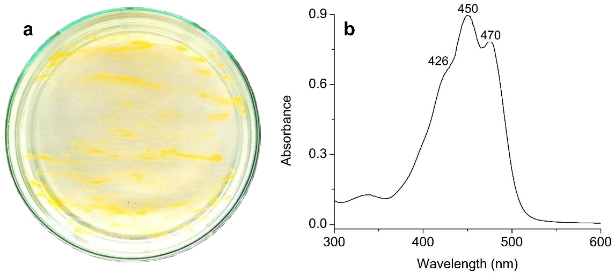
Fig. S1a Image of the pure colony of strain CC1 growing on agar medium and b UV-Vis absorption spectrum of crude methanol extracts of the pigment from strain CC1. The spectrum shows absorption peaks at 400–600 nm, with λ_{max} at 450 and 470 nm, which are indicative of carotenoids

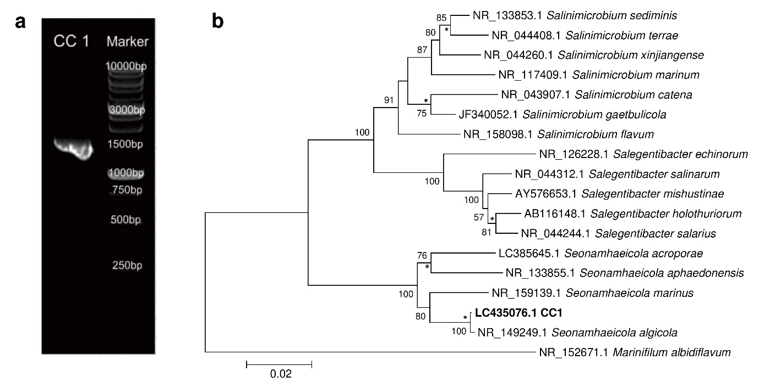
Fig. S2a PCR amplicon of the 16S rRNA gene on 0.8% agarose gel of S. algicola strain CC1 and b the phylogenetic tree of S. algicola strain CC1 based on 16S rRNA gene sequencing with a bootstrap resampling value of 100%. The strains of recognized species of the genus Seonamhaeicola, and representative of other related taxa are shown. Marinifilum albidiflavum was used as an outgroup. Bootstrap values >50% (expressed as percentages of 1000 replications) are shown at branch points. Asterisks indicate that the corresponding nodes were also recovered in the trees generated with the maximum-likelihood and maximum-parsimony algorithms. Bar, 0.02 substitutions per nucleotide position

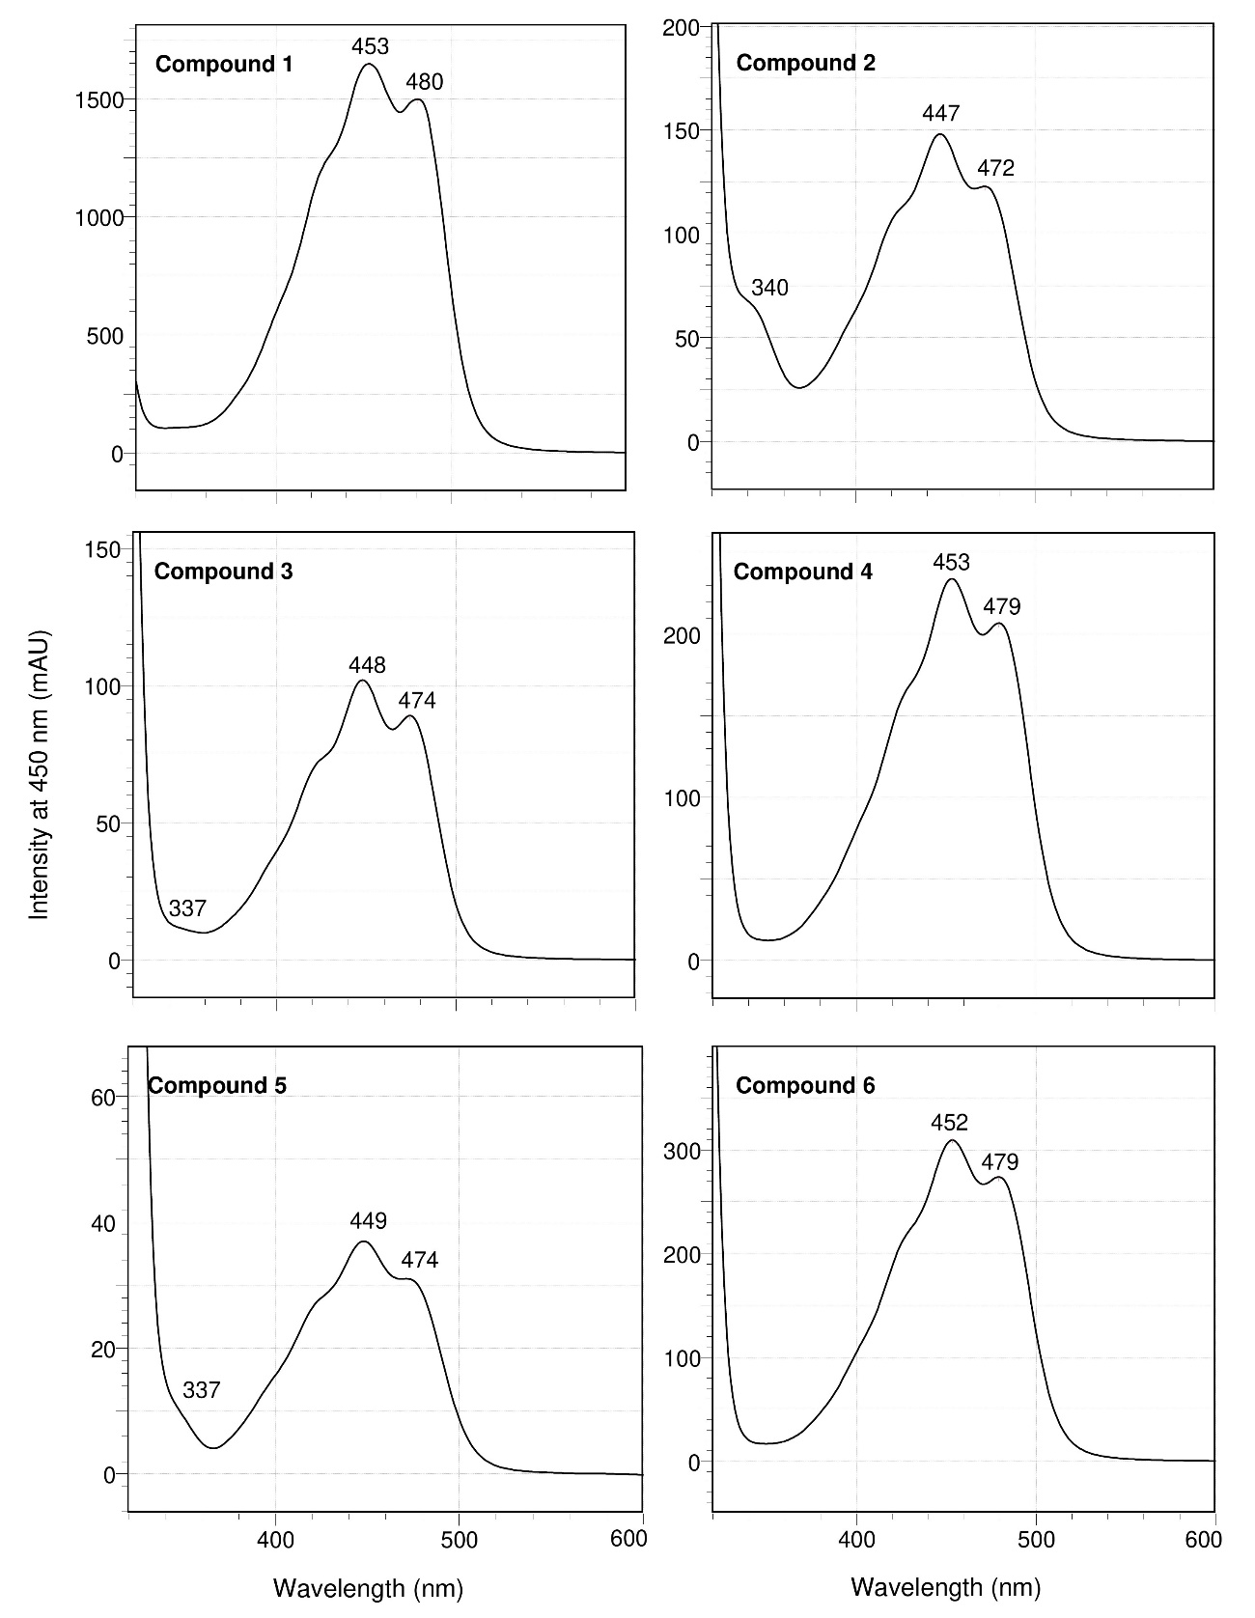
Fig. S3 Absorption spectra of six different carotenoids extracted from cell of S. algicola strain CC1 measured by HPLC equipped with a photodiode array detector as described in the text. Compound 1 (zeaxanthin), 2 and 3 (zeaxanthin cis isomer), 4 (β-cryptoxanthin), 5 (β-carotene cis isomer), and 6 (β-carotene).

1
2
3

Fig. S4 The plot of log k’ value of β-carotene (k’ = 1.38), β-cryptoxanthin (k’ = 1.32), and zeaxanthin (k’ = 1.25) versus number of atom oxygen of the carotenoid molecule showed a linear line with R² = 0.9943. The capacity factor (k') was measured by k' = (tR – t0)/t0, where tR and t0 are the retention times of the retained and unretained solute in the given system, respectively. 1. β-carotene (None); 2. β-cryptoxanthin (OH = 1); and 3. Zeaxanthin (OH = 2).

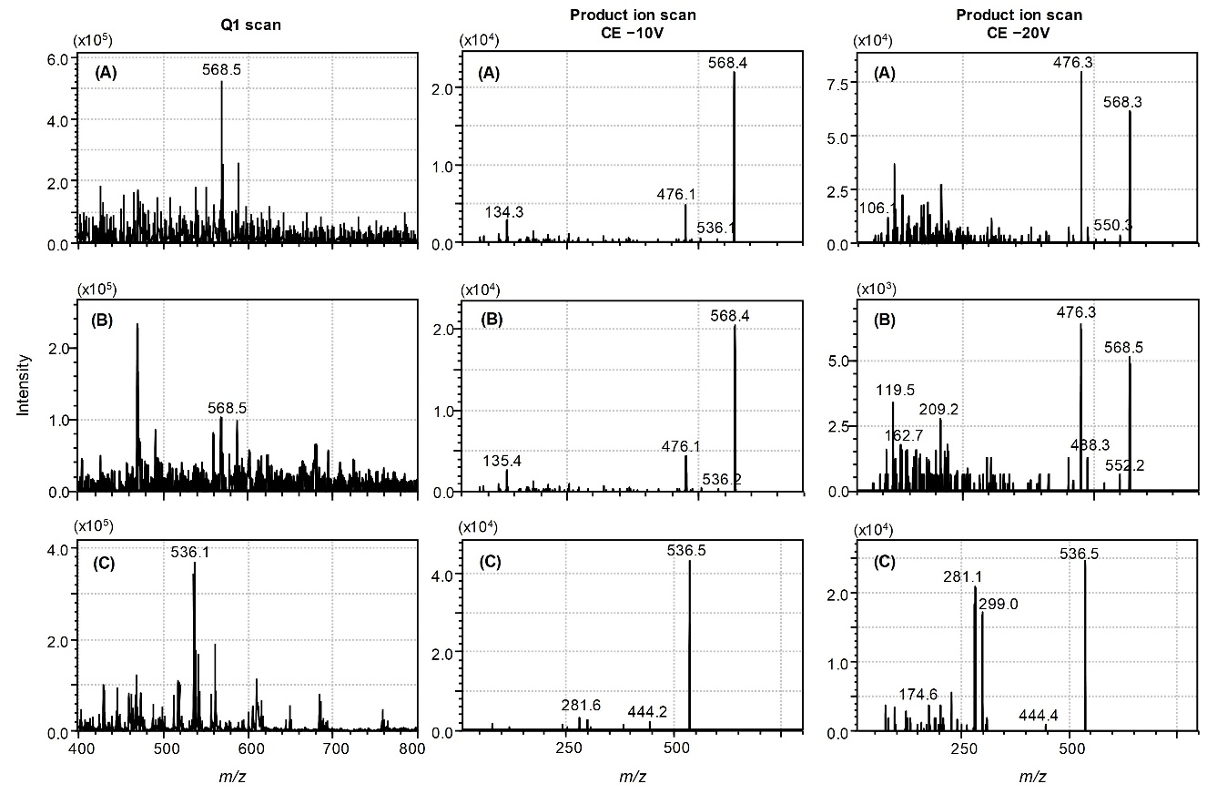
Fig. S5 ESI mass spectra of Q1 scan and product ion scan (–10V and –20V) from minor carotenoids in form of carotenoid cis isomer produced by S. algicola strain CC1. Two zeaxanthin cis isomer (A) and (B), as well as β-carotene cis isomer (C).

Table S1 Zeaxanthin-producing marine bacteria.
No | Strain | Family | Isolation source | Collection site | Ref.
1 | Mesoflavibacter zeaxanthinifaciens | Flavobacteriaceae | seawater | Kamakura coast (Japan) | [1]
2 | Zeaxanthinibacter enoshimensis | Flavobacteriaceae | seawater | Enoshima Island (Japan) | [2]
3 | Hyunsoonleella jejuensis | Flavobacteriaceae | seawater | Jeju Island (Korea) | [3]
4 | Muriicola jejuensis | Flavobacteriaceae | seawater | Jeju Island (Korea) | [4]
5 | Siansivirga zeaxanthinifaciens | Flavobacteriaceae | seawater | China Sea (Taiwan) | [5]
6 | Kordia aquimaris strain CC-AMZ-301 | Flavobacteriaceae | seawater | Taichung harbour (Taiwan) | [6]
7 | Aquibacter zeaxanthinifaciens | Flavobacteriaceae | seawater | Taichung harbour (Taiwan) | [7]
8 | Mesoflavibacter aestuarii strain KYW614 | Flavobacteriaceae | seawater | Gwangyang bay (Korea) | [8]
9 | Gramella planctonica strain CC-AMWZ-3T | Flavobacteriaceae | seawater | Kending coast (Taiwan) | [9]
10 | Muriicola marianensis strain A6B8 | Flavobacteriaceae | seawater | Mariana Trench Philipina | [10]
11 | Hanstruepera neustonica | Flavobacteriaceae | estuarine water | Pingtung (Taiwan) | [11]
12 | Paracoccus zeaxanthinifaciens strain R-1512 | Rhodobacteraceae | seaweed | African Red Sea | [12]
13 | Jejuia pallidilutea strain 11shimoA1 | Flavobacteriaceae | seaweed | Nabeta Bay (Japan) | [13]
14 | Seonamhaeicola algicola strain CC1 | Flavobacteriaceae | seaweed | Malang coast (Indonesia) | Present study
15 | Gramella oceani strain CC-AMSZ-T | Flavobacteriaceae | sediment | Kending coast (Taiwan) | [14]
16 | Zeaxanthinibacter aestuarii strain S2-22 | Flavobacteriaceae | sediment | Asan (South Korea) | [15]
17 | Flexibacter sp. DK30213 | Cytophagaceae | sponge | Sagami bay (Japan) | [16]
18 | Sphingomonas sp. KODA19-6 | Sphingomonadaceae | sponge | Gulf of Thailand | [17]
19 | Gaetbulimicrobium sp. strain 04OKA-17-12 | Flavobacteriaceae | coral | Kerama Island (Japan) | [18]
20 | Muricauda sp. YUAB-SO-11 | Flavobacteriaceae | sand | Ullal coast (India) | [19]
21 | Erythrobacter odishensis strain JA747 | Erythrobacteraceae | soil | Odisha (India) | [20]
22 | Flavobacterium kingsejongi strain WV39 | Flavobacteriaceae | feces of penguins | King George Island (Antarctica) | [21]
23 | Muricauda sp. GF1 | Flavobacteriaceae | algae | Japan | [22]

Table S2 Pigment characteristic in member of genus Seonamhaeicola
No | Strain | Collection site, habitat | Pigment characteriztic |  |  |  |  | Reference
No | Strain | Collection site, habitat | Color | Flexirubin | Zeaxanthin | β-cryptoxanthin | β-carotene | Reference
1 | S. aphaedonensis strain AH-M5 | Aphae Island (South Korea), marine sediment | orange yellow | - | Not studied | Not studied | Not studied | [23]
2 | S. algicola strain Gy8 | Lian Port (China), Gracilaria blodgettii | yellow | - | Not studied | Not studied | Not studied | [24]
3 | S. marinus strain B011 | Lingshui coast (China), Gracilaria blodgettii | orange | + | - | - | - | [25]
4 | S. acroporae strain 3KA7-17 | Okinawa (Japan), Acropora formosa | orange | - | Not studied | Not studied | Not studied | [26]
5 | S. maritimus strain 1505 | Weihai (China), marine sediment | orange | - | Not studied | Not studied | Not studied | [27]
6 | S. sediminis strain W255 | Weihai (China), marine sediment | orange | - | Not studied | Not studied | Not studied | [28]
7 | S. algicola strain CC1 | Malang coast (Indonesia), Chondrus crispus | yellow | - | + | + | + | Present study

Table S3 Summary of assigned carotenoids with the relative peak area (%). The peak area was detected at 450 nm.

Compound | t_{R} | Relative Peak Area (%) |  |  | Mean | SD
 | (min) | repetition 1 | repetition 2 | repetition 3
Zeaxanthin | 28.89 | 79.78 | 80.21 | 81.18 | 80.39 | 0.72
Zeaxanthin cis isomer | 30.36 | 4.61 | 4.24 | 3.80 | 4.22 | 0.40
Zeaxanthin cis isomer | 30.83 | 2.44 | 2.69 | 2.10 | 2.41 | 0.30
β-cryptoxanthin | 33.66 | 7.38 | 7.15 | 7.02 | 7.18 | 0.18
β-carotene cis isomer | 37.28 | 0.50 | 0.75 | 0.80 | 0.68 | 0.16
β-carotene | 37.88 | 5.28 | 4.96 | 5.10 | 5.11 | 0.16

References for Tables S1 and S2:
1. Asker, D.; Beppu, T.; Ueda, K. Mesoflavibacter zeaxanthinifaciens gen. nov., sp. nov., a novel zeaxanthin-producing marine bacterium of the family Flavobacteriaceae. Syst. Appl. Microbiol. 2007, 30, 291–296, doi:10.1016/j.syapm.2006.12.003.
2. Asker, D.; Beppu, T.; Ueda, K. Zeaxanthinibacter enoshimensis gen. nov., sp. nov., a novel zeaxanthin-producing marine bacterium of the family Flavobacteriaceae, isolated from seawater off Enoshima Island, Japan. Int. J. Syst. Evol. Microbiol. 2007, 57, 837–843, doi:10.1099/ijs.0.64682-0.
3. Yoon, B. J.; Lee, D. H.; Kang, B. J.; Kahng, H. Y.; Oh, Y. S.; Sohn, J. H.; Choi, E. S.; Oh, D. C. Hyunsoonleella jejuensis gen. nov., sp. nov., a novel member of the family flavobacteriaceae isolated from seawater. Int. J. Syst. Evol. Microbiol. 2010, 60, 382–386, doi:10.1099/ijs.0.006775-0.
4. Kahng, H. Y.; Lee, S. S.; Kim, J. M.; Jung, J. Y.; Lee, M. Y.; Park, W.; Jeon, C. O. Muriicola jejuensis gen. nov., sp. nov., isolated from seawater. Int. J. Syst. Evol. Microbiol. 2010, 60, 1644–1648, doi:10.1099/ijs.0.015313-0.
5. Hameed, A.; Shahina, M.; Lin, S. Y.; Sridhar, K. R.; Young, L. Sen; Lee, M. R.; Chen, W. M.; Chou, J. H.; Young, C. C. Siansivirga zeaxanthinifaciens gen. nov., sp. nov., a novel zeaxanthin-producing member of the family Flavobacteriaceae isolated from coastal seawater of Taiwan. FEMS Microbiol. Lett. 2012, 333, 37–45, doi:10.1111/j.1574-6968.2012.02596.x.
6. Hameed, A.; Shahina, M.; Lin, S. Y.; Cho, J. C.; Lai, W. A.; Young, C. C. Kordia aquimaris sp. nov., a zeaxanthin-producing member of the family Flavobacteriaceae isolated from surface seawater, and emended description of the genus Kordia. Int. J. Syst. Evol. Microbiol. 2013, 63, 4790–4796, doi:10.1099/ijs.0.056051-0.
7. Hameed, A.; Shahina, M.; Lin, S. Y.; Lai, W. A.; Hsu, Y. H.; Liu, Y. C.; Young, C. C. Aquibacter zeaxanthinifaciens gen. nov., sp. nov., a zeaxanthin-producing bacterium of the family Flavobacteriaceae isolated from surface seawater, and emended descriptions of the genera Aestuariibaculum and Gaetbulibacter. Int. J. Syst. Evol. Microbiol. 2014, 64, 138–145, doi:10.1099/ijs.0.052621-0.
8. Lee, J. H.; Hwang, Y. M.; Baik, K. S.; Choi, K. S.; Ka, J. O.; Seong, C. N. Mesoflavibacter aestuarii sp. nov., a zeaxanthinproducing marine bacterium isolated from seawater. Int. J. Syst. Evol. Microbiol. 2014, 64, 1932–1937, doi:10.1099/ijs.0.061085-0.
9. Shahina, M.; Hameed, A.; Lin, S. Y.; Lee, R. J.; Lee, M. R.; Young, C. C. Gramella planctonica sp. nov., a zeaxanthin-producing bacterium isolated from surface seawater, and emended descriptions of Gramella aestuarii and Gramella echinicola. Antonie van Leeuwenhoek, Int. J. Gen. Mol. Microbiol. 2014, 105, 771–779, doi:10.1007/s10482-014-0133-4.
10. Hu, J.; Zhang, W. Y.; Zhang, X. Q.; Cheng, H.; Zhu, X. F.; Wu, M. Muriicola marianensis sp. Nov., isolated from seawater. Int. J. Syst. Evol. Microbiol. 2015, 65, 407–411, doi:10.1099/ijs.0.070029-0.
11. Hameed, A.; Shahina, M.; Lai, W. A.; Lin, S. Y.; Liu, Y. C.; Hsu, Y. H.; Young, C. C. Hanstruepera neustonica gen. Nov., sp. nov., a zeaxanthin-producing member of the family flavobacteriaceae isolated from estuarine water, and emendation of sediminibacter furfurosus khan et al. 2007 emend. kwon et al. 2014, mangrovimonas yunxiaonensis li . Int. J. Syst. Evol. Microbiol. 2015, 65, 336–345, doi:10.1099/ijs.0.066852-0.
12. Berry, A.; Janssens, D.; Hümbelin, M.; Jore, J. P. M.; Hoste, B.; Cleenwerck, I.; Vancanneyt, M.; Bretzel, W.; Mayer, A. F.; Lopez-Ulibarri, R.; Shanmugam, B.; Swings, J.; Pasamontes, L. Paracoccus zeaxanthinifaciens sp. nov., a zeaxanthin-producing bacterium. Int. J. Syst. Evol. Microbiol. 2003, 53, 231–238, doi:10.1099/ijs.0.02368-0.
13. Takatani, N.; Nishida, K.; Sawabe, T.; Maoka, T.; Miyashita, K.; Hosokawa, M. Identification of a novel carotenoid, 2′-isopentenylsaproxanthin, by Jejuia pallidilutea strain 11shimoA1 and its increased production under alkaline condition. Appl. Microbiol. Biotechnol. 2014, 98, 6633–6640, doi:10.1007/s00253-014-5702-y.
14. Hameed, A.; Shahina, M.; Lin, S. Y.; Liu, Y. C.; Lai, W. A.; Young, C. C. Gramella oceani sp. nov., a zeaxanthin-producing bacterium of the family Flavobacteriaceae isolated from marine sediment. Int. J. Syst. Evol. Microbiol. 2014, 64, 2675–2681, doi:10.1099/ijs.0.059881-0.
15. Lee, Y.; Jeong, H. I.; Jeong, S. E.; Jeon, C. O. Zeaxanthinibacter aestuarii sp. nov., isolated from estuary sediment and emended description of the genus Zeaxanthinibacter Asker et al. 2007. Int. J. Syst. Evol. Microbiol. 2016, 66, 3264–3269, doi:10.1099/ijsem.0.001185.
16. Miki, W.; Otaki, N.; Yokoyama, A.; Kusumi, T. Possible origin of zeaxanthin in the marine sponge, Reniera japonica. Experientia 1996, 52, 93–96, doi:10.1007/BF01922424.
17. Thawornwiriyanun, P.; Tanasupawat, S.; Dechsakulwatana, C.; Techkarnjanaruk, S.; Suntornsuk, W. Identification of newly zeaxanthin-producing bacteria isolated from sponges in the gulf of thailand and their zeaxanthin production. Appl. Biochem. Biotechnol. 2012, 167, 2357–2368, doi:10.1007/s12010-012-9760-2.
18. Shindo, K.; Kikuta, K.; Suzuki, A.; Katsuta, A.; Kasai, H.; Yasumoto-Hirose, M.; Matsuo, Y.; Misawa, N.; Takaichi, S. Rare carotenoids, (3R)-saproxanthin and (3R,2′S)-myxol, isolated from novel marine bacteria (Flavobacteriaceae) and their antioxidative activities. Appl. Microbiol. Biotechnol. 2007, 74, 1350–1357, doi:10.1007/s00253-006-0774-y.
19. Prabhu, S.; Pd, R.; Young, C. C.; Hameed, A.; Lin, S. Y.; Ab, A. Zeaxanthin production by novel marine isolates from coastal sand of India and its antioxidant properties. Appl. Biochem. Biotechnol. 2013, 171, 817–831, doi:10.1007/s12010-013-0397-6.
20. Subhash, Y.; Tushar, L.; Sasikala, C.; Ramana, C. V. Erythrobacter odishensis sp. nov. and Pontibacter odishensis sp. nov. isolated from dry soil of a solar saltern. Int. J. Syst. Evol. Microbiol. 2013, 63, 4524–4532, doi:10.1099/ijs.0.052183-0.
21. Choi, J. Y.; Kim, J. H.; Lee, P. C. Flavobacterium kingsejongi sp. Nov., a carotenoid-producing species isolated from antarctic penguin faeces. Int. J. Syst. Evol. Microbiol. 2018, 68, 911–916, doi:10.1099/ijsem.0.002610.
22. Motone, K.; Takagi, T.; Aburaya, S.; Miura, N.; Aoki, W.; Ueda, M. A Zeaxanthin-Producing Bacterium Isolated from the Algal Phycosphere Protects Coral Endosymbionts from Environmental Stress. MBio 2020, 11, 1–13.
23. Park, S.; Won, S. M.; Park, D. S.; Yoon, J. H. Seonamhaeicola aphaedonensis gen. nov., sp. nov., a member of the family Flavobacteriaceae isolated from a tidal flat sediment. Int. J. Syst. Evol. Microbiol. 2014, 64, 1876–1881, doi:10.1099/ijs.0.060533-0.
24. Zhou, Y. X.; Du, Z. J.; Chen, G. J. Seonamhaeicola algicola sp. Nov., a complex-polysaccharide-degrading bacterium isolated from gracilaria blodgettii, and emended description of the genus seonamhaeicola. Int. J. Syst. Evol. Microbiol. 2016, 66, 2064–2068, doi:10.1099/ijsem.0.000991.
25. Fang, D.-B.; Han, J.-R.; Liu, Y.; Du, Z.-J. Seonamhaeicola marinus sp. nov., isolated from marine algae. Int. J. Syst. Evol. Microbiol. 2017, 67, 4857–4861, doi:10.1099/ijsem.0.002396.
26. Yoon, J.; Yasumoto-Hirose, M.; Kasai, H. Seonamhaeicola acroporae sp. nov., a marine species of the family Flavobacteriaceae isolated from the hard coral Acropora formosa. Arch. Microbiol. 2018, 0, 0, doi:10.1007/s00203-018-1589-9.
27. Cao, W.-R.; Lu, D.-C.; Sun, X.-K.; Sun, Y.-Y.; Saren, G.; Yu, X.-K.; Du, Z.-J. Seonamhaeicola maritimus sp. nov., isolated from coastal sediment. Int. J. Syst. Evol. Microbiol. 2020, 70, 902–908, doi:10.1099/ijsem.0.003844.
28. Yu, X.; Rui, Z.; Yan, Z.; Zhong, L.; Wei, D.; Zong, X.; Du, J. Seonamhaeicola sediminis sp. nov., isolated from marine sediment. Arch. Microbiol. 2020, doi:10.1007/s00203-020-01841-y.

