COPYRIGHT TRANSFER STATEMENT
When this article is accepted for publication, its copyright is transferred to ILMU KELAUTAN Indonesian Journal of Marine Sciences, UNDIP. The copyright transfer covers the non exclusive right to reproduce and distribute the article, including reprints, translations, photographic reproductions, microform, electronic form (offline, online) or any other reproductions of similar nature.
The author warrants that this article is original and that the author has full power to publish. The author signs for and accepts responsibility for releasing this material on behalf of any and all co-authors. In regard to all kind of plagiarism in this manuscript, if any, only the author(s) will take full responsibility. If the article is based on or part of student’s skripsi, thesis or dissertation, the student needs to sign as his/her agreement that his/her works is going to be published.

Title of article :
Variability of Ocean Circulation and Water Mass Characteristics in Celebes Sea during ENSO Phase: A Numerical Modelling Approach
Name of Author(s) :
- Isnaini Prihatiningsih | - Rizqi Rizaldi Hidayat | - Amir Yarkhasy Yuliardi
- Sentana Wahyu Saputra | - Muhammad Zaenudin Lubis | - Ferdy Gustian Utama
Author’s signature :
- 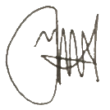 | - 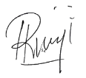 | - 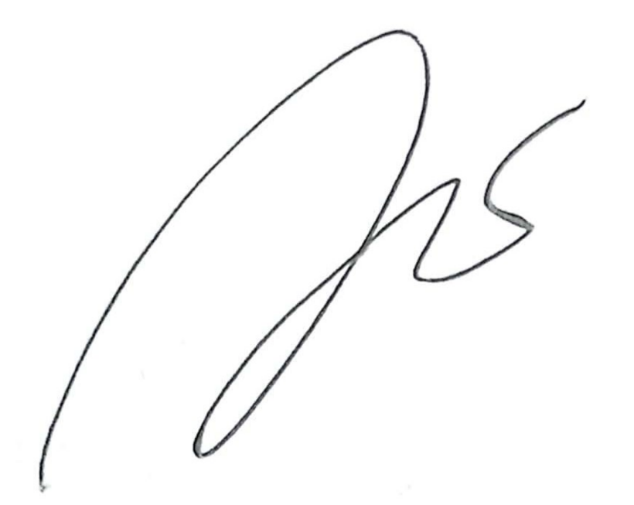
- 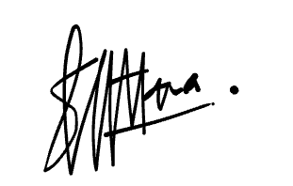 | - 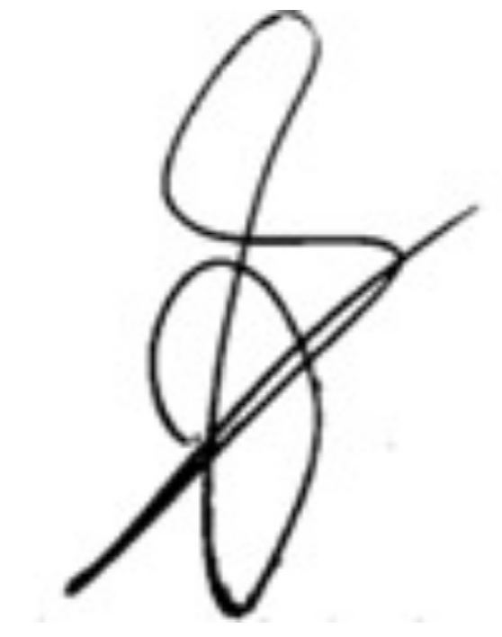 | - 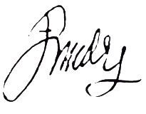

Date : December 21, 2025

