Organic carbon source and C/N ratio affect inorganic nitrogen profile in the biofloc-based culture media of Pacific white shrimp

Muhammad Hanif Azhar, Eddy Supriyono, Kukuh Nirmala, Julie Ekasari,

Department of Aquaculture, Faculty of Fisheries and Marine Science, Bogor Agricultural University

Abstract

Organic carbon source and C/N ratio play an important role in aquaculture system with biofloc technology application. The study investigated the effect molasses, tapioca, tapioca by product and rice bran as carbon sources in a biofloc media at three different C/N ratios i.e. 10, 15, and 20 on total ammonia reduction in biofloc media. Five liters of biofloc media in a conical tank was prepared for each replicate, which consisted of 500 mL of biofloc suspension collected from a shrimp culture unit with biofloc technology application and 4.5 L seawater. Pacific white shrimp culture was performed in 40L glass aquaria at a shrimp density of 30/aquarium. There was a significant interaction between carbon source and the C/N ratio applied (P<0.05). The use of molasses resulted in the highest reduction rate irrespective to the C/N ratio.

Keywords: molasses, tapioca, tapioca by product, rice bran, biofloc, total ammonia nitrogen

Introduction
As the demand of aquaculture product increases and the availability of resources in particular land and water becomes limited, intensification of aquaculture production is inevitable. Intensifying aquaculture production however is not easy, as it will need not only higher input such as feed, seed, and energy, but also higher management and higher impact to the environment. Intensive aquaculture system is characterized by the high density of animal per unit area thus higher feed input, which generally contains high protein, will be added to the system. Protein in shrimp feed is an important major nutrient not only because of its important role in the shrimp growth and survival, but also its impact to water quality as the main nitrogen source. As shrimp could only retained 10 – 20% of the nitrogen of the total nitrogen in the feed, the remaining will be in the water as the results of protein metabolism by the shrimp and the mineralization of protein by the decomposing microorganisms, both in the form of ammonia or ammonium depending on the pH and water temperature (Crab et al 2007, Avnimelech 2012). Ammonia on the other hand is highly toxic for most aquatic organisms, therefore its control in an aquaculture system is very important.
In order to control ammonia level in an aquaculture system, the most common procedure applied by farmers is regular water exchange, i.e. by discharging part of the water and replacing it with new clean water thus diluting the concentration of ammonia. When the wastewater is directly discharged into the surrounding water bodies, the nutrient rich water from an aquaculture unit will contribute to eutrophication and therefore might negatively affect natural water ecology (Crab et al 2007). Furthermore, water exchange will also reduce the biosecurity and hence increasing the risk of disease introduction to the aquaculture unit. To overcome this situation, several water quality managements have been introduced and applied including biofloc technology.
Biofloc technology is a water quality management technique which is based on the capacity of heterotrophic bacteria in utilizing organic and inorganic nitrogen in the water and convert them into new microbial biomass which can be harvested by the cultured animal itself (Avnimelech 1999; De Schryver et al. 2008). This technology applies a particular C/N ratio in the water to facilitate the heterotrophic bacteria in the water to utilize the excess nitrogen in an aquaculture system by the addition of organic carbon source. Previous research (Avnimelech 2009; De Schryver et al 2008) suggested that carbon source used in a biofloc system might influence the quality and quantity of the floc and most importantly the capacity of ammonia removal from the water.
The objective of this study is to investigate the effect of four locally based organic carbon source, molasses, tapioca, rice bran, and tapioca by-product, on total ammonia nitrogen (TAN) removal in biofloc medium at laboratory condition.

Materials and Methods
First experiment
A two factor experimental design was applied with organic carbon source and C/N ratio as the variables with three replicates. Four organic carbon sources were used, i.e. molasses, tapioca, tapioca by product, and rice bran. Thirty-six units of conical tanks (18L) each equipped with an aeration line were filled with 4.5 L of chlorinated seawater and 500 mL of biofloc suspension collected from a shrimp culture unit with biofloc system. To simulate nitrogen loading in an aquaculture system NH₄Cl, KH₂PO₄ and Na₂HPO₄ were added to each tank at 95,54 mg/L, 31 mg/L and 63,7 mg/L, respectively (Ekasari 2010). Organic carbon source was added to each tank according to the C/N ratio, i.e. 10, 15 or 20. Total ammonia concentration was observed every 2 h for 28 h. For this purpose, 25 mL of water sample was collected from each tank for TAN analysis. Other water quality parameters were observed on the initial and final sampling time. These parameters were found to be in acceptable ranges (Table 1).

Chemical analyses
Carbon content was determined according to Walkley and Black (1934). Total ammonia nitrogen concentration and other water quality parameters were measured with the procedures according to APHA (2005).

Table 1. Water temperature, dissolved oxygen, pH and salinity of biofloc medium with different organic carbon source
 | Organic C source
 | Molasses | Tapioca | Rice bran | Tapioca by-product
Temperature | 26.2 – 27.6 | 26.2 – 27.1 | 26.4 – 27.5 | 26.1 – 27.7
Dissolved oxygen | 4.9 – 5.9 | 4.9 – 5.8 | 5.0 – 5.8 | 4.9 – 5.8
pH | 7.91 – 8.56 | 8.32 – 8.56 | 8.25 – 8.52 | 8.36 – 8.59
Salinity | 30.0 – 30.6 | 30.1 – 30.5 | 30.0 – 30.6 | 30.0 – 30.6

Statistical analyses
The results were analyzed using Two Way ANOVA at a confidence level of 95%. Tukey Post hoc test was subsequently performed to determine significant differences between treatments.

Results
At a C/N ratio of 10, molasses consistently showed the lowest concentration during each time of sampling. At this C/N ratio however, the lowest TAN concentration after 28 h was still about 5 mg/L, in contrast to C/N ratio of 15 and 20 which had reached 1.4 – 2.9 mg/L. During the first 12 h, it was clearly shown that at a C/N ratio of 10, TAN concentration decreased gradually to half of the initial concentration. On the other hand, at C/N ratio of 15 and 20 TAN reductions occurred at higher level.
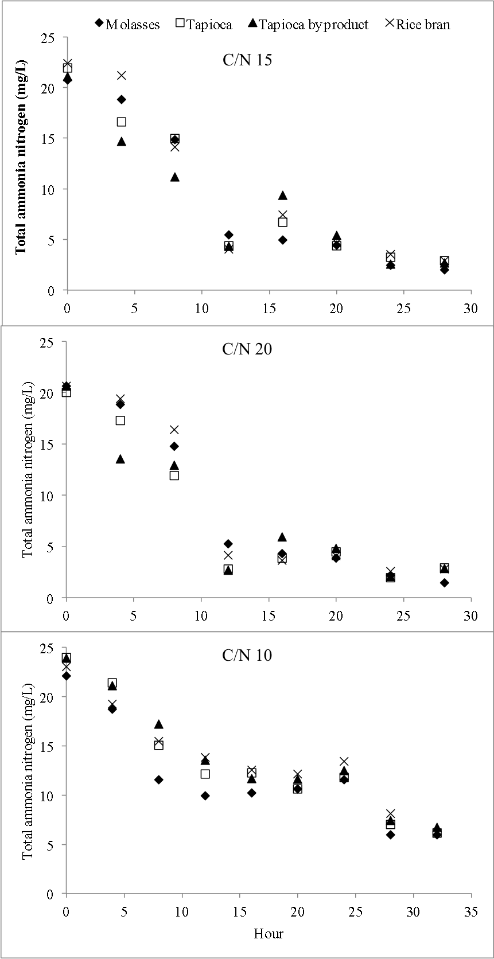
Figure 1. Total ammonia nitrogen (TAN) concentration of biofloc media with different organic C source at C/N ratio of 10, 15, and 20
Figure 2 presents total ammonia nitrogen concentration of of biofloc media with different organic carbon source. It is clearly shown that at C/N ratio of 15 and 20, all carbon sources showed the same trend, i.e. sharply decreased on the first 12 h and relatively stable afterward. For molasses, tapioca and tapioca by product, during the first 8 h there was relatively no difference in TAN reduction level, substantial differences between C/N ratios were started after 12 h onward. However, when rice bran was used, a different trend was shown by C/N ratio 10 where TAN concentration gradually decreased but at a slower rate than those of C/N ratio 15 and 20.
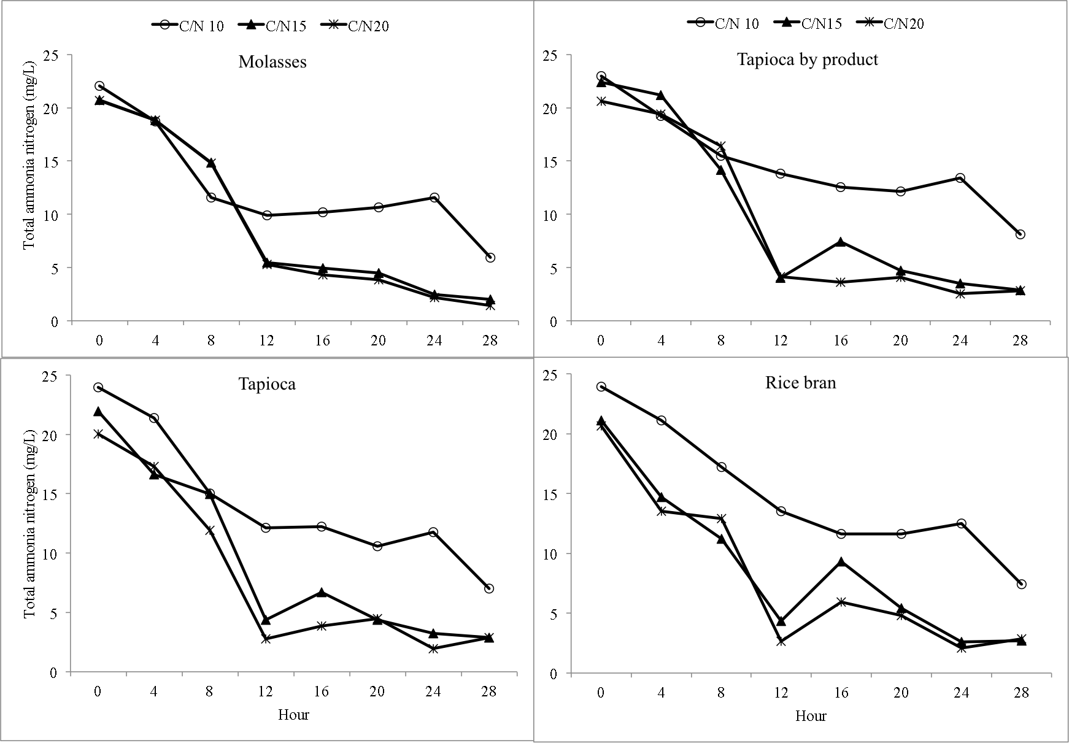
Figure 2. Total ammonia nitrogen concentration in biofloc media with different C/N ratio in each organic carbon source tested

Table 2. Total ammonia reduction (%) in biofloc medium with different organic carbon source at C/N ratio of 10, 15, and 20 at 28 hours after carbon source addition.
Organic C source | Reduction (%)*
 | C/N 10 | C/N 15 | C/N 20
Molasses | 73±2^{a†} | 91±2^{a‡} | 93±1^{a‡}
Tapioca | 71±1^{a†} | 87±2^{ab‡} | 88±2^{b‡}
Tapioca by product | 69±4^{a†} | 86±1^{b‡} | 87±0^{b‡}
Rice bran | 65±6^{a†} | 87±1^{b‡} | 86±3^{b‡}
* Different superscript symbol following mean values in the same row indicates significant difference (P<0.05). Different superscript letter following mean values in the same column indicates significant difference (P<0.05).
Total ammonia reduction percentage in biofloc medium is presented in Table 2. Two way ANOVA analysis showed that there was no significant interaction between the type of organic C source and the C/N ratio applied in the reduction percentage of TAN in biofloc medium (P<0.05). Both C/N ratio and organic C source significantly affect TAN reduction percentage. The highest TAN reduction was observed when using molasses as the carbon source at a C/N ratio of 20 (93%), whereas the lowest was shown by rice bran at 10 C/N ratio (65%).

Discussion
The results of the experiment clearly showed that organic carbon source determine the capacity of TAN reduction in a biofloc system. Inorganic nitrogen control with C/N ratio manipulation is a potential method for water quality management in an aquaculture system. Various organic C have been used and applied by shrimp farmer in biofloc-based aquaculture systems including sucrose (Kuhn et al 2009), glycerol (Ekasari et al 2010, Crab et al 2010), glucose (Crab et al 2010), acetate (Crab et al 2010), and wheat (Azim et al 2008, Mahanand et al 2013). However, the information concerning the difference of these organic C sources in controlling inorganic N in biofloc system is still limited.
The aim of biofloc technology is to control ammonia accumulation in an aquaculture environment. One of the factors that determine the success of controlling inorganic nitrogen in this system is the C/N ratio. The results of this experiment showed that C/N ratio of 15 and 20 reduced TAN at higher level than that of C/N ratio of 10. Furthermore there was no difference in TAN reduction between C/N ratios of 15 and 20, which indicate that further increase in C/N ratio may not result in higher reduction level. With this regard, C/N ratio of 15 can be considered as the most optimal ratio for TAN reduction in biofloc system.
The capacity of heterotrophic bacteria in utilizing an organic C source is determined by the complexity of C compound (Avnimelech 2009). Glucose and sucrose are the most readily available C source, whereas complex carbohydrate polymers required more time for decomposition into smaller fraction. The results of this experiment were in agreement with Avnimelech (2012) that pointed out the effectiveness of simple carbohydrates in controlling total ammonia nitrogen in aquaculture systems. Molasses, which is a by-product of sugar production that contained 49 – 50% sugar (Paturau 1982), consistently showed the highest reduction levels at any C/N ratios tested in this experiment. Although still lower than molasses, starch dominated carbohydrate sources, tapioca and tapioca by product, showed higher TAN reduction levels compared with rice bran. Tapioca starch is extracted from cassava, and is dominated by two carbohydrate polymers, i.e. amylose and amylopectin. As it was expected rice bran, which contains high level of fiber (13.3%), showed the lowest reduction levels compared to other carbon sources in this experiment.
Another important consideration of the application of organic carbon source in biofloc system is the price of the carbon source. Table 3 presents the estimated cost of carbon source to reduce 1 mg/L TAN concentration in a hectare of aquaculture unit. It can be seen that though less quantity is needed when using tapioca, however because the price is the highest (0.75 USD/kg), the total cost needed for 1 ha of aquaculture unit is also the highest (144 USD/ha). Alternatively, tapioca by product seems to be a potential carbon source as it can be used at a lesser amount (19.2 g) and cheaper price (0.30 USD/kg).

Table 3. Estimation of requirement and cost of organic carbon source to reduce total ammonia nitrogen concentration by 1 ppm N per unit area (ha) of aquaculture system
 | C (%) | ΔCH/g ΔN (g) * | ΔCH/ha (kg) | Price of CH per kg (USD) | USD/ha
Molasses | 36.3 | 27.5 | 275.5 | 0.50 | 138
Tapioca | 52.2 | 19.2 | 191.6 | 0.75 | 144
Tapioca by product | 52 | 19.2 | 192.3 | 0.30 | 58
Rice bran | 41.5 | 24.1 | 241.0 | 0.45 | 108
* ΔCH/g ΔN (g): the amount of carbohydrate to be added to reduce total ammonia nitrogen (TAN) concentration by 1 mg/L, which was calculated according to Avnimelech (1999)

Conclusion
Organic carbon source and C/N ratio determine the total ammonia nitrogen reduction in a biofloc system. Molasses resulted in the highest reduction level at any C/N ratios tested. C/N ratio of 10 resulted in the lowest reduction levels irrespective to the carbon sources used in this experiment.

Reference
APHA, 1998. Standard methods for the examination of the water and wastewater, American Public Health Association, Washington, D.C.
Avnimelech, Y., 1999. Carbon ⁄ nitrogen ratio as a control element in aquaculture systems. Aquaculture 176, 227 – 235.
Avnimelech, Y., 2012. Biofloc technology—a practical guide book. 2nd ed. Baton Rouge, United States: The World Aquaculture Society.
Azim, M.E., Little, D.C., Bron, J.E., 2008. Microbial protein production in activated suspension tanks manipulating C:N ratio in feed and the implications for fish culture. Bioresource Technol. 99, 3590 – 3599.
Crab, R., Avnimelech, Y., Defoirdt, T., Bossier, P., Verstraete, W., 2007. Nitrogen removal techniques in aquaculture for a sustainable production. Aquaculture 270, 1 – 14.
De Schryver, P., Crab, R., Defoirdt, T., Boon, N., Verstraete, W., 2008. The basics of bio-flocs technology: the added value for aquaculture. Aquaculture 277, 125 – 137.
Ekasari, J., Crab, R., Verstraete, W., 2010. Primary nutritional content of bio-flocs cultured with different organic carbon sources and salinity. Hayati Journal of Biosciences 17, 125–130.
Kuhn, D.D., Lawrence, A.L., Boardman, G.D., Patnaik, S., Marsh, L., Flick, G.J., 2010. Evaluation of two types of bioflocs derived from biological treatment of fish effluent as feed ingredients for Pacific white shrimp, Litopenaeus vannamei. Aquaculture 303, 28 – 33.
Mahanand, S.S., Moulick, S., Rao, S., 2013. Water quality and growth of rohu, Labeo rohita in a biofloc system. J. Appl. Aquac. 25, 121 – 131.
Paturau, J.M. 1982. Alternative Uses of Sugarcane and Its Byproducts In Agroindustries.www.fao.org.

