DEVELOPMENT OF JAPANESE QUAIL (Coturnix coturnix japonica) EMBRYO

Tyas Rini Saraswati, Silvana Tana ^{#)}

^{#)} Faculty of Sience and Mathematics,Diponegoro University, Semarang Indonesia.

E-mail:tyas_rini@rocketmail.com
__________________________________________________________________________________________________________________________________________
Abstract-This experiment was conducted to determine the development of Japanese quail embryo (Coturnix coturnix japonica), through observation and measurement of embryo organ development from the age of one day until hatching. The study used 15 female quails and 5 male quails. 15 female quails were divided into 5 cages, each cage containing 3 quails females and 1 male quail. Eggs which are inserted into an egg incubator is produced when the quail began the age of 3 months. Descriptive observation has been made ​​towards the development of organs in the embryo. Based on the results of the study, the growth and development of quail embryo organs occur in stages until hatching occurred during the 16 days.

Key words-The development of the embryo, Japanese quail (Coturnix coturnix japonica),

- INTRODUCTION
The development of biological research has used various avian species as model organisms for studying morphogenesis (Seidl et al., 2014); Pombero and Martinez, 2009). The Japanese quail remains one of the favored animal models in biology development and is being used to investigate a variety of development systems (Douarin and Lievre, 2012). The Japanese quail is a member of the pheasant (Phasianidae) family and is considered to be separate species from the common quail (Johnsgard and A. Paul, 2009). In comparison to the chicken egg, Japanese quail eggs are small, measuring about 30 mm in length and weighing approximately 10 g, although as with all avian species there is variation. The incubation period of the Japanese quail is approximately 16.5 days (Ainsworth et al., 2010).
Quail (Coturnix-coturnix japonica) types commonly bred by breeders who want high egg production. Quail 2700-300 able to produce as many eggs / year (Kumar, 2012). Quail females will begin to lay eggs at the age of 45 days. The peak of egg production is attained by the 5 month of age (Saraswati et al., 2013a). Average-sized eggs that will be hatched 11-13 grams. The normal size can be achieved after quail reaching age 2.5 month. Thus making quail eggs held since quail was 2.5 to 8 months (Jatoi et al., 2013). Beside having high nutrition meat, Quail meat can be used as an alternative choice because it contains high high level protein (Kartikayudha et al., 2013).
Quail embryos development occur in the body (oviduct) and outside the body (Sturkie, 2000). Shortly after the ovum has been released from the hen's ovary, it is picked up by the funnel or infundibulum. Sperms from the male are found in the folds of the infundibulum. Soon after the ovum is picked up by the infundibulum, many sperms contact the germinal disc, but only one unites with the germ. For a female in need of gametes to fertilize her eggs (Kamini and Galef, 2004). Thus spake occurs fertilization before the egg is laid. About three hours after fertilization the newly formed single cell divides and makes two cells. Then there are four, eight, sixteen, and more. Cell division continues until there are many cells grouped in a small, whitish spots visible on the upper surface of the egg yolk.
Energy obtained for the development of a number of foods that contained in eggs and of excretion glands in the lining of the uterus. After the oviposition, the embryo development occurs outside the body (Smith, 2014). During this development, the embryo acquires a meal of egg yolk and get protection from the egg white and egg shell. Embryogenic cells grow and evolve through several phases, blastula, gastrula, neurula, organogenesis, embryo (Hill, 2014). Quail embryos during development is a critical period for determining when the embryo hatches. Embryo in the egg grows rapidly until it hatches. The purpose of this study was to determine the development of the embryo during incubation by observing the growth and organ development in quail embryos from the age of 1 day of incubation to hatching. The expectation is over the maximum hatchability.

- MATERIALS AND METHODS
This study was carried out from April to September 2014. Maintenance of quails, hatching quail embryos and embryos are placed in the laboratory Structure and Animal Function, Department of Biology, Faculty of Science and Mathematics, Diponegoro University, the materials used in this study is the quail (Coturnix coturnix japonica) females and males. The tools used are cages, incubators, scales, surgical tools.
Experimental animals used in this study was 15 females and 5 males quails aged 5 days. Each cage consisted of 3 females and 1 male quail. The eggs are hatched which produced by females at the age of 3 months. Eggs put in the incubator automatic. 38-39ºC temperature. Humidity should not be less than 60%. Descriptive observations on the development of the embryo to embryo development from age 1 day to hatch. Observed the development of the organ that grows every day.

- RESULTS AND DISCUSSION
Yolk is a source of nutrients necessary for the growth of the embryo to hatch. Nutrient content in yolk as proteins, carbohydrates, fats, vitamins, minerals. Yolks contain high levels of HDL, vitamins A, vitamin B12, essential fatty acids are high (Saraswati and Tana, 2014). Precursor yolk (vitellogenin) is formed in the liver, then transported to the ovarian follicle (Saraswati et al., 2013b). The observation of embryo development until the age of 1 day hatched seen in Figure 1:

Day 1  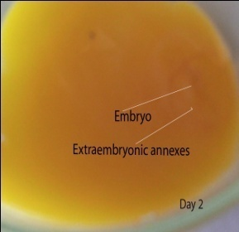  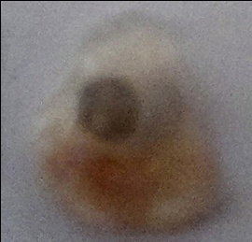  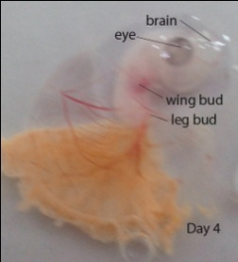  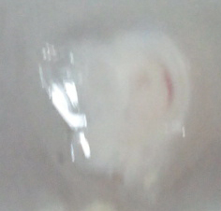  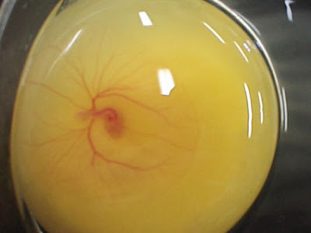  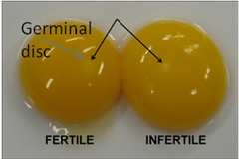  Blood vessel  embryo  yolk  Infertil : Ovum is merely a ligh spot on the yolk  Fertil: The ovum has fused with a sperm to begin forming an embryo. By the time the fertilized egg is laid. Many cells are devided on the surface of the yolk and formed a blastoderm | Day 2  Among the extraembryonic there are vittelin membrane which is a nutrient embryo | Day 3  Blood vessels grow, limb development begin, head and body can be distinguished | Day 4  Increasing the size of the embryo, the embryo forming C shaped, the head move towards to the tail.

Day 5  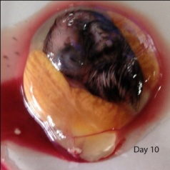  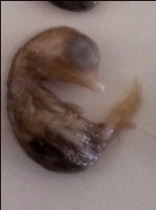  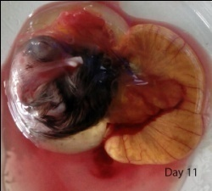  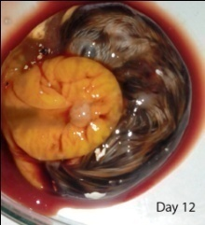  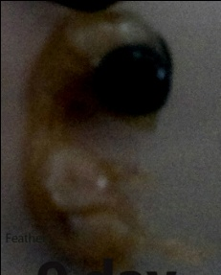  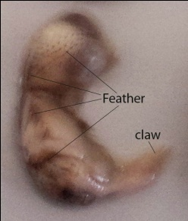  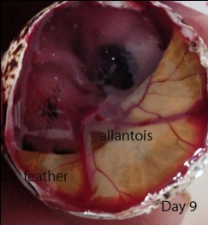  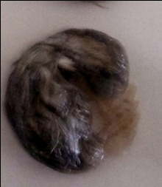  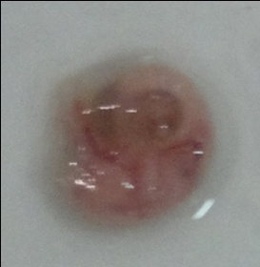  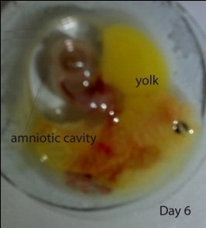  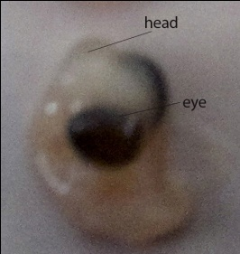  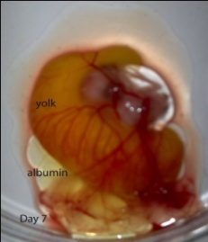  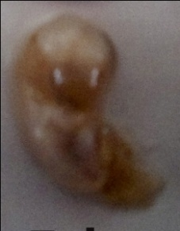  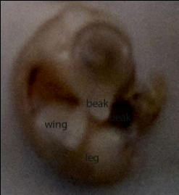  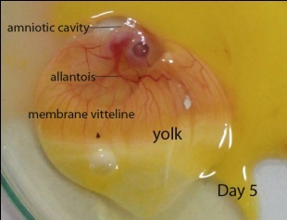  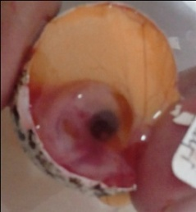  Membram viteline continues to grow and surrounds more than half of the yolk | Day 6  Amniotic cavity contains the amniotic fluid, the formation of beak | Day 7  Vitelina membrane covering almost all the yolk. Half of the upper and lower parts begin to separate, as well as wings and legs. | Day 8  Beak began to emerge. Growth eyelid

Day 9  Allantois grow to the maximum, amount of vitellus shrink, feathers have started to grow. | Day 10  Feather growth has spread to several parts of the body | Day 11  Feather grew more dense, vitellus number continues to shrink | Day 12  Feather growth has been uneven throughout the body

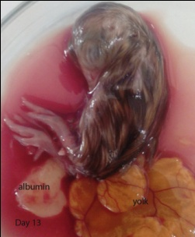  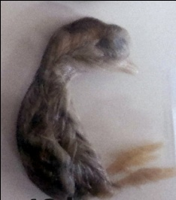  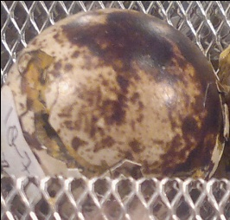  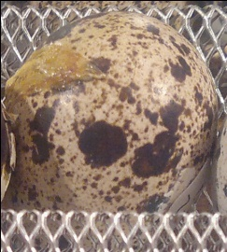  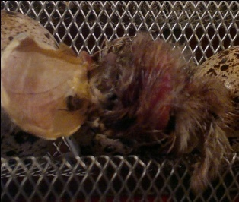  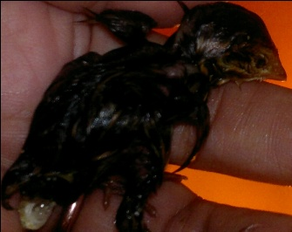  Day 13  Depreciation Vitellus very fast | Day 14  Beak to peck the inner shell membrane with circular direction | Day 15  Egg shell is open, the embryo breathe the outside air | Day 16  Quail escape from eggs
Figure 1: Daily change of the developing Japanese quail ( Coturnix coturnix japonica) embryo

Quail embryo development after oviposition until hatching occurred during the 16th days. The development of the embryo during incubation is the second phase of development of the embryo. In observation of embryonic development of quail on the first and second plates are embryonic, area opaca, and the area pellucida. Beginning form embryos on the first day is not clearly visible, germ cells develop into shapes such as rings with dark edges, while the middle section is rather bright. The middle part is a female germ cell fertilized zygote called blastoderm. It appears that there is segmentation cavity located below the area pellucida, found in dark-colored ring around it. On day two appeared simultaneously with the differentiation of primitive streak mesoderm. Primitive streak serves as the presence of the longitudinal axis of the body axis and the posterior extremity. On the third day, it can be distinguished body front and back, circulatory system begins to develop, vitteline membrane that play a role in embryo nutrition spreads over the surface of the yolk. The head and body can be distinguished, as well as the brain. There were also the structure of the heart.
The fourth day, the embryo forming the letter C, moving closer to the tail head. evident and limb buds like wing and leg buds have started to form. Amnion and allantois in sight. Allantoic membrane which helps the circulation system and when fully developed it will surround the embryo. The embryo is located in the amnion, the veins have more and more. Optic fesicle, prosencephalon, metencephalon, rombencephalon evident.
Day five vitteline membrane continues to grow and surrounds more than half the yolks, the sixth day of amniotic fluid-filled amniotic cavity evident, the embryo has begun to spin. Amnion is a pouch that helps young embryos during development, which is filled with a fluid sac that is transparent and mucoid, produced by the amnion and the skin of the body wall of the embryo. Amniotic prevents the embryo so as not to dry, eliminating shock, embryos discretion changing attitudes, and absorb albumin, beak began to form.
Seventh day, vitelina membrane covering almost all the yolk. Half of the upper and lower parts begin to separate, wings and legs are already apparent. Eighth day, growing elongated beak, eyelids and hair follicles begin to grow. Day nine, the allantois reaches the maximum size, while the waning vitellus, as used by the embryo yolk, then the amount or volume of increasingly smaller with the growth of the embryo, the hair has begun to grow. To ten days, feather growth has spread to several parts of the body, the claws are already formed. Day eleven growing feathers throughout the body, vitellus number continues to shrink. Twelve days to have dense feather growth and cover the entire body. Day thirteen allantoic membrane shrank to Chorioalantois. Egg sac is pulled into the abdominal space with the remaining egg yolk as a food source while for newly hatched chicks. The yolk sac is connected with the body of the embryo by the yolk limbs. Day fourteen to seventeen a series hatching process begins with a half-peck the eggshell membrane in a circular manner so that the shell started to open. The longer, the greater the shell will open, so that quail can breathe. At this time the humidity is very important that the drying eggshell membranes and the attachment of the stomach to the shell can be prevented. Furthermore twisted quail legs with the help of encouragement. With the help of its wings, the larger the shell outbreak situation, finally came out of quail eggs on day sixteen.
When the eggs are hatched, only newly hatched chicks and egg shell fragments that can be seen, while the egg yolk and albumin is absorbed, even a few days before hatching yolk sac yolk place to store withdrawn into the body. For 1-3 days post-hatch, yolk sac serves part of the digestive system (Shukra 2000).

- CONCLUSIONS
Observations on the development of quail embryos can be used for the maintenance management of quail

ACKNOWLEDGEMENTS
The author would like to thank LPPM Undip which has funded through tax revenues fund (Fundamental).

REFERENCES
Ainsworth, S.J., R.L. Stanley, D.J.R. Evan. 2010. Development stage of the Japanese quail. J.Anat 216(1):3-15.
Douarin and Lievre. 2012. How studies on the avian embryo have opened new avenues in the understanding of development: A view about the neural and hematopoietic systems. Article first published online: 20 DEC 2012. DOI: 10.1111/dgd.12015.
Hill, M.A. 2014. Embryology Book - The Early Embryology of the Chick 4. Retrieved September 14, 2014, from https://php.med.unsw.edu.au/embryology/index.php?title=Book_-_The_Early_Embryology_of_the_Chick_4
Jatoi, A.S., M.K. Khan, A.W. Sahota, M. Akram, K. Javed, M.H. Jaspal, and S.H. Khan. Post-Peak egg production in Local and important Strains of Japanese Quails (Coturnix coturnix japonica) as Influenced by Continuous and Intermittent Light regimens during early Growing Period. Journal of Animal & Plant Sciences 23(3): 2013: 727-730.
Johnsgard and A. Paul. 2009. Birds of Great Plains : Family Phasianidae (Quails, Pheasants, and Partidges. Paper 20.
Kamini, N.P. and B.G. Galef. 2004. Fertilized female quail avoid conspecific males: female tactics when potential benefits of new sexual encounters are reduced. Elsevier. Published online 27 October 2004; MS. number: A9649.http://digitalcommons.unl.edu/bioscibirdsgreatplains/20.

Kartikayudha W, Isroli, N.H. Suprapti, T.R. Saraswati. 2013. Muscle Fiber Diameter and Fat Tissue Score in Quail (Coturnix coturnix japonica) Meat as Affected by Dietary turmeric (Curcuma longa) Powder and Swangi Fish ( Priacanthus tayenus) Meal. Journal of the Indonesian Tropical Animal Agriculture 38 (4): 264-272.

Kumar, K.R. 2012. Quail Eggs production and Productivity. Poultry Technology. http://poultrytechnology.com/technology/59-quailegg-production-and-productivity.html.

Pombero and Martinez, 2009. Telencephalic morphogenesis during the process of neurulation: an experimental study using quail-chick chimeras. J Comp Neurol. 2009 Feb 20;512(6):784-97. doi: 10.1002/cne.21933
Saraswati, T.R., W. Manalu., D.R. Ekastuti., N.Kusumorini. 2013a. Increase Egg Production of Japanese Quail (Coturnix japonica) by Improving Liver Function Through Turmeric Powder Supplementation. International Journal of poultry Science 12(10):601-614.
Saraswati, T.R, W. Manalu., D.R. Ekastuti., N.Kusumorini. 2013b. The Role of Turmeric Powder in Lipid Metabolism and Its Effect on Quality of The First Quail’s Egg. Journal of The Indonesian Tropical Animal Agriculture. Volume 38. Number 2.
Saraswati, T.R, and Tana S. 2014. Effect of Supplementation of Turmeric Powder to The Age of Sexual Maturity, Physical and Chemical Quality of the First Japanese Quail (Coturnix japonica) Egg (Submit).
Seidl, A.H., J.T. Sanchez, L. Schecterson, K.M. Tabor, Y.Wang, D.T. Kashima, G. Poynter, D.Huss, S.E. Fraser, R. Lansford, E.W. Rubel. 2014. Transgenic quail as a model for research in the avian nervous system: a comparative study of the auditory brainstem. J Comp Neurol. 2013 Jan 1;521(1):5-23. doi: 10.1002/cne.23187.
Smith, T.W. 2014. Avian Embryo. http://msucares.com/publications/p1150.htm. Web page information:webmaster@ext.msstate.edu.
Sturkie P.D. 2000. Avian Physiology. Academic Press.

