- Sampling meiofauna and environmental physical-chemical parameters
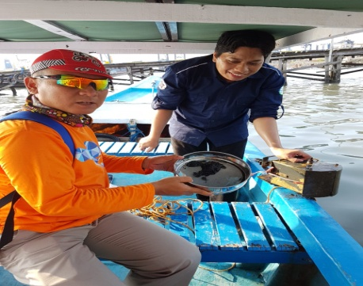
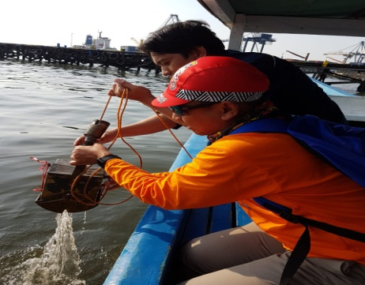

A
B
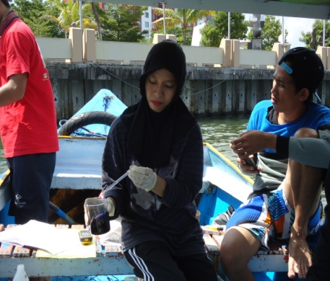
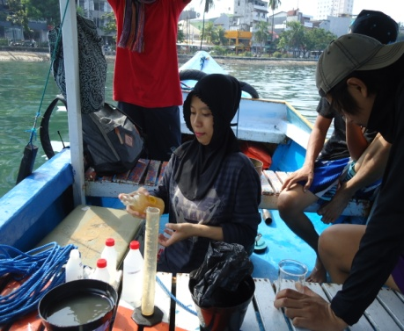

D
C

Figure 1. (A&B). The activities of meiofauna sampling;
(C&D). The sampling of environmental physical-chemical parameters.

- The Location of the Research Stations

Research Stations | Location Descriptions
Station I | nearby a hotel adjacent to Losari Beach (S 05º08’19.99”; E 119^{O}24’18.57”)
Station II | around the outlets of the sewage disposal of “Stella Maris” Hospital, houses, and shops or cafes in Losari Beach (S 05º08’40.59”; E 119º24’28.40”)
Station III | close to the reclamation project of Losari Beach (S 05º08’40.59”; E 119º24’08.51”)
Station IV | at the mouth of Fort Rotterdam canal, i.e., a water channel transporting various kinds of wastes from houses and gold craft industries on Jl. Somba Upu Makassar (S 05º08’09.62”; E 119º24’12.32”)
Station V | around Soekarno Hatta Port (S 05º08’02.43”; E 119º24’10.34”)
Station VI | at the mouth of Jeneberang River (S 05º11’28.67”; E 119º22’50.27”)
Station VII | in Merdeka Tanjung Beach (S 05º10’41.98”; E 119º22’50.27”)
Station VIII | around Paotere Port (S 05º06’34.06”; E 119º25’13.71”)
Station IX | at the mouth of Tallo River (S 05º05’58.27”; E 119º26’19.84”)

