LIST TABLE:
Tabel 1. Sumber emisi partikulat berdasarkan pengkategorian sumber
No | Surakarta Emission Sources
No | Point Sources | Area Sources | Mobile Sources
No | Activities | Activities | On Road | Non Road
1 | Modern Shopping | Bank | Major road | Train
2 | Hotels | Resident | Minor road | Bus Station
3 | Large Industry | School |  | Parking
4 | Medium Industry | Restaurant
5 | Hospitals | Refuelling Station
6 | Landfill | University
7 |  | Office
8 |  | Traditional Market
9 |  | Automotive Workshop
10 |  | Construction
11 |  | Warehouse
12 |  | Side Street Food
Sumber : data primer diolah

Tabel 2. Estimasi emisi partikulat (PM₁₀) pada sumber area
No | Activities | Sum of Spot | PM₁₀ anually emission (tonnes/year)
1 | Perbankan | 136 | 0,06
2 | Perumahan | 146.639 houses | 0,25
3 | Fasilitas Pendidikan (Sekolah) | 387 schools in various grade | 0,08
4 | Restoran | 189 | 9,83
5 | Universitas | 45 | 0,11
6 | Perkantoran | 7 surveyed offices | 0,00
7 | Pasar Tradisional | 28 | 1,95
8 | Jasa Perbengkelan | 168 | 0,10
9 | Kegiatan konsruksi | 150.742,13 m² construction area | 12,24
10 | Pergudangan | 6 | 1,44
11 | Pedagang Kaki Lima (PKL) | 2361 vendors | 56,69

Tabel 3. Estimasi emisi partikulat (PM10) pada sumber area
No | Activities | Sum of Spot | PM₁₀ anually emission (tonnes/year)
1 | Modern shopping | 17 | 0,07
2 | Hotels | 117 | 0,41
3 | Large scale industries | 5 | 10,85
4 | Medium scale industries | 118 | 0,57
5 | Hospitals | 13 | 0,29
Total Point Source Emission |  |  | 12,20

Tabel 4. Estimasi emisi partikulat (PM10) pada sumber bergerak
No | Activities | Sum of Spot | PM₁₀ anually emission (tonnes/year)
1 | Major road (on road) | 75 | 80,85
2 | Minor road (on road) | More than 700 km | 40,37
3 | Train traffic activities (non road) | 3 | 1,01
4 | Bus station activities (non road) | 1 | 0,02
Total Mobile Source Emission |  |  | 122,25

Tabel 5. Estimasi emisi partikulat (PM10) Kota Surakarta (seluruh sumber)
No | Emission sources | Number of activities | Dominant contributor | Percentage of emission contribution | PM₁₀ anually emission (tonnes/year)
1 | Area source | 11 | Side street food | 70% | 85,76
2 | Point source | 5 | Large industry | 89% | 12,20
3 | Mobile source | 4 | On road major road | 66% | 122,25
Total PM₁₀ anually emission in Surakarta (tonnes/year) |  |  |  |  | 220,21

LIST FIGURE:
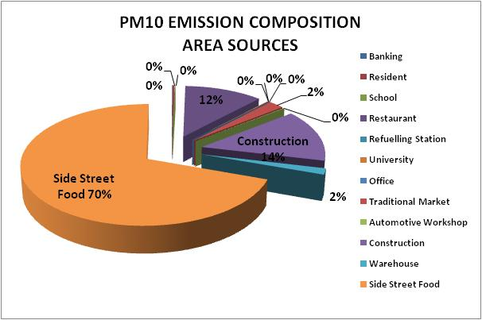
Gambar 1. Kontribusi emisi pada setiap kegiatan kategori sumber emisi area

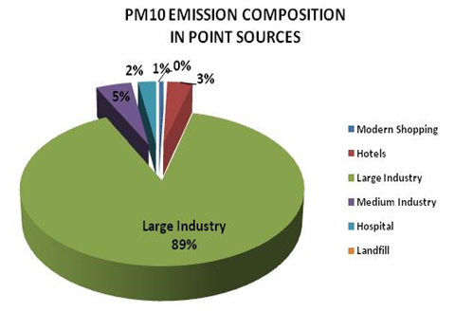
Gambar 2. Kontribusi emisi pada setiap kegiatan kategori sumber emisi titik

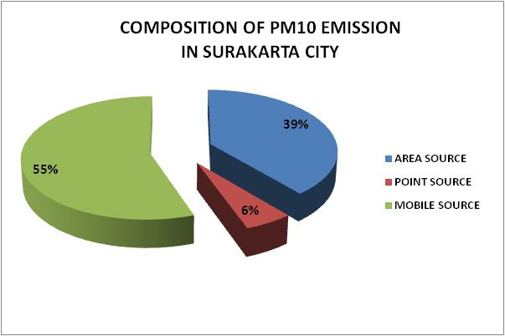
Gambar 3. Kontribusi emisi PM₁₀ dari setiap kategori sumber di Kota Surakarta

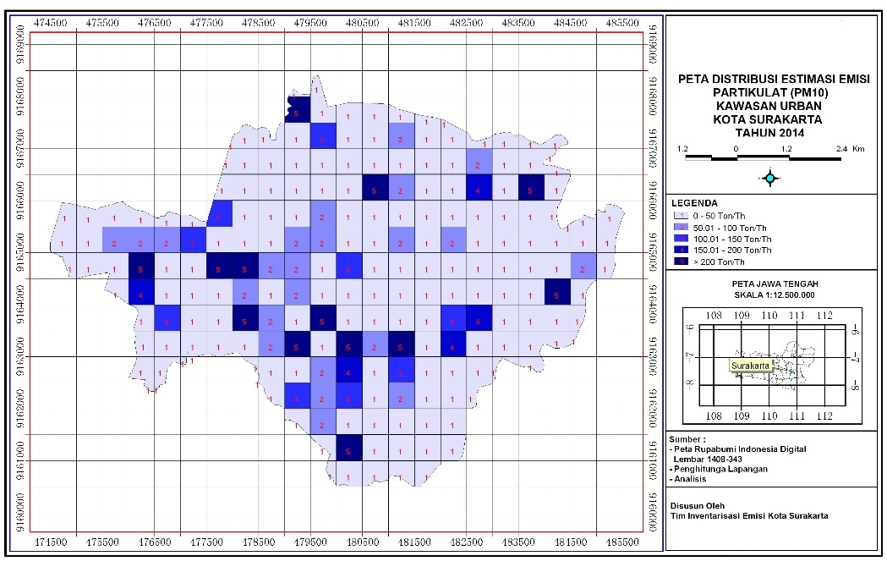
Gambar 4. Distribusi spasial emisi PM₁₀ dari setiap kategori sumber di Kota Surakarta

