SUPPLEMENTARY MATERIALS

Table S1 Number of Air Sampling Locations in Villages in Jawai District
Village Name | Rainwater | Drilled Well Water | Shallow Well Water | Ditch Water
Bakau | 10 | 70 | 1 | -
Parit Setia | 3 | 5 | 2 | 2
Dungun Laut | 22 | 29 | 1 | -
Mutus Darussalam | 52 | 8 | - | 1
Sarang Burung Danau | 63 | 12 | 1 | 3
Sarang Burung Kolam | 70 | 11 | 1 | 1
Sentebang | 52 | 37 | 1 | -
Sungai Nilam | 19 | 16 | 1 | 1
Desa Sungai Nyirih | 49 | 28 | 1 | -
Desa Lambau | 19 | 3 | 1 | -
Desa Pelimpaan | 38 | 7 | - | 1

Table S2 Number of water sampling locations in each village in South Jawai District
Village Name | Mountain Water | Rainwater | Drilled Well Water | Shallow Well Water | Ditch Water
Jawai Laut | 2 | - | 3 | 3 | -
Sabaran | - | 38 | 61 | - | 1
Semperiuk A | - | 4 | 50 | - | -
Semperiuk B | - | 1 | 43 | - | 1
Desa Suah Api | - | 41 | 36 | - | 1

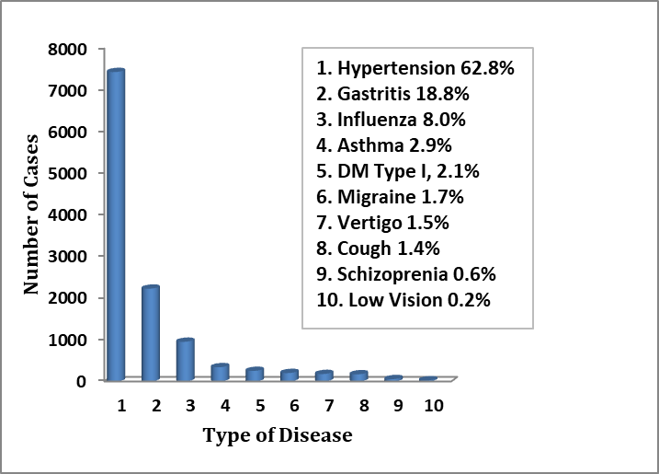
Source: Surveilans Pusk.2022
Figure S1 Top 10 diseases based on outpatient visits at Sentebang Community Health Center, Jawai District 2022

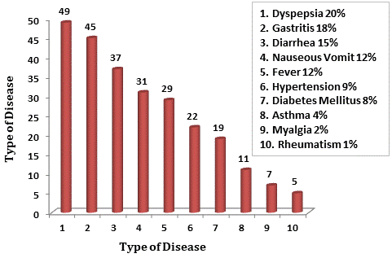
Source: Surveilans Pusk.2022
Figure S2 Top 10 diseases based on inpatient visits at Sentebang Community Health Center, Jawai District 2022

Source: Surveilans Pusk.2023
Figure S3 Top 10 diseases based on monthly reports of the most illnesses in August 2023, South Jawai District

