© xxx Program Studi Ilmu Lingkungan Sekolah Pascasarjana UNDIP

**JURNAL ILMU LINGKUNGAN**

*Volume xx Issue x (xxxx) : xx-xxxx ISSN 1829-8907*

The Study of Coastal Vulnerability in North Insana District, North Central Timor Regency, East Nusa Tenggara Province (Indonesia)

Ludgardis Ledheng1, Blasius Atini2 and Emanuel Maria Yosef Hano’e3

1,2,3Biology Education Study Program, Faculty of Teacher Training and Educational Sciences Timor University, Kefamenanu, 85613, Indonesia ; e-mail: ludgardisledheng12@gmail.com

**ABSTRAK**

Berkurangnya areal mangrove menyebabkan pesisir utara Kabupaten Timor Tengah Utara mengalami erosi. Dampak yang diterima kawasan pesisir ini merupakan hal yang perlu dikaji. Penelitian ini bertujuan untuk mengetahui sebaran spasial dan faktor-faktor yang mempengaruhi kerentanan pesisir. Metode yang digunakan adalah Coastal Vulnerability Index (CVI). Berdasarkan hasil penelitian, kategori kerentanan rendah sepanjang 7,07 km (48,71%) dan kategori kerentanan sedang sepanjang 6,66 km (51,28%). Variabel pasang surut, tinggi gelombang dan kenaikan muka air laut tidak menimbulkan ancaman karena kategori kerentanannya rendah. Variabel yang mempengaruhi kerentanan pantai adalah geomorfologi, kemiringan pantai, perubahan garis pantai dan elevasi pantai. Pengaruh geomorfologi mencapai 87,18%, laju perubahan garis pantai 7,6%, kemiringan lereng 66,6%, dan ketinggian 66,7% dari 39 sel yang diamati. Hasil penelitian ini akan lebih lengkap jika penelitian selanjutnya menambahkan lebih banyak variabel seperti aspek sosial ekonomi dan bagaimana aktivitas manusia dapat mempengaruhi perubahan lingkungan pesisir. Hal ini akan menghasilkan nilai kerentanan yang lebih holistik sehingga berguna dalam pengambilan keputusan dalam perencanaan mitigasi wilayah pesisir.

***Kata kunci*:** Kerentanan, Pesisir**,** Geologi, Variabel proses fisik, Insana Utara

**ABSTRACT**

The reduction in mangrove areas has caused the north coast of North Central Timor Regency to experience erosion. The impact received by this coastal area is something that needs to be studied. This research aims to determine the spatial distribution and factors that influence coastal vulnerability. The method used is the Coastal Vulnerability Index (CVI). Based on the research results, the low vulnerability category is 7.07 km (48.71%) and the medium vulnerability category is 6.66 km (51.28%). Tidal variables, wave height and sea level rise do not pose a threat because the vulnerability category is low. Variables that influence coastal vulnerability are geomorphology, beach slope, changes in coastline and beach elevation. The influence of geomorphology reached 87.18%, the rate of change in coastline was 7.6%, the slope was 66.6%, and the height was 66.7% of the 39 cells observed. The results of this research will be more complete if further research adds more variables such as socio-economic aspects and how human activities can influence changes in the coastal environment. This will produce a more holistic vulnerability value so that it is useful in decision-making in coastal area mitigation planning.

***Keywords*:** Coastal, Vulnerability, Geology, Physical process variables, North Insana

***Citation****:* Ledheng, L., Atini, B., dan Hano’e, E, M, Y. (2024). The Study of Coastal Vulnerability in North Insana District, North Central Timor Regency, East Nusa Tenggara Province (Indonesia). Jurnal Ilmu Lingkungan, xx(x), xx-xx, doi:10.14710/jil.xx.x.xxx-xx

**1. Introduction**

Coastal area has a wealth of biological and non-biological resources, thus influencing high economic activity and population pressure in utilizing coastal space (Febriansyah, Agus & Helmi, 2012). In general, the efforts to protect, preserve and utilize coastal areas in Indonesia are regulated in the Regulation of the Minister of Maritime Affairs and Fisheries of the Republic of Indonesia. One of the first steps in a coastal management plan is to identify the physical problems occur in coastal areas. This is because coastal areas are very sensitive and vulnerable to natural phenomena. According to Suhana et al., (2020) coastal areas are places that are vulnerable to the environmental factors such as climate change and rising sea levels. The impact received by coastal areas due to this phenomenon is the area that needs to be studied especially in identifying spatially the level of coastal vulnerability. Aspects that influence the vulnerability assessment of coastal areas are geomorphology, rate of change of shoreline, beach slope, elevation, sea level rise, tides and wave height (Rumahorbo, Warpur, Tanjung, & Hamuna, 2023).

Several studies have been conducted to examine the degree of vulnerability in the coastal areas in Indonesia, such as the one conducted by Sakka, Paharuddin & Rupang, (2014). This study examined how far the coastal susceptibility in Makassar City and found that the parameters that greatly influenced coastal vulnerability in Makassar City were base slope and shoreline changes. A study conducted in Papua Province by Hamuna, Sari & Alianto, (2018) stated that the parameters that affected the coastal vulnerability in Jayapura City were geomorphology and elevation. Meanwhile, a study of the coastal vulnerability in Semarang City by Karondia, Handoko & Handayani, (2022) stated that the sea level rise was one of the causes of coastal vulnerability in Semarang. The results of these studies have provided a real picture of vulnerability of coastal areas in Indonesia.

The condition of most coastal areas is facing various pressures and changes, including the areas in East Nusa Tenggara Province, namely the coast of North Central Timor Regency (NCT), especially the coast of North Insana District which is regarded as the center of coastal area development in NCT Regency. The coastal area of North Insana District has received various impacts caused by human activities. Ledheng, Ardhana, & Sundra's study (2012) showed that the influence of human activities on the coast of North Insana District has caused a very high decline in mangrove populations. The reduction in mangrove area is partly due to the utilization of coastal space for various purposes, including road infrastructure, housing and aquaculture (Ledheng et al., 2012). The decrease in mangrove vegetation area is followed by a decrease in species composition. There were 29 types of mangroves found on the north coast of NCT Regency in 2009 (Ledheng et al., 2012). However, this number has decreased in 2020 to only four species (Ledheng, Naisumu, & Binsasi, 2020). Damage and disturbance to the growth strata has become the obstacles to the regeneration process of mangrove trees. The results of the study conducted by Ledheng & Hano'e (2023) has shown that most of the north coast of NCT Regency experienced the abrasion with the highest change of shoreline happened in North Insana District, which was at 549 m. This condition has become the threat, especially for the coast of North Insana District. Therefore, a study is needed to map and examine using the spatial analysis about the coastal vulnerability in North Insana District by utilizing the CVI value. The hope is that this study could describe an initial overview about the coastal areas in North Insana District that is in threat of the sea level rise because of the climate change.

**2. Materials and Methods**

**2.1.** **Time and Location**

Materials This research was conducted from March to August 2023 in the north coast of North Central Timor Regency, East Nusa Tenggara Province, Indonesia. The research cells were placed in the coastal area along the length of 13.71 km with a total number of 39 cells and the size of 400 m x 400 m (Figure 1), located in Wini Village and Oesoko Village, North Insana District. The choice of location was based on several factors, including the high activity of coastal tourism, the construction of highways infrastructure and aquaculture activities which have influenced the increasing of space utilization. A map of the research locations is presented in Figure 1 below.

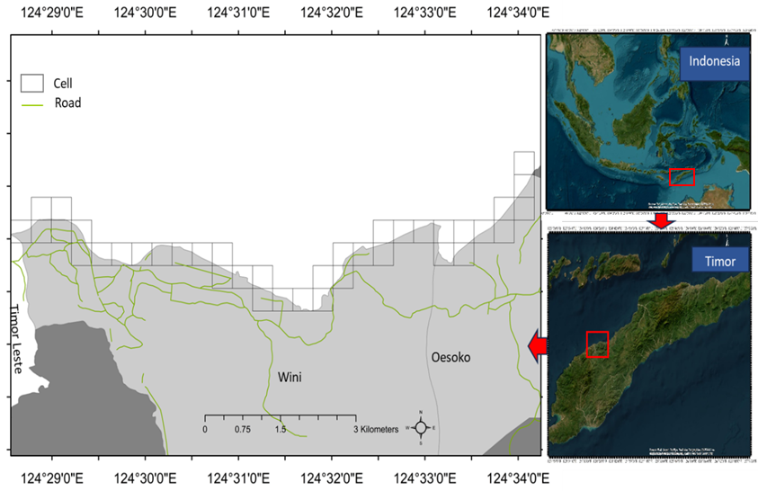

Figure 1. Research Location

**2.2. Data Collection**

This study used 7 variables to examine the level of coastal vulnerability, namely beach elevation, beach slope, geomorphology, shoreline changes, tidal range, wave height, and the sea level height. Most of these variables used the secondary data where field observation has been conducted first as the validation process, especially the variables of coastal geomorphology, beach slope, elevation and shoreline changes. This study gathered the data of elevation and slope from the Digital Elevation Model Nasional (DEMNAS) produced by Indonesian Geospatial Information.

Agency (Geospatial Information Agency) that could be found in https://tanahair.indonesia.go.id/demnas. The DEMNAS data was obtained from various data sources. This ranges from the data of IFSAR with 5 m resolution, the data of TERRASAR-X with 5 m resolution until the 11.25 m resolution of ALOS PAL-SAR where the masspoint data were added as the result of stereo-plotting. After gaining the data from Digital Elevation Model (DEM), the 6 DEM data files were used to perform an image mosaic, thus all the files were integrated into 1 file and saved using the Universal Transverse Mercator projection system (UTM 51S) and the World Geodetic System datum (WGS84). Next, the DEM data was cut based on the area of study by using the boundaries of the North Insana District (Shp format) which was then converted to become polygon features (Shp format) to create the elevation and slope data. Finally, the whole data of DEM data processing was examined to spatially produce a map of elevation vulnerability and coastal slope using ArcGis 10.8.1 software.

The geomorphological data were gathered from the land cover maps that has been processed by Indonesian b data (Hamuna et al., 2018). The data of shoreline change were obtained from the analysis of Landsat 8 imagery recorded on 2014-09-09 and 2023-05-13. The analytical tool used was ENVI software for shoreline extraction and the Digital Shoreline Analysis System (DSAS) which were integrated with ArcGis 10.8.1. The shoreline data used was the change rate of the shoreline obtained from the DSAS output in the form of End Point Rate (EPR).

The tidal data used were obtained from the results of the MIKE 21 software forecasting, namely the periods of 2014, 2017, 2020, 2021 and 2023. The tidal types and tidal characteristics were calculated using the formzahl equation:

F $= \frac{K1+O1}{M2+S2}$ (1)

where:

F represents Formzahl.

O1 represents the main single tidal element caused by the moon's gravity.

K1 represents the main single tidal element caused by the sun’s gravity.

M2 represents the main double tidal element caused by the moon's gravity.

S2 represents the main double tidal element caused by the sun’s gravity.

Table 1. Types of Tides Based on the Value of Formzahl Number (F)

|  |  |
| --- | --- |
| The Criteria of Formzahl Number | The Type of Tides |
| F ≤ 0.25 | Double |
| 0.25 ≤ F ≤1.5 | Double Dominant Mix |
| 1.5 ≤ F ≤ 3.0 | Single Dominant Mix |
| F > 3.0 | Single |

The calculation of Tidal Range (TR) follows the equation by Suhana et al., (2016) with a value of Mean Sea Level (MSL) = 0. These equations are:

MHWS $=MSL+(\frac{M2+Ki+O1}{2}$) (2)

MHWN $=MSL+(\frac{Ki+O1-m2}{2}$) (3)

MLWN $=MSL-(\frac{Ki+O1-m2}{2}$) (4)

MLWN $=MSL-(\frac{Ki+O1+m2}{2}$) (5)

TRS $=MHWS-MLWS$ (6)

TRN $=MHWN-MLWN$ (7)

TR $=TRS-TRN$ (8)

where:

MHWS represents Mean High Water Springs.

MHWN represents Mean High Water Neaps.

MHWN represents Mean High Water Neaps.

MLWS represents Mean Low Water Springs.

TRS represents Tidal Range Springs.

TRN represents Tidal Range Neaps.

TR represents Tidal Range.

The Copernicus Program was used to obtain the data of wave height and sea level that could be foun from the website https://cds.climate.copernicus.eu/about-c3s. The data of wave height obtained from that site were in the form of wind direction and wind speed which then converted into the data of wave height. Meanwhile, the data of sea level rise from the website <https://cds.climate.copernicus.eu/about-s>. Was then extracted using the NetCDF (*.nc) format with Ocean Data View (ODV) which then converted into the form of text format data. The data with *.txt format was then interpolated with Surfer 9 software. Next, the interpolation results were cropped according to the study area and exported into *.xyz format data using Global Mapper 9. The final process was to enter the closest value to the line cell of the coast, thus the overlay was conducted with the shoreline cells and digitized it using Surfer 9.

**2.3. Data Analysis**

To obtain the vulnerability indicators, the CVI value in the coastal area in North Insana District was calculated by incoporating the values of the seven variables used in this study. The vulnerability determination of elevation referred to Pendleton et al. (2010), while the wave height referred to Jadidi et al., (2013). Furthermore, the other variables such as coastal slope, geomorphology, shoreline changes, tidal range and sea level referred to Pendleton et al., (2010). This reference is considered to be ideal for the study location since it is an archipelago. The CVI grouping for seven variables were categorized into 5 groups, namely very low, low, moderate, high, and very high (Table 3). The CVI calculation referred to (Pendleton et al., 2010):

$CVI=\frac{\sqrt{a*b*c*d*e*f*g}}{n}$ (9)

where:

a = Coastal geomorphology variable

b = Beach slope variable

c = Abrasion/accretion variable

d = Tidal range variable

e = Elevation variable

f = Sea surface height variable

g = Wave height variable

n = The total number of variables

CVI = Coastal Vulnerability Index.

Table 2. Categories and Weighting of CVI Variable Scores

|  |  |  |  |  |  |
| --- | --- | --- | --- | --- | --- |
| Variable | Very Low | Low | Moderate | High | Very High |
|  | 1 | 2 | 3 | 4 | 5 |
| Geomorphology | High cliffs, vegetation | Medium cliffs, vegetation | Low cliffs,  alluvial plains, vegetation | Cobble beaches, estuary, lagoon, vevegation, | Barrier beaches, sand beaches, salt marsh, mud flats, deltas, vegetation, coral reefs |
| Shoreline change (m/year) | > 2.0 | 1.0–2.0 | -1.0–1.0 | -2.0–-1.0 | <-2.0 |
| Mean tidal range (m) | < 1.0 microtidal | 1.0–1.9  microtidal | 2.0–4.0  mesotidal | 4.1-6.0  macrotidal | > 6.0  macrotidal |
| Coastal slope (%) | > 14.7 | 10.9–14.69 | 7.75–10.89 | 4.6–7.74 | <4.59 |
| Elevation (m) | > 30 | 20.1–30 | 10.1–20 | 5.1–10 | <5 |
| Relative sea level rise (mm/year) | 1.8 | 1.81–2.5 | 2.51–3.0 | 3.01–3.4 | >3.4 |
| Mean wave height (m) | <0.5 | 0.5–1.0 | 1.0–1.5 | 1,5–2.0 | >2.0 |

The CVI value of coastal vulnerability was grouped into four categories according to Pendleton et al. (2010) which presented in Table 3.

Table 3. The Group of CVI

|  |  |
| --- | --- |
| Nilai | Category |
| <4.75 | Low |
| 4.75-10.64 | Medium |
| 10.64-19.66 | High |
| >19.66 | Very High |

**3. Results and Discussion**

**3.1. Geomorphology**

The coastal land in North Insana District consists of sandy dry land, meadow, gravel dry land, ricefields, sand beaches, mangrove vegetation on rocky land and settlements (Figure 2). In general, the coastal appearance of North Insana District is dominated by sandy dry land. It is known that on the expanse of sandy dry land, there is the salt production activities where the type of sand in the area is used as raw material for salt production as observed in cell 32 in Oesoko Village. While the development of the coastal area of North Insana District is more developed in Wini Village including the construction of highway infrastructure (Cell 15, 21, 22 and cell 23) (Figure 2), beach tourism areas (Cell 6) and a horserace (Cell 24). The impact of coastal development has reduced mangrove vegetation to extinction. The condition of the mangrove vegetation was monitored at Cell 20 and 21. However, the condition of the vegetation in cell 21 which was adjacent to the road has been damaged, this was confirmed by changes in the shoreline showing road and vegetation damage (Figure 5). The morphology of cell 21 was categorized as the low vulnerability because it was a rocky beach, while cell 22, 23, 29 and cell 30 had very low vulnerability because the slopes of the coast are hilly and there are many rocks that could block sea waves ashore.

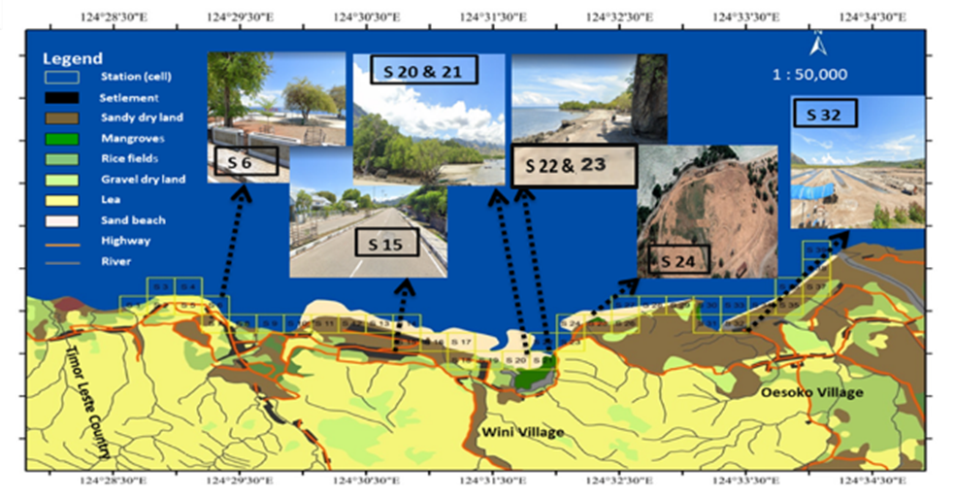

Figure 2. The Geomorphological Appearance

According to Ledheng & Hano'e (2023), in the northern coastal area of North Central Timor Regency there are two side by side accumulations of sand deposits, namely sand from the ebb and flow of seawater and sand from river flows. This causes sandy dry land to dominate along the coast and according to Yuliastini, Zainuri & Widiaratih, (2023) sandy dry land is included in the alluvial plains category which is prone to beach abrasion. The vulnerability index of geomorphological parameters along the coast of North Insana District can be seen in Figure 3.

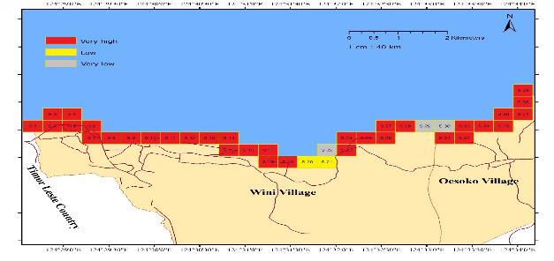

Figure 3. The Category of Vulnerability based on Geomorphology

Based on Figure 3, of the 39 cells observed, the vulnerabilty with very high criteria reached 87.18% while the criteria for low to very low were respectively 5.13%, 7.69%. It is known that the sandy dry land area in North Insana District is dominated by tidal flats. Geomorphology for tidal averages opens up space for vulnerability to occur, but areas covered by mangroves are relatively safe from the threat of coastal abrasion because the presence of mangroves can protect the coast.

**3.2. Shoreline Change**

The results of the DSAS analysis showed that the rate of abrasion in 2014–2023 on the coast of North Insana District was 1.2 m/year while the accretion was 2.1 m/year. In general, changes in the shoreline that occured on the coast of North Insana District were in residential areas, areas near the highways, horserace and aquaculture ponds. The vulnerability index was in the very low to very high category where the very low category was an area experiencing sedimentation. Cells with a high vulnerability category on Wini beach were in areas near the settlements (cell 3–8, 16), mangrove areas near the highways (cell 21) and near the horserace (cell 24 and cell 26 -28). Meanwhile, on Oesoko beach it can be found in the area of conservation (cell 31) and near the pond area (cell 33). The highest vulnerability was in the Oesoko coast, namely cell 32 and cell 35–36 (Figures 7). The impact of Seroja storm in 2021 has caused the coast of Oesoko (cell 31 and 32) to experience a shoreline shift of 567 m (Ledheng & Hano'e, 2023). This condition prompted the village and district governments to carry out a program to plant mangrove seedlings and designate them as the conservation areas. Even though cell 31 has been designated as a conservation area, looking on the criteria, it can be seen that the category was still at high vulnerability (Figure 4). The location of cell 35–36 on the coast of Oesoko was very high vulnerability where the area was dominated by sand without vegetation with a flat beach slope (Figure 4).

The shoreline with stable changes was in the area near the border post of Timor Leste State and Indoensia (cell 1–2) and in residential areas (cell 9–15, 17 and cell 19) while the most stable were in the mangrove area (cell 20), in the areas experiencing high sedimentation (cell 29-30), and in cell 37-39 which were placed on the coast of Oesoko (Figure 4). Based on Figure 4, of the 39 cells observed, it can be seen that the vurnerability criteria were moderate, high to very high at 38.46%, 25.64% and 7.69 respectively.

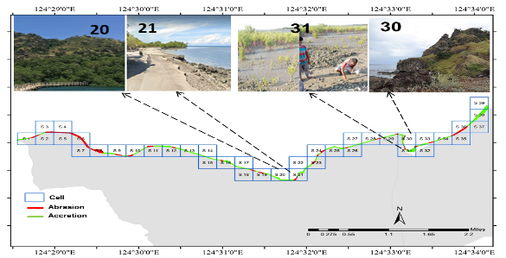

Figure 4. Map of Abrasion and Accretion of North Insana District in 2014 - 2023

**3.3. Sea Tides**

The maximum sea surface height at the highest tide from field measurements in July 2022 was 151 cm and the minimum height at the lowest tide was 26 cm with an average sea level surface (MSL) of 125 cm (Ledheng & Hano'e, 2023). The results of the validation of field measurements showed the similarity of sea level elevation patterns even though they had different elevation values. The validation using the MIKE 21 prediction in July 2023 has shown that the sea surface height at the highest tide was 149 cm with the minimum height at the lowest tide was 24 cm (Figure 5).

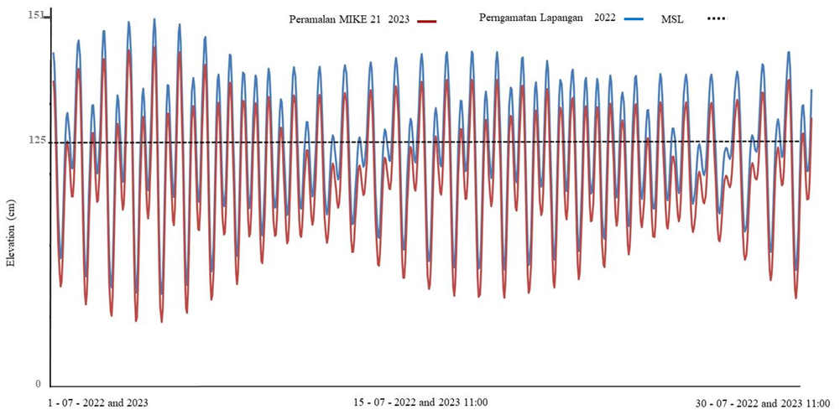

Figure 5. The tidal pattern from field measurements in July 2022 and the results of MIKE prediction in the 21th July 2023

Table 4. The Results of the 2023 Tidal Analysis on Coastal Vulnerability

|  |  |  |  |  |
| --- | --- | --- | --- | --- |
| MHHWS | MHHWN | TR | Scor CVI | Vulnerability Category |
| 53.82 | 8.52 | 125 | 2 | Low Vulnerability |

Notes: MHHWS = mean highest of high water spring; MHHWN = mean highest of high water neap; TR = tidal range

The results of tidal analysis in North Insana beach in July 2023 has shown that the maximum sea surface height during spring tide was 53.82 cm while the maximum sea surface height during neap tide was 8.52 cm with a tidal range of 125 cm. This value indicated that the coastal tidal limit of North Insana is microtidal according to Dipper’s category, (2022). The mean tide height is the difference in average height at the highest and the lowest tides. According to Pendleton et al. (2010) the average value of the slope has an important meaning in coastal vulnerability, where the tidal range contributes to the inundation of coastal areas because tidal movement causes the sea level to change all the time. The vulnerability index value based on tidal range parameters in the coast of North Insana for the last ten years was included in the vulnerability category or 100% of the 39 cells observed. Based on MIKE 21 analysis, it is known that the type of tides in North Insana waters in general was a double diurnal inclined mixture, where the Formzhal number value is 0.48 or in the range of 0.25 to 1.50. Mixed double daily inclined tides are tides that occur in one day but are more dominant in two highs and two lows.

**3.4. Slope and Elevation**

The slope class of North Insana beach consists of flat slopes, gentle slopes and very steep slopes. Flat slopes on the Wini coast rangedw from 0.05% – 1.58% in the very high vulnerability category was found in residential areas and on the expanse of dry sandy land (cell 1, cell 3-5, cell 7-19 and cell 24-28). Meanwhile, gentle slopes ranged from 3.07% - 7.95% category was near to the settlements (cell 2), coastal tourism areas (cell 6) and mangrove forest areas (cell 20-21). The slope with very high vulnerability on Wini coast of was found in the rocky hill area near the highways (cell 22 and 23) and in Tanjung Bastian area near the horserace (cell 29–30) with a slope of 19.58%, 19.49%, and 20.6% respectively. Meanwhile, on Oesoko coast, it was found in all observed cells (0.589%). Overall, the vulnerability with very high criteria reached 43.58%, while the moderate criteria was 23.07% and very low vulnerability category at 10.26%. Based on Tables 5 and 6, it can be seen that the vulnerability with very low criteria reached 10%, while medium and high criteria were respectively 23% and 66.6%.

Table 5. The Slope Classification on Wini Beach in 2023

|  |  |  |  |  |  |
| --- | --- | --- | --- | --- | --- |
| Cell | Coordinate | | Slope (%) | Slope Classification | Vulnerability Category |
| X | Y |
| 1 | 663971 | 8985205 | 7.582 | Flat | Moderate |
| 2 | 668631 | 8984757 | 7.956 | Gentle | Moderate |
| 3 | 670667 | 8985244 | 0.05 | Flat | Very High |
| 4 | 673538 | 8986826 | 1.361 | Flat | Very High |
| 5 | 692327 | 8999531 | 3.098 | Gentle | Moderate |
| 6 | 692397 | 8999597 | 3.076 | Gentle | Moderate |
| 7 | 695972 | 9002395 | 0.104 | Flat | Moderate |
| 8 | 696099 | 9002549 | 0.639 | Flat | Very High |
| 9 | 696187 | 9002629 | 7.589 | Gentle | Moderate |
| 10 | 664069 | 8985183 | 7.589 | Gentle | Moderate |
| 11 | 664182 | 8985194 | 0.589 | Flat | Very High |
| 12 | 664326 | 8985163 | 0.589 | Flat | Very High |
| 13 | 664429 | 8985127 | 0.589 | Flat | Very High |
| 14 | 664509 | 8985102 | 0.589 | Flat | Very High |
| 15 | 664587 | 8985100 | 0.589 | Flat | Very High |
| 16 | 664696 | 8985177 | 0.589 | Flat | Very High |
| 17 | 664822 | 8985303 | 0.589 | Flat | Very High |
| 18 | 664927 | 8985374 | 0.589 | Flat | Very High |
| 19 | 665035 | 8985437 | 0.589 | Flat | Very High |
| 20 | 665189 | 8985440 | 7.812 | Gentle | Moderate |
| 21 | 665313 | 8985427 | 7.76 | Gentle | Moderate |
| 22 | 665488 | 8985416 | 19.589 | Very Steep | Very Low |
| 23 | 665553 | 8985390 | 19.49 | Very Steep | Very Low |
| 24 | 665656 | 8985349 | 0.589 | Flat | Very High |
| 25 | 665799 | 8985294 | 0.589 | Flat | Very High |
| 26 | 665892 | 8985245 | 0.589 | Flat | Very High |
| 27 | 665986 | 8985198 | 0.589 | Flat | Very High |
| 28 | 666118 | 8985144 | 0.589 | Flat | Very High |
| 29 | 666202 | 8985105 | 20.601 | Very Steep | Very Low |
| 30 | 666290 | 8985063 | 20.589 | Very Steep | Very Low |

Table 6. The Slope Classification on Oesoko Beach in 2023

|  |  |  |  |  |  |
| --- | --- | --- | --- | --- | --- |
| Cell | Coordinate | | Slope (%) | Slope Classification | Vulnerability Category |
| X | Y |
| 31 | 666408 | 8985007 | 0.589 | Flat | Very High |
| 32 | 666512 | 8984961 | 0.589 | Flat | Very High |
| 33 | 666602 | 8984923 | 0.589 | Flat | Very High |
| 34 | 666669 | 8984966 | 0.589 | Flat | Very High |
| 35 | 666724 | 8984877 | 0.589 | Flat | Very High |
| 36 | 666853 | 8984850 | 0.589 | Flat | Very High |
| 37 | 666905 | 8984761 | 0.589 | Flat | Very High |
| 38 | 667026 | 8984714 | 0.589 | Flat | Very High |
| 39 | 667125 | 8984676 | 0.589 | Flat | Very High |

The elevation range of 0-5 meters were found in all cells on Oesoko coast while on Wini coast it could be found in cell 8 in the port area, cell 11-20 near the settlements and cell 24-28 near the horserace with a flat slope. The elevation range of 5-10 meters was found in the settlements and the highways, namely cell 1-10 on Wini coast with a gentle to flat slope. The elevation map is presented in Figure 6.

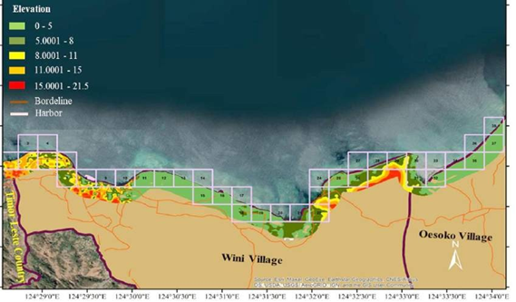

Figure 6. The Elevation Map in North Insana District

The highest elevation value was 11 meters at the village border near the horserace (cell 29-30) with a very high slope of 20.5% and 20.6%. The high elevation will affect the area of sea water inundation because of the sea level rise. Some areas on the coast of Wini that have the potential to have large areas of standing water due to the low elevation range are the port area (cell 8), residential areas to the east of the mangrove forest area (cell 11-20) and the horserace area (cell 24-28). Sea water inundation due to sea level rise also has the potential to affect the entire coastal area of Oesoko Village. Based on Figure 6 it is known that from the 39 obsercved cells, the vulnerability with the low category was 28% while the medium and very high categories reached 5% and 66.7% respectively.

**3.5. Relative Sea Level Rise**

Based on spatial analysis, it could be seen that the highest sea level rise on the Wini coast was at station 4, namely 0.73 mm/year, while on the Oesoko coast, it was 0.83 mm/year. The average relative sea level in the waters of North Insana District was 0.78 mm/year, so it can be said that these waters were included in the low vulnerability class. The dynamics of relative sea level rise in North Insana waters is presented in Figure 7.

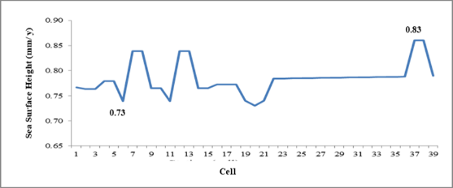

Figure 7. The Dynamics of Relative Sea Level Rise in North Insana Waters

The north coast of Timor Island generally has a calm sea surface physique. According to Ledheng & Hano'e (2023), ocean area with a calm surface has a relatively low energy pattern compared to the ocean. In addition, according to Suhana et al., (2016) archipelago areas have a lot of land that can reduce sea level rise. The relative sea level rise indicates how sea level rise affects a part of the shoreline. The change of sea surface height variable in North Insana District has a small spatial range because the data was taken from the same data stations along the shoreline. According to Koroglu et al., (2019) spatial variations of sea surface height changes only occur in large areas. The range of sea level rise in North Insana District is lower than the waters of Biak Island, Papua Province, which ranges from 1.57–1.97 mm/year (Rumahorbo et al., 2023).

**3.6. Sea Wave Height**

North Insana Beach is located in the southern hemisphere. The pattern of wind direction and speed in the southern hemisphere from May to August is strongly influenced by the east monsoon. This wind movement occurs during the first transitional season which moves from the southeast to the northwest (Rifai et al., 2020). This can be seen in the wind direction map in the waters of the northern part of Timor island recorded by the Meteorology, Climatology and Geophysics (BMKG) presented in Figure 8.

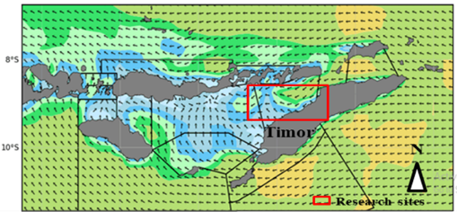

Figure 8. The Wind Direction Recorded by BMKG in July 2023

The wind blows from the east which tends to be dry because the wind blows from the south through a large desert area in the northern part of the Australian continent (Loupatty, 2013). Wind speed in the waters Figure 11. Coastal Vulnerability Map of North Insana Districtof North Insana as measured at the point of the fetch line (latitude: -8.9, longitude 124.66) is presented in Figure 9.

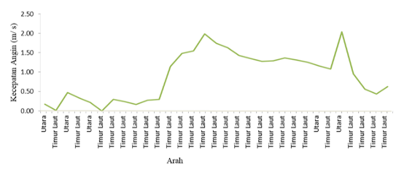

Figure 9. The Dominant Speed from Various Directions in the Waters of North Insana District in July 2023

The wind dominance comes from the north and northeast with speeds ranging from 0.05 to 2.18 m/s. The average wave height forecast for July 2023 was 0.27 m (Figure 10) with a maximum sea wave height of 0.1 m.

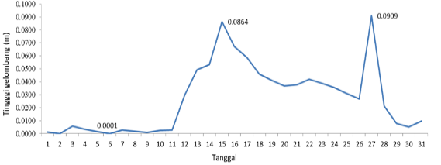

Figure 10. Daily Sea Wave Height in the Coastal Waters of North Insana

The observed values of average wave height represent 39 cells along the shoreline. Based on the vulnerability category by Lopez et al., (2016), the wave height below 0.65 m is considered very low vulnerability. In general, the wave height on the North Insana coast was in the very low category.

**3.7. The Coastal Vulnerability of North Insana District**

Spatially, the Coastal Vulnerability Index (CVI) towards the sea level rise on the coast of North Insana District is in the low to moderate category. The low criterion was at 7.07 km (48.71%) while the medium criterion was at 6.66 km (51.28%). The coastal vulnerability index of North Insana District in general was 4.29 which could be categorised to the low vulnerability category. This condition indicates that there are several variables with low vulnerability that provide a balance for the North Insana coast from the high several geological variables that influence it. This is in accordance with the study Suhana et al., (2016) which found that the existence of variables with low vulnerability is a counterweight in influencing the level of coastal vulnerability. The spatial map of North Insana's coastal vulnerability is presented in Figure 11.

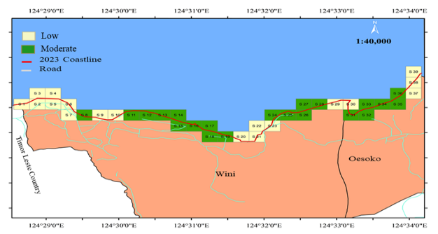

Figure 11. Coastal Vulnerability Map of North Insana District

The level of CVI category can be used to spatially describe the trait of vulnerability in a coastal area. Therefore, if the vulnerability category varies, then the category is relative to the scale of the area of assessment. On the other hand, if it is perpetual throughout the shoreline, then it shows that the category of vulnerability is regional to global (Kasim & Siregar, 2012). Variables that influence the vulnerability of the North Insana coast include elevation, slope, geomorphology and the change rate of the shoreline. According to Hamuna et al., (2018), beach elevation is frimly correlated to the coastal area’s weakness against the threats of seawater inundation, while the beach slope found to correlate with the relative risk of inundation and can perform as the indicator of shoreline retreat’s potential speed (Koroglu et al., 2019). This statement is consistent with the coastal conditions of North Insana District which are dominantly experiencing abrasion where the slope and elevation variables have a very large effect on the retreat of the shoreline. The development of residential locations on the coast of North Insana district was very closely related to the activities of most fishermen so that it influenced changes in the coastal area. In addition, North Insana District is an area that receives special attention from the central government because it is a border area with the State of Timor Leste so that development is given to the coastal areas. Therefore, the increase of human activity and development in the coastal areas will possibly threat the vulnerability in the coastal areas (Zonkouan et al., 2022).

In these study locations, it was found that there were no imperative effects of ocean physical variables (tides, wave height and rate of sea level rise) on coastal vulnerability. However, as a temporal variable, it could possibly have an essential impact in the future. It is predicted that the CVI value found in this study would likely to change along with the high intensity of infrastructure and settlement development in coastal areas.

**4. Conclusions**

This study has produced a coastal spatial map of North Insana District with CVI values that has been categorized as low to moderate risk of sea level rise. The vulnerability index for the low category was 7.07 km (48.71%) while the medium was 6.66 km (51.28%). The study results have shown that the variables of tides, wave height and sea level rise were in low-vulnerability conditions so that they did not have a significant effect on coastal vulnerability in the study area. However, as a temporal variable, it could possibly give an imperative effect in the future. While the variables that affected the coastal vulnerability of North Insana District were geomorphology, slope, changes in shoreline and elevation. The influence of geomorphology with very high vulnerability was 87.18%, the rate of change of the shoreline was 7.6%, the slope was 66.6% while the elevation was 66.7% from the 39 cells observed. The limited number of variables used in this study could be considered by further research. For example, there is a need to add other aspects to be taken into account, such as socio-economic factor and the influence of human activities towards the coastal environment in order to acquire a more holistic CVI value. This could help the coastal authorities and policy makers to create more appropriate mitigation plans for sea level rise that could potentially create the disaster.

**Acknowledgments**

The researchers would like to thank the University of Timor through the Research and Community Service Institute for funding this research through the 2023 Basic Research Scheme (LPPM Basic Research No: 339 / UN6O / PP / 2023).

**References**

Copernicus. n.d. Welcome to the Climate Data Store. Accessed September 25, 2023.https://cds.climate.copernicus.eu/#!/home.

Dipper, F., 2022. Chapter 2 - The seawater environment and ecological adaptations. Elements of Marine Ecology (Fifth Edition), Butterworth-Heinemann. Pages 37-151, https://doi.org/10.1016/B978-0-08-102826-1.00002-8.

DEMNAS.n.d. Download INAGEOPORTAL Accessed September 27, 2023. https://tanahair.indonesia.go.id/demnas.

Febriansyah, I. ,D. S, A. A., and Helmi, M. 2012. Kajian kerentanan pantai di pesisir Kabupaten

Cilacap, Jawa Tengah. Journal of Oceanography. 1(2): 139-148. https://ejournal3.undip.ac. id/index.p

Hamuna, B., Sari, A. N., and Alianto, A. 2018. Kajian kerentanan wilayah pesisir ditinjau dari geomorfologi dan elevasi pesisir Kota dan Kabupaten Jayapura, Provinsi Papua. Jurnal Wilayah dan Lingkungan. 6(1): 1-14. Doi: 10.14710/jwl.6.1.1-14.

Jadidi A. 2013. Using geospatial business intelligence paradigm to design a multidimensional conceptual model for efficient coastal erosion risk assessment. Journal of coastal conservation. 17: 527–543. Doi: 10.1007/s11852-013-0252-5

Karondia, L. A., Handoko, E. Y., and Handayani, H. H. 2022. Analisa Kerentanan Pesisir Kota Semarang menggunakan algoritma CVI (Coastal Vulnerability Index). Geoid. 18(1): 99‑111. Doi:10.12962/j24423998.v18i1.12969

Kasim F. and Siregar V.P. 2012. Coastal vulnerability as- sessment using integrated-method of CVI-MCA: a case study on the coastline of Indramayu. Forum Geografi. 26(1):65‑76. https://www.researchgate.net/publication/269409934

Koroglu, A., Ranasinghe, R., Jiménez, J. A., and Dastgheib, A. 2019. Comparison of coastal vulnerability index applications for Barcelona Province. Ocean & coastal management.178:1‑13. Doi:10.1016/j.ocecoaman.2019.05.001

Ledheng, L., Ardhana, I. and Sundra, I., K. 2012. Komposisi dan struktur vegetasi mangrove di pantai Tanjung Bastian Kabupaten Timor Tengah Utara Propinsi Nusa Tenggara Timur. Ecotrophic. 4(2): 80‑85. https://ojs.unud.ac.id/index.php/ECOTROPHIC/article/view/2535

Ledheng, L., Naisumu, Y., G., and Binsasi, R. 2020. Kajian biomassa dan cadangan karbon pada hutan mangrove pantai utara kabupaten timor tengah utara Provinsi Nusa Tenggara Timur. Prosiding Seminar Nasional Inergitas Multidisiplin Ilmu Pengetahuan dan Teknologi. 3(1): 217‑229. https://jurnal.yapri.ac.id/index.php/semnassmipt/article/view/166

Ledheng, L., and Hano'e, E. M. Y. (2023). Analysis of Shoreline Change of North Central Timor Regency, Indonesia. Nature Environment & Pollution Technology. 22(2): 777‑787. Doi:10.46488/NEPT.2023.v22i02.020

López Royo, M., Ranasinghe, R., and Jiménez, J. A. 2016. A rapid, low-cost approach to coastal vulnerability assessment at a national level. Journal of Coastal Research. 32 (4): 932 - 945. Doi: 10.2112/JCOASTRES-D-14-00217.1

Loupatty, G. 2013. Karakteristik energi gelombang dan arus perairan di Provinsi Maluku. BAREKENG: Jurnal Ilmu Matematika dan Terapan. 7(1): 19‑22. Doi:10.30598/barekengvol7iss1pp19-22

Pendleton E.A., Thieler E.R., and Williams S.J. 2010. Importance of coastal change variables in determining vulnerability ti sea-and lake-level change. Journal of Coastal Research. 26(1): 176 - 183. Doi: 10.2112/08-1102.1

Rifai, A., Rochaddi, B., Fadika, U., Marwoto, J. and Setiyono, H. 2020. Kajian Pengaruh Angin Musim Terhadap Sebaran Suhu Permukaan Laut (Studi Kasus: Perairan Pangandaran Jawa Barat). Indonesian Journal of Oceanography. 2(1): 98‑104. Doi:10.14710/ijoce.v2i1.7499

Rumahorbo, B. T., Warpur, M., Tanjung, R. H., and Hamuna, B. 2023. Spatial Analysis of Coastal Vulnerability Index to Sea Level Rise in Biak Numfor Regency (Indonesia). Journal of Ecological Engineering. 24(3): 113 - 125. Doi: 10.12911/22998993/157539

Sakka, S., Paharuddin, P., and Rupang, E. 2014. Analisis Kerentanan Pantai Berdasarkan Coastal Vulnerability Index (CVI) di Pantai Kota Makassar. Torani Journal of Fisheries and Marine Science. 24(3): 49 - 53. Doi: 10.35911/torani.v24i3.237.

Suhana, M. P., Nurjaya, I. W., and Natih, N. M. N. 2016. Analisis kerentanan pantai timur pulau Bintan menggunakan digital shoreline analysis dan coastal vulnerability index. Jurnal Teknologi Perikanan dan Kelautan. 7(1): 21 - 38. Doi: 10.24319/jtpk.7.21-38

Suhana, M. P., Putra, R. D., Shafitri, L. F., Muliadi, M., Khairunnisa, K., Nurjaya, I. W., & Natih, N. M. N. (2020). Tingkat Kerentanan Pesisir di Utara dan Timur Pulau Bintan Provinsi Kepulauan Riau Tahun 2020. Jurnal Teknologi Perikanan dan Kelautan. 11(1): 11 - 27. Doi: 10.24319/jtpk.11.11-27

Yuliastini, L. F., Zainuri, M., & Widiaratih, R. 2023. Analisis Kerentanan Pesisir di Kabupaten Kendal. Indonesian Journal of Oceanography. 5(1): 80-89. Doi: 10.14710/ijoce.v5hi1.16061

Zonkouan B.R.V., Bachri I., Beda A.H.J., N’Guessan K.A.M. 2022. Monitoring Spatial and Temporal Scales of Shoreline Changes in Lahou-Kpanda (Southern Ivory Coast) Using Landsat Data Series (TM, ETM+ and OLI). Geomatics and Envi- ronmental Engineering. 16(1): 145 - 158. DOI: 10.7494/geom.2022.16.1.145