Analysis of Evaluation of Revegetation Plant Growth on Post-Mining Land as an Effort to Restore the Function of Absorbing Carbon Dioxide Emissions

Mining activities can reduce sources of carbon dioxide emissions through clearing mining land, so efforts are needed to restore land function through reclamation with revegetation. Increasing vegetated land can help mitigate climate change. This research aims to evaluate the growth of revegetation plants to determine the success of revegetation. The results show that the high success of revegetation can increase sources of oxygen production and carbon dioxide emission absorption to restore the environmental function of vegetated land. In addition, changes in land cover directly impact changes in carbon storage.

Keywords : reclamation, revegetation, emissions, CO₂

Introduction
Global warming occurs because too many greenhouse gases are released into the atmosphere, especially carbon dioxide (CO₂), produced from burning fossil fuels such as coal, oil, and natural gas. These greenhouse gases capture heat from the sun and cause the temperature on the earth's surface to rise, which then causes significant global climate change (Dahlan, 2017).
As a country with a rapid population and economic growth, Indonesia faces significant challenges in overcoming climate change (Adiputra, 2018). The rapid increase in population in the world, which requires increased anthropogenic activities, has resulted in rapid land use and land cover, causing forest destruction and conversion of fertile land to urban development, which significantly impacts the ecosystem (Al-sharif & Pradhan, 2014).
With the reduction in vegetated land due to the conversion of land into built-up land, it is necessary to carry out scenarios and monitoring to maintain vegetated land cover, which absorbs CO₂ emissions (Pratiwi, 2022).
Mining activities have an impact on reducing land quality and increasing the rate of land degradation. The decline in land quality on ex-mining land is related to the fertility and chemical properties of the soil, soil texture, dryness, and waterlogging, so the land becomes challenging to plant (Mansur, 2011). Revegetation activities are one part that determines reclamation activities. Revegetation is a replanting effort on ex-mining land to improve biodiversity and restore landscape aesthetics and native plant communities sustainably to control erosion and surface runoff (Setiadi, 2006).
According to Minister of Forestry Regulation number P. 4/Menhut-II/2011 concerning Forest Reclamation Guidelines, it is stated that in reclamation activities it is necessary to carry out evaluation activities at least once a year to determine the success of reclamation activities carried out by mining companies. The activity that determines the success of reclamation is revegetation activities. Therefore, it is necessary to evaluate the growth of revegetation plants to determine the success of revegetation.

Methods
Research site The research was carried out in March-May 2023 at the Air Laya IUP PT Bukit Asam Tbk, Tanjung Enim, South Sumatra. This research is located in a reclamation area with a planting year 2022 total area of ​​5.3 Ha.
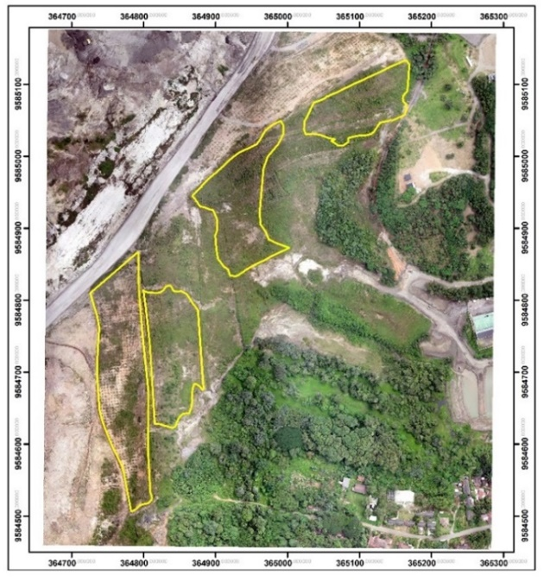
Figure 1 Map of research

Method of collecting data Before collecting data, field observations must be carried out; the aim is to get an overview of the research location, the plants that will be measured, the condition of the land, and so on. In this research, data collection was carried out by sampling. Sampling used the plot method. Determination of sample plots was carried out using the Systematic Sampling With Random Start (SSRS) method with a sampling intensity of 5% and measuring plots measuring 40 x 25 m (0.1 ha). According to the regulations (Minister of Forestry of the Republic of Indonesia, 2009), Systematic Sampling With a Random Start is a method carried out systematically, with the first sample being determined randomly. A measuring plot measuring 40 x 25 m uses a plastic rope. The sampling method resulted in 4 plots from the total revegetation area at the 2022 planting year location of 5.3 Ha, divided into 4 IDs.
Data analysis Data analysis for plant growth on reclaimed land includes plant type, height and diameter, number of plants, and plant health. This data will be analyzed statistically descriptively using the following formula (Rusdiana and Setiadi 2019).
Stem diameter and plant height The equation for calculating the average diameter and height of a plant is as follows:
$$d=\sum_{i}^{n}{\frac{di}{n}}$$
$$t=\sum_{i}^{n}{\frac{ti}{n}}$$
d = average stem diameter (cm)
t = average height (cm)
di = diameter of the ith tree
ti = height of the ith tree
n = number of trees measured

Plant Growth Percentage
$$T=\frac{\sum{hi}}{\sum{Ni}} ×100\%$$
T: percent plant growth (%)
hi : number of plants living in plot i
Ni: the number of plants that should be in the i plot

The average percentage of plant growth is calculated using the formula below:
$$R=\sum_{i=1}^{n}{\frac{Ti}{n}}$$
R: average percentage of plant growth
Ti: percentage of plant growth in plot i
n : number of plots

Number of Plants Per Hectare The number of plants per hectare is calculated using the formula below:
Number of plants per hectare = (Land area)/(planting distance)
Number of plants per measuring plot = (Area of ​​measuring plot)/(planting distance)

Plant Health The percentage of plant health will be calculated using the formula below:
K=$\frac{ns}{nh}×100\%$
K: Percentage of Plant Health (%)
ns: Number of healthy plants
nh: Number of living plants

Recapitulation of assessment results Recapitulation of assessment results is calculated using the formula below:
TN = $\frac{TS1+TS2+TS3}{SM1+SM2+SM3}$
TN: Total Value
TS1: Total score for the criteria for plant growth percentage
TS2: Total score for the assessment criteria for the number of plants per hectare
TS3: Total score for assessing plant health criteria
SM1: Maximum value of plant growth percentage criteria
SM2: Maximum value of the criteria for the number of plants per hectare
SM3: Maximum value of plant health criteria

Standardization of the Success of Revegetation Activities Guidelines for successful revegetation are listed in Minister of Forestry Regulation No. P60 of 2009, where the criteria for revegetation or tree planting are listed in Pasal 4, paragraph (2) letter c, namely as follows:
- Size of planting area
The planting area in reclamation activities was obtained from the team's measurement results report and mapped and compared to the planting plan.
- Percentage of plant growth
The percentage of plant growth in each measuring plot is calculated by comparing the number of existing plants with the planned number of plants that should be present in the assessed measuring plot.
Table 1 Realized value of planting area and percentage of plant growth
Realization | Value
≥ 90% | 5
80 % - 89 % | 4
70 % - 79 % | 3
60 % - 69 % | 2
< 60 % | 1
Permenhut No. P 60 tahun 2009

- Number of plants per hectare
The number of plants per hectare is determined with a maximum planting distance of 4 x 4 m so that the number of trees per hectare is at least 625.
Table 2 Realized value of number of plant per hectare
Realization | Value
≥ 625 | 5
551 – 624 | 4
476 – 550 | 3
400 – 475 | 2
< 400 | 1
Permenhut No. P 60 tahun 2009

- Composition of plant species
Usually, revegetation activities are carried out first with fast-growing species, but then enrichment needs to be carried out with local long-cycle species.
Table 3 Value composition of long-cycle plant species
Composition | Value
≥ 40 % | 5
30 % - 39 % | 4
20 % - 29 % | 3
10 % - 19 % | 2
< 10 % | 1

- Plant health
When counting growing plants, you should also observe the growth condition or health. Observations on plant growth are classified into 3 (three) categories: healthy plants, plants that grow fresh and have relatively straight stems, bushy crowns with a minimum height according to standards, and free from pests and diseases/weeds. Unhealthy plants are plants that grow abnormally or are attacked by pests, yellow or abnormally colored leaves and bent stems, and miserable plants are plants that grow abnormally or are attacked by pests and diseases so that if they are maintained, there is little chance that they will grow well.
Table 4 Percentage value of plant health
Realization | Value
≥ 90% | 5
80 % - 89 % | 4
70 % - 79 % | 3
60 % - 69 % | 2
< 60 % | 1

In Pasal 15, based on the criteria and indicators for the level of success of forest reclamation as intended in Pasal 14, the total evaluation value is calculated using the following formula:

TN = ∑ [ TS i/SM i x B i]
i=1
TN: Total value
TS i: Total score for assessment criteria i
SM i : Maximum value of criterion i
n : Number of criteria
B i : Weight for criterion i (The maximum total score is 100)

Based on the calculation of the total value as intended in Pasal 23, the following criteria and conclusions will be obtained:
- Total score > 80: Good (reclamation implementation results are acceptable).
- Total score 60 – 80: Medium (the results of the reclamation implementation are accepted with a note that improvements need to be made until it reaches a value > 80).
- Total score < 60: Bad (reclamation results are unacceptable and intensive maintenance is required).
Results and Discussion
Based on Minister of Forestry Regulation no. P60 of 2009, The success of plant life is determined by five aspects: the planting area's size, the percentage of plant growth, the number of plants per hectare, the composition of plant types, and plant health. This research used three criteria for successful plant life: the percentage of plant growth, the number of plants per hectare, and plant health.
Plant growth The plant growth observed in this research measured plant height and diameter in the revegetation area of ​​PT Bukit Asam Tbk for planting year 2022. The results of observations carried out at the research location were divided into four plots (Figure 1).
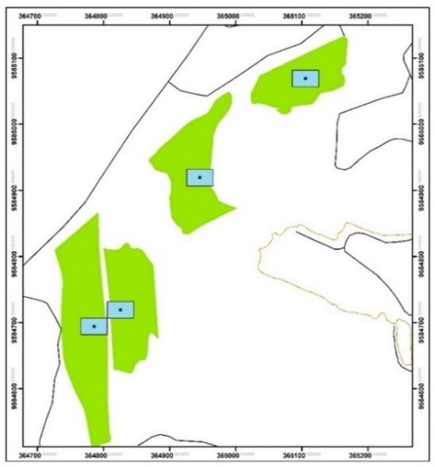
Figure 2 Scatter plot measure
The research results showed that the plants in the revegetation area of ​​PT Bukit Asam Tbk. Consisting of Angsana (Pterocarpus indicius), Sengon Buto (Entorolobium cyclocarpum), and Johar (Cassia siamea) where the ones with the best growth are the plants in the 4th plot, namely Angsana plants with an average plant height of 224 cm, while the average its diameter is 5 cm. This research found that plot 1 had four types of plants, namely Angsana, Sengon Buto, and Johar. In plots 2 and 3, it was found that there was 1 type of plant, namely Angsana. Meanwhile, in plot 4, there are two types of plants, namely Angsana and Sengon Buto. To see the types of plants per plot, see Table 5.

Table 5 Plant types per plot
Measuring plot | Local Names of Plants | Plant Scientific Name | Number of Plants Planted
1 | Angsana | Pterocarpus indicius | 29
1 | Sengon Buto | Entorolobium cyclocarpum | 22
1 | Johar | Cassia siamea | 12
2 | Angsana | Pterocarpus indicius | 63
3 | Angsana | Pterocarpus indicius | 63
4 | Angsana | Pterocarpus indicius | 32
4 | Sengon Buto | Entorolobium cyclocarpum | 31

Angsana plants can be planted at the beginning of planting activities because they have fast-growing properties. Plants that overgrow on mine revegetation land play an essential role in accelerating the process of forming a microclimate and improving soil conditions so that improvements in the condition of the revegetation area can run well. The effect is on the speed of the vegetation succession process because it creates conditions that can cause plants or other vegetation types to enter and grow (Badan for Standardization of Environmental and Forestry Instruments, 2022).

Table 6 Average growth identification of plant height, diameter, and crown
Plot | Type of plant | Diameter (cm) | High (cm) | Crown (cm)
1 | Angsana | 4 | 131 | 105
1 | Sengon Buto | 4 | 139 | 128
1 | Johar | 3 | 113 | 98
2 | Angsana | 3 | 141 | 120
3 | Angsana | 4 | 198 | 160
4 | Angsana | 5 | 224 | 151
4 | Sengon Buto | 4 | 155 | 95

It is thought that the growth of each plot is different due to differences in environmental conditions in each plot. According to Sopandie (2013), plant growth can be influenced by several factors, including the environment, biotic and abiotic, and climate, such as weather; some plants are susceptible to humidity and temperature.
Table 7 shows that the highest percentage of plant growth is in plot 3, 98.4%, and the lowest rate is in plot 4, 85.7%. The low percentage of plant growth is caused by plants that die, but no replanting or replacing plants is carried out, causing a small percentage of plant growth.

Table 7 Average percentage of plant growth in the PT Bukit Asam Tbk mine revegetation area planting 2022

Plot | Plot area | Plant Spacing | Trees Planted | Trees grow | Growth Percentage (%)
1 | 1000 m | 4 x 4 m | 63 | 59 | 93,7 %
2 | 1000 m | 4 x 4 m | 63 | 61 | 96,8 %
3 | 1000 m | 4 x 4 m | 63 | 62 | 98,4 %
4 | 1000 m | 4 x 4 m | 63 | 54 | 85,7 %
Average |  |  |  |  | 93,7 %
Value |  |  |  |  | 5

Number of Plants Per Hectare The number of plants per hectare is 625, with a maximum planting distance of 4 x 4 m, by Minister of Forestry Regulation No.60/Menhut-II/2009. The research shows a minimum of 63 plants in each measuring plot with an area of ​​0.1 ha (40x25 m) and a 4 x 4 m distance. To get the number of plants per hectare, the number of plants per plot obtained in the field is then converted into hectares using the formula for the number of plants multiplied by 10.
Table 8 Number of plants per plot

Planting Year | Plot | Plant type | Number of plants planted | Number of living plants | Total | Total (number/ha)
2022 | 1 | Angsana | 29 | 27 | 59 | 590
2022 | 1 | Sengon Buto | 22 | 20 | 59 | 590
2022 | 1 | Johar | 12 | 12 | 59 | 590
2022 | 2 | Angsana | 63 | 61 | 61 | 610
2022 | 3 | Angsana | 63 | 62 | 62 | 620
2022 | 4 | Angsana | 32 | 27 | 54 | 540
2022 | 4 | Sengon Buto | 31 | 27 | 54 | 540
 | Average |  |  |  |  | 590
 | Value |  |  |  |  | 4

The table above shows that the number of plants per hectare in ID 1 is 590 plants, ID 2 is 610 plants, ID 3 is 620 plants, and ID 4 is 540 plants. The average number of plants per hectare is 590 plants. The number of plants per hectare obtained has yet to reach 625 plants, so it is still categorized as good but not perfect, according to Minister of Forestry Regulation No P60/2009. The number of plants per hectare did not reach the target because many died, and no replanting or replacement of dead plants was done.

Plant Health The observations in the field showed that the percentage of health in plot 1 was 86.4%. In Plot 2, the health percentage is 93.4%. In Plot 3, the percentage of plant health was 96.8%. In plot 4, the plant health percentage was 92.6%. The average percentage of health for the four plots was obtained by dividing the total percentage of all plots by the total number of plots. In this observation, the average percentage of plant health was 92.3%. With plant health having a percentage of 92.3%, it can be categorized as in the PT Bukit Asam Tbk mine revegetation area. The planting year 2022 has good plant health.
Table 8 Average percentage of plant health in the revegetation area of PT Bukit Asam Tbk area planting 2022

Plot | type of plant | Number of live plants | Number of health plants | Percentage of plant health (%)
1 | Angsana | 59 | 51 | 86,4 %
1 | Sengon Buto | 59 | 51 | 86,4 %
1 | Johar | 59 | 51 | 86,4 %
2 | Angsana | 61 | 57 | 93,4 %
3 | Angsana | 62 | 60 | 96,8 %
4 | Angsana | 54 | 50 | 92,6 %
4 | Sengon Buto | 54 | 50 | 92,6 %
 | Avareage |  |  | 92,3 %
 | Value |  |  | 5

Based on the research results, of the total number of plants, there were 218 healthy plants, 17 less healthy plants, and one plant was miserable. The causes of unhealthy plants are that they grow abnormally, are attacked by disease pests, and have yellow or abnormally colored leaves that are bent (Figure). Meanwhile, miserable plants grow abnormally, are attacked by disease pests, are stunted, have no leaves, and have no stems. Typically, if maintained, it will have little chance of growing well.
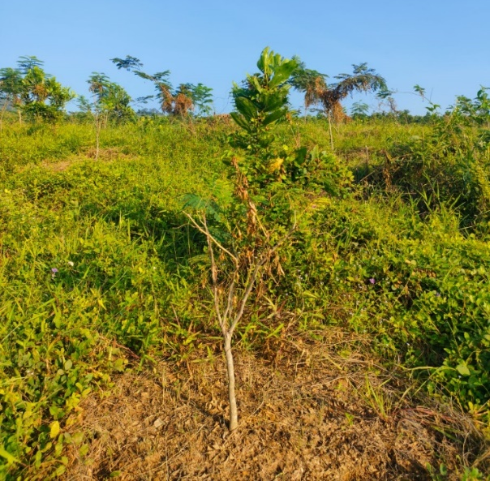
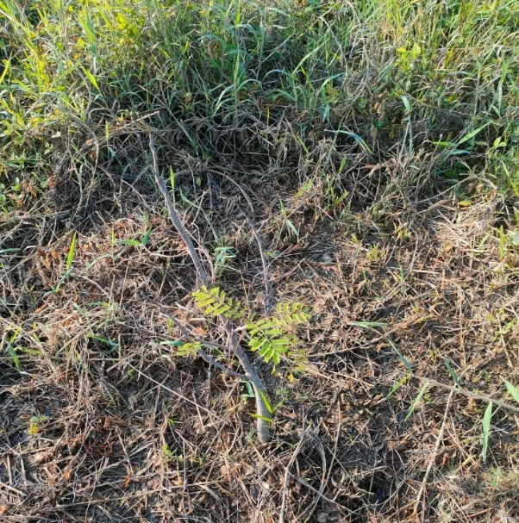

Figure 1 Unhealthy plants Figure 2 Plants languish

Plant Survival Rate The final assessment was conducted to determine the plants' survival rate in the revegetation area of ​​PT Bukit Asam Tbk. Planting year 2022. Based on Minister of Forestry Regulation no. P60/Menhut-II/2009 is based on the percentage of plant growth, number of plants per hectare, and percentage of plant health. The assessment is carried out by clustering the measuring plots used in the revegetation area for the 2022 planting year so that the evaluation in measuring plot units will represent the actual condition of the condition of the revegetation plants on the reclaimed land.
Table 8 Recapitulation of plant life success rates
Planting year 2022
Category | Value | Score | Level of success (%)
Plant growth (%) | 93,7 % | 5 | 93 %
Number of plants per hectare | 590 | 4 | 93 %
Plant health (%) | 92,3% | 5 | 93 %

The success rate for growing revegetation plants on ex-mining land at the Air Laya IUP PT Bukit Asam Tbk in 2022 reached 93%. The successful growth of these plants can return the former mining land to its productive function, producing oxygen and absorbing carbon dioxide. During mining activities, vegetated land has been removed so that CO2 is not absorbed by plants but is released directly into the atmosphere, which can increase greenhouse gases and impact global warming, so optimal efforts are needed to restore land function using revegetation or reforestation.
With revegetation, carbon reserves can be increased and land fertility restored. Syaufina and Ikhsan (2013) indicate that mining companies indirectly increase carbon reserves through post-mining land reclamation activities. In general, post-mining land reclamation aims to improve the condition of land damaged by mining activities to restore the fertility and productivity levels of that land. The level of success of this reclamation activity can be seen from the quality of growth of the types of plants planted on the land. The higher the success rate of reclamation activities, the greater the potential for carbon absorption from the land.
eforestation is a form of effort to restore critical land into optimal land and functions to preserve the environment. According to Setiadi (1991), reforestation is a human effort to restore essential land outside forest areas so that the land functions optimally.
Apart from producing emissions through the burning process, mining also produces emissions from clearing land for mining due to the loss of vegetated land cover. Vegetated land functions to absorb carbon dioxide emissions, produce oxygen and maintain water quality. So revegetation is needed on ex-mining land to restore land function.

Conclusion
The success of revegetation plants is significant for the environment because mining activities eliminate vegetated land, which absorbs carbon dioxide emissions and produces oxygen. The higher the success rate, the higher the possibility of returning its function to its original state.

References
Adiputra, M. (2018). The Potential of Nickel Industry in Indonesia and Analysis of Large Scale Electric Vehicle Battery Production. Journal of Energy and Power Engineering, 12(3), 153-157.

Al-sharif, A.A.A. and Pradhan, B. 2014. Monitoring and predicting land use change in Tripoli Metropolitan City using an integrated markov chain and cellular automata models in GIS. Arabian Journal of Geosciences. 7 (10) : 4291–301.

Dahlan, M. H. (2017). Pemanasan Global dan Dampaknya terhadap Lingkungan. Jurnal Ilmiah Mahasiswa Pertanian, 2(3), 94-103.

Mansur, I., 2011. Teknik Silvikultur untuk Reklamasi Lahan Bekas Tambang. SEAMEO BIOTROP, Bogor.

Setiadi, Y., 2006. Teknik revegetasi untuk merehabilitasi lahan pasca tambang [terhubung berkala]. Http://pkrlt.ugm.ac.id/files/yadi setiadi.pdf [7 Februari 2016].

Syaufina, L., dan Ikhsan, M. 2013. Estimasi Simpanan Karbon di Atas Permukaan Lahan Reklamasi Pasca Tambang PT. ANTAM UBPE Pongkor, Provinsi Jawa Barat. Jurnal Silvikultur Tropika. Vol 4 No 02: 100-107.

Wahyudi, A. T., Takeyama, H., Okamura, Y., Fukuda, Y., & Matsunaga, T. (2003). Characterization of Aldehyde Ferredoxin Oxidoreductase-gene defective mutant in Magnetospirillum Magneticum AMB-1. Biochemical and Biophysical Research Communications, 303, 223−229. https://doi.org/10.1016/S0006-291X(03)00303-6

Whitmore, T. (1998). An introduction to tropical rain forests (2nd ed.). New York: Oxford University Press.

Yovi, E. Y., Takimoto, Y., & Matsubara, C. (2007, November 26−29). Promoting alternative physical load measurement method: Approaching % VO₂ max through HR [Conference presentation]. The Agriculture Ergonomics Development Conference. Kuala Lumpur, Malaysia.

Title, Describing the Content of the Principal Manuscript in Clear and Concise Way (Centered, Bold, Times New Roman 14)

First Author^{1*}, Second Author¹, Third Author² (Centered, Bold,
Times New Roman 12)

¹Department of Forest Management, Faculty of Forestry, IPB University, Academic Ring Road Campus IPB Dramaga, Bogor, Indonesia 16680
²Institution name, institution address, name of city, name of country, post code (Centered, Times New Roman 12)

Abstract (Times New Roman 12, align left, bold, italic)
Abstract is written in Times New Roman, font size 12, italic, and single space. Abstract is more or less 200 words which has no reference and does not contain numbers, abbreviation, acronym or measurement unless essential. Abstract should commence with a clear introduction of 2 or 3 sentences mentioning the background of the research. Subsequently, state the general problem of the research. Results are the main findings that directly answer the problem(s) of the research. Give 1 or 2 sentence(s) to discuss the finding(s) or prospective(s). Editor has the right to edit the Abstract for clarity.

Keywords (Times New Roman 12 italic): consist of 4−5 phrases, first keyword being the most important (do not use word in the title)

*Correspondence author, email: email address of correspondence author @Times New Roman.12, tel. Institution phone number, fax. Institution fax number

Introduction (Times New Roman 12, align left, bold)
Contains theory, research results and latest news or the background of the importance of the research conducted, the formulation of the problem, and research purposes. Write down the background of the research and mention the previous studies that had been done. State one question(s) that are needed to answer through your work. Give a description (local and scientific name) of the studied organism.
Each new paragraph is spaced 1.5 from the main chapter and be started with indentation (0.5 cm). The writing uses Times New Roman 12 with 1.5 space. The introduction must contain sufficient background from the chosen theme, so the readers are able to understand the problems and the importance of the research. It is necessary to explain how the research is related to the results of other recent research. The explanation must be adequate, so the general scientific community who are unfamiliar with the field can still understand the topic and how the results are applied.
The next paragraph is written in indent 0.5 cm like the example. The introduction needs to be supplemented with important literature that is related to research themes (Bonkowski et al., 2000; Hrynkiewicz & Baum, 2011). The literature needs to be reviewed generally in the Introduction. Literature review and summary of research results in detail need to be avoided. The research objectives are necessary to be clearly stated. The way (2015) of literature citation is sorted from the longest to the newest year as shown in the example (Schulz & Boyle 2005; Bayman, 2007; Sitepu et al., 2007). Italic format is used for writing genus/species and special terms other than English such as Tectona grandis, hutan ulayat, and abbreviations of latin words such as viz, i.e. etc. The cited literature is recommended not less than 80% as primary and most recent literature.
Manuscript is submitted to the redactor in the format of MS Word or OpenOffice Writer to facilitate the editing process and the page limit consists of 5−20 pages. From this document template, the author can change the contents and save the file in a new name. Headers and footers will be added by the redactor after the manuscript has been approved by peer reviewer for proper publication

Methods (Times New Roman 12, align left, bold)
Describe in brief and concise about the research methods used include (1) the specificity of materials and equipment, (2) sampling (qualifications and chopped), (3) measurement, (4) research design, (5) stages of the workings, (5) parameters, and (6) data analysis.

The subchapter (optional, Times New Roman 12, align left, bold, without full stop) The writing uses Times New Roman 12 with 1.5 space. The subchapter is explained in detail, so other researchers can follow and conduct the research with the same results. The brand name of tool, chemical material or others is mentioned refers to its generic name or general specifications.
The next paragraph is written with indent (0.5 cm). The standard methods can be explained briefly and cited as needed, meanwhile new methods or techniques need to be explained in detail.
Sub-subchapter (optional, Times New Roman 12, align left, italic, without full stop) If sub-subchapters are needed, the title is written in italic.
The next paragraph is written with indent (0.5 cm).

Results and Discussion (Times New Roman 12, align left, bold)
Presenting the results obtained in brief and can be supported by the illustrations in the form of tables, figures or qualitative descriptions. The discussion is made with emphasis on cause-effect relationship, the linkage between theory and the results of previous similar studies. The author is expected to assess the advantages and disadvantages of results obtained in a way to compare the results of research with the hypothesis, quality standards, and or the results of previous research or similar through the inclusion and use of primary reference in the discussion. The impact of the research conducted should be outlined at the end of the discussion.
The writing is in Times New Roman 12 with 1.5 space. The results of research are explained clearly and concisely. The results must be discussed and interpreted with the results of other studies. The use of abbreviations or acronyms is recommended if the word will be often mentioned. The way of writing is by mentioning the full word in the early part of text, for example the inventarisasi hutan menyeluruh berkala (IHMB). The use of tables and images is essential to clarify the findings and must be referenced in the text clearly (Table 1, Figure 1). In manuscript preparation, tables and images are grouped together at the end of manuscript in separated sheets. A decimal number is written in dot (.), for example 20.19. The percentage number (%) is written without spaces, for example 100%. Writing the unit refers to the systems such as: g m⁻², m³ day⁻¹, 30 °C year⁻¹, etc. If there are several mathematical equations, the numbering must be given sequentially.
Reporting statistical result should follow the APA style as written below:
- Mean and standard deviation: The forest stand as a whole was relatively young (M = 10.11, SD = 2.34)
- Percentages: More than half (75%) of the sample was logged
- Chi-square: The percentage of respondents that were selected did not differ by gender, 𝜒² = 0.79, p-value = 0.45
- T-tests: There was a significant effect for vibration, t = 4.43, p-value < 0.001, with large types of chainsaw receiving higher scores than smaller one
- ANOVAs: There was a significant main effect for treatment, F = 7.43, p-value = 0.02, and a significant interaction, F = 7.24, p-value = 0.04
- Correlations: The two variables were strongly correlated, r = 0.79, p-value < 0.01
- Regression: Forest community support significantly predicted depression scores, b = -.35, t = 6.23, p-value < 0.001. The community support also explained a significant proportion of variance in depression scores, R² = 0.52, F = 47.64, p-value < 0.001
This section is possible to be divided into several subsections with concise and informative titles. Explanation and interpretation of results as well as conclusions must be concise and accurate. The discussion must emphasize the importance of results in the latest conditions or other research results, but it does not repeat results. The results and its implications must be discussed in a possible and broader context. Future research plans are also necessary to be emphasized.
Examples of tables and images are shown below. Charts and tables must be in the MS Word or Excel version so it can be edited by the editor. In the table, the title is written in Times New Roman 12 and the contents are written in Times New Roman, minimum font size 8. Vertical lines are not displayed in the table. Regarding the graph, vertical and horizontal labels are written in Times New Roman in appropriate size, so it can be seen in size 12 or rather large in the final version on the journal page and no border/frame. The font size of numbers on the axis is smaller or equal to size 8. The graph is prepared in such a way that the numbers and symbols are clear when printed in black and white. Images in the form of photos are prepared in JPG or JPEG format.

Conclusion (Times New Roman 12, align left, bold)
The writing is in Times New Roman 12 with 1.5 space. The conclusion is written in a narrative, not by pointers, and in one paragraph to answer the research objectives or hypotheses. Conclusion is supported by the results of the research. Speculative statements, opinions, or suggestions of future research can be written in the "Conclusion" section if it has not been discussed in the "Results and Discussion" section and to help the readers to understand the potential/implications of research results. Describe or give an answer to the problem or research purposes, and not as a summary of research results. Conclusion made a brief, clear, qualitative, general, and is written in 1 paragraph.

Recommendation (Times New Roman 12, align left, bold) (if necessary)
State the possible advice according to the conclusion. The writing is in Times New Roman 12 with 1.5 space.

Acknowledgment (Times New Roman 12, align left, bold) (if necessary)
This section is optional, delivered to people who support the funding and technical research. State the grant source (institution, year of the contract) and the person to whom the grant was given. Name the person(s) that help your work and write in a paragraph of 50 words maximum. The writing is in Times New Roman 12 and 1.5 space.

References (Times New Roman 12, align left, bold)
Brancalion, P. H. S., Meli, P., Tymus, J. R. C., Lenti, F. E. B., Benini, R. M., Silva, A. P. M., ..., & Holl, K. D. (2019). What makes ecosystem restoration expensive? A systematic cost assessment of projects in Brazil. Biological Conservation, 240, 108274. https://doi.org/10.1016/j.biocon.2019.108274

Blüthgen, N., Verhaagh, M., Goitía, W., Jaffé, K., Morawetz, W., & Barthlott, W. (2000). How plants shape the ant community in the Amazonian rainforest canopy: The key role of extrafloral nectarines and homopterans honeydew. Oecologia, 125, 229−240. https://doi.org/10.1007/s004420000449

Covington, W. W., Niering, W. A,. Starkey, E., & Walker, J. (1999). Ecosystem restoration and management: Scientifict principles and concept. In Ecological Stewardship: A common Reference for Ecosystem Management Reference (pp. 599−617). Amsterdam: Elsevier. Retrieved from: https://www.srs.fs.usda.gov/pubs/misc/misc_covington.pdf

Dolphin, C. Z. (1994). Variables in the use of personal space in intercultural transaction. In L. A. Samovar, & R. E. Porter (Eds.), Intercultural communication: A reader. California: Wadsworth, Inc.

Fricke, C., & Føllesdal, D. (Eds.). (2012). Intersubjectivity and objectivity in Adam Smith and Edmund Husserl. Berlin, Boston: De Gruyter. https://doi.org/10.1515/9783110325942

Loewenstein, E. F. (1996). An analysis of the size and age structure of an uneven-aged oak forest [dissertation]. Columbia: University of Missouri.

Scoot, L. (1995). Nutritional ecology and population biology of the long-nosed bandicoot (Perameles nasuta): Implications for conservation [thesis]. Sidney: University of Sidney.

Singh, H., & Tripathi. (2007). Soil erosion and conservation. New Delhi: New Age International Publishers.

Verbug, P. H., Overmars, K. P., Huigen, M. G. A., de Groot, W. T., & Veldkamp, A. (2006). Analysis of the effects of land use change on protected areas in Philippines. Applied Geography, 26, 153−173. https://doi.org/10.1016/j.apgeog.2005.11.005

Wahyudi, A. T., Takeyama, H., Okamura, Y., Fukuda, Y., & Matsunaga, T. (2003). Characterization of Aldehyde Ferredoxin Oxidoreductase-gene defective mutant in Magnetospirillum Magneticum AMB-1. Biochemical and Biophysical Research Communications, 303, 223−229. https://doi.org/10.1016/S0006-291X(03)00303-6

Whitmore, T. (1998). An introduction to tropical rain forests (2nd ed.). New York: Oxford University Press.

Yovi, E. Y., Takimoto, Y., & Matsubara, C. (2007, November 26−29). Promoting alternative physical load measurement method: Approaching % VO₂ max through HR [Conference presentation]. The Agriculture Ergonomics Development Conference. Kuala Lumpur, Malaysia.
Table 1 Comparison of nyamplung seedling growth on the several plant establishment methods [Title of table is written in Times New Roman 12 with single space, hanging indent 2 cm]

Plant establishment method | Survival (%) | Seedling height (cm) | Seedling diameter (cm)
Direct seedling | 20 ± 5d | 25.86 ± 9.06c | 4.38 ± 1.54c
Direct seedling using seed pellet | 62 ± 5c | 32.77 ± 0.69b | 6.14 ± 2.10b
Bare root seedling | 84 ± 4b | 37.38 ± 9.63b | 6.34 ± 1.43b
Containerized seedling | 98 ± 2a | 46.15 ± 5.40a | 7.79 ± 2.62a
Blocked media seedling | 98 ± 1a | 48.12 ± 7.85a | 9.26 ± 1.11a
F-test
Planting method | 230.314** | 21.823* | 7.512**
Block |  | 0.858^{ns} | 0.335^{ns}
Note: ** = very significant, p-value > 0.01; * = significant, p-value > 0.05; ns = non significant; p-value < 0.05

Figure 1 The comparisons of density (ind ha⁻¹) in three location mangrove forest KNP. [The title of figure is written in Times New Roman, font 12]

