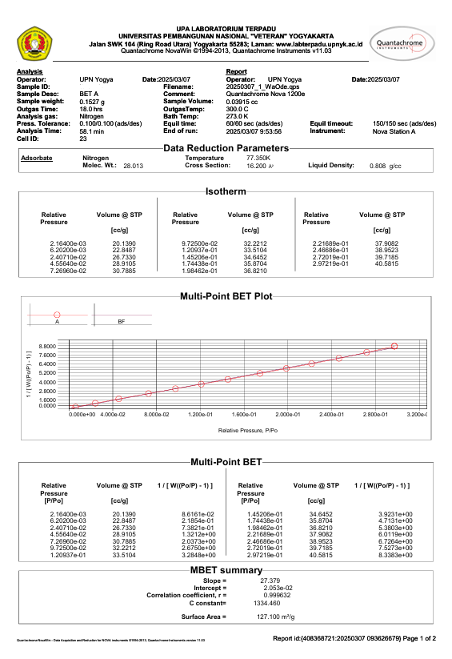

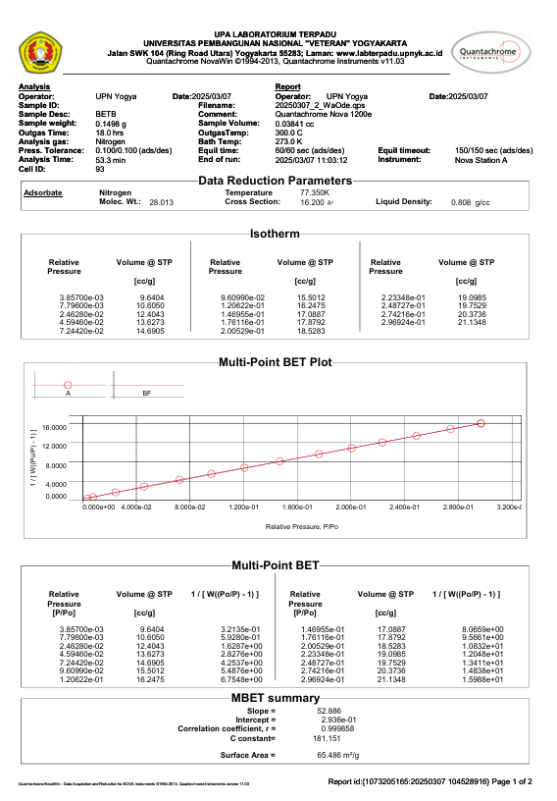

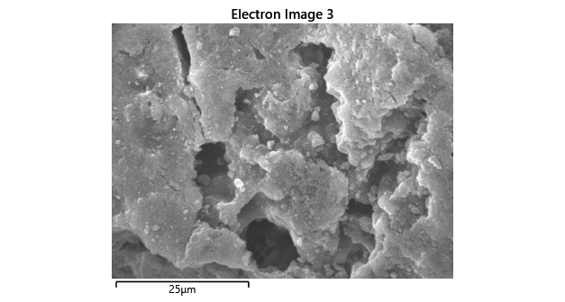
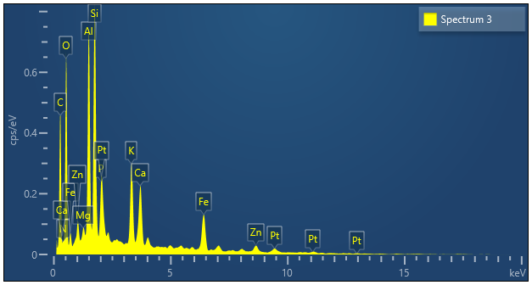

Spectrum 3
Element |  |  |  | Signal Type | Wt% | Wt% Sigma
C |  |  |  | EDS | 39.23 | 1.89
N |  |  |  | EDS | 0.00 | 3.67
O |  |  |  | EDS | 33.44 | 1.29
Mg |  |  |  | EDS | 0.37 | 0.11
Al |  |  |  | EDS | 6.05 | 0.27
Si |  |  |  | EDS | 6.47 | 0.28
P |  |  |  | EDS | 1.26 | 0.14
K |  |  |  | EDS | 3.53 | 0.19
Ca |  |  |  | EDS | 2.86 | 0.18
Fe |  |  |  | EDS | 4.89 | 0.32
Zn |  |  |  | EDS | 1.91 | 0.36
Total |  |  |  |  | 100.00

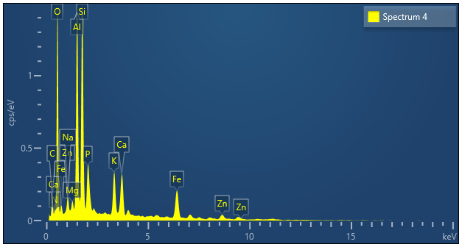
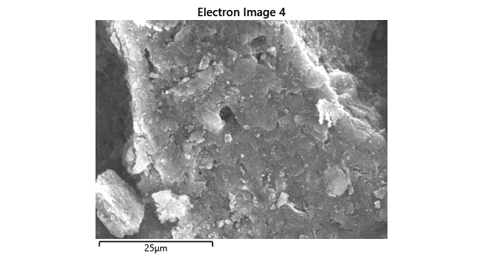

Spectrum 4
Element | Signal Type | Wt% | Wt% Sigma
C | EDS | 15.57 | 2.55
N | EDS | 0.57 | 2.56
O | EDS | 44.19 | 1.91
Na | EDS | 0.79 | 0.25
Mg | EDS | 0.62 | 0.14
Al | EDS | 10.32 | 0.50
Si | EDS | 10.52 | 0.51
P | EDS | 2.15 | 0.21
K | EDS | 3.12 | 0.21
Ca | EDS | 3.45 | 0.23
Fe | EDS | 6.35 | 0.42
Zn | EDS | 2.34 | 0.41
Total |  | 100.00

