© xxx Program Studi Ilmu Lingkungan Sekolah Pascasarjana UNDIP
JURNAL ILMU LINGKUNGAN
Volume xx Issue x (xxxx) : xx-xxxx ISSN 1829-8907
Analysis of Microplastic Content in Edible Fish from a Traditional Market in Bandung City, Indonesia
Rahmat Taufiq Mustahiq Akbar ^{1*}, Haikal Azmi², Ita Fitriyyah²
¹Department of Environmental Engineering, Faculty of Science and Technology, UIN Sunan Gunung Djati Bandung, 40614, Indonesia.
² Biology Study Program, Faculty of Science and Technology, UIN Sunan Gunung Djati Bandung, 40614, Indonesia;
*e-mail: rahmattaufiq@uinsgd.ac.id
ABSTRAK
Microplastic pollution in the ocean poses a serious threat to aquatic ecosystems and human health, especially through fish consumption. This study aims to identify the abundance, characteristics, and types of microplastic polymers in the gills and digestive tracts of skipjack tuna (Euthynnus affinis) and mackerel (Rastrelliger kanagurta) sold at Traditional Market X in Bandung City. Analysis was performed using FTIR spectroscopy, with the Mann-Whitney test to determine differences in microplastic counts between species, as well as descriptive analysis for shape, color, and size. The results showed that all fish samples contained microplastics (100%) with a total of 550 particles (average 15.278 ± 5.629 particles/individual). No significant difference in the amount of microplastics was found between species (p > 0.05). The dominant microplastics were fiber-shaped (43%), transparent in color (40%), and <500 µm in size (70%), with the main polymers being PE and PET in tuna, and PE, PET, and PS in mackerel. These findings indicate that fish consumed from traditional market X are an important indicator of environmental pollution in aquatic ecosystems and form the basis for mitigation efforts.

Keywords: indian mackerel, mackerel tuna, microplastics

ABSTRACT
Microplastic pollution in the ocean poses a serious threat to aquatic ecosystems and human health, especially through fish consumption. This study aims to identify the abundance, characteristics, and types of microplastic polymers in the gills and digestive tracts of skipjack tuna (Euthynnus affinis) and mackerel (Rastrelliger kanagurta) sold at Traditional Market X in Bandung City. Analysis was performed using FTIR spectroscopy, with the Mann-Whitney test to determine differences in microplastic counts between species, as well as descriptive analysis for shape, color, and size. The results showed that all fish samples contained microplastics (100%) with a total of 550 particles (average 15.278 ± 5.629 particles/individual). No significant difference in the amount of microplastics was found between species (p > 0.05). The dominant microplastics were fiber-shaped (43%), transparent in color (40%), and <500 µm in size (70%), with the main polymers being PE and PET in tuna, and PE, PET, and PS in mackerel. These findings indicate that fish consumed from traditional market X are an important indicator of environmental pollution in aquatic ecosystems and form the basis for mitigation efforts.
Keywords: indian mackerel, mackerel tuna, microplastics

Citation: Akbar, R.T.M., Azmi, H., dan Akhir, P. (2025). Analisis Kandungan Mikroplastik Pada Ikan Tongkol (Euthynnus affinis) dan Ikan Kembung (Rastrelliger kanagurta) di Pasar Ikan Ciroyom Kota Bandung. Jurnal Ilmu Lingkungan, xx(x), xx-xx, doi:10.14710/jil.xx.x.xxx-xx

1. Introduction
Plastic pollution is one of the global environmental issues that has a serious impact on ecosystems and human health. The ability of plastics to degrade over a very long period of time, namely tens to hundreds of years, creates environmental problems in the form of microplastic accumulation in marine ecosystems. The process of physical abrasion due to wave impact, reinforced by mechanical mechanisms, as well as photochemical degradation triggered by exposure to ultraviolet (UV) light, can cause plastic to fragment into small parts. Plastic fragments less than 5 millimeters in size are classified as microplastics (Yudhantari et al., 2019).
Microplastics carry various harmful chemical compounds, such as plastic additives and environmental contaminants, which are known to disrupt the endocrine system to trigger carcinogenic effects when accumulated in aquatic organisms (Wright & Kelly, 2017). This risk not only impacts marine life, but also potentially jeopardizes human health through the food chain, particularly from the consumption of seafood that has been contaminated with microplastics. Commercial fishes such as tuna (Euthynnus affinis) and mackerel (Rastrelliger kanagurta), which form an important part of public consumption, are potential transmission media for microplastic exposure. Given that both species are commonly sold in traditional and modern markets, the presence of microplastics in these fish could increase the potential for exposure to toxic compounds to the wider community, especially those who consume fish regularly. Possible health impacts include chromosomal changes, infertility (Chatterjee & Sharma, 2019), pathogen transfer, and chronic inflammation of body tissues (Prata et al., 2020).
This concern is increasingly relevant in Indonesia, given the results of a study Zhou et al., (2021) shows that Indonesians are estimated to consume around 15 grams of microplastics every month. This consumption mostly comes from fishery products, especially marine fish, which is an important source of animal protein in people's diets. Research on the presence of microplastics in fish samples in traditional markets has been conducted by Aryani et al., (2024), who found that milkfish contained an average of 149.4 microplastic particles per individual, while tuna contained about 178 particles per individual. This study was conducted in Kranggot Traditional Market, Cilegon, Banten, and showed that fish sold in traditional markets are potentially contaminated with microplastics, raising concerns regarding their potential impact on human health.
The level of fish consumption in Bandung City continues to increase from year to year. Based on data from the West Java Maritime and Fisheries Service, fish consumption in Bandung in 2022 reached 41.37 kg/capita/year, with tuna and mackerel being the most consumed types of marine fish, reaching an average of 0.017 per capita per week. Tuna (Euthynnus affinis) and mackerel (Rastrelliger kanagurta) are economically important pelagic fish. These fish can be found and traded at Traditional Market X Bandung City, located in Andir Subdistrict, Bandung City, West Java. In this market, there is a special area for selling fish catches, both from the sea and freshwater. Traditional Market X Bandung City is known as one of the main markets that provide various types of fish as a source of animal protein (Ria Arifianti, 2019).
Traditional Market X Bandung City, as the main source of fish supply in Bandung City, plays an important role in providing seafood for the community. This market supplies various types of marine fish from the waters of Indonesia, especially the Java Sea. Fish is distributed from fishing ports along the north coast of Java such as Cirebon, Tegal, and Pekalongan. With its role as one of the marine fish distribution centers in Bandung City, food safety aspects, including the potential for contamination, are important to consider. This study is expected to provide an overview to the public regarding the impact of microplastic exposure in fish. This research is also expected to contribute to efforts to mitigate microplastic pollution in food products, especially fish.

.

2. Research and Methods
2.1. Research time
This research was conducted from February to April 2025. Fish samples were taken from Traditional Market X Bandung City Fish Market, Bandung City. Fish samples were then identified at the Integrated Laboratory of the State Islamic University Sunan Gunung Djati Bandung, by observing using a Stereo Microscope and then carried out further FTIR (Fourier-transform Infrared Spectroscopy) tests at the Chemistry Department Laboratory of the Bandung Institute of Technology.

2.2. Tools and materials
The core tools and materials used in this research include stereo microscope, Optilab camera, Optilab Viewer software, Image Raster software, FTIR spectroscopy, beaker glass, erlenmeyer, funnel, 0.45 µm filter paper, oven, digital balance, and analytical balance. The materials used include tuna (Euthynnus affinis), mackerel (Rastrelliger kanagurta), 10% KOH solution, 30% H₂O₂, and distilled water.

2.3. Sampling
Sampling was conducted by purposive sampling at Traditional Market X is one of the fish markets located in the city of Bandung, with a total of 36 fish, consisting of 18 tuna (Euthynnus affinis, length 34-40 cm) and 18 mackerel (Rastrelliger kanagurta, length 20-28 cm). Sample selection was based on the size criteria of adult fish (gonad maturity) that are commonly consumed. Fish were taken from the appropriate stalls, stored in a cool box, and brought to the laboratory for analysis of microplastics in the digestive tract and gills.

2.4. Extraction of microplastics from fish gills and digestive tracts
Research procedures refer to quality assurance standards to prevent contamination, such as cleaning equipment before use, keeping samples covered, wearing cotton clothing, and gloves. Sample testing followed the method of Lusher dkk. (2016), starting with species identification, measurement of fish length and weight. The stages of microplastic analysis include: (1) fish dissection according to Suprijanto et al., (2021) which is taking the digestive tract and gills; (2) tissue deconstruction using 10% KOH solution as much as three times the sample weight and incubated for 24 hours at 40°C (Rochman et al., 2015). If ja Pada light is not completely dissolved, 5 ml of 30% H₂O₂ is added and incubated again for 24 hours at room temperature (Yudhantari dkk., 2019); and (3) filtering using 0.45 µm filter paper, followed by drying in an oven at 60°C for 1 hour. The dried samples were then identified based on the guidelines of Kovač Viršek et al., (2016).

2.5. Microplastic identification
Samples that have been dried are identified using a stereo microscope with a magnification of 4-13.5X (Yudhantari et al., 2019). Samples are placed on a petri dish, focused, then visible microplastic particles are documented with Optilab software and analyzed for size using Image Raster. This identification aims to determine the type, shape, color, and size of microplastics in the sample.

2.6. FTIR test
Identification of the type of microplastic polymer was carried out using FTIR spectroscopy KBr disc method (Campopiano et al., 2015; Olori et al., 2021). Microplastics were finely crushed, mixed with dry KBr powder, and pressed into thin disks. Analysis was performed in transmission mode in the range 4000-400 cm-¹ with a resolution of 4 cm-¹ and 50 scans. The resulting absorption spectra were compared with spectrum libraries to identify polymer types such as PE, PP, and PET (Veerasingam et al., 2024).

2.7. Data analysis
The microplastic data obtained were analyzed to calculate their abundance based on the formula developed by Crawford & Quinn, (2017).
$$K= \frac{Ni}{N}$$

Description:
K : Microplastic abundance (partikel/indivdu)
Ni : Number of microplastic (particle)
N : Number of fish (individuals)

2.8. Statiscal analysis
Microplastic data were analyzed descriptively and inferentially using R Studio software. Descriptive analysis included the number, shape, color, and size of microplastics, which were presented in tables and graphs. For inferential analysis, the Mann-Whitney Test was used to compare the abundance of microplastics between two fish species, as well as the Spearman Correlation Test to evaluate the relationship between fish morphometric parameters and the number of microplastics found. All analyses considered data distribution and the suitability of non-parametric methods.

3. Result and Discussion
3.1. Microplastic abundance

In this study, all samples of tuna (Euthynnus affinis) and mackerel (Rastrelliger kanagurta) showed microplastic contamination in the gill organs and digestive tract, with a prevalence of 100%. The average number of microplastics per individual in tuna was 15.00 ± 6.61 particles, while in mackerel it reached 15.56 ± 4.63 particles (Table 1). The slightly higher abundance of microplastics in mackerel compared to tuna can be attributed to differences in feeding strategies and ecological behavior. Mackerel (Rastrelliger kanagurta) are filter feeders that filter plankton from the water column, and are therefore more at risk of ingesting suspended microplastic particles. In contrast, mackerel (Euthynnus affinis) is an active predator that preys on larger organisms, with a lower chance of direct contact with microplastics. In addition, mackerel tend to move in surface waters near the coast that are more polluted with plastic waste due to human activities (Bakir et al., 2014).
However, the Mann-Whitney U test results showed that the difference in the number of microplastics per individual between the two species was not statistically significant (p = 0.349). This indicates that in general, the levels of exposure to microplastics in tuna and mackerel are relatively similar. Both fish species were caught from coastal areas of the North Sea of Java, such as Tegal, Pekalongan and Kendal-areas reported as hotspots of microplastic pollution in Indonesia. The study by Cordova et al., (2024) noted that these areas have high microplastic concentrations in the sub-surface water layer, at 0.48 ± 0.07 particles/m³. This finding reinforces the notion that microplastic contamination in the northern waters of Java has the potential to cause accumulation in the bodies of commercial pelagic fish.

Table 1. Microplastic Abundance in Mackerel and Tuna
Local name (Scientific name) | Number of amples | Number of samples with MPs | Body length (cm) | Body weight (g) | Gill weight  (g) | Range of MPs per individual in gills | Digestive tract weight (g) | Range of MPs per individual in the digestive tract | Number of MPs per individual (mean±SD)
Tuna (Euthynnus affinis) | 18 | 18 | 37.806±2.214 | 803±70.580 | 39.39±7.155 | 2-16 | 28.39±4.840 | 1-19 | 15.00±6.607
Mackerel (Rastrelliger kanagurta) | 18 | 18 | 23.706±1.034 | 170.72±20.894 | 8.39±2.173 | 4-18 | 8.17±2.007 | 2-11 | 15.56±4.630
Notes: MPs (Microplastics)

Spearman correlation analysis results showed that fish body length and weight had no significant relationship with microplastic abundance per individual (p = 0.79 and p = 0.63). This very weak correlation indicates that morphometric body size is not an appropriate indicator to determine the level of microplastic accumulation. Similar results were observed for organ weights. The correlation between gill weight and microplastic abundance resulted in p = 0.37 and ρ = -0.15, while digestive tract weight showed a positive direction (p = 0.18; ρ = 0.23), but remained insignificant.
Similar studies Koongolla et al., (2022) and Seetapan & Prommi, (2023) also found that fish body size was not significantly related to the amount of microplastics in the body. This finding indicates that the accumulation of microplastics in fish is more influenced by external environmental factors, such as fishing location, water conditions, and feeding behavior, than by morphometric characteristics. The diet and habitat preferences of each species play a significant role in determining the level of microplastic contamination (Morgana et al., 2018).

3.2. Shape of microplastics
‎ This study identified four main forms of microplastics in fish: fiber, fragment, film and pellet. Of the four, fiber type was the most dominant form in both species, with a higher proportion in mackerel (46.43%) compared to tuna (41.11%) (Figure 1a) (For further interpretation). Meanwhile, pellets were found in the least amount. The dominance of fiber form was also reported in previous studies, such as by. Meanwhile, pellets were found in the least amount. The dominance of fiber form was also reported in previous studies, such as by Hastuti et al., (2019) which noted that 89.63% of microplastics ingested by fish were fiber, and Hidayati et al., (2023) which found a proportion of 62%. Similar patterns are observed regionally and globally, with fiber-shaped microplastics being the most common in Asian waters (Cordova et al., 2024; Oza et al., 2024).
Based on their physical characteristics (Figure 1b) and sources, fibers are elongated particles derived from synthetic textile waste, fishing nets, or plastic ropes (Dewi et al., 2015), as well as from clothes washing activities; (Rochman et al., 2015; Hiwari et al., 2019). Fragments are small pieces of solid plastic objects such as bottles, gallons, pipes, or jars that experience physical weathering (Dewi et al., 2015). Meanwhile, film generally comes from plastic bags and food packaging, and has a lower density than other forms (Hiwari et al., 2019).

a) | 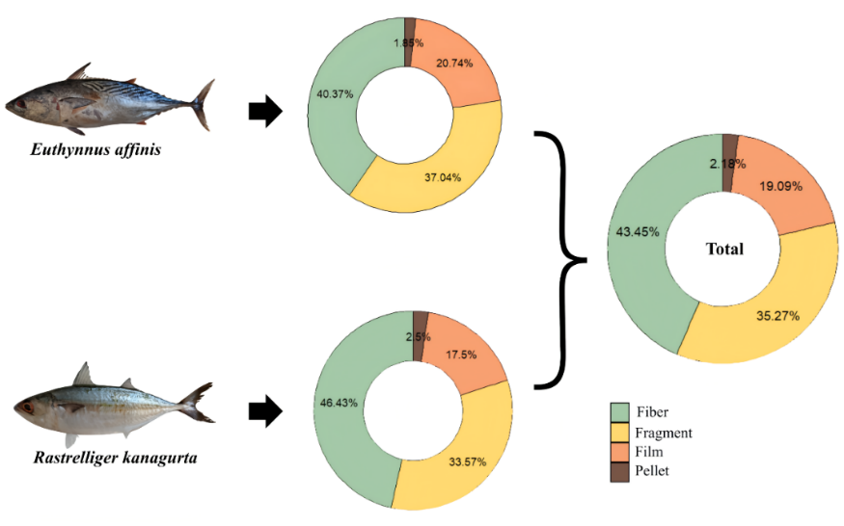  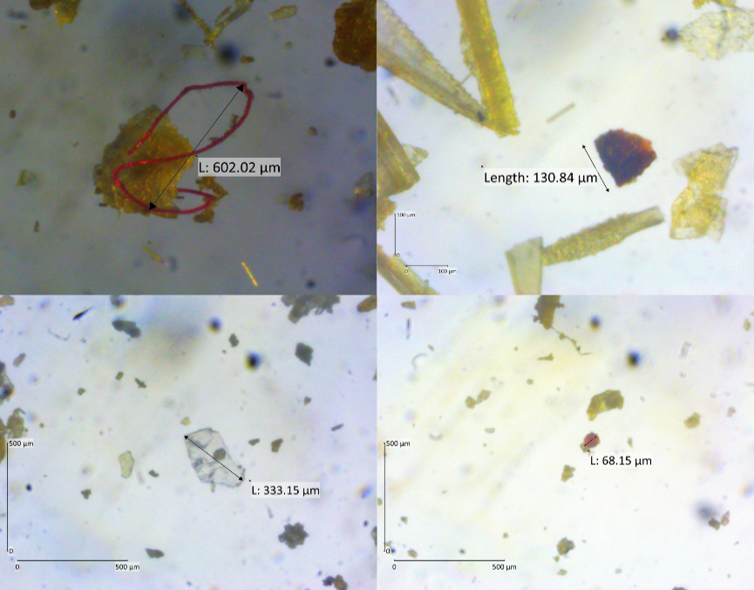  b)  Fiber  Fragmen  Film  Pellet
Figure 1. Microplastic Forms in Tuna and Mackerel, a) abundance of microplastic forms, b) microscopic images of microplastic forms

Dominasi fiber diduga kuat berkaitan dengan tingginya aktivitas domestik dan industri tekstil yang menghasilkan The dominance of fiber is strongly suspected to be related to the high domestic and industrial textile activities that produce synthetic fibers, which are then carried into the aquatic environment and potentially accumulated in the body of fish (Zhang et al., 2022). The flexible, lightweight and elongated nature of fibers makes them easily suspended in the water column and more likely to be ingested by fish, either actively or passively. Because they resemble plankton or small invertebrates, fiber particles can easily be mistaken for prey by pelagic fish that rely on vision in foraging (Mizraji et al., 2017; Ory et al., 2018).
Experiments by Roch et al., (2020) support these findings by showing that fish with a visual feeding orientation tend to have higher microplastic ingestion rates than fish with olfactory or taste (chemosensory) systems. Pathways for microplastics to enter fish include active ingestion due to misidentification, passive ingestion during foraging, serta transfer trofik dari mangsa yang telah terkontaminasi (Welden et al., 2018). Thus, the shape of fibers that resemble natural food particles, coupled with the visual feeding behavior of pelagic fish, are major factors in the high accumulation of microplastics in these species.

3.3. Microplastics color
The results of this study showed that microplastics found in tuna (Euthynnus affinis) and mackerel (Rastrelliger kanagurta) were dominated by transparent particles, followed by black (Figure 2a). The dominance of transparent particles is most likely due to the physical and chemical degradation of plastics, such as UV exposure, abrasion, and biological weathering processes, which cause plastics to lose their original color (Song et al., 2017). Transparent colors also tend to be difficult for fish to visually recognize, putting them at greater risk of accidental ingestion, especially by fish that actively forage in the water column.
Feeding behavior also influences the color type of microplastics ingested. Tuna, which are opportunistic carnivores, and mackerel, which are filter feeders, have different microplastic ingestion tendencies. Tuna can ingest particles that resemble prey, while the filtering system of mackerel facilitates the entry of small transparent microplastics with plankton (Pebiloka et al., 2023; Rahma et al., 2024). The black color found is likely from recycled plastic or rubber-based materials, such as nets, pipes, and garbage bags.
Transparent microplastics generally come from single-use plastics such as bottles, food packaging, and clear plastic bags. Photodegradation and abrasion processes in aquatic environments cause these plastics to fragment into small particles that remain translucent, resembling zooplankton or fish eggs, increasing the likelihood of active or passive ingestion. In contrast, black-colored particles containing carbon black are more resistant to degradation and tend to last longer in the environment. Their dark color also makes it difficult for fish to distinguish them from detritus or organic particles, especially in turbid waters (Bessa et al., 2018).

a) | 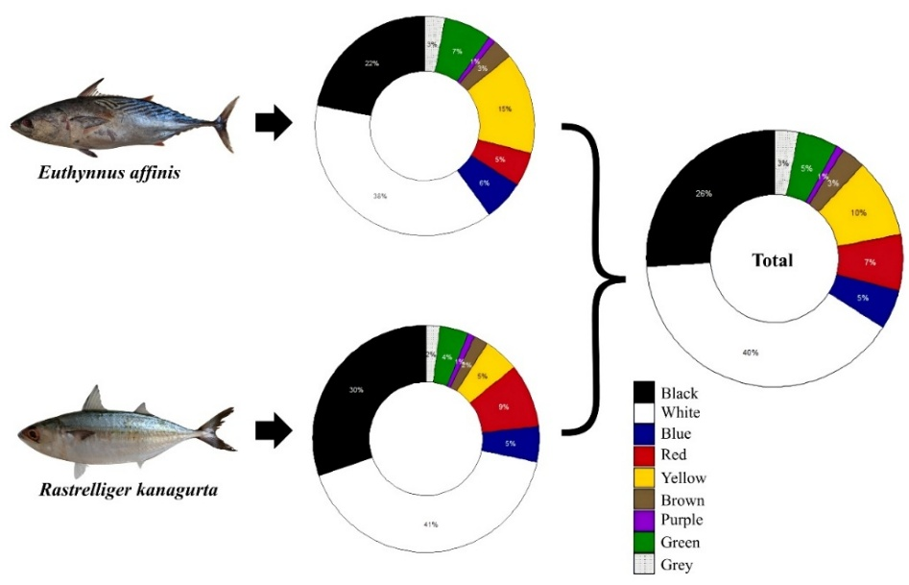
b) | 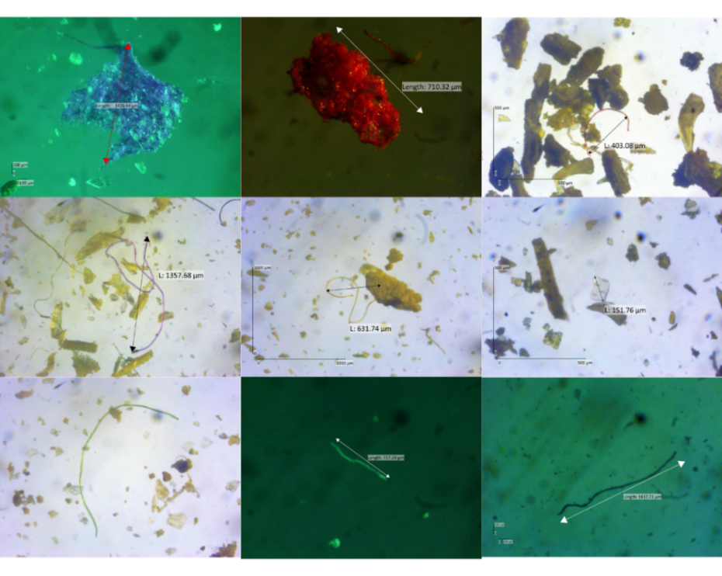
Figure 2. Microplastics color in Tuna and Mackerel, a) percentage of microplastic color, b) microscopic color of microplastic

Furthermore, the color of microplastics is closely related to fish feeding strategies. Omnivorous and carnivorous species generally have higher levels of microplastic exposure due to lower selectivity to prey, including particles that resemble natural food such as transparent and black colored microplastics (Oza et al., 2024). This confirms that visual factors, including color, play an important role in the interaction between fish and microplastics in aquatic environments.
.
‎3. 4. Microplastics size
The majority of microplastics found in both fish species were <500 µm in size, with the highest proportion in Euthynnus affinis (72.96%) and Rastrelliger kanagurta (67.14%), and 70% in total (Figure 3a). This indicates that small particles are easier to enter and accumulate in the fish body. The size distribution of microplastics by organ also showed a similar pattern, with the gills dominated by small particles, while the digestive tract contained a wider range of sizes, including medium to large particles. However, small size remained the most dominant form in both organs (Figure 3b).
The size of microplastics plays an important role in determining the likelihood of ingestion of particles by aquatic organisms. The results showed that the majority of microplastics found in Euthynnus affinis and Rastrelliger kanagurta were in the <500 µm range. Particles of this size tend to be suspended in the water column and resemble the size of plankton, making it easier to be consumed accidentally, especially by pelagic fish that actively forage in the surface to sub-surface zone (Wright & Kelly, 2017). The results of this study are consistent with the study of Cordova et al., (2024), which reported that more than 51% of microplastics in Indonesian sub-surface waters, including the North Sea of Java, were below 500 µm in size.
The dominant size distribution of microplastics in the <500 µm range also indicates the potential accumulation of primary microplastics, which are particles that have been produced in micro sizes from the beginning, such as microbeads or fibers from textiles. Meanwhile, particles >500 µm in size tend to be secondary microplastics resulting from the fragmentation of macroplastics that have undergone physical and chemical weathering (Duis & Coors, 2016).

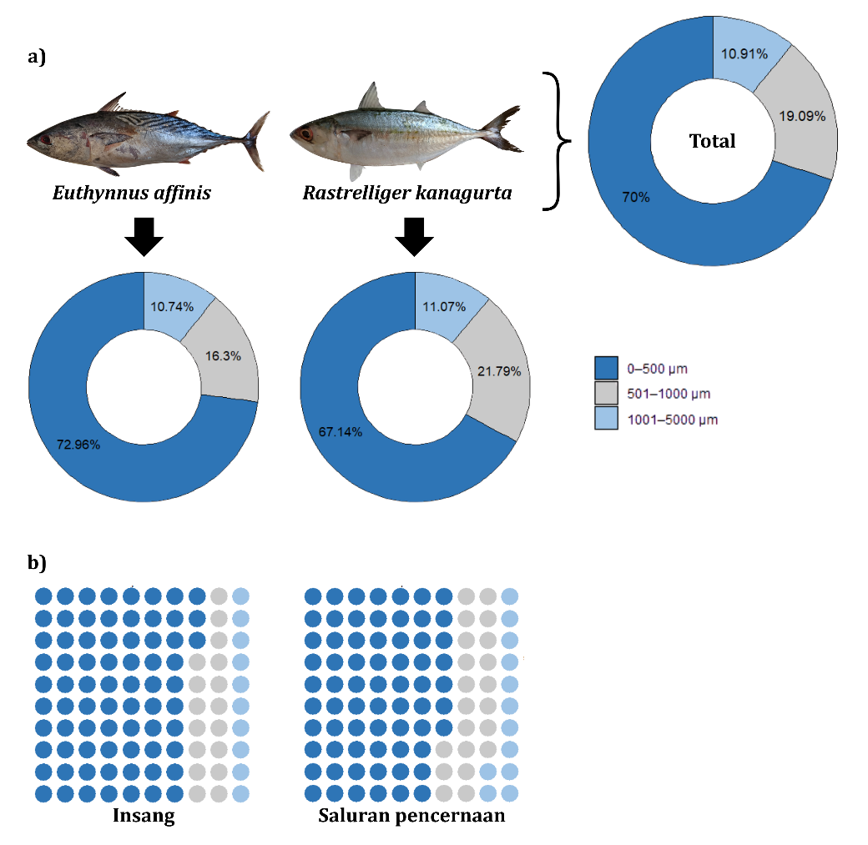

Figure 3. Microplastic Size in Tuna and Mackerel, a) By Individual, b) By Organ

Microplastics <500 µm in size have the potential to penetrate deeper into an organism's tissues, increasing the risk of systemic toxicity. These particles can pass through the digestive system and trigger physiological responses such as oxidative stress, inflammation, and impaired nutrient absorption. In addition, these small particles have a high potential to move between trophic levels, from low-level organisms such as zooplankton to fish, and ultimately to humans as the ultimate consumers (Wright & Kelly, 2017).
The presence of small microplastics in the marine environment is also attributed to the plastic degradation process due to UV exposure, wave abrasion, and microorganism activity, which produces micro-sized fiber particles and fragments. In the Java North Sea region, these small particles were found to dominate, along with local oceanographic characteristics characterized by strong currents and short water residence times, causing suspended microplastics to be evenly distributed in the water column (Cordova et al., 2024; Iskandar et al., 2021).
3.5. Polymer type of microplastics
The results of FTIR spectroscopy analysis showed that the microplastics detected in the gills and digestive tract of Euthynnus affinis and Rastrelliger kanagurta consisted of three main polymer types, namely polyethylene (PE), polyethylene terephthalate (PET), and polystyrene (PS) (Figure 4). These three types are synthetic polymers that are commonly used in various plastic products and have physicochemical characteristics that allow for their widespread presence in the aquatic environment.
In Euthynnus affinis species (Figure 4a), the presence of PE was indicated by absorption peaks at wave numbers 1465, 2852.72, and 2922.16 cm⁻¹, which represent bending vibrations of -CH₂- groups and symmetric and asymmetric stretching of aliphatic C-H bonds, respectively (Amelia et al., 2016). In addition, PET was identified through absorption peaks of 3425.58 cm-¹ (-OH group), 1653 cm-¹ (C=O stretching), 1035.77 cm-¹ (C-O stretching), and 871.82 cm-¹ (aromatic C-H bending), which indicated the typical structure of aromatic esters (Alzuhairi et al., 2018). Pada spesies Rastrelliger kanagurta (Gambar 4b), In Rastrelliger kanagurta species (Figure 4b), in addition to PE and PET showing similar absorption patterns, PS was also identified through wave numbers 1601, 1492, 872.44, 758, and 698 cm-¹, reflecting the presence of aromatic groups and out-of-plane bending of the PS structure (Smith et al., 2024).

a)  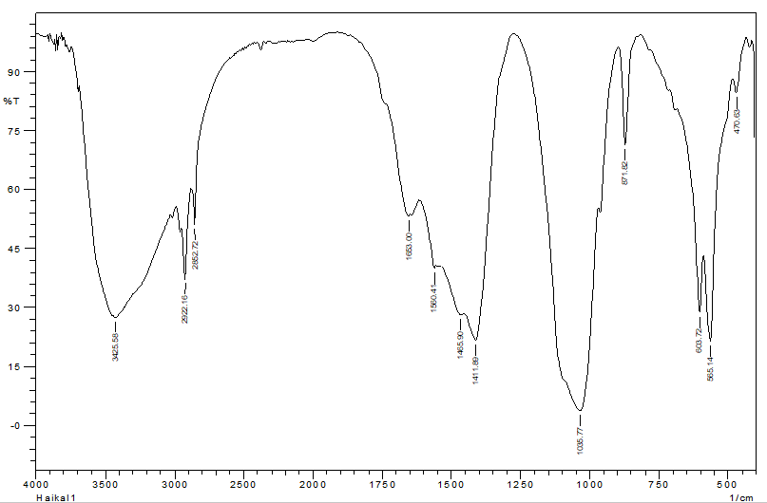 |  | b)  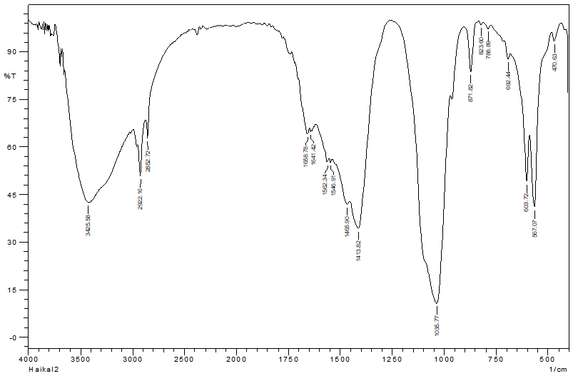
Figure 4. FTIR spectra of microplastics, a) Tuna MPs, b) Mackerel MPs

In Euthynnus affinis species (Figure 4a), the presence of PE was indicated by absorption peaks at wave numbers 1465, 2852.72, and 2922.16 cm⁻¹, which represent bending vibrations of -CH₂- groups and symmetric and asymmetric stretching of aliphatic C-H bonds, respectively (Amelia et al., 2016). In addition, PET was identified through absorption peaks of 3425.58 cm-¹ (-OH group), 1653 cm-¹ (C=O stretching), 1035.77 cm-¹ (C-O stretching), and 871.82 cm-¹ (aromatic C-H bending), which indicated the typical structure of aromatic esters (Alzuhairi et al., 2018). Pada spesies Rastrelliger kanagurta (Gambar 4b), In Rastrelliger kanagurta species (Figure 4b), in addition to PE and PET showing similar absorption patterns, PS was also identified through wave numbers 1601, 1492, 872.44, 758, and 698 cm-¹, reflecting the presence of aromatic groups and out-of-plane bending of the PS structure (Smith et al., 2024).
Polyethylene (PE) is the most widely found type of polymer. PE is known for its low density and high resistance to biological degradation, so it tends to float on the surface of seawater and stay in the environment for a long time. This polymer is commonly used in the production of plastic bags, food wrappers, and fishing equipment such as nets and ropes (Amelia et al., 2016). PET, which was also identified in the samples, is widely used in the manufacture of beverage bottles and food packaging. PET has a higher density and therefore has the potential to settle to the bottom, especially if bound with other particles. PS is found in the form of small particles from Styrofoam products, food containers and plastic cutlery, and is known to fragment easily into very small microplastics.
Each type of polymer has a different toxicological potential. PE is known to disrupt digestive function and inhibit nutrient absorption, while PS is reported to have higher genotoxic effects and is capable of triggering physiological stress such as increased cortisol levels in fish. Meanwhile, PET is associated with oxidative stress and metabolic disorders (Jakubowska et al., 2020; Ma et al., 2024).
The presence of these polymers suggests that the main source of pollution comes from daily human activities, especially from the household, fishery, and food industry sectors. Poorly managed plastic waste tends to fragment and end up as microplastics in the water, which can then accumulate in the bodies of consumed fish. Thus, the presence of PE, PET and PS in fish is not only an indicator of environmental pollution, but also indicates potential risks to food safety and human health through trophic pathways (Windheim et al., 2022).

4. Conclusions
All tuna (Euthynnus affinis) and mackerel (Rastrelliger kanagurta) samples from Traditional Market X Bandung City contained microplastics (100%). The average abundance of microplastics in tuna was 15.00 ± 6.607 particles per individual, while in mackerel it was 15.56 ± 4.630 particles per individual. Microplastics found in the gills and digestive tract of tuna and mackerel have the form of fibers (43%), fragments (36%), films (19%), and pellets (2%). The color of most microplastics is transparent (40%), black (26%), and yellow (10%). Most of the microplastics were <500 µm in size (70%). Based on the type of polymer test, four types of polymers were found, namely polymer types in tuna, namely Polyethylene (PE) and Polyethylene Terephthalate (PET) while in mackerel, namely Polyethylene (PE), Polyethylene Terephthalate (PET) and Polystyrene (PS).

References
Alzuhairi, M., Al-Ghaban, A., & Almutalabi, S. (2018). Chemical recycling of polyethylene terephthalate (waste water bottles) for improving the properties of asphalt mixture. MATEC Web of Conferences, 162, 1–7. https://doi.org/10.1051/matecconf/201816201042
Amelia, R. P. D., Gentile, S., Nirode, W. F., & Huang, L. (2016). Quantitative Analysis of Copolymers and Blends of Polyvinyl Acetate ( PVAc ) Using Fourier Transform Infrared Spectroscopy ( FTIR ) and Elemental Analysis ( EA ). World Journal of Chemical Education, 4(2), 25–31. https://doi.org/10.12691/wjce-4-2-1
Aryani, D., Hasanah, A. N., Haryati, S., & Pratama, R. (2024). Identfikasi Mikroplastik Pada Ikan Bandeng (Cahnos chanos) dan Ikan Tongkol (Euthynnus affinis) di Pasar Tradisional Kranggot, Cilegon-Banten. Berita Biologi, 23(2), 311–319. https://doi.org/10.55981/beritabiologi.2024.4964
Bakir, A., Rowland, S. J., & Thompson, R. C. (2014). Transport of persistent organic pollutants by microplastics in estuarine conditions. Estuarine, Coastal and Shelf Science, 140, 14–21. https://doi.org/10.1016/j.ecss.2014.01.004
Bessa, F., Barría, P., Neto, J. M., Frias, J. P. G. L., Otero, V., Sobral, P., & Marques, J. C. (2018). Occurrence of microplastics in commercial fish from a natural estuarine environment. Marine Pollution Bulletin, 128(October 2017), 575–584. https://doi.org/10.1016/j.marpolbul.2018.01.044
Campopiano, A., Olori, A., Cannizzaro, A., Iannò, A., & Capone, P. P. (2015). Quantification of Tremolite in Friable Material Coming from Calabrian Ophiolitic Deposits by Infrared Spectroscopy. Journal of Spectroscopy, 2015. https://doi.org/10.1155/2015/974902
Chatterjee, S., & Sharma, S. (2019). Microplastics in our oceans and marine health. Field Actions Science Reports. The journal of field actions, Special Issue 19, 54–61. https://journals.openedition.org/factsreports/5257
Cok Istri Agung Sucipta Yudhantari, I Gede Hendrawan, & Ni Luh Putu Ria Puspitha. (2019). Kandungan Mikroplastik pada Saluran Pencernaan Ikan Lemuru Protolan (Sardinella Lemuru) Hasil Tangkapan di Selat Bali. Journal of Marine Research and Technology, 2(2), 48–52. https://doi.org/10.24843/JMRT.2019.v02.i02.p10
Cordova, M. R., Iskandar, M. R., Surinati, D., Kaisupy, M. T., Wibowo, S. P. A., Subandi, R., Ulumuddin, Y. I., Purbonegoro, T., Yogaswara, D., Sani, S. Y., Puspitasari, R., Rositasari, R., Riani, E., Zheng, S., Sun, X., & Wang, Z. (2024). Microplastic occurrence in sub-surface waters of the Indonesian archipelago. Frontiers in Marine Science, 11(March), 1–16. https://doi.org/10.3389/fmars.2024.1362414
Crawford, C. B., & Quinn, B. (2017). Plastic production, waste and legislation. Microplastic Pollutants, 306, 39–56. https://doi.org/10.1016/b978-0-12-809406-8.00003-7
Duis, K., & Coors, A. (2016). Microplastics in the aquatic and terrestrial environment: sources (with a specific focus on personal care products), fate and effects. Environmental Sciences Europe, 28(1), 1–25. https://doi.org/10.1186/s12302-015-0069-y
Hastuti, A. R., Lumbanbatu, D. T. F., & Wardiatno, Y. (2019). The presence of microplastics in the digestive tract of commercial fishes off pantai Indah Kapuk coast, Jakarta, Indonesia. Biodiversitas, 20(5), 1233–1242. https://doi.org/10.13057/biodiv/d200513
Herath, D. R., Perera, H. A. C. C., Hettiarachchi, G. H. C. M., & Ranasinghe, V. K. (2016). Diet composition of Kawakawa (Euthynnus affinis) in three major landing sites of Sri Lanka. Proceedings of the National Aquatic Resources Research and Development Agency (NARA), Scientific Sessions 2016, March, 16–18.
Hidayati, D., F, F., A, A., Ashuri, N. M., Setiawan, E., Mulyadi, Y., Syahroni, N., Joesidawati, M. I., & S, S. (2023). Microplastic Characteristic Found in Gastrointestinal Tract of Pelagic and Demersal Fishes in Tuban, East Java. Journal of Marine-Earth Science and Technology, 4(1), 9–15. https://doi.org/10.12962/j27745449.v4i1.648
Iskandar, M. R., Surinati, D., Cordova, M. R., & Siong, K. (2021). Pathways of floating marine debris in Jakarta Bay, Indonesia. Marine Pollution Bulletin, 169(May), 112511. https://doi.org/10.1016/j.marpolbul.2021.112511
Jakubowska, M., Białowąs, M., Stankevičiūtė, M., Chomiczewska, A., Pažusienė, J., Jonko-Sobuś, K., Hallmann, A., & Urban-Malinga, B. (2020). Effects of chronic exposure to microplastics of different polymer types on early life stages of sea trout Salmo trutta. Science of the Total Environment, 740. https://doi.org/10.1016/j.scitotenv.2020.139922
Koongolla, J. B., Lin, L., Yang, C. P., Pan, Y. F., Li, H. X., Liu, S., & Xu, X. R. (2022). Microplastic prevalence in marine fish from onshore Beibu Gulf, South China Sea. Frontiers in Marine Science, 9(July), 1–8. https://doi.org/10.3389/fmars.2022.964461
Kovač Viršek, M., Palatinus, A., Koren, Š., Peterlin, M., Horvat, P., & Kržan, A. (2016). Protocol for Microplastics Sampling on the Sea Surface and Sample Analysis. Journal of visualized experiments : JoVE, 118. https://doi.org/10.3791/55161
Ma, L., Wu, Z., Lu, Z., Yan, L., Dong, X., Dai, Z., Sun, R., Hong, P., Zhou, C., & Li, C. (2024). Differences in toxicity induced by the various polymer types of nanoplastics on HepG2 cells. The Science of the Total Environment, 918, 170664. https://doi.org/10.1016/j.scitotenv.2024.170664
Mizraji, R., Ahrendt, C., Perez-Venegas, D., Vargas, J., Pulgar, J., Aldana, M., Patricio Ojeda, F., Duarte, C., & Galbán-Malagón, C. (2017). Is the feeding type related with the content of microplastics in intertidal fish gut? Marine Pollution Bulletin, 116(1–2), 498–500. https://doi.org/10.1016/j.marpolbul.2017.01.008
Morgana, S., Ghigliotti, L., Estévez-Calvar, N., Stifanese, R., Wieckzorek, A., Doyle, T., Christiansen, J. S., Faimali, M., & Garaventa, F. (2018). Microplastics in the Arctic: A case study with sub-surface water and fish samples off Northeast Greenland. Environmental Pollution, 242, 1078–1086. https://doi.org/10.1016/j.envpol.2018.08.001
Olori, A., Pietro, D., & Campopiano, A. (2021). Preparation of Uktrapure KBr Pellet: New Methode for FTIR Quantitative Analysis. International Journal of Science Academic Research, 02(02), 1015–1020. http://www.scienceijsar.com
Ory, N. C., Gallardo, C., Lenz, M., & Thiel, M. (2018). Capture, swallowing, and egestion of microplastics by a planktivorous juvenile fish. Environmental Pollution, 240, 566–573. https://doi.org/10.1016/j.envpol.2018.04.093
Oza, J., Rabari, V., Yadav, V. K., Sahoo, D. K., Patel, A., & Trivedi, J. (2024). A Systematic Review on Microplastic Contamination in Fishes of Asia: Polymeric Risk Assessment and Future Prospectives. Environmental Toxicology and Chemistry, 43(4), 671–685. https://doi.org/10.1002/etc.5821
Pebiloka, S., Johansyah, A., & Aggadhania, L. (2023). Production volume of mackarel tuna (Euthynnus affinis) as a one of fisheries commodity in Singkawang City. Journal of Fisheries and Marine Applied Science, 1(1), 26–32. https://doi.org/10.58184/jfmas.v1i1.36
Prata, J. C., Castro, J. L., da Costa, J. P., Duarte, A. C., Rocha-Santos, T., & Cerqueira, M. (2020). The importance of contamination control in airborne fibers and microplastic sampling: Experiences from indoor and outdoor air sampling in Aveiro, Portugal. Marine Pollution Bulletin, 159. https://doi.org/10.1016/j.marpolbul.2020.111522
Rahma, H. S., Ayuningtyas, H. R., Nabila, I., Dadiono, M. U. H. S., Naim, D., & Setyawan, A. D. W. I. (2024). Review : The nutritional value and health benefits of kawakawa ( Euthynnus affinis ). 8(2), 72–83. https://doi.org/10.13057/oceanlife/o080203
Roch, S., Friedrich, C., & Brinker, A. (2020). Uptake routes of microplastics in fishes: practical and theoretical approaches to test existing theories. Scientific Reports, 10(1). https://doi.org/10.1038/s41598-020-60630-1
Rochman, C. M., Tahir, A., Williams, S. L., Baxa, D. V., Lam, R., Miller, J. T., Teh, F. C., Werorilangi, S., & Teh, S. J. (2015). Anthropogenic debris in seafood: Plastic debris and fibers from textiles in fish and bivalves sold for human consumption. Scientific Reports, 5(April), 1–10. https://doi.org/10.1038/srep14340
Seetapan, K., & Prommi, T. O. (2023). Microplastics in commercial fish digestive tracts from freshwater habitats in Northern Thailand. Ecologica Montenegrina, 68, 48–65. https://doi.org/10.37828/EM.2023.68.6
Smith, C. A., Mandal, S., Fan, C., & Pramanik, S. (2024). Microplastic Volatile Organic Compounds Found within Chrysaora chesapeakei in the Patuxent River, Maryland. In Microplastics (Vol. 3, Nomor 2, hal. 250–263). MDPI AG. https://doi.org/10.3390/microplastics3020015
Song, Y. K., Hong, S. H., Jang, M., Han, G. M., Jung, S. W., & Shim, W. J. (2017). Combined Effects of UV Exposure Duration and Mechanical Abrasion on Microplastic Fragmentation by Polymer Type. Environmental Science and Technology, 51(8), 4368–4376. https://doi.org/10.1021/acs.est.6b06155
Suprijanto, J., Senduk, J. L., & Makrima, D. B. (2021). Penggunaan Fourier Transform Infrared untuk Analisis Mikroplastik pada Loligo sp. dan Rastrelliger sp. dari TPI Tambak Lorok Semarang. Buletin Oseanografi Marina, 10(3), 291–298. https://doi.org/10.14710/buloma.v10i3.38964
Veerasingam, S., Al-Khayat, J. A., Aboobacker, V. M., & Vethamony, P. (2024). Microplastics in the Arabian/Persian Gulf marine environment: Abundance, characterization, ecotoxicological effect, and implications. In Meso and Microplastic Risk Assessment in Marine Environments (hal. 27–42). Elsevier. https://doi.org/10.1016/b978-0-323-90980-8.00004-2
Welden, N. A., Abylkhani, B., & Howarth, L. M. (2018). The effects of trophic transfer and environmental factors on microplastic uptake by plaice, Pleuronectes plastessa, and spider crab, Maja squinado. Environmental Pollution, 239, 351–358. https://doi.org/10.1016/j.envpol.2018.03.110
Windheim, J., Colombo, L., Battajni, N. C., Russo, L., Cagnotto, A., Diomede, L., Bigini, P., Vismara, E., Fiumara, F., Gabbrielli, S., Gautieri, A., Mazzuoli-Weber, G., Salmona, M., & Colnaghi, L. (2022). Micro- and Nanoplastics’ Effects on Protein Folding and Amyloidosis. International Journal of Molecular Sciences, 23(18), 1–13. https://doi.org/10.3390/ijms231810329
Wright, S. L., & Kelly, F. J. (2017). Plastic and Human Health: A Micro Issue? Environmental Science and Technology, 51(12), 6634–6647. https://doi.org/10.1021/acs.est.7b00423
Zhang, M., Liu, S., Bo, J., Zheng, R., Hong, F., Gao, F.-L., Miao, X., Li, H., & Fang, C. (2022). First Evidence of Microplastic Contamination in Antarctic Fish (Actinopterygii, Perciformes). In Water. https://doi.org/10.3390/w14193070
Zhou, J., Wen, Y., Marshall, M. R., Zhao, J., Gui, H., Yang, Y., Zeng, Z., Jones, D. L., & Zang, H. (2021). Microplastics as an emerging threat to plant and soil health in agroecosystems. Science of the Total Environment, 787, 147444. https://doi.org/10.1016/j.scitotenv.2021.147444
Arnia dan Warganegara. 2012. Identifikasi Kontaminasi Bakteri coliform pada Daging sapi Segar yang Dijual di Pasar Sekitar Kota Bandar Lampung. Majority 26 (4) 101-108. ISSN 2337-3776.
Bazrafshan, E., F. Kord Mustafapour, M. Farzadkia, K.A. Ownagh, A.H. Mahvi. 2012. Slaughter house Wastewater Treatment by Combined Chemical Coagulation and Electrocoagulation Process. Plos ONE 7 (6): e40108. Doi:10.1371/journal.pone.0040108.
Darmayasa, I.G.B. 2008. Isolasi dan Identifikasi Bakteri Pendegradasi Lipid (lemak) pada Beberapa Tempat Pembuangan Limbah dan Estuari DAM Denpasar. Jurnal Bumi Lestari, Vol. 8 No. 2, Agustus 2008. Hal 122-127.
Effendi, H. 2003. Telaah kualitas air bagi pengelola sumber daya dan lingkungan perairan. Yogyakarta. Kanisius.
Kementerian Pertanian. 2010. Peraturan Menteri Pertanian Republik Indonesia No. 13/permentan/OT.140/I/2010 Tentang Persyaratan Rumah Potong Hewan Ruminansia dan Unit Penanganan daging (meat cutting plant).
Kementerian Lingkungan Hidup. 2014. Peraturan Menteri Lingkungan Hidup No. 5 Tahun 2014 Tentang Baku Mutu Air Limbah.
Kobya, M., E. Sentruk, C. Aydiner and E. Demirbas. 2006. Treatment of potato chips manufacturing waste
water by electroagulation. Desalination, 190: 201-211.

Kundu, P., A. Dabsarkar, S. Mukherjee. 2013. Treatment of Slaughter House Wastewater in a sequencing Batch Reactor, Performance evaluation and Biodegradation Kinetics. Hindawi Publishing Corporation, BioMed Research International Article ID134872, II pages.

