Non Verbal Communication in Anime "Diamond no Ace" Chapter 1 and 2
(Barthes Semiotic Approach)
Ningrum Tresnasari, S.S.,M.A.

Widyatama University, Jalan Cikutra No 204A, Bandung 40125, Indonesia

Email: ningrum.tresnasari@widyatama.ac.id

Abstract

Non-verbal communication is a process of communication in which the media used to communicate is bodily movements or cues as a form of depiction of emotions and feelings. Non-verbal communication consists of several types, but in this study only focus on kinesik markers namely body movements such as facial expressions, eye contact, hand movements and others. This study aims to describe the types and meanings contained in the kinesik markers in the anime "Diamond no Ace". The research data used are anime “Diamond no ace” episodes of episodes 1 and 2. The research method used is the semiotics approach toarth. The types of kinesik markers on the facial sign include the eyes, eyebrows, forehead, cheeks mouth and teeth, while the gestures include hand movements and body postures ranging from head to foot and iconography. In addition, the meaning contained in the kinesik marker is divided into denotation and connotation meanings.

Keywords: non-verbal communication; kinesik markers; anime

- Introduction
Verbal communication (verbal communication) is a form of communication delivered by the communicator to the communicant in a written (written) or oral (oral) manner (Pharm, 2010). This type of language when viewed from its understanding focuses more on delivering clear messages to the speaker. Verbal language uses alphanumeric (alphanumeric), one of the most impressive human advantages (Alatas, 2013).
But the public is now aware that communication can not only be conveyed through words, which means that non-verbal language is very important in its use. The working definition of nonverbal communication itself is verbal and not verbal messages that are expressed through other tools outside the language tool (Herlina, 2014).
A person's ability to communicate is not only seen from how the person speaks, but also from their attitude. Body language is an important point and is used more often, and is the most honest thing humans do in communicating. One form of nonverbal communication is kinesic. Kinesics includes facial expressions, gestures, gait and posture, and visible arm and body movements. In the 1960s the Japanese group supported the concept that there are large cultural differences in emotional assessments (Handayani, 2013).
Dewita (2012) had previously researched nonverbal communication with the title "Speeches and Kinesics in Japanese Films". In her research, Dewita explained the various kinds of utterances and kinesics of the gesture section and explained the meaning and purpose. Based on the data analysis carried out, it can be concluded that there are several meanings of utterances and kinesics that appear in Japanese films, namely "thank you", "I'm sorry", "good night", "please", "wait a minute", "I", "hooray", "what do you want?", "Come here", and others. Kinesics that are often used by Japanese people are hands.

The difference between the author's research and previous research lies in the object to be researched. This research discusses the types and meanings contained in the kinesic markers in the anime "Diamond no Ace" episodes 1 and 2. The author chose anime media because the expressive form is more attractive in describing the character, and the anime I chose is an example of body movement reflection. which is almost the same in the general public. Apart from that, anime is almost the same as cartoons, and cartoons approach the reflection of human characteristics in general caricaturally (Sasongko (2005: 9) in Vera (2014: 96)).

- Methods
This type of research is a research by Roland Barthes's semiotic analysis method. This method studies how humanity interprets things. Understanding (to sinify) in this case cannot be confused by communicating (to communicate). Meaning means that objects not only carry information, in which case they want to communicate, but also constitutes a structured system of signs (Barthes, 1988: 178 in Sobur, 2009: 15). Barthes uses the term orders of signification. First order of signification is denotation, while connotation is second order of signification. The first order includes markers and markers in the form of signs. This sign is called the meaning of denotation. Then from that sign comes another meaning, another mental concept attached to the sign (marker). This new usage then becomes the connotation. (Mayo, 2009).

- Result and Discussion
The overall data that the authors managed to collect amounted to 16 expressions, with details of episode 1 there are 8 expressions and episode 2 there are 3 expressions. The selection of these images is based on what the writer will research about nonverbal markers to study the habits of Japanese society, therefore the writer chooses images with expressions and gestures that are shown by the characters in accordance with what is in real life but still contains elements of anime. The data that the writer will examine include the following.

3.1 Kind of Kinesic Sign

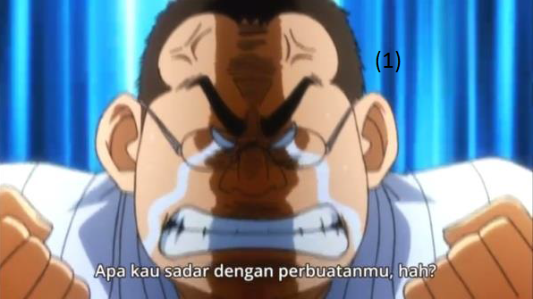

Figure 1: Picture of Sano Sensei

(Data 1)
Category | Explanation
Facial Sign | Eyes narrowed sharply
 | Brow in a dip
 | mouth open and teeth clenching
Gesture | both hands clenched into fists
Body Posture | Shoulders raised
Iconography | speedline
 | Heavy tears
 | Black aura
 | T-symbol

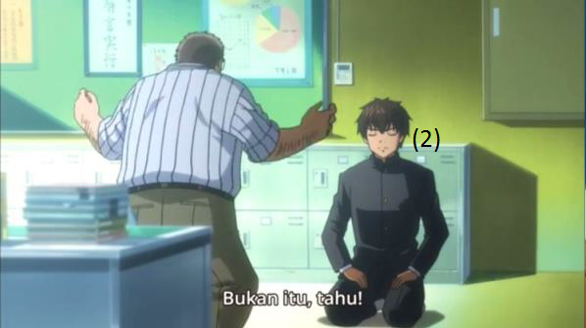

Figure 2: Picture of Eijun

(Data 2)

Category | Explanation
Facial Sign | Eyes closed
 | mouth closed relaxed
Gesture | both hands on the thigh
Body posture | fold the legs under the body
Iconograhpy | -

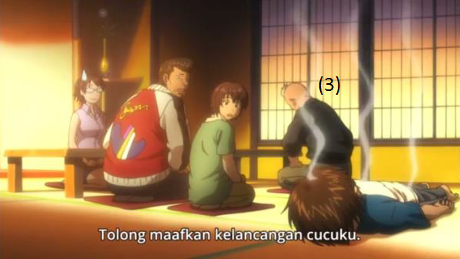

Figure 3: picture of Eijun’s grandfather

(Data 3)
Category | Explanation
Facial sign | -
Gesture | both hands on the thigh
 | elbows bend
Body Posture | Sit on the calf
 | Bend down
 | Head down
Iconography | -

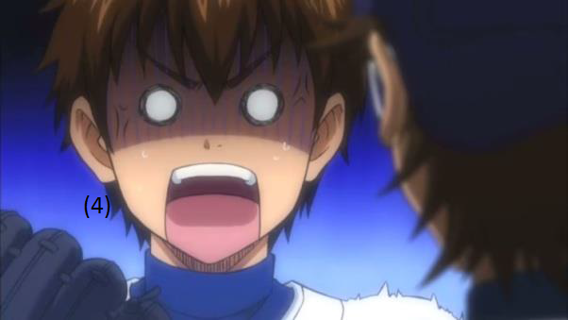Figure 4: Picture of Eijun

(Data 4)
Category | Explanation
Facial Sign | Eyes rounded
Gesture | -
Body Posture | Shoulders taut up
Iconography | Light blue background
 | T-symbol
 | Purple lines on the forehead
 | Empty eyes
 | The shoulders trembled like shocked



Figure 5: Picture of Eijun’s grandfather

(Data 5)
Category | Explanation
Facial sign | Mouth wide open
 | Arched eyebrows
 | Eyes narrowed
Gesture | Wiping the back of the head
Body Posture | Raise head
Iconography | White-yellow-orange background
 | Blushing

3.2 Meaning of Kinesic Sign

No  Data | Category |  | Denotatif Meaning | Konotatif Meaning | Expression
1 | Facial  Sign | Eyes narrowed sharply | Almost closed the eyelid | Showing dislike towards something | Angry
1 | Facial  Sign | Brow in a dip | Curved and swooping eyebrows close together | Angry, annoyed, or confused | Angry
1 | Facial  Sign | mouth open and teeth clenching | Mouth open and upper and lower teeth clash with each other | Keep one's temper | Angry
1 | Gesture | both hands clenched into fists | Bend the five fingers and press them like squeezing something | Withstand explosive emotions | Angry
1 | Body  Posture | Shoulders raised | Raise the shoulder position to be higher or make the shoulder position parallel to the chin | Hold back emotions | Angry
1 | Icono  graphy | speedline | background with vertical lines in blue and white | to maintain the feel of anime lovers and to reinforce action | Angry
1 | Icono  graphy | Heavy tears | Water comes out of the eyes swiftly | depicts the emotions of a sad character but still gives a comedy effect | Angry
1 | Icono  graphy | Black aura | The appearance of black aura around the body or face | Is a bad trait and usually has bad intentions towards others | Angry
1 | Icono  graphy | T-symbol | The appearance of lines that form a T-junction like veins on the skin | Indicates if the character is feeling angry or angry | Angry
2 | Facial  Sign | Eyes closed | eyelid closed perfectly | try to focus on what is being heard | Calm
2 | Facial  Sign | mouth closed relaxed | lips pressed together | no intention of interrupting the other person | Calm
2 | Gesture | both hands on the thigh | put both palms on the thighs | traditional japanese way of sitting (seiza) | Calm
2 | Body  posture | fold the legs under the body | body sitting on folded legs | traditional japanese way of sitting (seiza) | Calm
2 | Icono  grahpy | - | - | - | Calm

3 | Facial  sign | - | - | - | Sorry
3 | Gesture | both hands on the thigh | Put your palms on each thigh | One of the expressions of apology in Japanese culture is shown by traditional Japanese sitting (seiza) coupled with forming (ojigi). | Sorry
3 | Gesture | elbows bend | Bend your elbows outwards |  | Sorry
3 | Body  Posture | Sit on the calf | Sitting on bent legs |  | Sorry
3 | Body  Posture | Bend down | Bend forward |  | Sorry
3 | Body  Posture | Head down | Lower the head slightly down |  | Sorry
3 | Icono  graphy | - | - | - | Sorry
4 | Facial  Sign | Eyes rounded | Eyes wide open | shocked | Surprised  and upset
4 | Gesture | - | - | - | Surprised  and upset
4 | Body  Posture | Shoulders taut up | shoulder position rises | shocked | Surprised  and upset
4 | Icono  graphy | Light blue background | Background with gradations of light blue | Blue symbolizes fear while light blue has a cold nature | Surprised  and upset
4 | Icono  graphy | T-symbol | The appearance of lines forms a T-junction symbol resembling the veins from the skin's surface | Angry or annoyed | Surprised  and upset
4 | Icono  graphy | Purple lines on the forehead | The appearance of a purple horizontal line on the forehead | purple indicates a feeling of shock and feeling pain in the stomach | Surprised  and upset
4 | Icono  graphy | Empty eyes | Eyes that do not have iris | Feel surprised and stunned | Surprised  and upset
4 | Icono  graphy | The shoulders trembled like shocked | A phenomenon when the body is electrified by large electric currents so that shock occurs in the organs of the body | When someone is hit by an electric current, his body will be shocked and experience a shock sensation. In other words, someone who is shocked feels like being stunned. | Surprised  and upset

5 | Facial  sign | Mouth wide open | Both ends of the lips raised until the mouth is wide open with a "haha" sound | Expressing happiness or overflowing emotions | Happy
5 | Facial  sign | Arched eyebrows | The inner brow is pulled up to the lower end of the eyebrows | Expressing happiness or overflowing emotions | Happy
5 | Facial  sign | Eyes narrowed | Almost closed the eyelid | Expressing happiness or overflowing emotions | Happy
5 | Gesture | Wiping the back of the head | Put one hand behind the head and wipe it | In Japan, people who feel shy or nervous usually rub their heads back to neutralize their feelings | Happy
5 | Body  Posture | Raise head | The chin lifted face upward | Confident and proud | Happy
5 | Icono  graphy | White-yellow-orange background | Background with vertical gradations white-yellow-orange | white has the meaning of naivete, cheerful for orange, and bright and friendly for yellow | Happy
5 | Icono  graphy | Blushing | Part or all of the face turns red | Embarrassed, happy, or in love, and makes the character so much sweeter | Happy

- Conclusions
Based on the above analysis, the authors conclude that in the "Diamond no Ace" episodes 1 and 2 there are many nonverbal markers (in this case kinesik) found, especially in hand gestures. From the whole scene, there are 43 kinesik markers on the facial sign ranging from the eyes, eyebrows, forehead, mouth cheeks and teeth, 15 gestures on the gesture, 25 on the body posture starting from the head, shoulders and body, while on iconography there are 12 markers. From these markers, it can be known various expressions that show the characters, ranging from anger, surprise, to feelings of disbelief.
Based on the theory of Semiotics Barthes, each marker has 2 meanings, namely connotative meaning and denotative meaning. The term meaning used is orders of signification. First order of signification is the meaning of denotation, where all markers are stated in accordance with what is seen while the connotation meaning or second order of signification is the meaning implied from what is seen.

References
Eskawati, Dewi. 2015. Pintar Membaca Watak dan Pikiran Orang Lain. Yogyakarta: Notebook.
Macwilliams, Mark W. 2008. Japanese Visual Culture. New York: M.E. Sharpe, Inc.
Navarro, Jeo. 2014. Cara Cepat Membaca Bahasa Tubuh. Jakarta: PT. Zaytuna Ufuk Abadi.
Sobur, Alex. 2009. Semiotika Komunikasi. Bandung: PT Remaja Rosdakarya.
Vera, Nawiroh. 2014. Semiotika dalam Riset Komunikasi. Bogor: Ghalia Indonesia.

PAGE LIBRARY:
Alatas, Salim. 2013. Bahasa: Aspek Verbal dalam Komunikasi. [online]. <https://salimalatas.wordpress.com/2013/11/02/bahasa-aspek-verbal-dalam-komunikasi/> diakses pada tanggal 05 Maret 2015.
Basnendar. 2010. Kajian Makna Kartun Editorial Melalui Pendekatan Ikonografi. [online]. <http://basnendar.dosen.isi-ska.ac.id/2010/07/26/kajian-makna-kartun-editorial-melalui/> diakses pada tanggal 09 Juli 2015.
Handayani. 2013. Kinesik. [online]. <http://stia- asmisolo.ac.id/jurnal/index.php/jmbb/article/download/30/28> diakses pada tanggal 20 Januari 2015.
Herlina. 2014. Komunikasi Nonverbal. [online]. <file.upi.edu/...HERLINA/IP-TM5_KOMUNIKASI_NONVERBAL.pdf> diakses pada tanggal 19 Januari 2015
Herlina. 2014. Sistem Komunikasi Kinesik. [online]. <file.upi.edu/.../FIP/.../IP-TM6_SISTEM_KOMUNIKASI_KINESIK.pdf> diakses pada tanggal 19 Januari 2015.
Kristianto, Ruben. 2013. Iconography. [online]. <https://prezi.com/xsre0ufirm_t/untitled-prezi/> diakses pada tanggal 08 Juli 2015.
Mayo, Melisa Septiana. 2009. Teori Semiotik Konotasi Foto Menurut Roland Barthes. [online]. <http://melisamayo.blogspot.com/2009/12/teori-semiotik-konotasi-foto-menurut.html> diakses pada tanggal 11 Juli 2015.
Miles. 2014. Expressions of Emotions: Manga Iconography. [online]. <http://www.intlictc.com/2014/expressions-of-emotions-manga-iconography/> diakses pada tanggal 11 Mei 2015.
Pamangsah, Anang. 2009. Gender dalam Komunikasi Nonverbal. [online]. <http://pamangsah.blogspot.com/2009/06/gender-dalam-komunikasi-non-verbal.html> diakses pada tanggal 17 April 2015.
Pharm, Fredy. 2010. Pengertian Komunikasi Verbal dan Nonverbal. [online]. <ferdy-pharm.blogspot.com/2010/01/pengertian-komunikasi-verbal-dan-non.html> diakses pada tanggal 17 April 2015.

