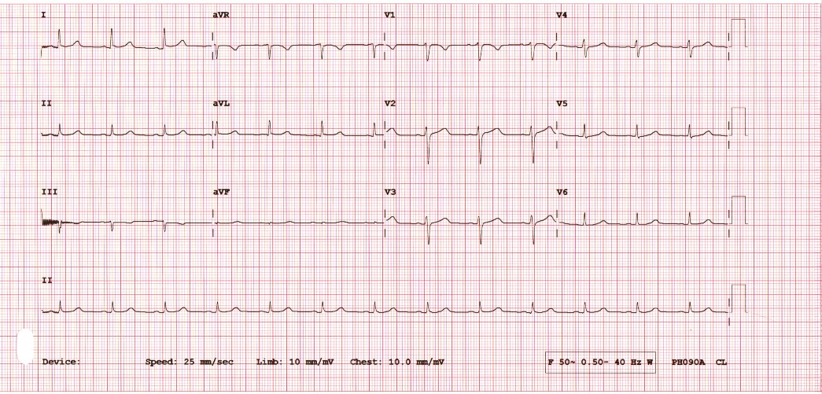
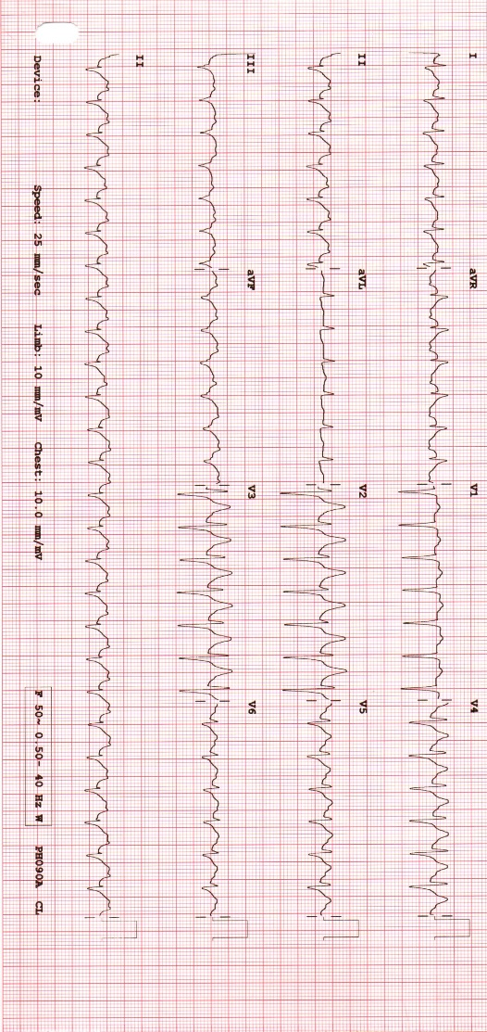
b

A
B
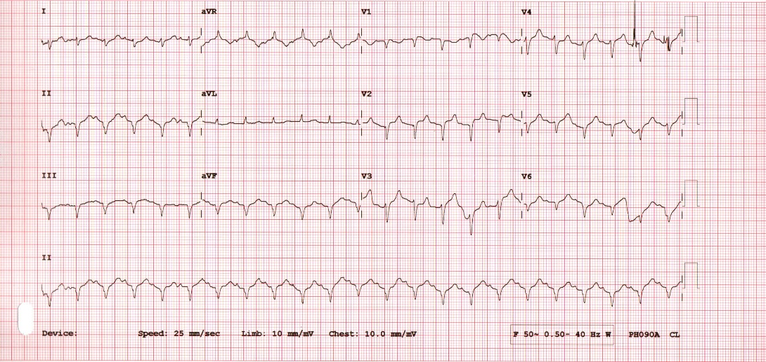
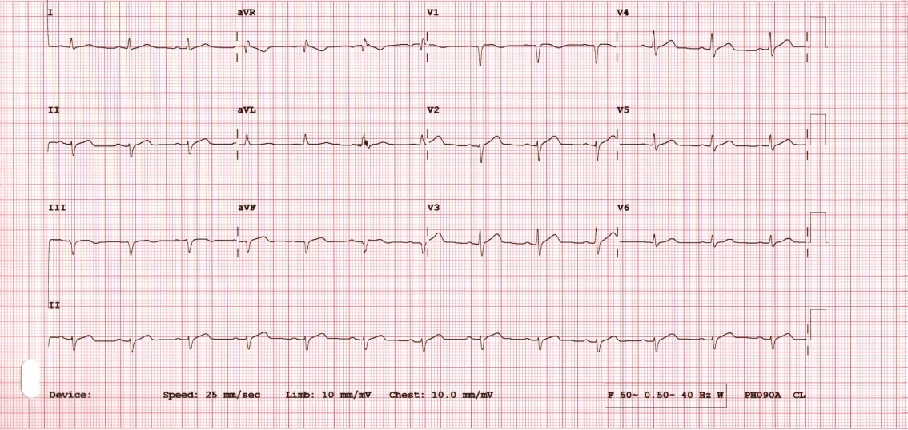

C
D
Gambar 4. A gambaran EKG perawatan hari ke-7 (sebelum komplikasi emboli paru), B. Gambaran EKG saat terjadi kecurigaan komplikasi emboli paru. Didapatkan Sinus Takikardi, pemanjangan interval QTC 552 ms dan pola S1Q3T3, C. Gambaran EKG 1 hari setelah kecurigaan komplikasi emboli paru, sinus takikardi pola S1Q3T3, Right Axis deviation, dan tidak ditemukan lagi pemanjangan QTc interval, D. Gambaran EKG perawatan hari ke -19, didapatkan gambaran Sinus ritme.
 | H1 | H.7 | H.8 | H.9 | H.10 | H.14 | H.14 | H.15 | H.16 | H.17 | H.18 | H.21 | H.24 | H.25 | H.28
Terapi O2 | NC 4 lpm | HFNC 60lpm FiO2 81% | HFNC 60lpm FiO2 81% | HFNC 60lpm FiO2 81% | HFNC 60lpm FiO2 81% | NC 4 lpm | On venti  PC BIPAP  FiO2 100% | On venti  PC BIPAP  FiO2 95% | On venti  PC BIPAP  FiO2 90% | On venti  PC BIPAP  FiO2 90% | On venti  PC BIPAP  FiO2 80% | On venti PC BIPAP  FiO2 : 50% | On venti  PC BIPAP  FiO2 : 60% | HFNC 60lpm FiO2 71% | NK 3lpm
SpO2 | 98 | 68 | 91 | 94 | 93 | 89 | 78 | 88 | 93 | 97 | 97 | 98 | 98 | 98 | 97
PO2 | 116 | 42 | 52 | 67 | 58 | 52 | 49 | 57 | 73 | 93 | 92 | 96 | 98 | 90 | 79
P/F Ratio | 351,5 | 51,8 | 64,1 | 82,7 | 71,6 | 140,5 | 49 | 57 | 76,8 | 103,3 | 115 | 192 | 163,3 | 126.7 | 213
Hb | 15.6 |  | 14.1 |  |  | 15.3 | 15.2 |  |  |  | 13.6 | 13.6 | 12.8 | 12.9
Trombosit | 150.000 |  | 318000 |  |  | 429000 | 414000 |  |  |  | 184000 | 91000 | 529000 | 310.000
aPTT | 34.2 |  |  | 24 | 31.5 | 25.9 | 51.5 | 44.2 | 65.2 | 44.9 | >100 | 27.1 | 25.7 | 33.8
LDH | 566 |  |  | 574 |  | 536 |  |  |  |  | 903 | 794 |  | 689
CRP | 48 | <6 | >32 | >32 |  |  |  | 1.8 |  |  | 15.7 | 50.5 |  |  | 88.2
D-dimers | 0.23 |  | 0.58 |  |  |  |  |  |  |  | <0.19
Terapi Heparin | - | Inj Heparin 2x5000 IU | Inj Heparin 2x5000IU | Inj Heparin 1x5000IU | Inj Heparin 1x5000IU | Drip Heparin 1600 IU/jam | 7200 IU bolus iv  Drip Heparin 1600 IU/jam | Drip Heparin 1000 IU/jam | Drip Heparin 1000 IU/jam | Drip Heparin 1000 IU/jam | Drip Heparin 1000 IU/jam | Inj heparin 3x5000 IU sc | Inj heparin 3x5000 IU sc | Inj heparin 3x5000 IU sc | -
Tabel 1 Data Tren pasien selama perawatan di RSUD Ulin Banjarmasin
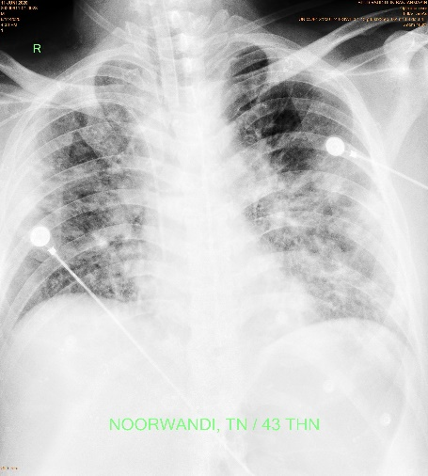
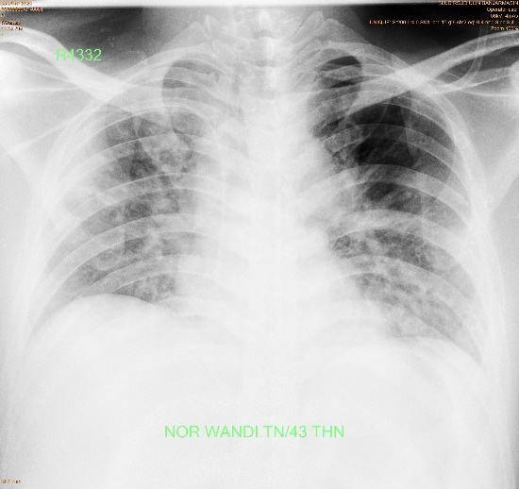
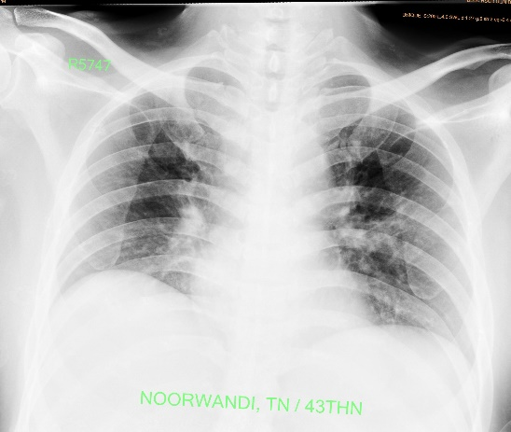
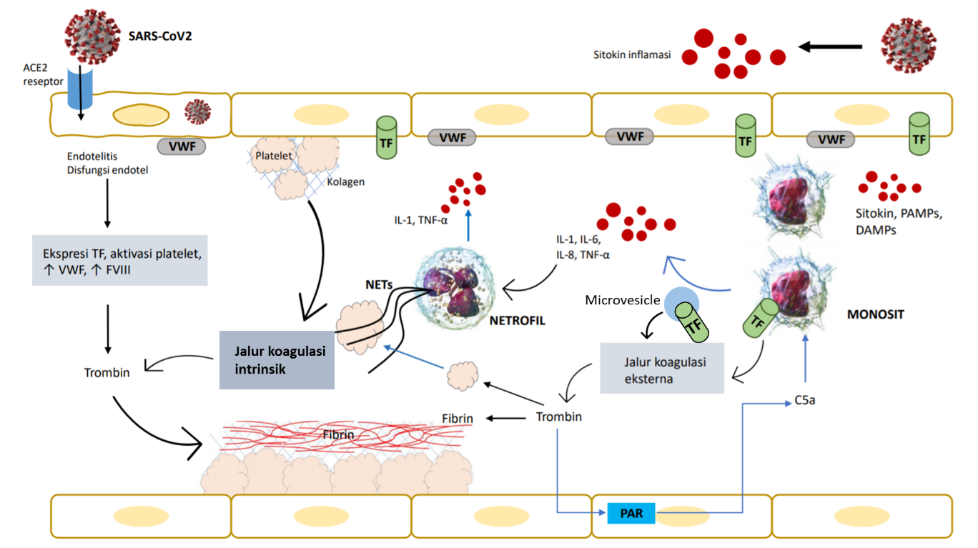
Hari Perawatan ke 12
Hari Perawatan ke 14
Hari Perawatan ke 50
Hari Perawatan ke 1
Jalur Koagulasi Ekstrinsik

