October 20th 2020

Dear Dr. Urip Budiono
Editorial Office of JAI (Jurnal Anestesiologi Indonesia)
Department of Anesthesiology and Intensive Theraphy, Faculty of Medicine, Diponegoro University/ Dr. Kariadi General Hospital Medical Center (RSUP Dr. Kariadi)
Jl. Dr. Soetomo No. 16 Semarang, Central Java, Indonesia, 50231
Telp. : (024) 8444346
Email : janestesiolgo@gmail.com

On behalf of all the authors, I would like to ask you to consider our manuscript entitled “Perioperative Management Pediatric Patient with Patent Ductus Arteriosus and Mild Tricuspid Regurgitation Undergoing Transanal Endorectal Pull-Through” for publication in Jurnal Anestesi Indonesia as a case report.

This report highlights the Patent Ductus Arteriosus management, which has special interest because this manuscript provides perioperative management in pediatric patient with congenital heart defect undergoing non cardiac surgery. The patient has provided permission to publish these features of her case, and the identity of the patient has been protected.

We feel that the findings described in this case report will be of special interest to the readers of Jurnal Anestesi Indonesia.

Without wishing to take a liberty, my coauthors and I would like to suggest, as potential referees, Dr. dr. Purwoko, Sp.An-KAKV-KAO (Anesthesiology and Intensive Therapy Department of Dr. Moewardi General Hospital, Jalan Kolonel Sutarto 132 Jebres, Surakarta 57126, purwokoanest@gmail.com), dr. Chairi Rusydi (Anesthesiology and Intensive Therapy Department of Dr. Moewardi General Hospital, Jalan Kolonel Sutarto 132 Jebres, Surakarta 57126, knovia11@gmail.com, 081215156060), Rizki Fitria Febrianti, S.Ked (Faculty of Medicine Sebelas Maret University Surakarta, Jalan Ir. Sutami 36A Kentingan, Jebres Surakarta 57126, rizkifitriaf@outlook.com, 087764651956)

This manuscript has not been published and is not under consideration for publication elsewhere. All the authors have read the manuscript and have approved this submission.

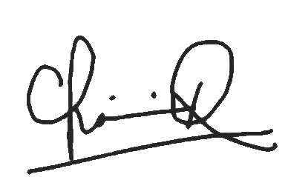
Sincerely,

(dr. Chairi Rusydi)

Anesthesiology and Intensive Therapy Department of Dr. Moewardi General Hospital, Jalan Kolonel Sutarto 132 Jebres, Surakarta 57126

Letter of Statement

I’m the undersigned,
Name : Dr. dr. Purwoko, Sp.An-KAKV-KAO
Place of work : Anesthesiology and Intensive Therapy Department of Dr. Moewardi General Hospital
E-mail : purwokoanest@gmail.com
hereby declare that:
- I have contributed to the article submitted,
- These articles have not been published or sent for publication in other journals and have been approved by co-authors.
- I upon receipt of the issuer, the rights are entitled to the copyright of the material published.
- The views and statements in the manuscript are the responsibility of the author (me).

This statement is made truthfully and to be used accordingly.

Surakarta, October 20th 2020
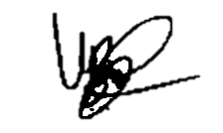

Dr. dr. Purwoko, Sp.An-KAKV-KAO

Letter of Statement

I’m the undersigned,
Name : dr. Chairi Rusydi
Place of work : Anesthesiology and Intensive Therapy Department of Dr. Moewardi General Hospital
E-mail : knovia11@gmail.com
hereby declare that:
- I have contributed to the article submitted,
- These articles have not been published or sent for publication in other journals and have been approved by co-authors.
- I upon receipt of the issuer, the rights are entitled to the copyright of the material published.
- The views and statements in the manuscript are the responsibility of the author (me).

This statement is made truthfully and to be used accordingly.

Surakarta, October 20th 2020

dr. Chairi Rusydi

Letter of Statement

I’m the undersigned,
Name : Rizki Fitria F, S.Ked
Place of work : Faculty of Medicine Sebelas Maret University
E-mail : rizkifitriaf@outlook.com
hereby declare that:
- I have contributed to the article submitted,
- These articles have not been published or sent for publication in other journals and have been approved by co-authors.
- I upon receipt of the issuer, the rights are entitled to the copyright of the material published.
- The views and statements in the manuscript are the responsibility of the author (me).

This statement is made truthfully and to be used accordingly.
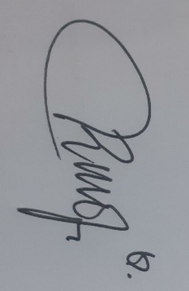
Surakarta, October 20th 2020

Rizki Fitria F, S.Ked

