Mochamat
Editor-in-chief
Jurnal Anestesiologi Indonesia

September 30th, 2022

Dear Editor:
We are greatly honored to submit our original paper entitled “Effect of Blood Lead Levels on Increased Superoxide Dismutase (S)D) Levels in Preeclampsia” to Jurnal Anestesiologi Indonesia for your consideration for publication.
Here is the manuscript in Bahasa and English. Each author has seen and approved the submission of this version of the manuscript and takes full responsibility for the manuscript. There are no prior publications or submissions with any overlapping information. The work is not and will not be submitted to any other journal while under consideration by Jurnal Anestesiologi Indonesia. In the manuscript, there is not any potential conflict of interest. We did not give an honorarium, grant, or other form of payment to anyone to produce the manuscript.
Corresponding author: dr. Besari Adi Pramono, Sp.OG Subsp.K.FM, Department of Obstetric and Gynecology, Faculty of Medicine Diponegoro University, Prof. H. Soedarto, S.H. Street, Tembalang, Semarang 50275, Indonesia, Email : babas1504@yahoo.com , Tel : +628122820024

Thank you so much for your work done for our paper. We hope it will be published.

Sincerely yours,
Besari Adi Pramono
Sultana M.H Faradz
Suhartono
Noor Pramono

Title of Manuscript :
Indonesia :
Pengaruh Kadar Timbal dalam Darah terhadap Peningkatan Kadar Superoxide Dismutase (SOD) pada Preeklampsia

English :
Effect of Blood Lead Levels on Increased Superoxide Dismutase (SOD) Levels in Preeclampsia

Author :
- dr. Besari Adi Pramono, Sp.OG(K), M.Si.Med, Departemen Obsteri dan Ginekologi, Fakultas Kedokteran Universitas Diponegoro, Semarang, Indonesia, babas1504@yahoo.com
- Prof. dr. Sultana M.H. Faradz, Ph.D, Center for Biomedical Research, Fakultas Kedokteran Universitas Diponegoro, Semarang, Indonesia, sultanafaradz@gmail.com
- Dr, dr. Suhartono, M.Kes, Fakultas Kesehatan Masyarakat, Universitas Diponegoro, Semarang, Indonesia, suhartono.damas62@gmail.com
- Prof. dr. Noor Pramono, MMedSc, Sp.OG(K), Departemen Obstetri dan Ginekologi, Fakultas Kedokteran, Universitas Diponegoro, Semarang, Indonesia, noerpramana@gmail.com
Funding: This research did not receive any financial support.
Competing Interest: The authors have declared that no competing interest exist.
Reference Application: Mendeley
Total words for abstracts :196 words
Total words for article : 1631 words

Gambar dan Tabel Manuscript Pengaruh Kadar Timbal dalam Darah terhadap Peningkatan Kadar Superoxide Dismutase (SOD) pada Preeklampsia

Tabel 1. Karakteristik Subjek Penelitian
Populasi | n = 46
Ibu Hamil dengan Preeklampsia | Rerata (SB) | Median (Min – Max)
Kadar Pb Darah | 42,35 (9,16) μg/dl | 43,10 (17,2 – 75,6)
Kadar SOD Serum | 118,43 (68,22) U/L | 109,50 (5 – 422)

Tabel 2. Analisis Korelasi Kadar Pb darah terhadap SOD Serum pada pasien Preeklampsia
Variabel |  | Validitas
 |  | Korelasi (r) | Sig. (p)
Kadar Pb Darah | Kadar SOD Serum | -0,263 | 0,078

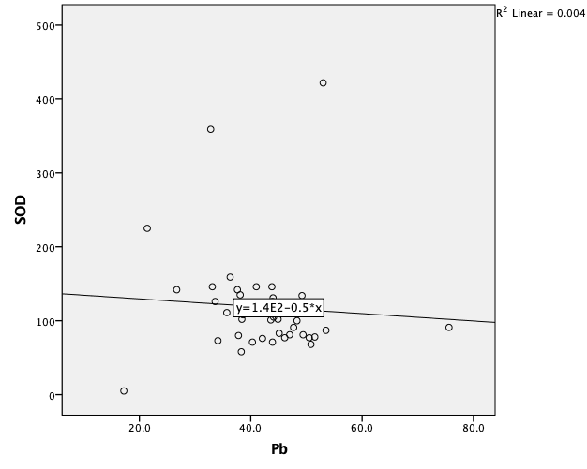
Gambar 1. Korelasi antara Kadar Pb darah terhadap SOD Serum pada pasien Preeklampsia

