Table 1. Patient Characteristics (Categorical Data)
Variable |  | PDPH/Case  (n= 37) |  | No PDPH/Control  (n= 37) |  | Total (n= 74)
 |  | n | % | n | % | n | %
BMI | Obesity | 15 | 60 | 10 | 40 | 25 | 33.8
 | Non Obesity | 22 | 44.9 | 27 | 55.1 | 49 | 66.2
Neurological disorders | Yes | 9 | 90 | 1 | 10 | 10 | 13.5
 | No | 28 | 43.8 | 36 | 56.3 | 64 | 86.5
Spinal history | Yes | 6 | 66.7 | 3 | 33.3 | 40 | 54.1
 | No | 31 | 47.7 | 34 | 52.3 | 34 | 45.9
Total punctures | Multiple | 30 | 75 | 10 | 25 | 8 | 10.8
 | Single | 7 | 20.6 | 27 | 79.4 | 66 | 89.2
Bevel orientation | Sagittal | 2 | 25 | 6 | 75 | 8 | 10.8
 | Horizontal | 35 | 53 | 31 | 47 | 66 | 89.2
Needle size | 25 G | 8 | 88.9 | 1 | 11.1 | 9 | 12.2
 | 26 G | 26 | 46.4 | 30 | 53.6 | 56 | 75.7
 | 27 G | 3 | 33.3 | 6 | 66.7 | 9 | 12.2
Mobilization | Yes | 14 | 31.1 | 31 | 68.9 | 45 | 60.8
 | No | 23 | 79.3 | 6 | 20.7 | 29 | 39.2
PDPH: post-dural puncture headache; BMI: body mass index

Table. 2 Patient Characteristics (Numerical Data)
Variable | PDPH (n= 37) | Without PDPH (n= 37) | Total (n= 74)
 | Mean ± SB  Median  Min-max | Mean ± SB  Median  Min-max | Mean ± SB  Median  Min-max
Age (years) | 28.22 ± 0.78  28.00  19-44 | 28.05 ± 4,83  27.00  17-44 | 28.14 ± 4.89  28  17 – 44
Systolic (mmHg) | 126 ± 2.16  130.00  105-150 | 121.92 ± 1,74  120.00  110-150 | 124.34 ± 12.14  120  (105 – 150)
Diastolic (mmHg) | 81.92 ± 1,46  83.00  60-90 | 77.51 ± 1,12  80.00  60-90 | 79.72 ± 8.18  80  60 – 90
MAP (mmHg) | 69.18 ± 1,24  69.00  63-72 | 70.18 ± 1,28  70.00  64-80 | 69.19 ± 0.87  72.00  65 - 78

Table 3. Factors influence PDPH (Categorical Data)
Variable | PDPH |  | p | OR | 95% CI
 | Yes  (n = 37) | No  (n = 37) |  |  | lower | upper
BMI |  |  |  | 1.841 | 0.692 | 4.897
obesity | 15 (60%) | 10 (40%) | 0.326¥
non obese | 22 (44.9%) | 27 (55.1%)
Neurological disorders |  |  |  | 11.571 | 1.383 | 96.808
Yes | 9 (90%) | 1 (10%) | 0.017¥*
No | 28 (43.8%) | 36 (56.3%)
Spinal history |  |  |  | 2.194 | 0.505 | 9.530
Yes | 6 (66.7%) | 3 (33.3%) | 0.240£
No | 31 (47.7%) | 34 (52.3%)
Total punctures |  |  |  | 11.571 | 3.864 | 34.656
Multiple | 30 (75%) | 10 (25%) | <0.001¥*
Single | 7 (20.6%) | 27 (79.4%)
Bevel orientation |  |  |  | 0.295 | 0.055 | 1.571
Sagittal | 2 (25%) | 6 (75%) | 0.131£
Horizontal | 35 (53%) | 31 (47%)
Needle size |  |  |  | 9.931 | 1.174 | 84.038
25 G | 8 (88.9%) | 1 (11.1%) | 0.014£*
26 G | 26 (46.4%) | 30 (53.6%)
27 G | 3 (33.3%) | 6 (66.7%)
Mobilization |  |  |  | 0.118 | 0.039 | 0.353
Yes | 14 (31.1%) | 31 (68.9%) | <0.001¥*
No | 23 (79.3%) | 6 (20.7%)
*Significant (p < 0.05); ¥Yates Correction; £Fisher’s exact test

Table 4. Factors influence PDPH (Numerical Data)
Variable | PDPH  Mean ± SD  Median  Min-max | No PPDH  Mean ± SD  Median  Min-max | P
MAP (mmHg) | 69.18 ± 1,24  69.00  63-72 | 70.18 ± 1,28  70.00  64-80 | 0,311^{ʍ}
Age (years) | 28.22 ± 0.78  28.00  19-44 | 28.05 ± 4,83  27.00  17-44 | 0,261^{t}
MAP (mean arterial pressure); SD (standard deviation); min (minimal); max (maximal); *significant (p<0.05); ^{ʍ}Mann Whitney; ^{ʈ}Independent t-test.

Table 6. The interaction effect based on the results of bivariate and multivariate analysis
No | Variable | OR Bivariat | OR multivariate | Interaction effect
1 | Neurological Disorders | 11,591 | 9,306 | Multiplicative
2 | Total Puncture | 11,571 | 4,798 | Multiplicative
3 | Needle Size | 9,931 | 3,362 | Multiplicative
4 | Mobilization | 0,118 | 0,162 | Additives
OR, odd ratio; if OR bivariate>multivariate: multiplicative; if OR multivariate>bivariate: additive;

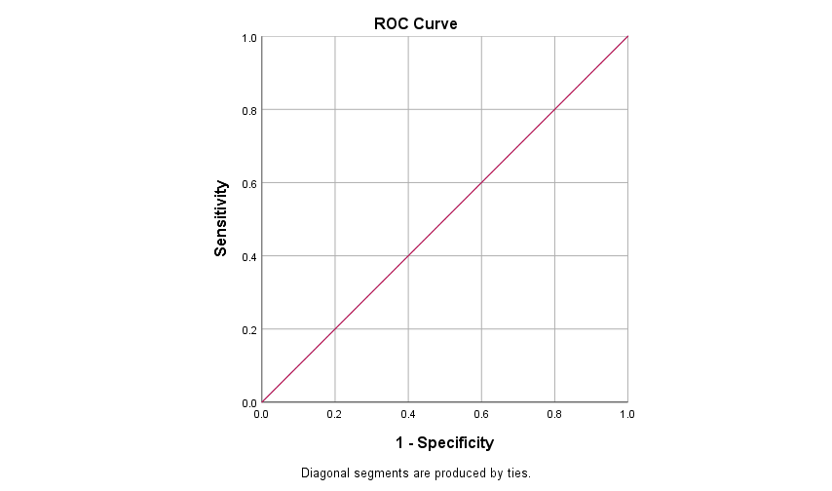
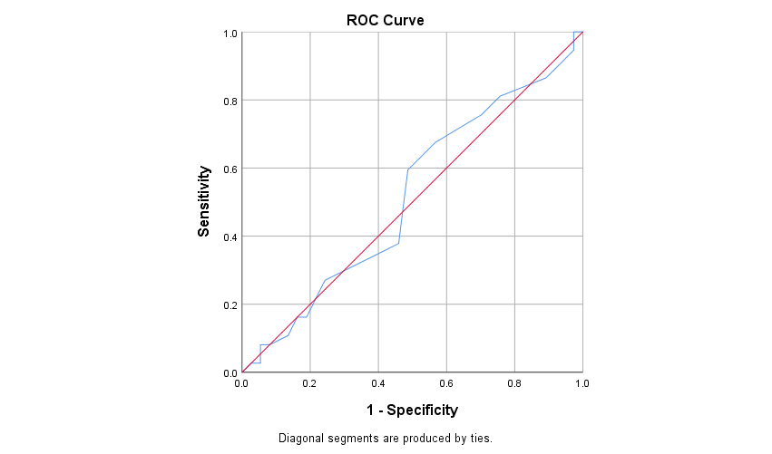
a
b

Figure 1. Receiver Operating Characteristics (ROC) of age [a] and mean arterial pressure (MAP) [b] towards post-dural puncture headache (PDPH)

