Characteristics | Ketamine Group (n=26) |  | Paracetamol Group (n=26) |  | p-value
Patient age (years) | 30.81 ± 3.86 |  | 31.27 ± 3.43 |  | 0.651§
Gestational age (weeks) | 38.50 ± 0.86 |  | 38.00 ± 1.20 |  | 0.151‡
Body weight (kg) | 71.57 ± 5.70 |  | 71.19 ± 5.32 |  | 0.885‡
Height (m) | 1.57 ± 0.88 |  | 1.55 ± 0.70 |  | 0.709‡
Body mass index (BMI) (kg/m²) | 29.01 ± 3.86 |  | 29.21 ± 3.74 |  | 0.560‡
TTV Pre-anestesi
Systolic Blood Pressure (SBP, mmHg) | 126.11 ± 13.7 |  | 123.84 ± 9.80 |  | 0.494§
Diastolic Blood Pressure (DBP, mmHg) | 65.27 ± 6.93 |  | 61.53 ± 7.03 |  | 0.060§
Mean Arterial Pressure (MAP, mmHg) | 85.50 ± 8.46 |  | 82.30 ± 6.61 |  | 0.130§
Heart Rate (beats/min) | 77.11 ± 12.1 |  | 74.96 ± 10.1 |  | 0.490§
Temperature (°C) | 36.73 ± 0.45 |  | 36.88 ± 0.32 |  | 0.163‡
Note: §, Independent t-test; ‡ Mann-Whitney U test

Table 1. Patient Characteristics

Table 2. Test of Difference in the Incidence of Shivering in the Two Groups
Group | Shivering |  |  | No Shivering
Group | n |  | % | n | % | p-value
Ketamine | 3 |  | 11.53 | 23 | 88.47 | 0.025*
Paracetamol | 10 |  | 38.46 | 16 | 61.54
Note: *Significant (p < 0.05)

Table 3. Test of Difference on the Time to Onset of Shivering in the Two Groups
Groups | N | Mean ± SD | Median (min-max) | Normality | p-value
Ketamine | 3 | 55,00 ± 8,67 | 60 (45 – 60) | 0,000 | 0,009‡*
Paracetamol | 10 | 27,30 ± 5,56 | 30 (21 – 33) | 0,004

Table 4. Test of Difference of Side Effects (Nausea and Vomiting) in Two Groups
Side Effects
Group | Yes |  |  | No | p-value
 | N | % | n | %
Ketamine | 7 | 53,8 | 19 | 48,7 | 1,000^
Paracetamol | 6 | 46,2 | 20 | 51,3
Note: ^, Chi-Square test; *Significant (p < 0.05)

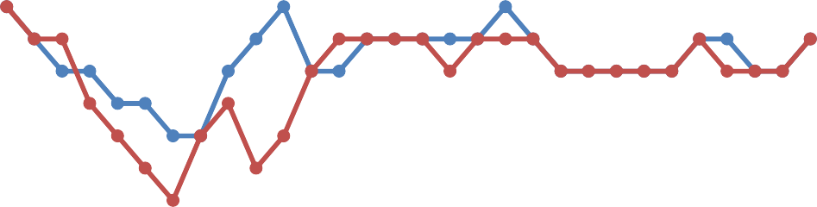
84
83
82
81
80
79
78
77
76
75
74
Ketamine
Paracetamol

Figure 1. MAP Graphic in the Two Groups
Minute 3
Minute 6 Minute 9 Minute 12 Minute 15 Minute 18 Minute 21 Minute 24 Minute 27 Minute 30 Minute 33 Minute 36 Minute 39 Minute 42 Minute 45 Minute 48 Minute 51 Minute 54 Minute 57 Minute 60 Minute 63 Minute 66 Minute 69 Minute 72 Minute 75 Minute 78 Minute 81 Minute 84 Minute 87 Minute 90

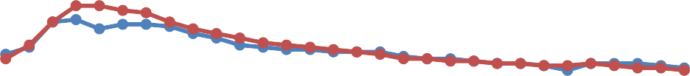
120

100

80

60

40

20

0
Ketamine
Paracetamol

Figure 2. Heart Rate Graphic in the Two Groups
Minute 3
Minute 6 Minute 9 Minute 12 Minute 15 Minute 18 Minute 21 Minute 24 Minute 27 Minute 30 Minute 33 Minute 36 Minute 39 Minute 42 Minute 45 Minute 48 Minute 51 Minute 54 Minute 57 Minute 60 Minute 63 Minute 66 Minute 69 Minute 72 Minute 75 Minute 78 Minute 81 Minute 84 Minute 87 Minute 90

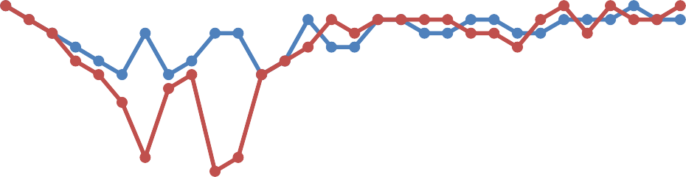
36.6
36.4
36.2
36
35.8
35.6
35.4
35.2
35
34.8
34.6
Ketamine
Paracetamol

Figure 3. Body Temperature Graphic in the Two Groups
Minute 3
Minute 6 Minute 9 Minute 12 Minute 15 Minute 18 Minute 21 Minute 24 Minute 27 Minute 30 Minute 33 Minute 36 Minute 39 Minute 42 Minute 45 Minute 48 Minute 51 Minute 54 Minute 57 Minute 60 Minute 63 Minute 66 Minute 69 Minute 72 Minute 75 Minute 78 Minute 81 Minute 84 Minute 87 Minute 90

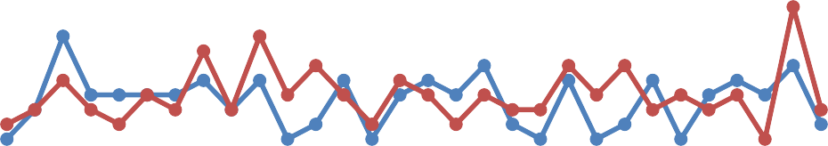
17.8
17.6
17.4
17.2
17
16.8
16.6
16.4
16.2
Ketamine
Paracetamol

Figure 4. Respiratory Rate Graphic in the Two Groups
Minute 3
Minute 6 Minute 9 Minute 12 Minute 15 Minute 18 Minute 21 Minute 24 Minute 27 Minute 30 Minute 33 Minute 36 Minute 39 Minute 42 Minute 45 Minute 48 Minute 51 Minute 54 Minute 57 Minute 60 Minute 63 Minute 66 Minute 69 Minute 72 Minute 75 Minute 78 Minute 81 Minute 84 Minute 87 Minute 90

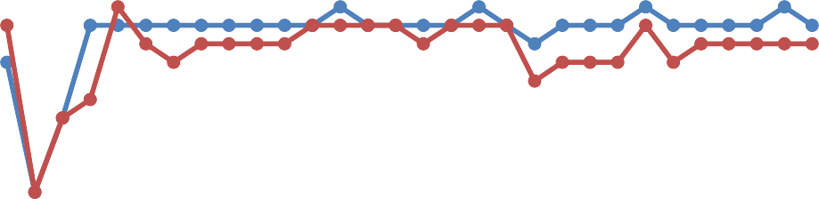
100.2
100
99.8
99.6
99.4
99.2
99
98.8
98.6
98.4
Ketamin
Parasetamol

Figure 5. Respiratory Rate Graphic in the Two Groups
Minute 3
Minute 6 Minute 9 Minute 12 Minute 15 Minute 18 Minute 21 Minute 24 Minute 27 Minute 30 Minute 33 Minute 36 Minute 39 Minute 42 Minute 45 Minute 48 Minute 51 Minute 54 Minute 57 Minute 60 Minute 63 Minute 66 Minute 69 Minute 72 Minute 75 Minute 78 Minute 81 Minute 84 Minute 87 Minute 90

