**Figure 1**. Graph of COPUR Score Cutoff for Sensitivity and Specificity



1

0,8

0,6

0,4

0,2

0

≥5 >5 >6 >7 >8 >9 >10 >11

Sensitivity

Specificity

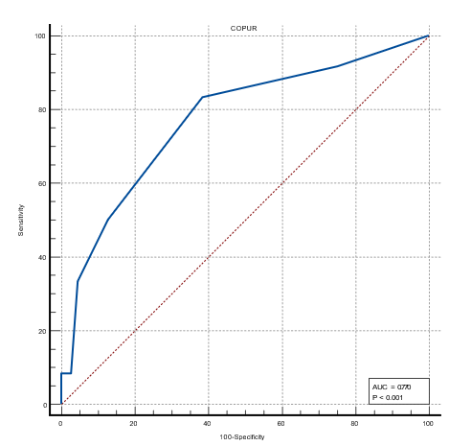

**Figure 2**. ROC Curve of COPUR Score for Predicting Difficult Intubation



**27**

**20,7G**

**40**

**30,8**

**28**

**21,56**

**0,177 0,177**

5 6

**3,408**

7

**6,GG3**

**1,254**

8

**21,323514**

9

**2,331**

**0**

**0,1077**

10 11

Actual Easy Intubation

Predicted Easy Intubation

Actual Difficult Intubation

Predicted Difficult Intubation

**Figure 3**. The goodness-of-fit test using the Hosmer-Lemeshow method.

Chi-square calibration value of 2.98 with a p-value of 0.561.