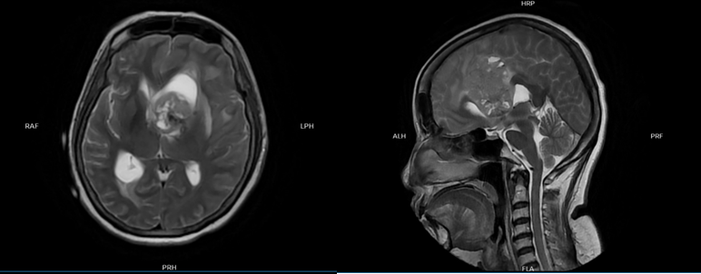
Figure 1. MRI examination of the head.

