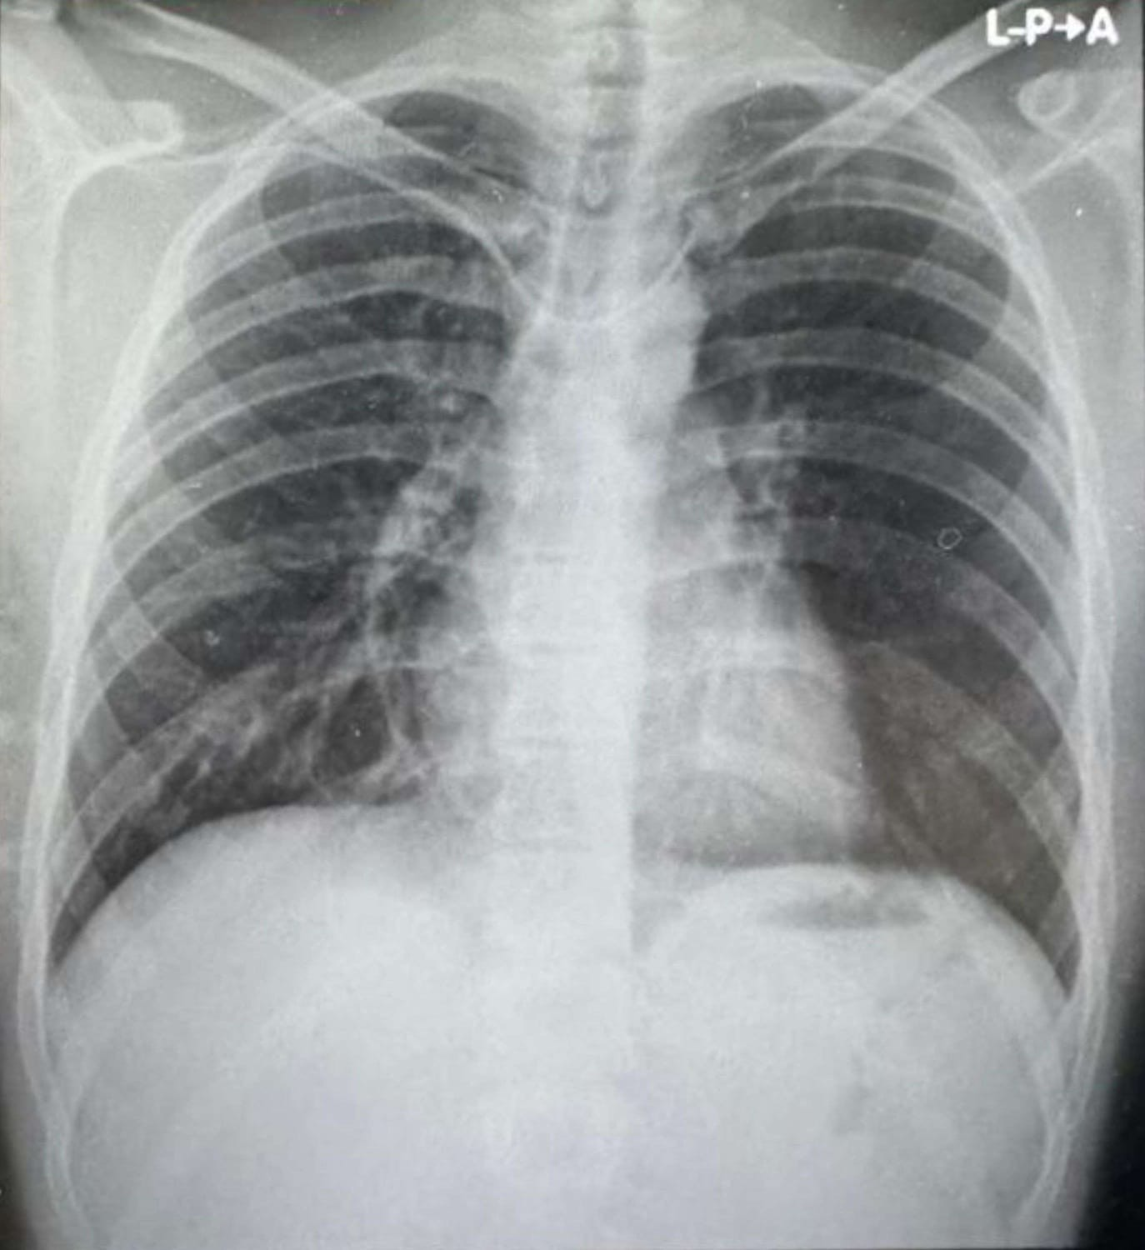
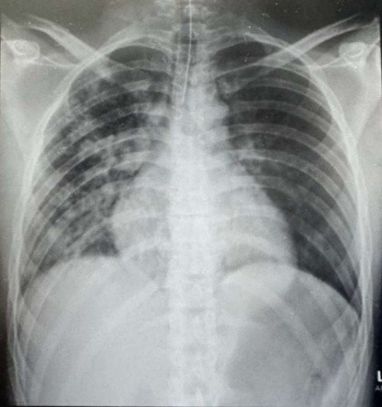
Figure 1 – Chest X-ray on admission revealed bilateral diffuse alveolar infiltrates consistent with moderate ARDS following drowning. Follow-up imaging after extubation (day 4) demonstrated significant radiological resolution, paralleling clinical recovery.
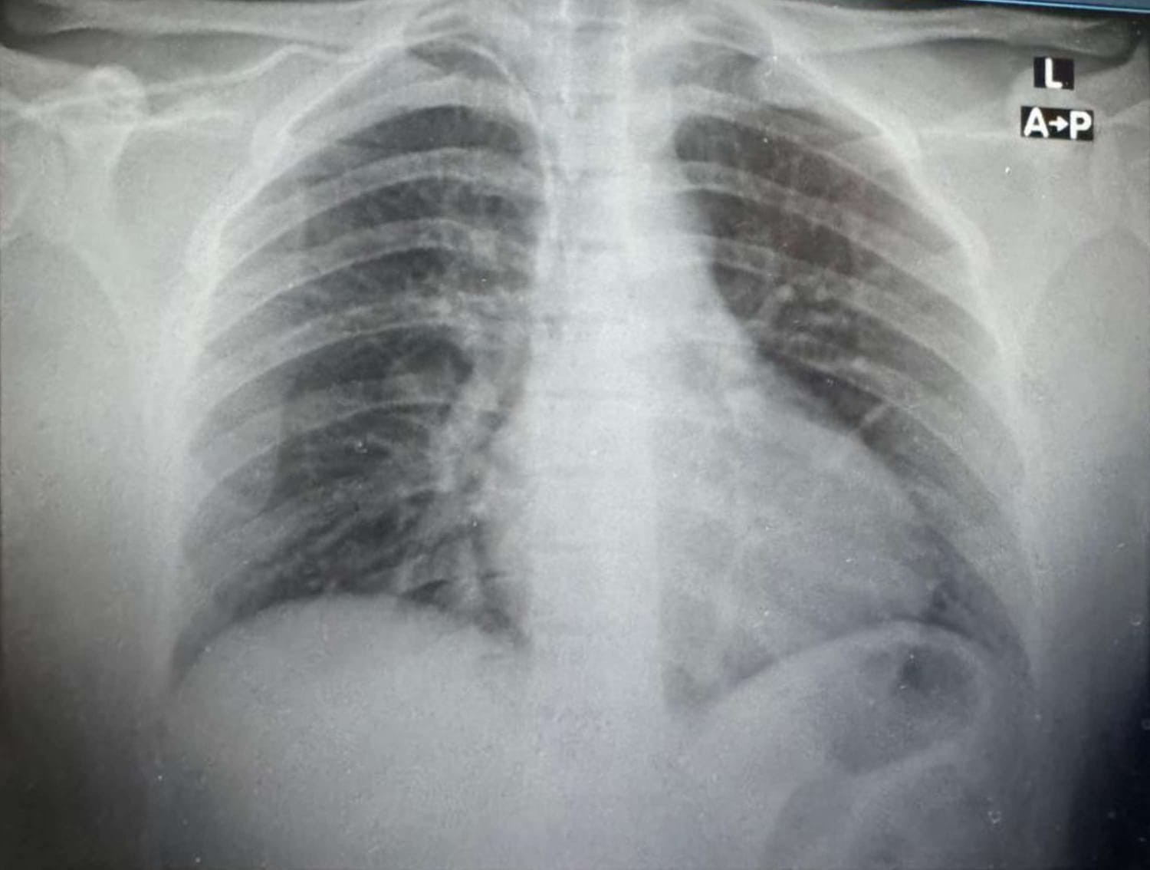
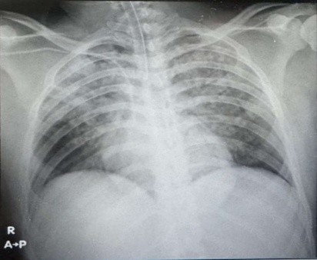

Figure 2 - Chest X-ray on admission showed bilateral diffuse alveolar infiltrates consistent with severe ARDS following freshwater drowning. Follow-up imaging prior to extubation demonstrated substantial radiological resolution, in parallel with clinical recovery.
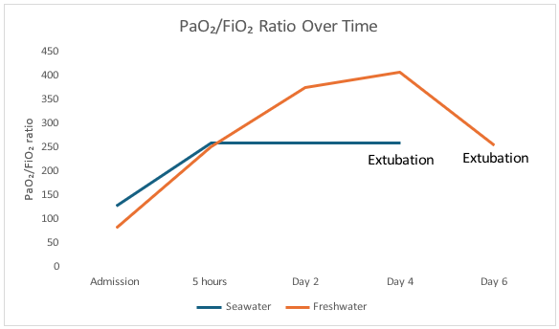
Figure 3 - PaO₂/FiO₂ ratio over time in seawater and freshwater drowning–associated ARDS, demonstrating rapid improvement in oxygenation following early lung-protective mechanical ventilation.
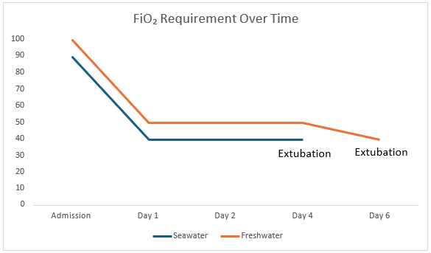
Figure 4 - Progressive reduction in FiO₂ requirement over time in both cases, reflecting successful ventilator weaning following early improvement in oxygenation.
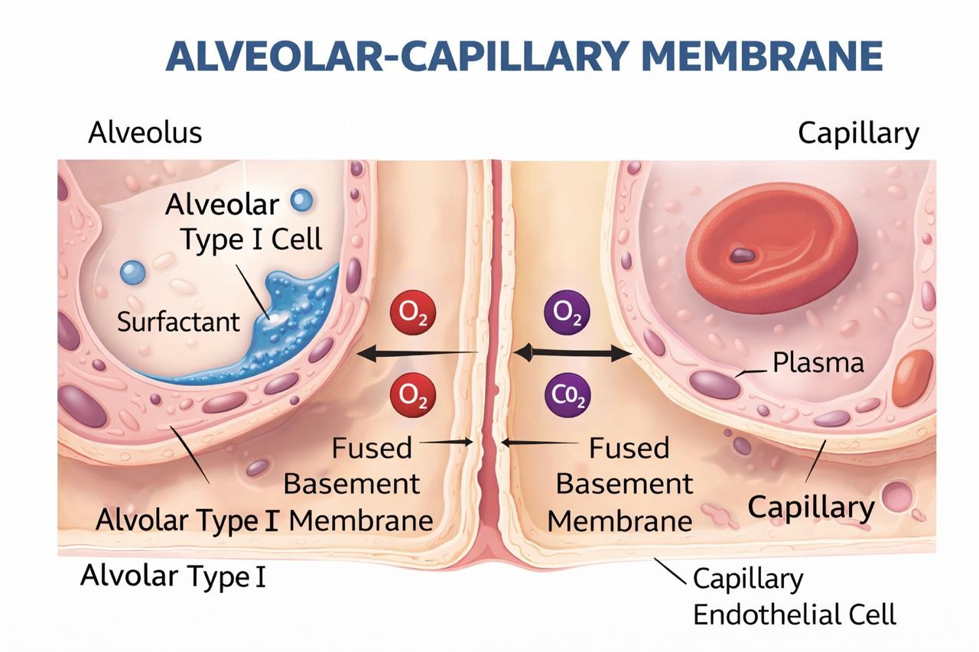

Figure 5 - Alveolar–capillary membrane structure and gas exchange. Schematic illustration of the normal alveolar–capillary membrane showing the close apposition of the alveolar epithelium, fused basement membrane, and capillary endothelium, which facilitates efficient oxygen (O₂) and carbon dioxide (CO₂) exchange. In drowning-associated lung injury, aspiration-induced surfactant dysfunction and disruption of the alveolar–capillary membrane increase permeability, leading to alveolar flooding, impaired gas exchange, and development of acute respiratory distress syndrome (ARDS).

