**Faktor-Faktor Yang Mempengaruhi Peningkatan Adopsi E-Banking Pada Masyarakat Pedesaan (Studi Kasus Masyarakat Batang Kuis)**

|  |  |
| --- | --- |
| **Tabel 1. Indikator Penelitian** | |
| **Variabel** | **Indikator** |
| Minat Menggunakan E-Banking(Y) | 1. Persepsi kemudahan menggunakan e-banking. |
| 1. Persepsi keamanan bertransaksi melalui e-banking. |
| 1. Persepsi manfaat yang di rasakan dari e-banking. |
| 1. Seberapa besar motivasi menggunakan e-banking. |
| Literasi Keuangan(X1) | 1. Pengetahuan tentang produk dan jasa keuangan. |
| 1. Pemahaman tentang risiko keuangan. |
| 1. Pengetahuan tentang hak dan kewajiban konsumen. |
| 1. Keterampilan tentang manajemen keuangan pribadi. |
| Infrastruktur(X2) | 1. Kemudahan mengakses jaringan internet. |
| 1. Ketersediaan perangkat yang di butuhkah. |
| 1. Kualitas layanan telekomunikasi. |
| 1. Ketersediaan fasilitas pendukung (KC Bank). |
| Keamanan(X3) | 1. Persepsi keamanan data pribadi pada e-banking. |
| 1. Persepsi keamanan saat bertransaksi di e-banking. |
| 1. Kepercayaan terhadap sistem keamanan bank. |
| 1. Pengalaman terhadap kasus penipuan. |
| Pengalaman Pengguna(X4) | 1. Seberapa rutin menggunakan layanan e-banking. |
| 1. Seberapa baik kualitas layanan yang di berikan. |
| 1. Kepuasan saat menggunakan layanan e-banking. |
| 1. Kemungkinan merekomendasikan e-banking. |
| Keuntungan Dan Manfaat(X5) | 1. Efisien waktu ketika menggunakan e-banking. |
| 1. Aksesibilitas menggunakan layanan e-banking. |
| 1. Persepsi terhadap biaya yang di keluarkan. |
| 1. Manfaat tambahan (Promo, Hadiah, Fitur). |
| *Sumber : Hasil Olahan Penulis (2024)* | |

|  |  |  |  |
| --- | --- | --- | --- |
| **Tabel 2. Identitas Responden Pengguna E-banking** | | | |
| Karakteristik | Indikator | Jumlah responden | Persentase(%) |
| kelamin | Pria | 23 | 38,3% |
| Wanita | 37 | 61,7% |
| Umur | 17-24 tahun | 51 | 85% |
| 25-30 tahun | 4 | 6,7% |
| 31-35 tahun | 3 | 5% |
| 36-40 tahun | 2 | 3,3% |
| Pekerjaan | Belum/Tidak bekerja | 7 | 11,7% |
| Aparatur/Pejabat negara | 1 | 1,7% |
| Tenaga mengajar | 2 | 3,3% |
| Petani/peternak | 1 | 1,7% |
| Pelajar/mahasiswa | 43 | 71,7% |
| Wiraswasta | 8 | 13,3% |
| Jenis e-banking | Mobile-bangking | 56 | 93,3% |
| Internet bangking | 4 | 6,7% |
| *Hasil Olahan Data (2024)* | | | |

|  |  |  |  |  |  |
| --- | --- | --- | --- | --- | --- |
| **Tabel 3. Hasil Uji Validitas** | | | | | |
| variabel | indikator | R hitung | R tabel | Sig. (2-tailed) | keterangan |
| Literasi Keuangan(X1) | 1 | 0,783 | >0,254 | 0,000 | Valid |
| 2 | 0,658 |
| 3 | 0,720 |
| 4 | 0,653 |
| Infrastruktur(X2) | 1 | 0,752 | >0,254 | 0,000 | Valid |
| 2 | 0,746 |
| 3 | 0,758 |
| 4 | 0,735 |
| Keamanan(X3) | 1 | 0,866 | >0,254 | 0,000 | Valid |
| 2 | 0,885 |
| 3 | 0,762 |
| 4 | 0,843 |
| Pengalaman Pengguna(X4) | 1 | 0,807 | >0,254 | 0,000 | Valid |
| 2 | 0,822 |
| 3 | 0,859 |
| 4 | 0,767 |
| Keuntungan Dan Manfaat(X5) | 1 | 0,804 | >0,254 | 0,000 | Valid |
| 2 | 0,824 |
| 3 | 0,692 |
| 4 | 0,771 |
| Minat Menggunakan E-Banking(Y) | 1 | 0,819 | >0,254 | 0,000 | Valid |
| 2 | 0,799 |
| 3 | 0,840 |
| 4 | 0,818 |
| *Hasil Olahan Data (2024)* | | | | | |

|  |  |  |  |
| --- | --- | --- | --- |
| **Tabel 4. Hasil Uji Reliabilitas** | | | |
| Variabel | Nilai Cronbach’s Alpha | Titik keritis | Keterangan |
| Literasi Keuangan | 0.653 | >0.60 | Reliabel |
| Infrastruktur | 0.736 |
| Keamanan | 0.857 |
| Pengalaman Pengguna | 0.824 |
| Keuntungan Dan Manfaat | 0.763 |
| Minat Menggunakan E-Banking | 0.836 |
| *Hasil Olahan Data (2024)* | | | |

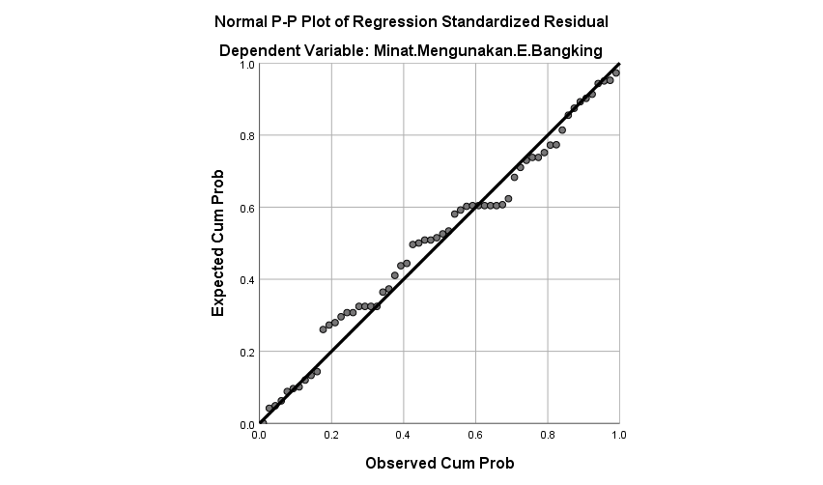

**Gambar 1. Uji Normalitas Scatterplot**

*Hasil Olahan Data (2024)*

|  |  |  |
| --- | --- | --- |
| **Tabel 5.Hasil Uji Kolmogorov-Smirnov** | | |
| N | | 60 |
| Normal Parametersa,b | Mean | .0000000 |
| Std. Deviation | 1.62569489 |
| Most Extreme Differences | Absolute | .084 |
| Positive | .072 |
| Negative | -.084 |
| Test Statistic | | .084 |
| Asymp. Sig. (2-tailed) | | .200c,d |
| *Hasil Olahan Data (2024)* | | |

|  |  |  |  |  |  |  |  |  |
| --- | --- | --- | --- | --- | --- | --- | --- | --- |
| **Tabel 6. Hasil Uji Multikolinieritas** | | | | | | | | |
| **Coefficientsa** | | | | | | | | |
| Model | | Unstandardized Coefficients | | Standardized Coefficients | t | Sig. | Collinearity Statistics | |
| B | Std. Error | Beta | Tolerance | VIF |
|  | (Constant) | 5.663 | 2.410 |  | 2.349 | .022 |  |  |
| LIterasi Keuangan | -.103 | .188 | -.077 | -.546 | .587 | .464 | 2.157 |
| Infrastruktur | -.139 | .134 | -.142 | -1.032 | .307 | .484 | 2.065 |
| Keamanan | .654 | .137 | .731 | 4.777 | .000 | .389 | 2.573 |
| Pengalaman Pengguna | -.146 | .151 | -.139 | -.962 | .340 | .440 | 2.274 |
| Keuntungan Dan Manfaat | .428 | .139 | .392 | 3.084 | .003 | .564 | 1.773 |
| *Hasil Olahan Data (2024)* | | | | | | | | |

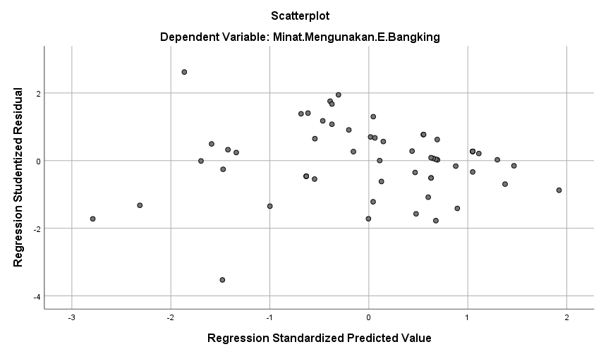

**Gambar 2. Uji Multikolinieritas**

*Hasil Olahan Data (2024)*

|  |  |  |  |  |  |  |
| --- | --- | --- | --- | --- | --- | --- |
| **Tabel 7. Hasil Uji t** | | | | | | |
| **Coefficientsa** | | | | | | |
| Model | | Unstandardized Coefficients | | Standardized Coefficients | T | Sig. |
| B | Std. Error | Beta |
|  | (Constant) | 5.663 | 2.410 |  | 2.349 | .022 |
| LIterasi Keuangan | -.103 | .188 | -.077 | -.546 | .587 |
| Infrastruktur | -.139 | .134 | -.142 | -1.032 | .307 |
| Keamanan | .654 | .137 | .731 | 4.777 | .000 |
| Pengalaman Pengguna | -.146 | .151 | -.139 | -.962 | .340 |
| Keuntungan Dan Manfaat | .428 | .139 | .392 | 3.084 | .003 |
| *Hasil Olahan Data (2024)* | | | | | | |

|  |  |  |  |  |  |  |
| --- | --- | --- | --- | --- | --- | --- |
| **Tabel 8. Hasil Uji F** | | | | | | |
| **ANOVAa** | | | | | | |
| Model | | Sum of Squares | df | Mean Square | F | Sig. |
| 1 | Regression | 161.053 | 5 | 32.211 | 11.155 | .000b |
| Residual | 155.930 | 54 | 2.888 |  |  |
| Total | 316.983 | 59 |  |  |  |
| *Hasil Olahan Penulis (2024)* | | | | | | |

|  |  |  |  |  |
| --- | --- | --- | --- | --- |
| **Tabel 9. Hasil Uji Koefisien Determinasi (r²)** | | | | |
| **Model Summaryb** | | | | |
| Model | R | R Square | Adjusted R Square | Std. Error of the Estimate |
| 1 | .713a | .508 | .463 | 1.69929 |
| *Hasil Olahan Penulis (2024)* | | | | |