Hasil Uji Run Test
Runs Test
 | Unstandardized Residual
Test Valueª | ,00163
Cases < Test Value | 73
Cases >= Test Value | 73
Total Cases | 146
Number of Runs | 66
Z | -1,329
Asymp. Sig. (2-tailed) | ,184
a. Median
Runs Test
 | Unstandardized Residual
Test Valueª | -,00914
Cases < Test Value | 73
Cases >= Test Value | 73
Total Cases | 146
Number of Runs | 63
Z | -1,827
Asymp. Sig. (2-tailed) | ,068
a. Median

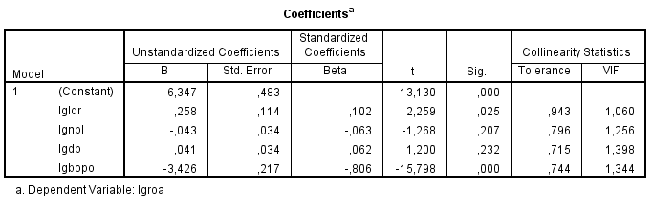

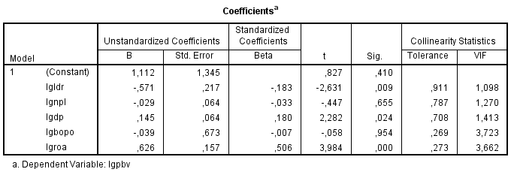

Matrix
Run MATRIX procedure:

*************************************************************************

Preacher And Hayes (2004) SPSS Script For Simple Mediation

Written by Andrew F. Hayes, The Ohio State University

http://www.comm.ohio-state.edu/ahayes/

VARIABLES IN SIMPLE MEDIATION MODEL
Y lgpbv
X lgldr
M lgroa

DESCRIPTIVES STATISTICS AND PEARSON CORRELATIONS
Mean SD lgpbv lgldr lgroa
lgpbv .1279 .2561 1.0000 -.1306 .5639
lgldr 1.8939 .0821 -.1306 1.0000 .1176
lgroa .3004 .2072 .5639 .1176 1.0000

SAMPLE SIZE
146

DIRECT And TOTAL EFFECTS
Coeff s.e. t Sig(two)
b(YX) -.4074 .2577 -1.5810 .1161
b(MX) .2966 .2088 1.4207 .1576
b(YM.X) .7262 .0835 8.7015 .0000
b(YX.M) -.6227 .2105 -2.9580 .0036

INDIRECT EFFECT And SIGNIFICANCE USING NORMAL DISTRIBUTION
Value s.e. LL 95 CI UL 95 CI Z Sig(two)
Effect .2154 .1546 -.0876 .5184 1.3932 .1636

BOOTSTRAP RESULTS For INDIRECT EFFECT
Data Mean s.e. LL 95 CI UL 95 CI LL 99 CI UL 99 CI
Effect .2154 .2041 .1360 -.0649 .4764 -.1374 .5750

NUMBER OF BOOTSTRAP RESAMPLES
1000

FAIRCHILD ET AL. (2009) VARIANCE IN Y ACCOUNTED FOR BY INDIRECT EFFECT:
-.0223

********************************* NOTES **********************************

------ END MATRIX -----
Matrix

Run MATRIX procedure:

*************************************************************************

Preacher And Hayes (2004) SPSS Script For Simple Mediation

Written by Andrew F. Hayes, The Ohio State University

http://www.comm.ohio-state.edu/ahayes/

VARIABLES IN SIMPLE MEDIATION MODEL
Y lgpbv
X lgnpl
M lgroa

DESCRIPTIVES STATISTICS AND PEARSON CORRELATIONS
Mean SD lgpbv lgnpl lgroa
lgpbv .1279 .2561 1.0000 -.1065 .5639
lgnpl .2339 .2990 -.1065 1.0000 -.1609
lgroa .3004 .2072 .5639 -.1609 1.0000

SAMPLE SIZE
146

DIRECT And TOTAL EFFECTS
Coeff s.e. t Sig(two)
b(YX) -.0912 .0710 -1.2853 .2007
b(MX) -.1115 .0570 -1.9559 .0524
b(YM.X) .6939 .0865 8.0239 .0000
b(YX.M) -.0139 .0599 -.2316 .8172

INDIRECT EFFECT And SIGNIFICANCE USING NORMAL DISTRIBUTION
Value s.e. LL 95 CI UL 95 CI Z Sig(two)
Effect -.0774 .0410 -.1577 .0030 -1.8865 .0592

BOOTSTRAP RESULTS For INDIRECT EFFECT
Data Mean s.e. LL 95 CI UL 95 CI LL 99 CI UL 99 CI
Effect -.0774 -.0790 .0412 -.1603 -.0018 -.2017 .0197

NUMBER OF BOOTSTRAP RESAMPLES
1000

FAIRCHILD ET AL. (2009) VARIANCE IN Y ACCOUNTED FOR BY INDIRECT EFFECT:
.0111

********************************* NOTES **********************************

------ END MATRIX -----
Matrix

Run MATRIX procedure:

*************************************************************************

Preacher And Hayes (2004) SPSS Script For Simple Mediation

Written by Andrew F. Hayes, The Ohio State University

http://www.comm.ohio-state.edu/ahayes/

VARIABLES IN SIMPLE MEDIATION MODEL
Y lgpbv
X lgdp
M lgroa

DESCRIPTIVES STATISTICS AND PEARSON CORRELATIONS
Mean SD lgpbv lgdp lgroa
lgpbv .1279 .2561 1.0000 .3645 .5639
lgdp -.0669 .3174 .3645 1.0000 .3743
lgroa .3004 .2072 .5639 .3743 1.0000

SAMPLE SIZE
146

DIRECT And TOTAL EFFECTS
Coeff s.e. t Sig(two)
b(YX) .2942 .0626 4.6976 .0000
b(MX) .2444 .0504 4.8440 .0000
b(YM.X) .6146 .0902 6.8136 .0000
b(YX.M) .1440 .0589 2.4456 .0157

INDIRECT EFFECT And SIGNIFICANCE USING NORMAL DISTRIBUTION
Value s.e. LL 95 CI UL 95 CI Z Sig(two)
Effect .1502 .0383 .0751 .2253 3.9200 .0001

BOOTSTRAP RESULTS For INDIRECT EFFECT
Data Mean s.e. LL 95 CI UL 95 CI LL 99 CI UL 99 CI
Effect .1502 .1504 .0359 .0843 .2278 .0667 .2546

NUMBER OF BOOTSTRAP RESAMPLES
1000

FAIRCHILD ET AL. (2009) VARIANCE IN Y ACCOUNTED FOR BY INDIRECT EFFECT:
.1055

********************************* NOTES **********************************

------ END MATRIX -----

Matrix

Run MATRIX procedure:

*************************************************************************

Preacher And Hayes (2004) SPSS Script For Simple Mediation

Written by Andrew F. Hayes, The Ohio State University

http://www.comm.ohio-state.edu/ahayes/

VARIABLES IN SIMPLE MEDIATION MODEL
Y lgpbv
X lgbopo
M lgroa

DESCRIPTIVES STATISTICS AND PEARSON CORRELATIONS
Mean SD lgpbv lgbopo lgroa
lgpbv .1279 .2561 1.0000 -.5082 .5639
lgbopo 1.9042 .0487 -.5082 1.0000 -.8455
lgroa .3004 .2072 .5639 -.8455 1.0000

SAMPLE SIZE
146

DIRECT And TOTAL EFFECTS
Coeff s.e. t Sig(two)
b(YX) -2.6701 .3771 -7.0807 .0000
b(MX) -3.5936 .1891 -19.0015 .0000
b(YM.X) .5821 .1595 3.6501 .0004
b(YX.M) -.5783 .6778 -.8531 .3950

INDIRECT EFFECT And SIGNIFICANCE USING NORMAL DISTRIBUTION
Value s.e. LL 95 CI UL 95 CI Z Sig(two)
Effect -2.0918 .5843 -3.2371 -.9465 -3.5798 .0003

BOOTSTRAP RESULTS For INDIRECT EFFECT
Data Mean s.e. LL 95 CI UL 95 CI LL 99 CI UL 99 CI
Effect -2.0918 -2.0990 .5811 -3.2013 -.8719 -3.5405 -.4850

NUMBER OF BOOTSTRAP RESAMPLES
1000

FAIRCHILD ET AL. (2009) VARIANCE IN Y ACCOUNTED FOR BY INDIRECT EFFECT:
.2548

********************************* NOTES **********************************

------ END MATRIX -----

