LAMPIRAN 8 : MODEL PERSAMAAN PERTAMA

Descriptives

Descriptive Statistics
 | N | Minimum | Maximum | Mean | Std. Deviation
Tobinsq | 112 | 18,54 | 92,35 | 49,7587 | 16,57323
DPR | 112 | -60,47 | 1350,54 | 59,8898 | 150,92612
DER | 112 | ,18 | 3,40 | 1,0519 | ,75505
KI | 112 | 20,00 | 100,00 | 39,4938 | 13,06975
INST | 112 | 19,96 | 98,18 | 66,5838 | 16,77784
ROI | 112 | -,29 | 91,17 | 13,6804 | 12,07853
LNSIZE | 112 | 12,52 | 19,32 | 16,1632 | 1,60086
MBV | 112 | ,14 | 756,27 | 83,8726 | 115,20601
Valid N (listwise) | 112

Regression
Variables Entered/Removedª
Model | Variables Entered | Variables Removed | Method
1 | LNSIZE, DPR, KI, SQRTDER, ROI, INST^{b} | . | Enter
a. Dependent Variable: Tobinsq
b. All requested variables entered.

Model Summary^{b}
Model | R | R Square | Adjusted R Square | Std. Error of the Estimate | Durbin-Watson
1 | ,973ª | ,948 | ,945 | 3,90182 | 1,939
a. Predictors: (Constant), LNSIZE, DPR, KI, SQRTDER, ROI, INST
b. Dependent Variable: Tobinsq

ANOVAª
Model |  | Sum of Squares | df | Mean Square | F | Sig.
1 | Regression | 28890,048 | 6 | 4815,008 | 316,273 | ,000^{b}
1 | Residual | 1598,544 | 105 | 15,224
1 | Total | 30488,591 | 111
a. Dependent Variable: Tobinsq
b. Predictors: (Constant), LNSIZE, DPR, KI, SQRTDER, ROI, INST

Coefficientsª
Model |  | Unstandardized Coefficients |  | Standardized Coefficients | t | Sig. | Collinearity Statistics
 |  | B | Std. Error | Beta | t | Sig. | Tolerance | VIF
1 | (Constant) | 10,324 | 5,136 |  | 2,010 | ,047
1 | DPR | -,001 | ,002 | -,012 | -,531 | ,597 | ,971 | 1,030
1 | SQRTDER | 46,440 | 1,085 | ,975 | 42,785 | ,000 | ,961 | 1,041
1 | KI | ,066 | ,029 | ,052 | 2,272 | ,025 | ,955 | 1,047
1 | INST | -,107 | ,026 | -,108 | -4,166 | ,000 | ,745 | 1,342
1 | ROI | ,122 | ,033 | ,089 | 3,673 | ,000 | ,857 | 1,167
1 | LNSIZE | -,154 | ,252 | -,015 | -,610 | ,543 | ,840 | 1,190
a. Dependent Variable: Tobinsq

Coefficient Correlationsª
Model |  |  | LNSIZE | DPR | KI | SQRTDER | ROI | INST
1 | Correlations | LNSIZE | 1,000 | ,061 | -,006 | -,050 | ,020 | ,373
1 | Correlations | DPR | ,061 | 1,000 | -,025 | ,067 | -,031 | ,144
1 | Correlations | KI | -,006 | -,025 | 1,000 | -,114 | -,186 | ,097
1 | Correlations | SQRTDER | -,050 | ,067 | -,114 | 1,000 | ,133 | -,119
1 | Correlations | ROI | ,020 | -,031 | -,186 | ,133 | 1,000 | -,304
1 | Correlations | INST | ,373 | ,144 | ,097 | -,119 | -,304 | 1,000
1 | Covariances | LNSIZE | ,064 | 3,814E-5 | -4,101E-5 | -,014 | ,000 | ,002
1 | Covariances | DPR | 3,814E-5 | 6,201E-6 | -1,792E-6 | ,000 | -2,551E-6 | 9,173E-6
1 | Covariances | KI | -4,101E-5 | -1,792E-6 | ,001 | -,004 | ,000 | 7,160E-5
1 | Covariances | SQRTDER | -,014 | ,000 | -,004 | 1,178 | ,005 | -,003
1 | Covariances | ROI | ,000 | -2,551E-6 | ,000 | ,005 | ,001 | ,000
1 | Covariances | INST | ,002 | 9,173E-6 | 7,160E-5 | -,003 | ,000 | ,001
a. Dependent Variable: Tobinsq

Collinearity Diagnosticsª
Model | Dimension | Eigenvalue | Condition Index | Variance Proportions
 |  |  |  | (Constant) | DPR | SQRTDER | KI | INST | ROI | LNSIZE
1 | 1 | 5,549 | 1,000 | ,00 | ,00 | ,00 | ,00 | ,00 | ,01 | ,00
1 | 2 | ,851 | 2,554 | ,00 | ,95 | ,00 | ,00 | ,00 | ,00 | ,00
1 | 3 | ,387 | 3,785 | ,00 | ,00 | ,02 | ,00 | ,00 | ,81 | ,00
1 | 4 | ,093 | 7,716 | ,00 | ,01 | ,48 | ,55 | ,01 | ,03 | ,00
1 | 5 | ,077 | 8,492 | ,00 | ,00 | ,48 | ,23 | ,19 | ,06 | ,01
1 | 6 | ,039 | 11,880 | ,01 | ,02 | ,01 | ,20 | ,48 | ,08 | ,07
1 | 7 | ,003 | 41,537 | ,98 | ,01 | ,00 | ,02 | ,31 | ,00 | ,92
a. Dependent Variable: Tobinsq

Residuals Statisticsª
 | Minimum | Maximum | Mean | Std. Deviation | N
Predicted Value | 23,2561 | 87,5824 | 49,7587 | 16,13291 | 112
Std. Predicted Value | -1,643 | 2,344 | ,000 | 1,000 | 112
Standard Error of Predicted Value | ,456 | 3,274 | ,882 | ,418 | 112
Adjusted Predicted Value | 23,0020 | 87,1732 | 49,8592 | 16,22365 | 112
Residual | -8,87237 | 17,11460 | ,00000 | 3,79490 | 112
Std. Residual | -2,274 | 4,386 | ,000 | ,973 | 112
Stud. Residual | -2,470 | 4,741 | -,010 | 1,026 | 112
Deleted Residual | -12,08741 | 19,99290 | -,10047 | 4,27776 | 112
Stud. Deleted Residual | -2,533 | 5,322 | -,002 | 1,072 | 112
Mahal. Distance | ,526 | 77,158 | 5,946 | 9,870 | 112
Cook's Distance | ,000 | ,738 | ,021 | ,093 | 112
Centered Leverage Value | ,005 | ,695 | ,054 | ,089 | 112
a. Dependent Variable: Tobinsq

Charts

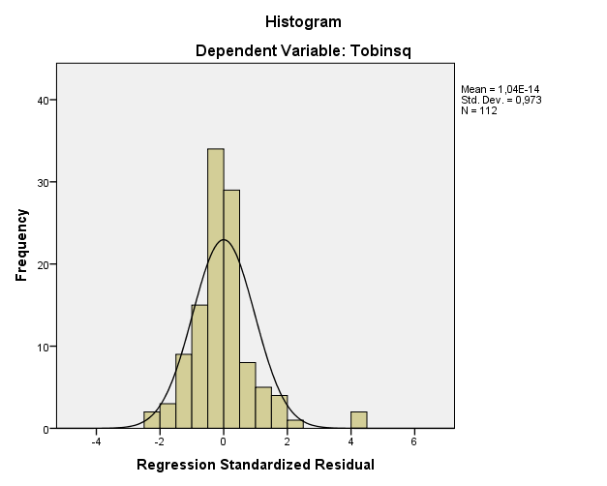
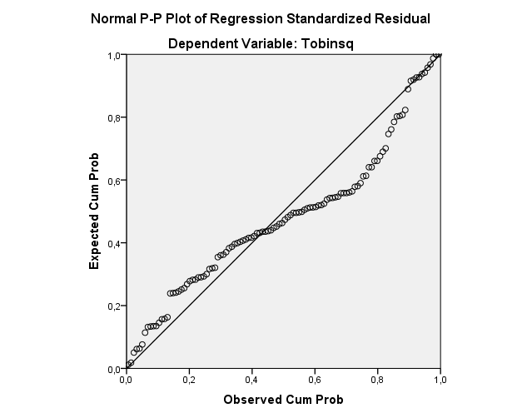

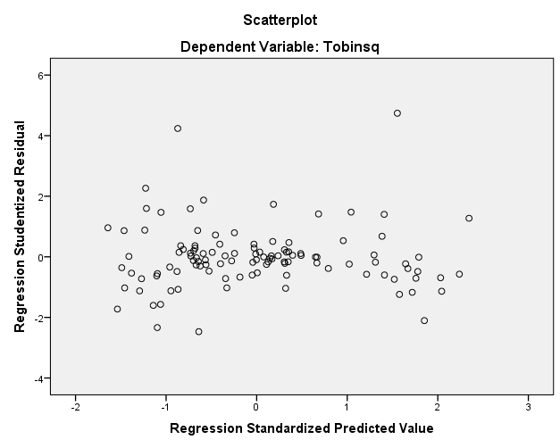

Regression
Variables Entered/Removedª
Model | Variables Entered | Variables Removed | Method
1 | LNSIZE, SQRTDER, DPR, KI, ROI, INST^{b} | . | Enter
a. Dependent Variable: LNRES_1
b. All requested variables entered.

Model Summary^{b}
Model |  | R | R Square |  | Adjusted R Square |  | Std. Error of the Estimate |  | Durbin-Watson
1 |  | ,332ª | ,110 |  | -,017 |  | 1,43598 |  | 1,944
a. Predictors: (Constant), LNSIZE, SQRTDER, DPR, KI, ROI, INST
b. Dependent Variable: LNRES_1
ANOVAª
Model |  |  |  | Sum of Squares |  | df |  | Mean Square |  | F | Sig.
1 | Regression |  |  | 10,724 |  | 6 |  | 1,787 |  | ,867 | ,527^{b}
1 | Residual |  |  | 86,605 |  | 42 |  | 2,062
1 | Total |  |  | 97,329 |  | 48
a. Dependent Variable: LNRES_1
b. Predictors: (Constant), LNSIZE, SQRTDER, DPR, KI, ROI, INST

Coefficientsª
Model |  | Unstandardized Coefficients |  | Standardized Coefficients | t | Sig. | Collinearity Statistics
 |  | B | Std. Error | Beta | t | Sig. | Tolerance | VIF
1 | (Constant) | 4,302 | 3,076 |  | 1,399 | ,169
1 | DPR | ,000 | ,002 | ,029 | ,194 | ,847 | ,932 | 1,073
1 | SQRTDER | ,410 | ,704 | ,089 | ,583 | ,563 | ,909 | 1,101
1 | KI | ,026 | ,022 | ,182 | 1,213 | ,232 | ,937 | 1,068
1 | INST | -,028 | ,018 | -,295 | -1,571 | ,124 | ,600 | 1,668
1 | ROI | ,025 | ,029 | ,141 | ,841 | ,405 | ,752 | 1,329
1 | LNSIZE | -,240 | ,150 | -,269 | -1,603 | ,116 | ,751 | 1,332
a. Dependent Variable: LNRES_1

Charts

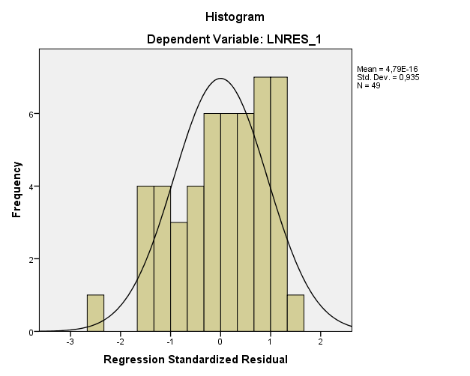

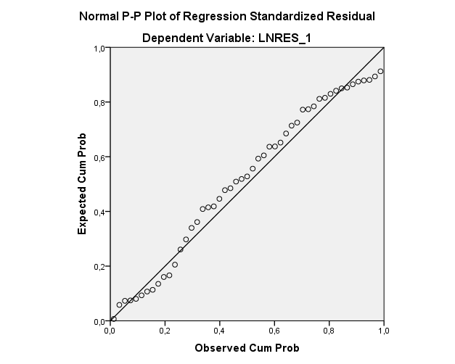

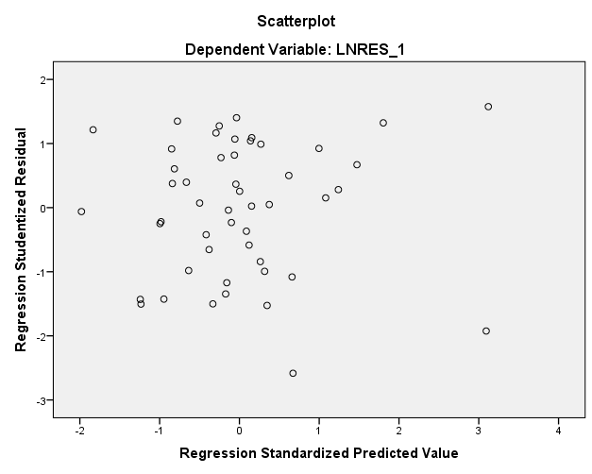

LAMPIRAN 9 : MODEL PERSAMAAN KEDUA

Regression

Variables Entered/Removedª
Model | Variables Entered | Variables Removed | Method
1 | ABSINST, Zscore(KI), Zscore(SQRTDPR), Zscore(DER), Zscore(INST), ABSDER, Zscore(ROI), Zscore(LNSIZE), ABSKI, Zscore(MBV), ABSDPR^{b} | . | Enter
a. Dependent Variable: ABSRES_1
b. All requested variables entered.

Model Summary^{b}
Model | R | R Square | Adjusted R Square | Std. Error of the Estimate | Durbin-Watson
1 | ,458ª | ,210 | ,121 | 2,57424 | 2,071
a. Predictors: (Constant), ABSINST, Zscore(KI), Zscore(SQRTDPR), Zscore(DER), Zscore(INST), ABSDER, Zscore(ROI), Zscore(LNSIZE), ABSKI, Zscore(MBV), ABSDPR
b. Dependent Variable: ABSRES_1

ANOVAª
Model |  | Sum of Squares | df | Mean Square | F | Sig.
1 | Regression | 172,321 | 11 | 15,666 | 2,364 | ,012^{b}
1 | Residual | 649,415 | 98 | 6,627
1 | Total | 821,736 | 109
a. Dependent Variable: ABSRES_1
b. Predictors: (Constant), ABSINST, Zscore(KI), Zscore(SQRTDPR), Zscore(DER), Zscore(INST), ABSDER, Zscore(ROI), Zscore(LNSIZE), ABSKI, Zscore(MBV), ABSDPR

Coefficientsª
Model |  | Unstandardized Coefficients |  | Standardized Coefficients | t | Sig. | Collinearity Statistics
 |  | B | Std. Error | Beta | t | Sig. | Tolerance | VIF
1 | (Constant) | 2,566 | ,699 |  | 3,669 | ,000
1 | Zscore(DER) | -,433 | ,312 | -,153 | -1,389 | ,168 | ,666 | 1,501
1 | Zscore(KI) | -,323 | ,308 | -,119 | -1,048 | ,297 | ,630 | 1,588
1 | Zscore(INST) | ,486 | ,298 | ,175 | 1,627 | ,107 | ,695 | 1,440
1 | Zscore(ROI) | -,011 | ,299 | -,004 | -,036 | ,972 | ,684 | 1,463
1 | Zscore(LNSIZE) | -,515 | ,296 | -,189 | -1,740 | ,085 | ,686 | 1,457
1 | Zscore(MBV) | ,319 | ,507 | ,117 | ,630 | ,530 | ,234 | 4,267
1 | Zscore(SQRTDPR) | -,405 | ,465 | -,147 | -,871 | ,386 | ,281 | 3,553
1 | ABSDPR | ,391 | ,512 | ,164 | ,764 | ,447 | ,175 | 5,713
1 | ABSDER | ,580 | ,449 | ,153 | 1,293 | ,199 | ,573 | 1,746
1 | ABSKI | ,260 | ,438 | ,085 | ,593 | ,554 | ,390 | 2,563
1 | ABSINST | -,084 | ,408 | -,026 | -,206 | ,838 | ,495 | 2,021
a. Dependent Variable: ABSRES_1

Charts
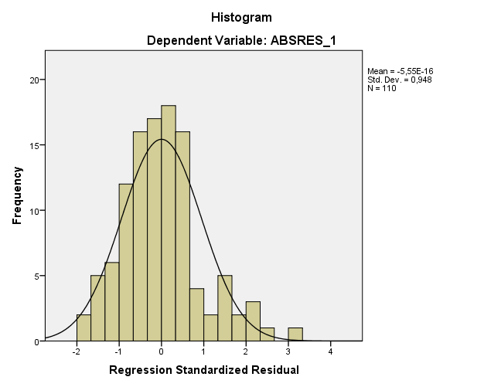

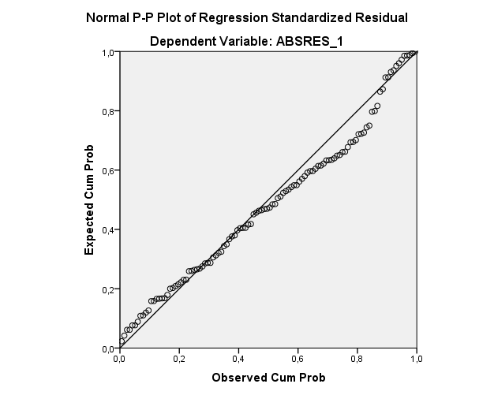

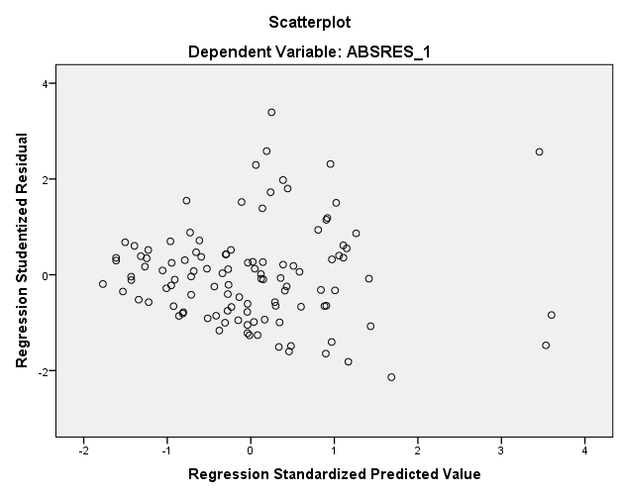

Regression

Variables Entered/Removedª
Model |  | Variables Entered |  |  | Variables Removed |  |  | Method
1 |  | ABSINST, Zscore(KI), Zscore(SQRTDPR), Zscore(DER), Zscore(INST), ABSDER, Zscore(ROI), Zscore(LNSIZE), ABSKI, Zscore(MBV), ABSDPR^{b} |  |  | . |  |  | Enter
a. Dependent Variable: Tobinsq
b. All requested variables entered.

Model Summary^{b}
Model |  | R | R Square |  |  | Adjusted R Square |  |  | Std. Error of the Estimate |  |  | Durbin-Watson
1 |  | ,963ª | ,928 |  |  | ,920 |  |  | 4,64278 |  |  | 1,647
a. Predictors: (Constant), ABSINST, Zscore(KI), Zscore(SQRTDPR), Zscore(DER), Zscore(INST), ABSDER, Zscore(ROI), Zscore(LNSIZE), ABSKI, Zscore(MBV), ABSDPR
b. Dependent Variable: Tobinsq
ANOVAª
Model |  |  |  | Sum of Squares |  |  | df |  |  | Mean Square |  |  | F | Sig.
1 | Regression |  |  | 27339,715 |  |  | 11 |  |  | 2485,429 |  |  | 115,304 | ,000^{b}
1 | Residual |  |  | 2112,429 |  |  | 98 |  |  | 21,555
1 | Total |  |  | 29452,143 |  |  | 109
a. Dependent Variable: Tobinsq
b. Predictors: (Constant), ABSINST, Zscore(KI), Zscore(SQRTDPR), Zscore(DER), Zscore(INST), ABSDER, Zscore(ROI), Zscore(LNSIZE), ABSKI, Zscore(MBV), ABSDPR

Coefficientsª
Model |  | Unstandardized Coefficients |  | Standardized Coefficients | t | Sig. | Collinearity Statistics
 |  | B | Std. Error | Beta | t | Sig. | Tolerance | VIF
1 | (Constant) | 51,593 | 1,261 |  | 40,905 | ,000
1 | Zscore(DER) | 15,841 | ,562 | ,934 | 28,184 | ,000 | ,666 | 1,501
1 | Zscore(KI) | 1,465 | ,556 | ,090 | 2,637 | ,010 | ,630 | 1,588
1 | Zscore(INST) | -1,910 | ,538 | -,115 | -3,550 | ,001 | ,695 | 1,440
1 | Zscore(ROI) | ,584 | ,540 | ,035 | 1,083 | ,282 | ,684 | 1,463
1 | Zscore(LNSIZE) | -,270 | ,533 | -,017 | -,507 | ,613 | ,686 | 1,457
1 | Zscore(MBV) | 3,236 | ,914 | ,198 | 3,539 | ,001 | ,234 | 4,267
1 | Zscore(SQRTDPR) | 1,518 | ,838 | ,092 | 1,811 | ,073 | ,281 | 3,553
1 | ABSDPR | -2,174 | ,924 | -,152 | -2,353 | ,021 | ,175 | 5,713
1 | ABSDER | -,404 | ,810 | -,018 | -,499 | ,619 | ,573 | 1,746
1 | ABSKI | -1,801 | ,791 | -,099 | -2,278 | ,025 | ,390 | 2,563
1 | ABSINST | 1,573 | ,736 | ,082 | 2,139 | ,035 | ,495 | 2,021
a. Dependent Variable: Tobinsq

Coefficient Correlationsª
Model |  |  | ABSINST | Zscore(KI) | Zscore(SQRTDPR) | Zscore(DER) | Zscore(INST) | ABSDER | Zscore(ROI) | Zscore(LNSIZE) | ABSKI | Zscore(MBV) | ABSDPR
1 | Correlations | ABSINST | 1,000 | ,208 | ,349 | ,198 | -,080 | -,087 | -,193 | ,131 | -,175 | ,088 | -,515
1 | Correlations | Zscore(KI) | ,208 | 1,000 | ,018 | ,165 | ,051 | ,017 | -,176 | -,042 | -,511 | ,020 | -,058
1 | Correlations | Zscore(SQRTDPR) | ,349 | ,018 | 1,000 | ,157 | ,085 | -,075 | -,262 | -,150 | ,035 | ,416 | -,835
1 | Correlations | Zscore(DER) | ,198 | ,165 | ,157 | 1,000 | -,128 | -,061 | ,102 | -,026 | -,214 | -,156 | -,162
1 | Correlations | Zscore(INST) | -,080 | ,051 | ,085 | -,128 | 1,000 | -,089 | -,360 | ,279 | -,007 | ,168 | -,064
1 | Correlations | ABSDER | -,087 | ,017 | -,075 | -,061 | -,089 | 1,000 | ,197 | ,252 | ,253 | -,542 | ,130
1 | Correlations | Zscore(ROI) | -,193 | -,176 | -,262 | ,102 | -,360 | ,197 | 1,000 | ,090 | ,163 | -,382 | ,267
1 | Correlations | Zscore(LNSIZE) | ,131 | -,042 | -,150 | -,026 | ,279 | ,252 | ,090 | 1,000 | ,211 | -,317 | ,117
1 | Correlations | ABSKI | -,175 | -,511 | ,035 | -,214 | -,007 | ,253 | ,163 | ,211 | 1,000 | -,406 | ,028
1 | Correlations | Zscore(MBV) | ,088 | ,020 | ,416 | -,156 | ,168 | -,542 | -,382 | -,317 | -,406 | 1,000 | -,511
1 | Correlations | ABSDPR | -,515 | -,058 | -,835 | -,162 | -,064 | ,130 | ,267 | ,117 | ,028 | -,511 | 1,000
1 | Covariances | ABSINST | ,541 | ,085 | ,215 | ,082 | -,032 | -,052 | -,077 | ,052 | -,102 | ,059 | -,350
1 | Covariances | Zscore(KI) | ,085 | ,309 | ,009 | ,052 | ,015 | ,008 | -,053 | -,012 | -,225 | ,010 | -,030
1 | Covariances | Zscore(SQRTDPR) | ,215 | ,009 | ,703 | ,074 | ,038 | -,051 | -,119 | -,067 | ,023 | ,319 | -,647
1 | Covariances | Zscore(DER) | ,082 | ,052 | ,074 | ,316 | -,039 | -,028 | ,031 | -,008 | -,095 | -,080 | -,084
1 | Covariances | Zscore(INST) | -,032 | ,015 | ,038 | -,039 | ,290 | -,039 | -,105 | ,080 | -,003 | ,083 | -,032
1 | Covariances | ABSDER | -,052 | ,008 | -,051 | -,028 | -,039 | ,656 | ,086 | ,109 | ,162 | -,401 | ,097
1 | Covariances | Zscore(ROI) | -,077 | -,053 | -,119 | ,031 | -,105 | ,086 | ,291 | ,026 | ,070 | -,188 | ,133
1 | Covariances | Zscore(LNSIZE) | ,052 | -,012 | -,067 | -,008 | ,080 | ,109 | ,026 | ,284 | ,089 | -,154 | ,058
1 | Covariances | ABSKI | -,102 | -,225 | ,023 | -,095 | -,003 | ,162 | ,070 | ,089 | ,625 | -,294 | ,020
1 | Covariances | Zscore(MBV) | ,059 | ,010 | ,319 | -,080 | ,083 | -,401 | -,188 | -,154 | -,294 | ,836 | -,432
1 | Covariances | ABSDPR | -,350 | -,030 | -,647 | -,084 | -,032 | ,097 | ,133 | ,058 | ,020 | -,432 | ,854
a. Dependent Variable: Tobinsq

Collinearity Diagnosticsª
Model | Dimension | Eigenvalue | Condition Index | Variance Proportions
 |  |  |  | (Constant) | Zscore(DER) | Zscore(KI) | Zscore(INST) | Zscore(ROI) | Zscore(LNSIZE) | Zscore(MBV) | Zscore(SQRTDPR) | ABSDPR | ABSDER | ABSKI | ABSINST
1 | 1 | 3,913 | 1,000 | ,01 | ,00 | ,00 | ,00 | ,00 | ,00 | ,00 | ,00 | ,01 | ,01 | ,01 | ,01
1 | 2 | 1,624 | 1,552 | ,00 | ,00 | ,00 | ,17 | ,08 | ,13 | ,00 | ,01 | ,00 | ,00 | ,00 | ,00
1 | 3 | 1,607 | 1,561 | ,01 | ,10 | ,07 | ,01 | ,00 | ,01 | ,04 | ,00 | ,00 | ,00 | ,00 | ,01
1 | 4 | 1,352 | 1,701 | ,00 | ,02 | ,01 | ,00 | ,08 | ,00 | ,00 | ,12 | ,01 | ,01 | ,00 | ,00
1 | 5 | 1,060 | 1,921 | ,00 | ,16 | ,26 | ,01 | ,04 | ,00 | ,01 | ,01 | ,00 | ,00 | ,01 | ,00
1 | 6 | ,795 | 2,219 | ,00 | ,00 | ,11 | ,00 | ,29 | ,30 | ,01 | ,02 | ,00 | ,01 | ,01 | ,00
1 | 7 | ,552 | 2,663 | ,01 | ,15 | ,03 | ,39 | ,03 | ,29 | ,07 | ,00 | ,00 | ,03 | ,01 | ,00
1 | 8 | ,432 | 3,009 | ,01 | ,34 | ,03 | ,36 | ,29 | ,07 | ,07 | ,00 | ,00 | ,09 | ,01 | ,00
1 | 9 | ,331 | 3,438 | ,01 | ,11 | ,14 | ,01 | ,04 | ,00 | ,06 | ,04 | ,01 | ,41 | ,06 | ,06
1 | 10 | ,184 | 4,614 | ,01 | ,07 | ,31 | ,02 | ,00 | ,01 | ,01 | ,08 | ,03 | ,01 | ,50 | ,32
1 | 11 | ,094 | 6,445 | ,34 | ,01 | ,00 | ,01 | ,00 | ,08 | ,06 | ,23 | ,29 | ,16 | ,18 | ,49
1 | 12 | ,055 | 8,401 | ,60 | ,03 | ,03 | ,02 | ,15 | ,10 | ,67 | ,49 | ,65 | ,27 | ,20 | ,11
a. Dependent Variable: Tobinsq

Residuals Statisticsª
 | Minimum | Maximum | Mean | Std. Deviation | N
Predicted Value | 27,2744 | 97,6386 | 49,3488 | 15,83739 | 110
Std. Predicted Value | -1,394 | 3,049 | ,000 | 1,000 | 110
Standard Error of Predicted Value | ,795 | 3,581 | 1,410 | ,606 | 110
Adjusted Predicted Value | 27,3349 | 103,8035 | 49,3895 | 16,04158 | 110
Residual | -12,00535 | 13,44667 | ,00000 | 4,40228 | 110
Std. Residual | -2,586 | 2,896 | ,000 | ,948 | 110
Stud. Residual | -2,731 | 3,369 | -,004 | 1,022 | 110
Deleted Residual | -13,39498 | 18,18951 | -,04072 | 5,21521 | 110
Stud. Deleted Residual | -2,827 | 3,564 | -,005 | 1,037 | 110
Mahal. Distance | 2,203 | 63,850 | 10,900 | 12,640 | 110
Cook's Distance | ,000 | ,457 | ,018 | ,060 | 110
Centered Leverage Value | ,020 | ,586 | ,100 | ,116 | 110
a. Dependent Variable: Tobinsq

Charts

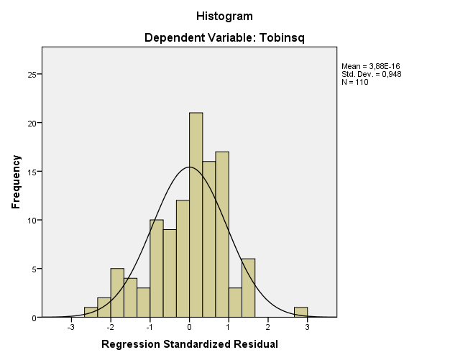

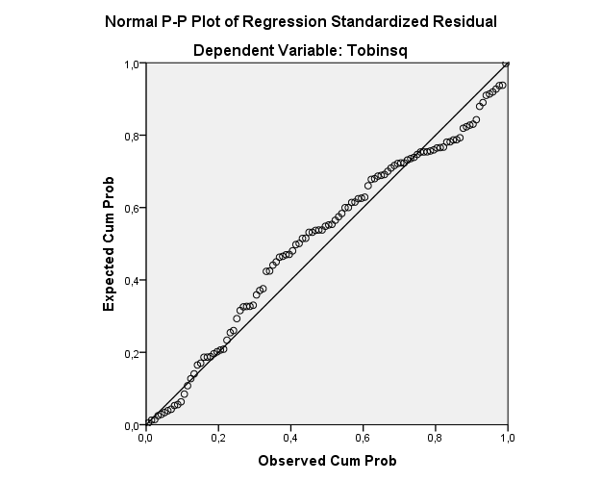

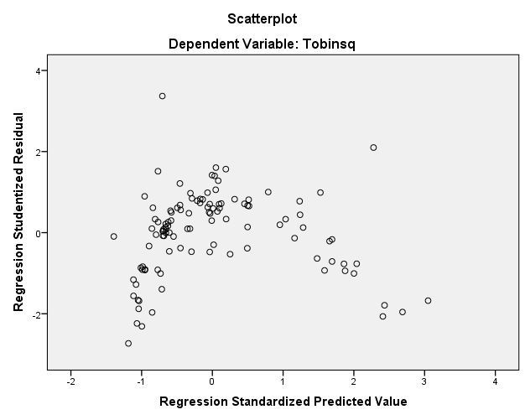

Regression

Variables Entered/Removedª
Model | Variables Entered | Variables Removed | Method
1 | ABSINST, Zscore(SQRT.KI), Zscore(SQRTDER), Zscore(SQRTINST), ABSDER, Zscore(ROI), Zscore(LNSIZE), ABSDPR, ABSKI, Zscore(MBV), Zscore(DER)^{b} | . | Enter
a. Dependent Variable: LNTOBINSQ
b. All requested variables entered.

Model Summary^{b}
Model | R | R Square | Adjusted R Square | Std. Error of the Estimate | Durbin-Watson
1 | ,983ª | ,966 | ,962 | ,06710 | 2,068
a. Predictors: (Constant), ABSINST, Zscore(SQRT.KI), Zscore(SQRTDER), Zscore(SQRTINST), ABSDER, Zscore(ROI), Zscore(LNSIZE), ABSDPR, ABSKI, Zscore(MBV), Zscore(DER)
b. Dependent Variable: LNTOBINSQ

