STATEMENT OF ORIGINALITY AND
COPYRIGHT TRANSFER AGREEMENT

The undersigned, on behalf of all authors, authenticate that the manuscript document:
Tittle of the Manuscript | : | Phytoestrogens and Women’s Health: Implications for Fibroids and Breast Cancer: a Scoping Review
Name of All Author(s) | 1.  2. | Nell Lesnik, MS, RDN  Sandi Tenflede, PhD, APRN, WHNP-BC

Corresponding Author :
Name : Nell Lesnik, MS, RDN
Institution : Loyola Univeristy Chicago
Address : 1032 W Sherdian Road, Chicago, IL 60660
Mobile Phone Number 312-934-9548
Fax …….……N/A……………………… ; Email: nlesnik@luc.edu

has been thoroughly reviewed and approved by all authors and supervisors. It does not contain any fabrication, falsification, or plagiarism. It is intended solely for publication in Jurnal Gizi Indonesia (The Indonesian Journal of Nutrition) where the manuscript has not been previously submitted, nor is it currently under consideration or in the publication process in any other journal or publication platform.

I/We hereby agree to transfer to Jurnal Gizi Indonesia (The Indonesian Journal of Nutrition), the copyright of the above - named manuscript. I/We reserve the following: (1) All proprietary rights other than copyright such as patent rights. (2) The right to use all or part of this article in future works of our own such as in books and lectures.

The author agrees to pay a review fee of IDR 250,000 upon receiving a first decision indicating the manuscript is eligible for peer review, and a publication fee of IDR 1,250,000 upon acceptance and prior to the issuance of the Letter of Acceptance (LOA), which may be invoiced to* :

[X ] First Author
[ ] Corresponding Author

Declarant**,
Date & Sign : 1st Author : 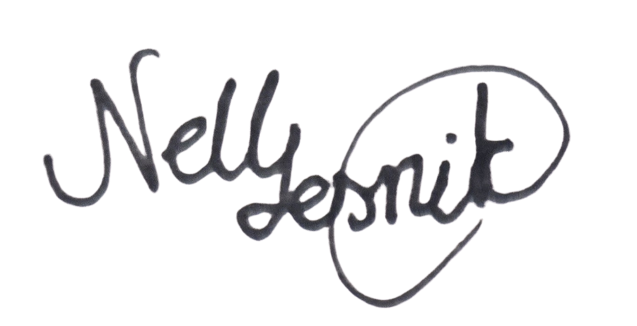 10/17/25
2nd Author : 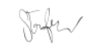10/17/25

