Bengkulu, November 25, 2016
To:
Editor in Chief of JITAA

Dear Sir/Madam
We hereby send manuscript entittled “THE EFFECT OF Sauropus androgynus LEAF EXTRACT, FISH OIL AND VITAMIN E ON PERFORMANCE, EGG QUALITY AND COMPOSITION IN LAYING HENS” for publication in Journal of The Indonesian Tropical Animal Agriculture.
Thank you for your coorporation, and we hope this manuscript could be published in your journal.
Sincerely yours,
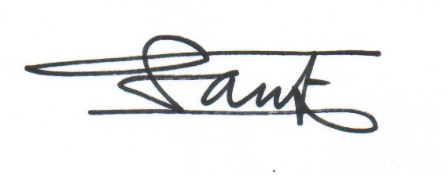
Urip Santoso

