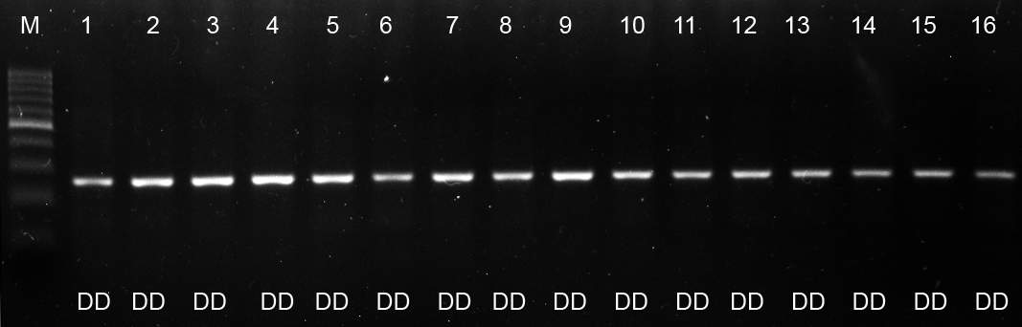
200 bp
500 bp
265 bp
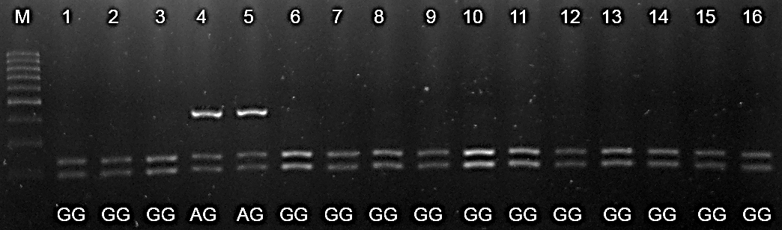
Figure 1. Amplification product of promoter region ADIPOQ gene in 2% agarose gel (w/v). Lane M = marker with 100 bp DNA ladder; Lane 1-16 = DD genotype.
411 bp
300 bp
200 bp
500 bp
186 bp
225 bp

Figure 2. Digestion pattern of 5’UTR EDG1 gene by MscI in 2% agarose gel (w/v). Lane M = marker with 100 bp DNA ladder; Lane 1-3 and 6-16 = GG genotype; Lane 4-5 = AG genotype.

3’UTR
5’UTR
Exon 2
5’UTR
Intron 1
(a)

1 bp
411 bp
(b)

228 bp
102 bp
189 bp

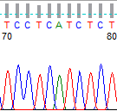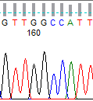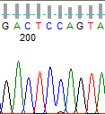
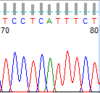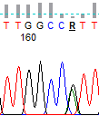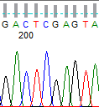
c.-399C>T c.-312A>G c.-273C>G

Figure 3. Schematic of SNP position located in 5’UTR of EDG1 gene. (a) sequences reference of EDG1 gen (ENSBTAG00000005990); (b) SNP position in PCR product 411 bp; c.-399C> T and c.-273C> G = candidat novel SNP in Bali cattle; c.-312A>G = SNP was recognized by MscI restriction enzyme (A allele); R = purine base (adenine or guanine).

