Association of MC4R on Bligon goat

Association of Melanocortin 4 Receptor gene polymorphism with growth traits in Bligon goat

Latifah¹, Dyah Maharani¹, Kustantinah² and Tety Hartatik ¹*,
¹Department of Animal Breeding and Reproduction, Faculty of Animal Science, Universitas Gadjah Mada, Yogyakarta, Indonesia
²Department of Animal Nutrition and Feed Science, Faculty of Animal Science, Universitas Gadjah Mada, Yogyakarta, Indonesia
Jl. Fauna No. 3, Sleman-Yogyakarta, Indonesia
*Corresponding author: tety@ugm.ac.id

ABSTRAK
Melanocortin merupakan marker gen yang potensial untuk pertumbuhan pada hewan ruminansia dan non-ruminansia. Tujuan penelitian ini untuk mengidentifikasi distribusi alel dan hubungan gen MC4R dengan sifat pertumbuhan pada kambing Bligon. Total 30 sampel darah telah dikoleksi dan diisolasi DNA. Sepasang primer digunakan untuk amplifikasi gen MC4R (F: 5’-TCGGGCGTCTTGTTCATCAT-3’ dan R: 5’-CAAGACTGGGCACTGCTTCA-3’) menggunakan metode PCR . Terdapat 2 SNP di g.998A>G dan g.1079C>T terletak di exon dan 3’UTR terindikasi dengan menggunakan metode sekuensing DNA dan PCR-RFLP. Pada SNP g.998A>G teridentifikasi adanya perubahan asam amino (I-M). Berdasarkan analisis hubungan antara gen MC4R dengan sifat pertumbuhan (Berat sapih, panjang badan sapih dan lingkar dada sapih) menunjukkan bahwa kambing Bligon dengan genotip AA dan AG memiliki pertumbuhan lebih tinggi dibandingkan genotip GG. Sementara pada g.1079C>T, Berat sapih dan pertambahan berat badan harian (PBBH) pada genotip CC dan CT lebih tinggi dibandingkan dengan genotip TT. Sementara panjang badan dan lingkar dada sapih pada individu CT lebih tinggi daripada individu CC dan TT. Hasil penelitian ini mengindikasi bahwa SNP g.998A>G dan g.1079C>T dapat dijadikan marker genetik sifat pertumbuhan untuk seleksi kambing Bligon.
Kata Kunci : Bligon, MC4R, SNP, sifat pertumbuhan, hubungan
ABSTRACT
Melanocortin 4 receptor gene is potential marker gene for growth performance in ruminant and non-ruminant animals. The objective of this study was to perform allele distribution and association of melanocortin 4 receptor with growth traits in Bligon goat. Thrity blood samples were collected and DNA isolated successfully. One pair primer was used for PCR of MC4R gene (F: 5’-TCGGGCGTCTTGTTCATCAT-3’ and R: 5’-CAAGACTGGGCACTGCTTCA-3’). Two SNPs (g.998A>G and g.1079C>T) were identified in exon and 3’UTR of Bligon MC4R by DNA sequencing and PCR-RFLP, respectively. The SNP g.998A>G identified amino acid change (I-M). Based on relationship analysis between Genotype of MC4R gene (SNP g.998A>G) and Growth traits indicated that GG genotype was highest in weaning weight (WW), weaning body length (WBL) and weaning chest circumference (WCC) compare to AA and AG genotype (p<0,05). Individual with CC and CT genotypes at SNP g.1079C>T had higher in WW and ADG than TT genotype (p<0,05), while, individual with CT genotype was significantly higher in WBL and WCC than CC and TT individuals. This results suggested that SNP g.998A>G and SNP g.1079C>T of MC4R gene could be used as the genetic marker of growth traits for selection in Bligon.
Keywords : Bligon, MC4R, SNP, Growth traits, Association
INTRODUCTION
Indonesia has many goats (Bligon, Kacang, Kecobong, Samosir, Kosta, Benggala, Muara and Peranakan Etawah) that live in both intensive and extensive rearing system. Grass and roughage are the main diets for goats in two rearing systems. The domestic goat is categorized as Capra, Caprovinae, and ruminant. Bligon goat is a crossbreed between Kacang and Peranakan Etawah goat (Budisatria et al., 2009; Suhartanto and Kustantinah, 2009; Hartatik, 2014). Growing of Bligon is influenced by Genetic and environment (Hardjosubroto, 1994). The recent study, molecular genetics has provided a new system for selection goats based on genetics marker that significantly influenced growth traits. Growth traits are influence by many pairs of gene. The melanocortin 4 receptor gene is among the candidate genes for growth traits in goats (Jun et al., 2013).
Melanocortin 4 receptor (MC4R) gene, which leds to pharmacological tool development, is a model of melanocortin system in controlling the energy balance. The MC4R gene functions to regulate food intake and homeostasis. This role has been shown to be evolutionarily conserved in vertebrates (Andersone et al., 2016). Allele and genotype distribution of MC4R gene have been described by many researchers in monogastric and polygastric animal such as in chicken (Yan et al., 2013), pig (Piorkoswka et al., 2010; Davoli et al., 2012), sheep (Wang et al., 2015), cattle (Liu et al., 2010; Maharani et al., 2018) and buffalo (Deng et al., 2016).
The genotype of MC4R gene based on single nucleotide polymorphism has also been reported as genetics marker for body weight in female Beagle dogs (Zeng et al., 2014), sexual desire behavior feed intake and finishing weight in rabbit (Fontanesi et al., 2013; El-Sabrout, 2017; El-Sabrout and Soliman, 2017), egg production in Langsan chicken (Yan et al., 2013), feed intake, body weight and ADG in yak (Cai et al., 2015), backfat thickness and marbling score in Korean cattle (Seong et al., 2012), birth body length in Kebumen cattle (Maharani et al., 2018), ADG, loin-eye area and meat quality in sheep (Zou et al., 2014) and milk production in buffalo (Deng et al., 2016). In the previous study, genetics analysis (SNPs detection, amino acid change, restriction enzyme mapping and phylogenetic tree) of MC4R gene were reported in Bligon goat (Latifah et al., 2017). However, no report on the allele distribution and association of MC4R with growth traits study have been identified in Bligon goat. The work of MC4R gene in monogastric and polygastric animals suggested that it may be an important genetic marker in Bligon goat. Therefore, the objective of this study was to perform allele distribution and association study of Melanocortin 4 Receptor with growth traits in the Bligon goat.

MATERIALS AND METHODS
Animal and DNA samples
Thrity blood samples (female=17 head; male=13 head) were sampled from Bligon goat. The samples were randomly selected from a local farmer in Banyusoco village, Gunungkidul, Special Region of Yogyakarta, Indonesia. The body weight, body measurement (BL: body length; CC: chest circumference; HS: height of shoulder; HH: height of hip) and average daily gain (from the birth to the 3rd month) were observed. The blood samples were collected and maintained in an ice box being transport to the laboratory. Genomic DNA of each individual was extracted from the blood using SYNCTM DNA Extraction Kit (Geneaid, Taiwan) method.
MC4R gene genotyping
PCR was performed using the primers MC4R F (F: 5’-TCGGGCGTCTTGTTCATCAT-3’) and primer R (R: 5’-CAAGACTGGGCACTGCTTCA-3’), designed by Latifah et al. (2017) to PCR a fragment of 642 bp in length covering the exon and 3’UTR of the goat MC4R gene. PCR was performed in the 30 μL reaction mixture containing 10 μL of DDW, 1.5 μL of primer F and R, 15 μL of PCR kit (KAPPABIOSYSTEMS, USA), and 2 μL of DNA genome. The protocol was followed: the pre-denaturation temperature at 94ºC for 3 min, 35 cycles of denaturation at 94ºC for 30 sec, extension at 72ºC for 30 sec, and followed by a final extension at 72ºC for 10 min. The product PCR was sequenced with the same primer. Sequencing was performed by 1st Base DNA sequencing, Malaysia. The MC4R gene sequence of 21 Bligon goats was aligned an edited in Bioedit ver. 7.00. Polymorphism sites of nucleotide and amino acid sequence of the coding region of MC4R gene were analyzed using Bioedit ver. 7.00. The method of detection SNPs and amino acid change were described by Hartatik (2016). The SNP g.1079C>T from 9 samples was used for genotyping using PCR-restriction fragment length polymorphism (PCR-RFLP) method. The restriction enzyme digestion was performed in 9 µL reaction volumes with approximately 4 µL of PCR products and 0,2 µL of Kpn1 restriction enzyme. The digested products were run on 3% agarose gels..

Data analysis
The growth traits of Bligon were adjusted based on birth type, an age of doe and gender. The adjusted data analysis using the method that described by Hardjosubroto (1994). The following models were:
Adjusted BW = Actual BW x BTF x ADF x GF
$$\text{AdjustedWW}=\left(\text{ActualBW}+\frac{\text{ActualWW}−\text{ActualBW}}{\text{Age}}x\text{100}\right)\text{xBTFxADFxGF}$$

Where: BW is birth weight, WW is weaning weight, BTF is birth type factor, ADF is an age of doe factor and GF is gender factor. The genotype of Bligon goats were determined by sequencing and PCR-RFLP analysis. Test of Person’s Chi-square was used to verify the samples not deviant to Hardy-Weinberg equilibrium. The model analysis was:
$X^{2}=\sum_{i=1}^{n}{\frac{{\left(O_{i}−E_{i}\right)}^{2}}{E_{i}}}$

Where: X² is chi-square value, O_{i} is observed frequency, E_{i} is expected frequency and n is Number of data. The association between growth traits and genotype of MC4R SNP were analysis using way ANOVA procedure in the software SPSS ver. 16.00 (SPSS, USA). The model was as follows:
Yij = µ + ɑi + єij

Where Y is the phenotypic data (body weight, body measurement, and average daily gain) of the sample, µ is the overall mean, α is the genotype effect of sample i and ε is a random error. Duncan's test was performed to analyze the pair-wise differences between the genotypes.

RESULTS AND DISCUSSIONS
SNPs detection, allele, and genotype distribution
We sequenced 642 bp of Bligon MC4R gene, including 461 of exon 1 and 181 of 3’UTR. This study was the first to evaluate the relationship of SNPs in the MC4R gene on growth traits in Bligon. In our study, two SNPs were identified in Bligon MC4R gene. The SNPs in MC4R gene was initially identified by direct sequencing using 21 samples of PCR product. The SNP was confirmed by BioEdit program. As the results, two SNPs of MC4R gene were identified: SNP g.998A>G and SNP g.1079C>T (Figure 1a, b). Among two SNPs, the SNP g.998A>G was found to have amino acid variants I-M (isoleucine to methionine) (Figure 2). However, no amino acid change has been detected in SNP g.1079C>T.
Three patterns (AA, AG and GG) were clearly detected at SNP g.998A>G, while three genotypes (CC, CT, and TT) were observed at location of g.1079C>T. The SNP g.1079C>T was used for genotyping using PCR-RFLP for 9 samples of Bligon. Homozygote CC and TT were defined when the fragments size being recognized at 165 and 477 and 642 bp, respectively. The heterozygote CT existed by the PCR-RFLP method at the same position of the homologous chromosome with 163, 253 and 642 bp of fragments size (Figure 3). There were two extra band in the figure 3, this was due to the extra band of PCR products. Latifah et al., (2017) reported only 2 genotypes produced at both SNP g.998A>G (AA and AG) and g.1079C>T (CC and CT) in the Bligon.
Allele, genotype frequencies and Hardy-Weinberg equilibrium for two SNP were shown in Table 2. The C and G Allele at SNP g.998A/G and SNP g.1079C/T were dominant alleles, respectively. The highest number of AA (0,47) and CC (0,43) homozygote genotypes were observed at SNP g.998A/G and SNP g.1079C/T, respectively. Both SNP g.998A/G and SNP g.1079C/T were in HWE because of estimation of the x² value lower than the x² value (0,05;2) in the table of Person’s Chi-square test. Similar results have been reported in Yak population that five SNPs indicated no significant deviation from HWE (p>0,05) (Cai et al., 2013). The results of Pearson‘s Chi-square test in Kebumen cattle was not deviate (P>0.05) from the HWE (Maharani et al., 2018). In the Buffalo was identified eight SNPs st exon and 3’UTR region. Allele and genotype frequencies of six polymorphisms were appropriated in HWE (p>0,05), while two SNPs (g.226C/T and g.1525A/G) were not in HWE (Deng et al., 2015). The result of chi-square test showed that the chicken and pig species were not in HWE (Yan et al., 2013; Davoli et al., 2012)
Association of MC4R gene polymorphism with growth traits
The result of association analysis between the MC4R gene based on SNP g.998A/G and SNP g.1079C/T and growth traits shows in Table 2 and Table 3. A significant interaction between growth traits at birth and MC4R gene genotype released that SNP g.998A/G and SNP g.1079C/T was not found in all observed traits (p>0,05). However, both SNP g.998A/G and SNP g.1079C/T were effected with weaning weight (WW), weaning body length (WBL) and weaning chest circumference (WCC). The AA and AG genotype had higher WW, WBL and CC in the SNP g.998A/G (P<0,05). Similarly, in SNP g.1079C/T, the CC and CT significantly differed from TT in varied WW and average daily weight (ADG) (P<0,05). Whereas, the Bligon with genotype CT at SNP g.1079C/T showed higher WBL and WCC (P<0,05). These results indicated that the Bligon with AA and AG genotype at SNP g.998A/G, and CC and CT genotype at SNP g.1079C/T had a tendency to gain more WW, WBL, WCC, and ADG. Our result indicated that polymorphisms (g.998A>G and g.1079C>T) could be used for a genetic marker in Bligon.
The MC4R gene polymorphisms were highly frequent in both monogastric and polygastric animal. In cattle, five mutations in MC4R gene has been found. The mutation at g. 1069G/C have been associated with backfat thickness. Animals with CT and CC genotype higher backfat thickness (p<0,01) than animals with GG genotype (Huang et al., 2010). The SNPs in UTR or exon can effect phenotypes in animals (Zeng et al., 2014; Fontanesi et al., 2013; El-Sabrout, 2017; El-Sabrout and Soliman, 2017; Yan et al., 2013; Cai et al., 2015; Seong et al., 2012; Zou et al., 2014; Deng et al., 2016). Polymorphism at 1069G/C was detected in cattle and high effected with backfat thickness (p<0,01) (Huang et al., 2010). Maharani et al. (2018) reported the SNP at g.1133C/G of MC4R gene with GG genotype in Kebumen cattle having highest body length at birth (P<0,05).
The study in Hu sheep found four novels in 3’UTR that associated with 45 weaning weight (Song et al., 2012). Deng et al. (2015) reported eight SNPs in water Buffalo. Statistical analysis suggested that SNP g.1104C/T differed significantly with milk yield, protein and fat percentage (p<0,05). In other species, five polymorphism were detected in obese and non-obese dogs (Mankoswka et al., 2017). In beagle dogs, SNP at 420A/C was significantly correlation canine body weight (Zeng et al., 2014). Mignone et al (2002) reported the UTR that controlled of translation efficiency, mRNA stability and mRNA subcellular localization.

CONCLUSION
Two polymorphisms (SNP g.998A>G and g.1079C>T) were detected in Bligon MC4R gene in this study. Both of the SNPs were consistent in HWE. The SNP g.998A>G was significantly associated with WW, WBL and WCC (p<0,05), whereas the polymorphism at g.1079C>T high relationship with WW, WBL, WCC and ADG (p<0,05). Our result suggested that MC4R gene might have a potential effect on growth traits in Bligon.

ACKNOWLEDGMENTS
The study was supported by the grant from Indonesia Higher Education (Dikti) in PMDSU (Master Program of Education Leading to Doctoral Degree for Excellent Graduates) program scheme with contract no. 1987/UN1-P.III/LT/DIT-LIT/2017. Thank Akhmad Fathoni, Hanum Muarifah, Niken Rahmawati, Minuk Kusmia, Dwi Ahmad Priyadi, Amir Husaini, Eris Riswanto, Nur Muhammad and Dwi Nur Happy Hariyono for helping data collection. Also, thank to Retno Setyawati for helping DNA analysis.
REFERENCES
Anderson, E. J. P., I. Cakir, S. J. Carrington, R. D. Cone, M.G. Langroudi, T. Gillyard, L.E. Gimenez and M. J. Litt. 2016. Regulation of feeding and energy homeostasis by α-MSH. J. Mol. Endoc. 56(3): 157-174.
Budisatria, I.G.S., D. Widayati, B. Suhartanto, Kustantinah, H. Mulyadi dan K.A. Santosa. 2009. Germ Plasm of Goats in Indonesia. CV. Bawah Sadar. Yogyakarta:8
Cai, X., T. D. Mipam, F. F. Zhao, and L. Sun. 2015. SNPs detected in the yak MC4R gene and their association with growth traits. J. Animal. 9: 1097-1103. https://doi.org/10.1017/S1751731115000397
Davoli R., S. Braglia, V. Valastro, C. Annarratone, M. Comella, P. Zambonelli, I. Nisi, M. Gallo, L. Buttazzoni and V. Russo. 2012. Analysis of MC4R polymorphism in Italian Large White and Italian Duroc pigs: Association with carcass traits. J. Meat Sci. 90: 887–89. https://doi.org/10.1016/j.meatsci.2011.11.025
Deng, T. X., C. Y. Pang, M. Q. Liu, C. Zhang, & X. W. Liang. 2016. Synonymous single nucleotide polymorphisms in the MC4R gene that are significantly associated with milk production traits in water buffaloes. J. Gen. Mol. Res. 15:1-8. https://doi.org/10.4238/gmr.15028153
El-Sabrout K. 2017. Associations between single-nucleotide polymorphisms of melanocortin gene and sexual desire behavior in rabbit (Oryctolagus cuniculus). J. Vet. Beh. 19. 69-71. https://doi.org/10.1016/j.jveb.2017.02.005
El-Sabrout K. and F. Soliman. 2017. Association of single- nucleotide polymorphism of melanocortin gene with feed intake in rabbit (Oryctolagus cuniculus). J Anim Physiol Anim Nutr. 00: 1–4. https://doi.org/10.1016/j.jveb.2017.02.005
Fontanesi L., E. Scotti, K. Cisarova, P. D. Battista, S. Dall'Olio, D. Fornasini and A. Frabetti. 2013. A missense mutation in the rabbit melanocortin 4 receptor (mc4r) gene is associated with finishing weight in a meat rabbit line. J. Anim. Biotec.. 24(4): 268-277. https://doi.org/10.1080/10495398.2013.781034
Hardjosubroto, W. 1994. Aplikasi Pemuliaan Ternak di Lapangan. Grasindo. Jakarta:210-227.
Hartatik, T. 2014. Analisis Genetik Ternak Lokal. Gadjah Mada University Press. Yogyakarta: 75-88.
Hartatik, T. 2016. Pendekatan Praktis Deteksi Polimorfisme DNA Sapi Aceh. Gadjah Mada University Press. Yogyakarta:118-134.
Huang, M., X. Gou and J. Y. Li. 2010. Polymorphisms in MC4R gene and correlations with economic traits in cattle. J. Mol. Biol. Rep. 37:3941-3944. https://doi.org/10.1007/s11033-010-0051-0
Jun, Z., Q. Yong, Z. Sheng, C. Hua, W. H. Li, L.Y. Xia, and C. S. Xian. 2013. Single nucleotide polymorphisms of gene fragment of melanocortin receptor-4 C-terminal and its association with body weight in Boer goats. Jiangsu J. Agr. Sci. 6. (Abstract).
Latifah, D. A. Priyadi, D. Maharani, Kustantinah and T. Hartatik. 2017. Genetic Analysis Using Partial Sequencing of Melanocortin 4 Receptor (MC4R) Gene in Bligon Goat. J. Med. Pet.. 40(2):71-77. http://dx.doi.org/10.5398/medpet.2017.40.2.71
Maharani, D., A. Fathoni, Sumadi, T. Hartatik and M. Khusnudin. 2018. Identification of MC4R gene and its association with body weight and body size in Kebumen Ongole Grade cattle. J. Indonesian Trop. Anim. Agric. 43(2):87-93.
Mankowska, M., J. N. Woszuk, A. Graczyk, P. Ciazynska, M. Stachowiak and M. Switonski. 2017. Polymorphism and methylation of MC4R gene in obese and non-obese dogs. J. Mol. Biol. Rep. 44: 333-339.
Mignone F.,C. Gissi, ad S. Liuni. 2002. Untranslated regions of mRNAs (Review). Gen. Bio. 3:1-10. https://doi.org/10.1186/gb-2002-3-3-reviews0004
Piorkowska, K., M. Tyra, M. Rogoz, K. R. Molik, M. Oczkowicz, and M. Rozycki. 2010. Association of the melanocortin-4 receptor (MC4R) with feed intake, growth, fatness and carcass composition in pigs raised in Poland. J. Meat Sci. 85: 297–301. https://doi.org/10.1016/j.meatsci.2010.01.017
Seong, J., S. S. Dong, D. P. Kyung, K. L. Hak, and S. K. Hong. 2011. Identification and analysis of MC4R polymorphisms and their association with economic traits of Korean cattle (Hanwoo). J. Mol. Biol. Rep. 39: 3597-3601. https://doi.org/10.1007/s11033-011-1133-3
Song, X. M., J. F. Jiang, G. Z. Zhang, F. X. Shiand, and Y. Q. Jiang. 2012. DNA polymorphisms of the Hu sheep melanocortin-4 receptor gene associated with birth weight and 45-day weaning weight. J. Gen. Mol. Res. 11: 4432-4441. https://doi.org/10.4238/2012.September.27.3
Suhartanto, B dan Kustantinah. 2009. Goat Feeding. In: Budisatria, I.G.S., D. Widayati, B. Suhartanto, Kustantinah, H. Mulyadi dan K.A. Santosa. Germ Plasm of Goats in Indonesia. CV. Bawah Sadar. Yogyakarta: 45.
Wang, Y., C. Wang, J. Zhang, C. Meng, X. Zhang, Z. Wang, Y. Fang, D. Mao, & S. Cao. 2015. Three novel MC4R SNPs associated with growth traits in Hu sheep and East Friesian x Hu crossbreed sheep. Small Rum. Res. 125: 26-33. https://doi.org/10.1016/j.smallrumres.2015.02.007
Yan, L. J., X. T. Fang, Y. Liu, C. L. Zhang, X X Liu, J. Zhao, J. J. Li and H. Chen. 2013. Effects of single and combined genotypes of MC4R and POU1F1 genes on two production traits in Langshan chicken. J. Mol. Biol. Rep. 40:4645–4650. https://doi.org/10.1007/s11033-013-2558-7
Zhang, J., J. Chai, Z. Luo, H. He, L. Chen, X. Liu and Q. Zhou. 2017. Meat and nutritional quality comparison of purebred and crossbred pigs. Anim. Sci. Jour. 89(1):202-210. https://doi.org/10.1111/asj.12878
Zheng, R., Y. Zhang and P. Du. 2014. The SNPs of Melanocortin 4 Receptor (MC4R) associated with Body Weight in Beagle Dogs. J. Exp. Anim. 63(1): 73–78. https://doi.org/10.1538/expanim.63.73
Zuo, B., G. Liu, Y. Peng, H. Qian, J. Liu, X. Jiang, and A. Mara. 2014. Melanocortin-4 receptor (MC4R) polymorphisms are associated with growth and meat quality traits in sheep. J. Mol. Biol. Rep. 41: 6967-6974. https://doi.org/10.1007/s11033-014-3583-x
Table and Figure
- Table
Tabel 1. Allele, genotype frequencies and Hardy-Weinberg equilibrium in MC4R gene of Bligon
No | SNP | Genotype | N | Genotype Frequency | Allele Frequency | X²
1 | g.998A/G | AA  AG  GG | 10  8  3 | 0.47  0.38  0.15 | C= 0.67  T=0.33 | 0.30
2 | g.1079C/T | CC  CT  TT | 13  12  5 | 0.43  0.40  0.17 | G=0.63  C=0.37 | 0.35
N = number of data
X² in the table of Person’s Chi-square test 0.05;2 = 5.99

Table 2. Association of SNP g.998A/G genotype with growth traits
Growth traits (N=21) | AA | AG | GG
BW | 3.6±0.4 | 3.7±0.4 | 3.1±1.0
BBL | 32.0±1.6 | 31.5±3.4 | 30.7±5.0
BCC | 33.5±1.9 | 34.9±2.4 | 33.8±3.8
BHS | 35.9±1.3 | 38.2±2.7 | 33.1±5.8
BHH | 37.5±2.6 | 39.6±2.0 | 37.4±4.3
WW | 13.0±1.7ª | 11.2±3.6ª | 9.2±3.9^{b}
WBL | 46.8±2.4ª | 46.3±6.0ª | 43.8±5.3^{b}
WCC | 50.9±4.0ª | 50.7±4.6ª | 47.1±7.3^{b}
WHS | 58.2±3.2 | 55.2±6.2 | 51.9±6.5
WHH | 56.7±4.5 | 56.1±4.0 | 53.2±8.3
ADG | 82.3±1.0 | 86.3±4.9 | 81.3±5.3
N: number of animal; BW: birth weight (kg); BBL: birth body lenght (cm); BCC: birth chest circumference (cm); BHS: birth height of shoulder (cm); BHH: birth height of hip (cm); WW: weaning weight (kg); WBL: weaning body lenght (cm); WCC: weaning chest circumference (cm); WHS: weaning height of shoulder (cm); WHH: weaning height of hip (cm); ADG: average daily gain (g).
^{(a,b)} different superscripts at the same raw indicate significant differences (P<0.05)

Table 3. Association of SNP g.1079C/T genotype with growth traits
Growth traits (N=30) | CC | CT | TT
BW | 3.6±0.5 | 3.6±0.5 | 3.6±0.5
BBL | 31.8±2.6 | 31.8±2.6 | 31.8±2.6
BCC | 33.6±2.1 | 33.6±2.1 | 33.6±2.1
BHS | 35.6±1.8 | 35.6±1.8 | 35.6±1.8
BHH | 37.5±2.5 | 37.5±2.5 | 37.5±2.5
WW | 12.9±2.0ª | 13.0±3.9ª | 11.8±4.7^{b}
WBL | 47.1±2.9^{b} | 49.0±6.4ª | 47.4±7.4^{b}
WCC | 51.0±4.2^{b} | 53.4±6.0ª | 51.8±9.6^{b}
WHS | 58.0±4.4 | 57.5±6.2 | 56.9±7.5
WHH | 56.6±4.5 | 59.4±6.2 | 57.9±9.4
ADG | 104±20.6ª | 104±44.4ª | 93±43.7^{b}
N: number of animal; BW: birth weight (kg); BBL: birth body lenght (cm); BCC: birth chest circumference (cm); BHS: birth height of shoulder (cm); BHH: birth height of hip (cm); WW: weaning weight (kg); WBL: weaning body lenght (cm); WCC: weaning chest circumference (cm); WHS: weaning height of shoulder (cm); WHH: weaning height of hip (cm); ADG: average daily gain (g).
^{(a,b)} different superscripts at the same raw indicate significant differences (P<0.05)

- Figure
a)
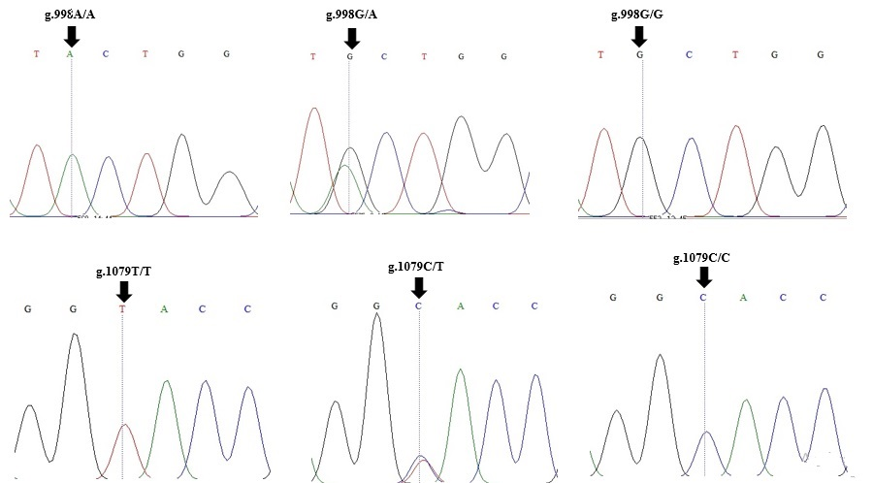
b)
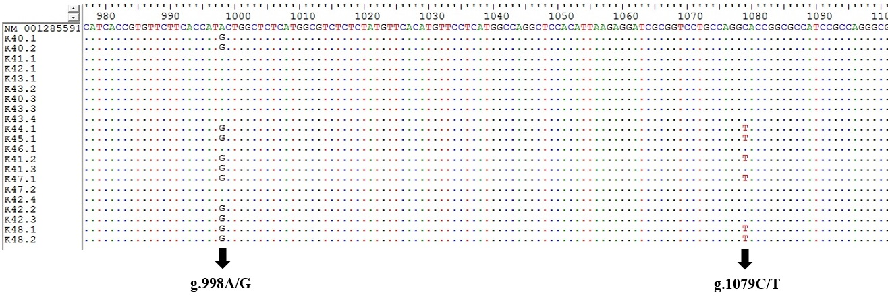
Fig. 1(a-b): Detection of two SNPs based on MC4R gene in Bligon (a) Electrophoregram and (b) Alignment sequence of PCR products
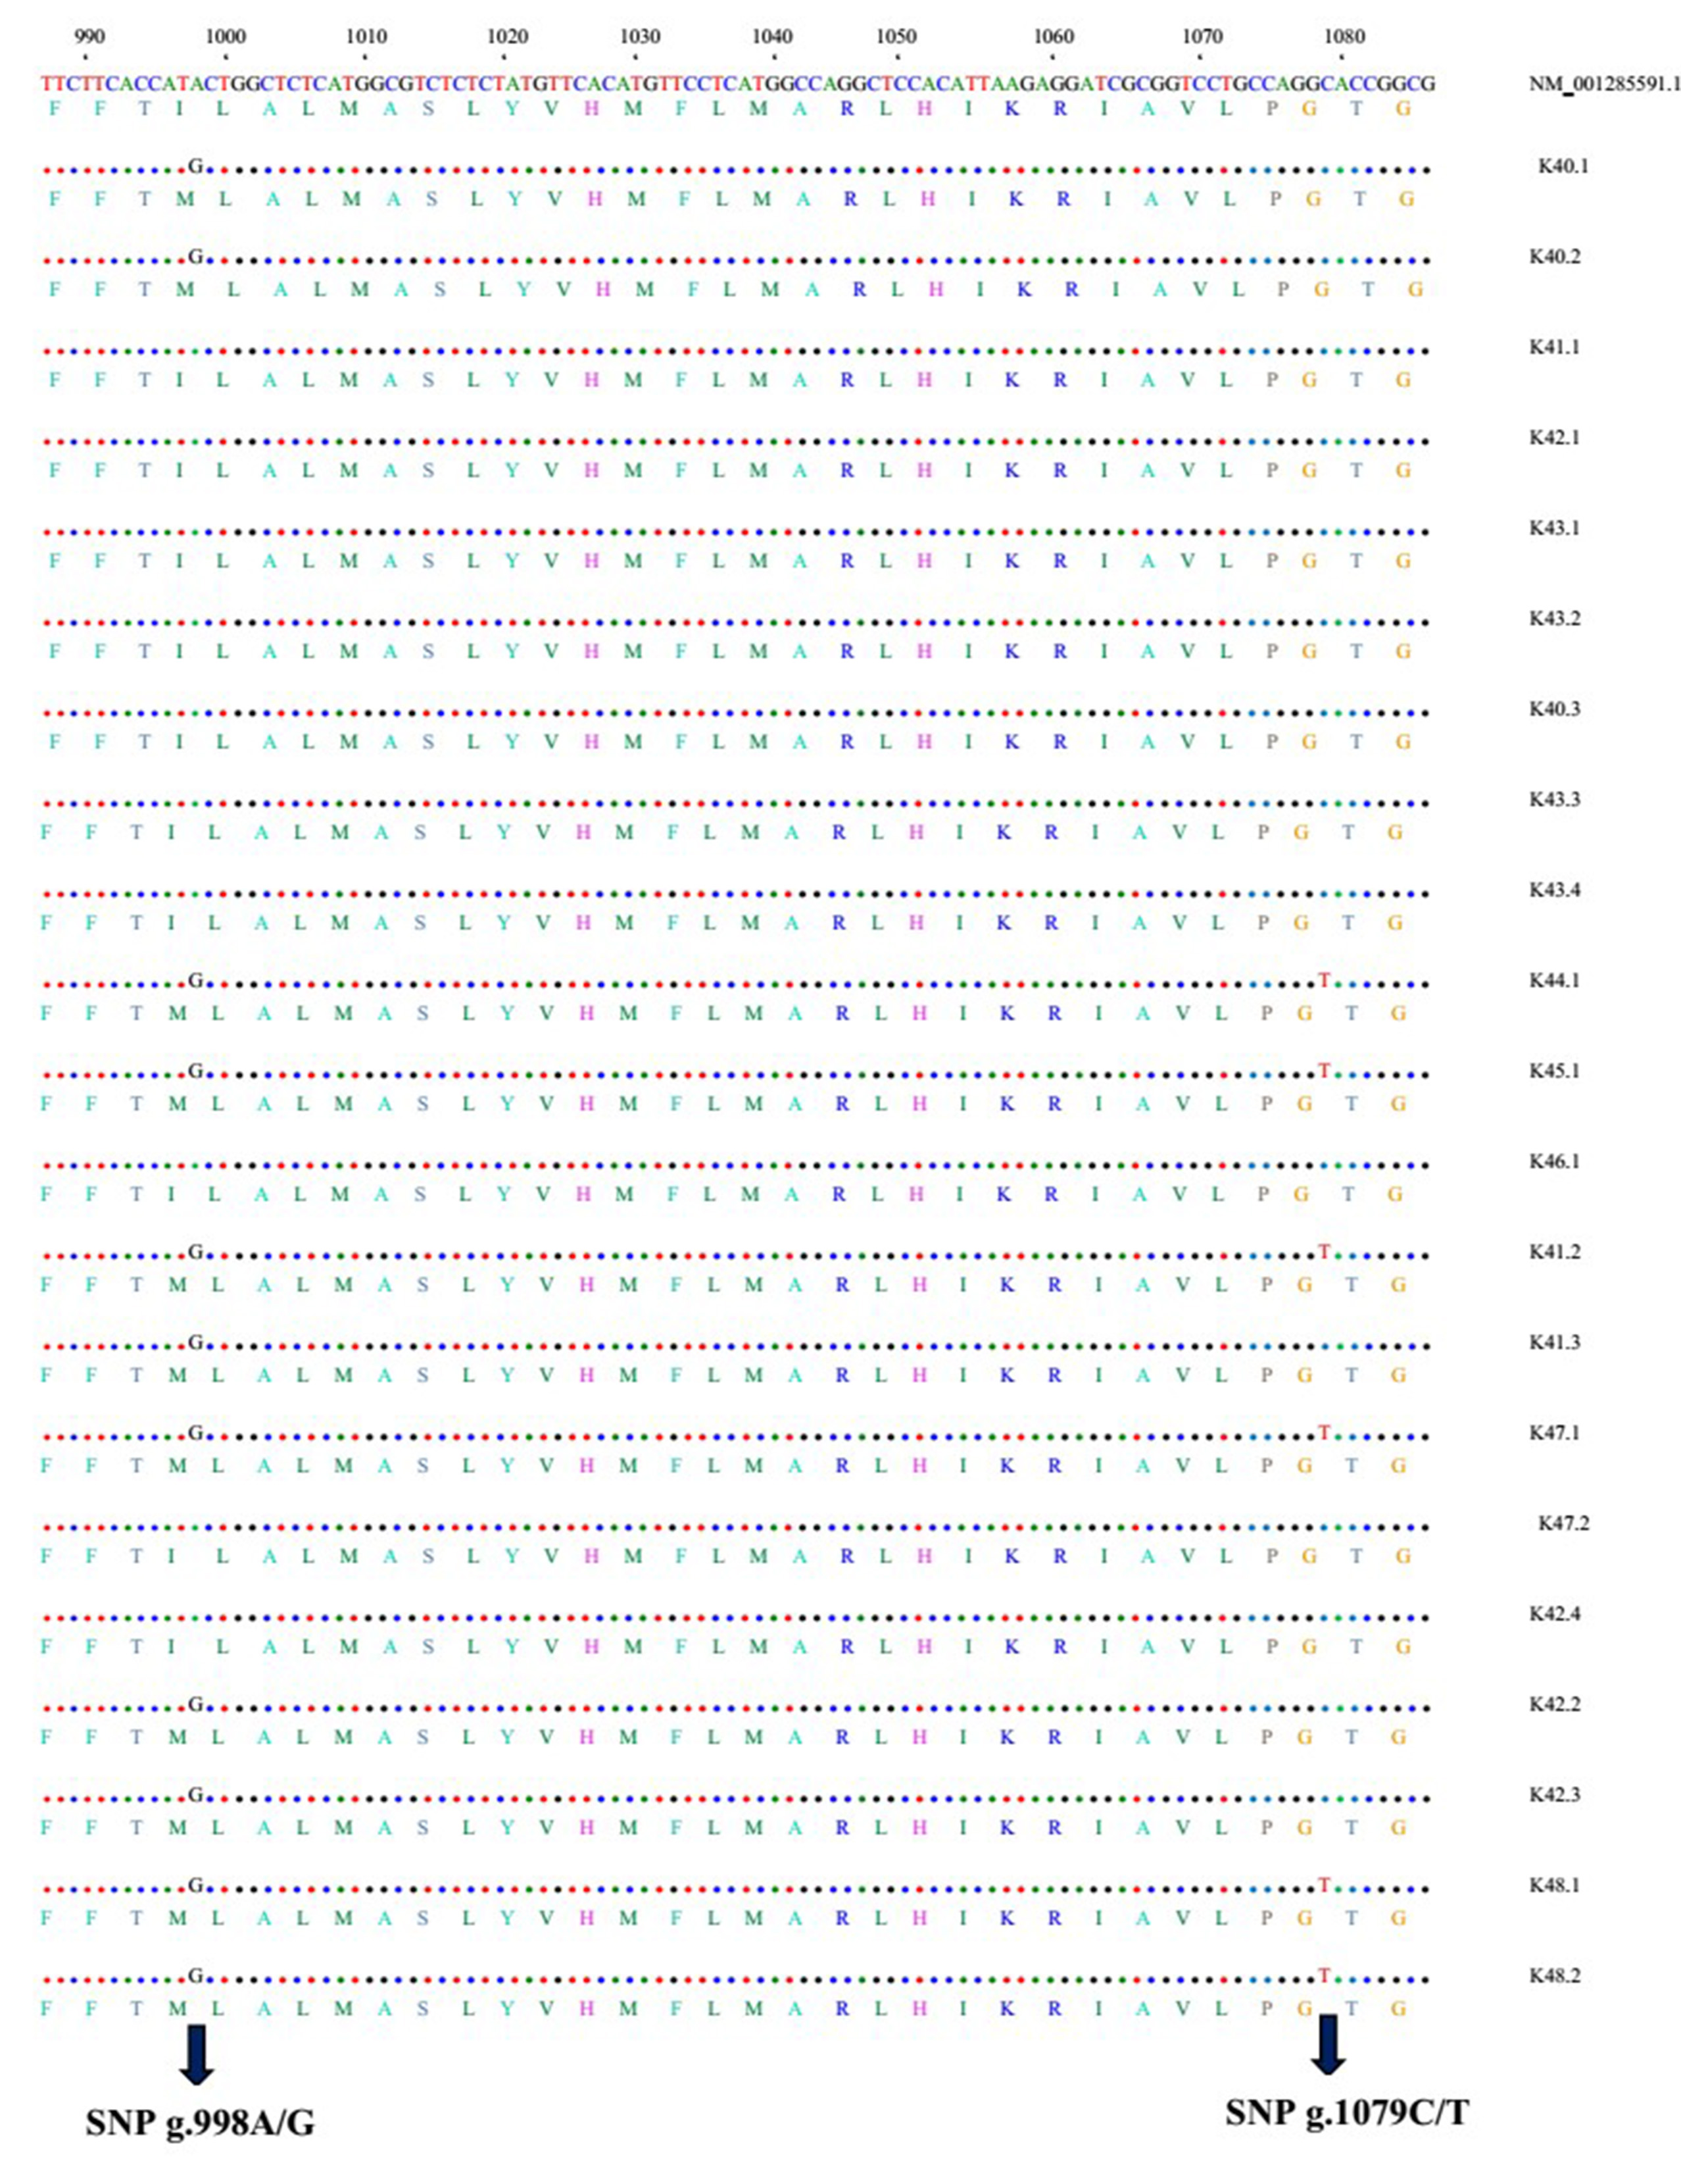
Fig. 2. The amino acid variant in both SNP g.998A/G and g.1079C/T
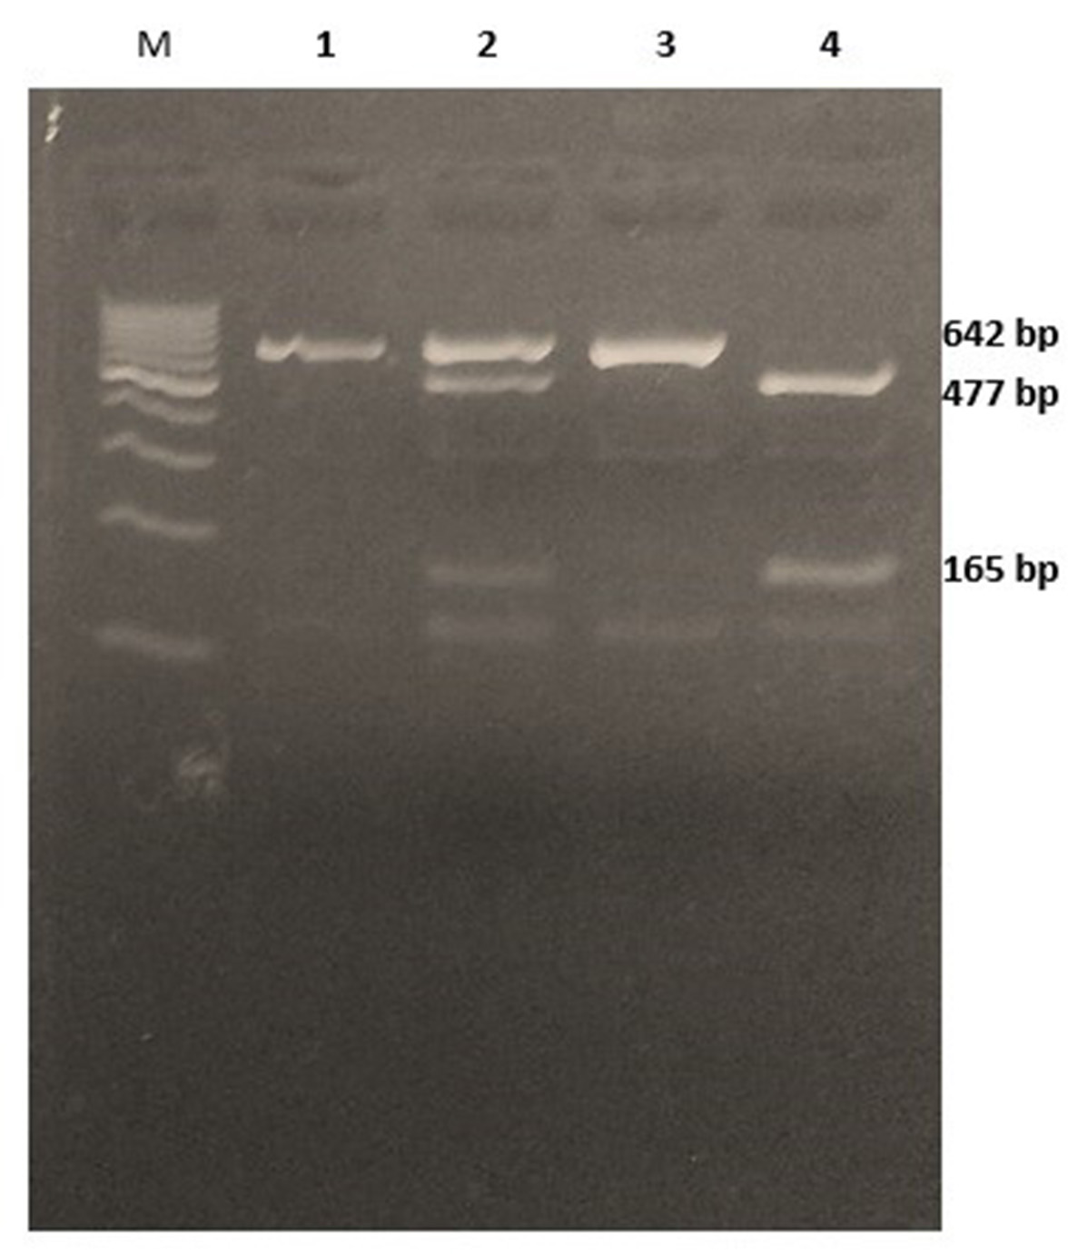
Fig. 3.. PCR-RFLP genotyping results for SNP 1079C>T of MC4R in Bligon goats, heterozygote goat with CT genotype was defined when the fragment size being recognized with 165, 477 and 642 bp, CC genotype with 165 and 477 bp and TT genotype with 642 bp; M: Marker 1 Kb; 1: PCR product; 2: CT genotype; 3: CC genotype; 4: TT Genotype (Agorese 3%, 50 volt for 1 hour).

