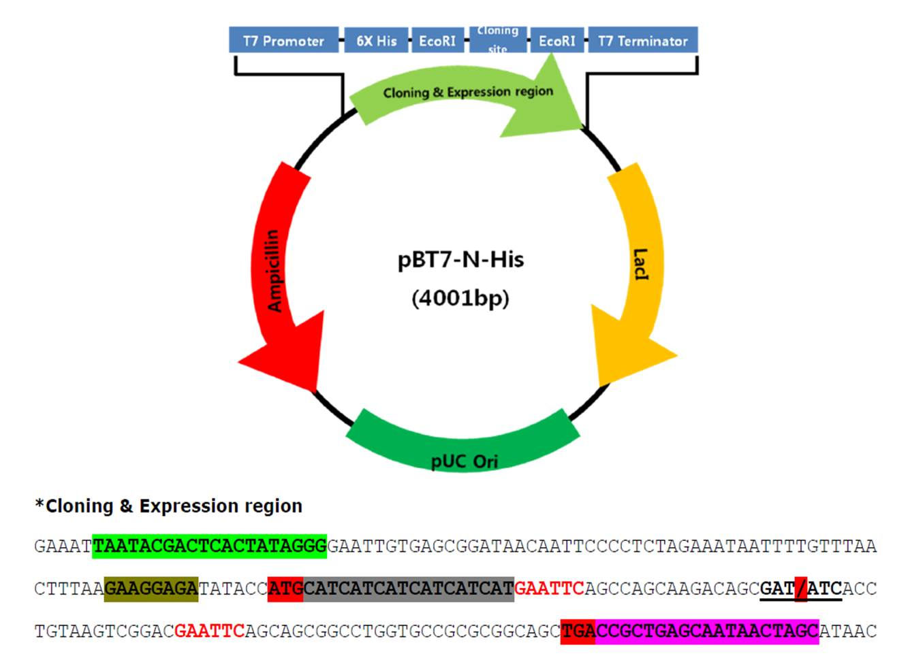

Figure 1. Construction of the vector recombinant plasmid pBT7-N-His-Fusion NDV

Figure 2. Electrophoresis of pBT7-N-His-Fusion NDV recombinant plasmid digested with Eco RI enzyme on 1.5% agarose gel with 1 kb marker DNA. The resulting size of the digested plasmid is 642 bp and 3959 bp. (M). Marker DNA ladder, (1). Recombinant plasmid pBT7-N-His-F that is digested with Eco RI enzyme from clone-1 (C-1) plasmid isolation, (2). Intact pBT7-N-His-F recombinant plasmid from C-1 plasmid isolation, (3). Recombinant plasmid pBT7-N-His-F digested with Eco RI enzyme from clone-2 (C-2) plasmid isolation, (4). Intact pBT7-N-His-F recombinant plasmid from C-2 plasmid isolation, (5). Recombinant plasmid pBT7-N-His-F digested with Eco RI enzyme from clone-3 (C-3) plasmid isolation, (6). Intact pBT7-N-His-F recombinant plasmid from C-3 plasmid isolation.

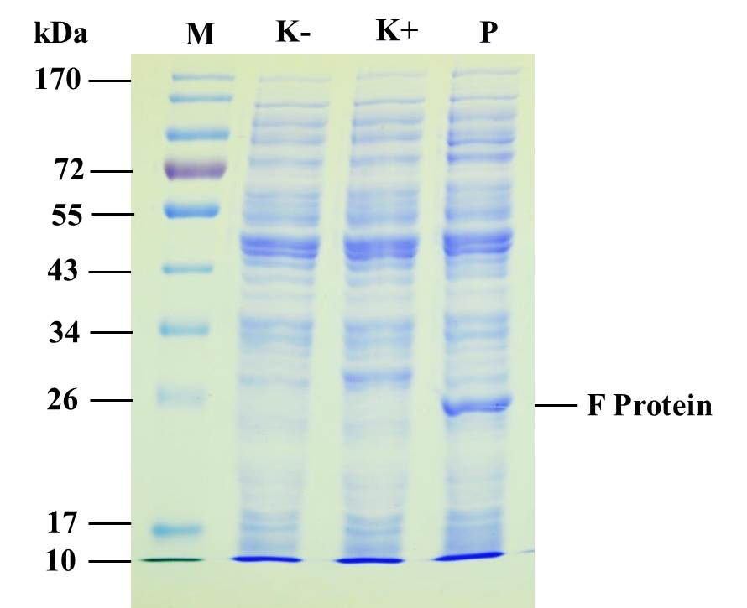

Figure 3. Electrophoresis of expressed NDV recombinant F protein on 12% SDS-PAGE gel with Coomassie Brilliant Blue staining. (M) Marker protein, (K-) Negative control, (K+) Positive control protein (28 kDa), (P) NDV recombinant F protein with a size of 25.6 kDa from pBT7-N-His-F C1 recombinant plasmid.

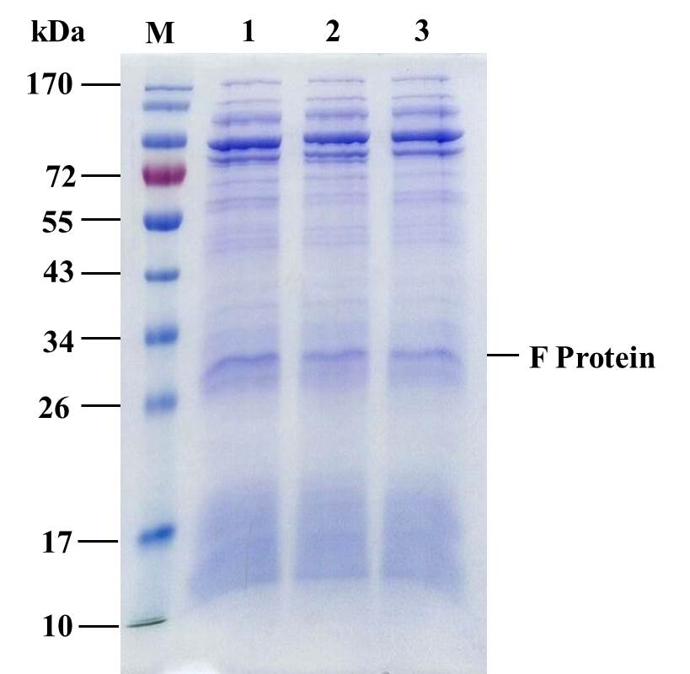

Figure 4. Electrophoresis of NDV recombinant F protein after purification on 12% SDS-PAGE with Coomassie Brilliant Blue staining. (M). Marker protein, (1). Expressed Protein from C-1 recombinant plasmid, (2). Expressed protein from C-2 recombinant plasmid, (3). Expressed protein from C-3 recombinant plasmid.

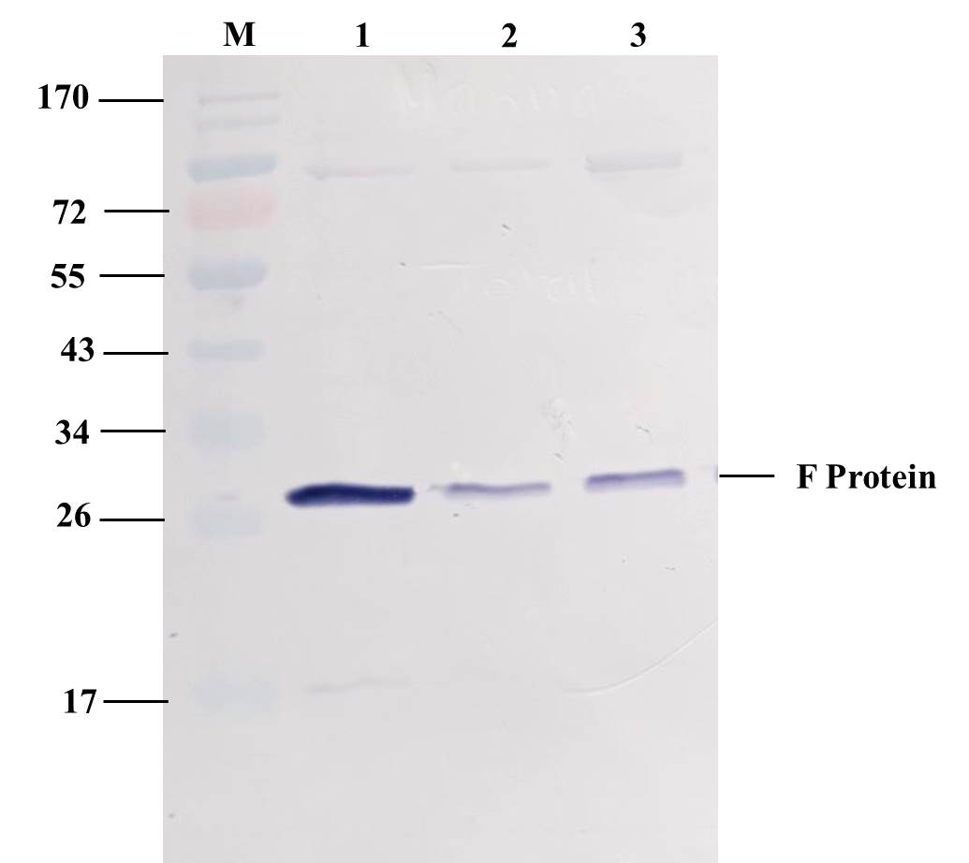

Figure 5. Western blot of the pure NDV recombinant F protein. (M) Marker protein. (1). NDV recombinant F protein from C-1 clone, (2). NDV recombinant F protein from C-2 clone, (3). NDV recombinant F protein from C-3 clone.

Figure 6. The antibody response of broiler chicken sera against ND vaccines in different groups which was analyzed by indirect ELISA. Quantification of F protein in 28th and 36th days (1.393±0.491; 1.525±0.332), Quantification of S Vaccine in 28th and 36th days (1.454±0.299; 1.308±0.15), Quantification of Adjuvant in 28th and 36th days (0.886±0.145; 0.961±0.101), Quantification of Control in 28th and 36th days (0.965±0.162; 0.868±0.083). Comparison of antibody titer of NDV recombinant F protein. (ns) There is no significant difference in Protein F, asterisk (*) there is a significant difference in Protein F (36 days), double asterisk (**) there is a significant difference in Protein F (36 days), triple asterisk (***) there is a significant difference of Protein F (36 days). Data were analyzed using ANOVA followed by Tukey’s multiple comparison test.

