AUTHOR DECLARATION FORM
(Journal of the Indonesian Tropical Animal Agriculture)

We, the undersigned authors of the manuscript entitled: “The Effects of Dextrin Concentration as Filler on Physical, Chemical, and Microbiology Properties of Powdered Goat Milk Kefir”
hereby declare the authors responsibility, source of funding and copy right statement in order to publish the article in Journal of the Indonesian Tropical Animal Agriculture (JITAA).

1. Authors Responsibility
- The manuscript is not previously published or is not being considered for publication elsewhere.
- We have approved the content of the manuscript.
- We follow the format of JITAA (see Guide for Authors and Template for Manuscript)
- The corresponding author is responsible for publication fee.

2. Source of Funding
The source of funding for study (contract number and year of funding):
Program Hibah Penelitian Dasar Unggulan Perguruan Tinggi (No. 257-45/UN7.6.1/PP/2020 tanggal 20 Maret 2020)

3. Copyright Statement Agreement
The copyright of an article is transferred to the Journal of the Indonesian Tropical Animal Agriculture (JITAA), when the article is accepted for publication.

Name of Authors Signature Date
_________________________________ ____________________________ ________________________
Heni Rizqiati 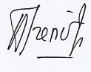 21 October 2020
Siti Susanti 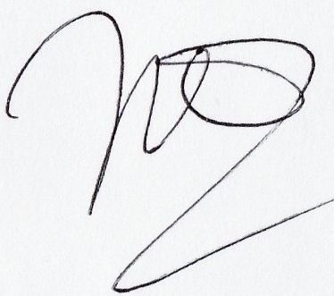 21 October 2020
Nurwantoro 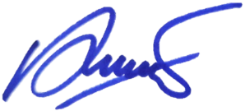 21 October 2020
Mohammad Ihsan Yahya P 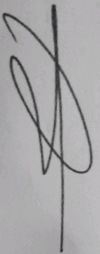 21 October 2020

