AUTHOR DECLARATION FORM
(Journal of the Indonesian Tropical Animal Agriculture)

We, the undersigned authors of the manuscript entitled Seroprevalence and associated risk factors of Avian Influenza subtype H9N2 in backyard poultry of Peshawar Pakistan
Hereby declare the authors responsibility, source of funding and copy right statement in order to publish the article in Journal of the Indonesian Tropical Animal Agriculture (JITAA).
1. Authors Responsibility
- The manuscript is not previously published or is not being considered for publication elsewhere.
- We have approved the content of the manuscript.
- We follow the format of JITAA (see Guide for Authors and Template for Manuscript)
- The corresponding author is responsible for publication fee.

2. Source of Funding
The source of funding for study (contract number and year of funding):
There is no Source of Funding
3. Copyright Statement Agreement
The copyright of an article is transferred to the Journal of the Indonesian Tropical Animal Agriculture (JITAA), when the article is accepted for publication.

Name of Authors Signature Date
_________________________________ ____________________________ ________________________
Saifur Rehman¹ 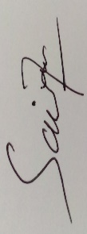 January 27, 2021
Fedik Abdul Rantam^{1*} 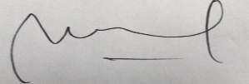 January 27, 2021
Mustofa Helmi Effendi¹ January 17, 2021
Muhammad Ilyas khan² 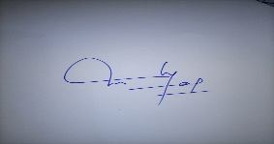 January 22, 2021
Aamir Shehzad¹ 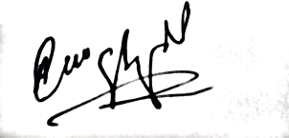 January 27, 2021
Ambrina Tariq³ 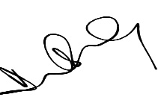 January 20, 2021

