AUTHOR DECLARATION FORM
(Journal of the Indonesian Tropical Animal Agriculture)

We, the undersigned authors of the manuscript entitled: socio-economic factors affecting the use of non-timber forest PRODUCTS in swine production in the colombian amazon
hereby declare the authors responsibility, source of funding and copy right statement in order to publish the article in Journal of the Indonesian Tropical Animal Agriculture (JITAA).

1. Authors Responsibility
- The manuscript is not previously published or is not being considered for publication elsewhere.
- We have approved the content of the manuscript.
- We follow the format of JITAA (see Guide for Authors and Template for Manuscript)
- The corresponding author is responsible for publication fee.

2. Source of Funding
The source of funding for study (contract number and year of funding):

The authors would like to thank the small pig producers of the municipalities of Albania, Cartagena del Chaira, El Doncello, Puerto Rico and San Vicente del Caguán in the department of Caqueta, Colombia for all the willingness and support for the development of this research. Likewise, to the OCAD of the Science, Technology and Innovation Fund of the General System of Royalties of Colombia (SGR) that through Agreement No. 78 of August 21, 2019 approves the funding of the project identified with the code BPIN 2018000100107 called "Use of agro-industrial and non-timber forest resources in animal feed -ARAINMBA- in the municipalities of Cartagena del Chairá, Albania, San Vicente del Caguán, El Doncello, Puerto Rico. Finally, to the Universidad de la Amazonia for being the executing and co-financing entity of the project.

3. Copyright Statement Agreement
The copyright of an article is transferred to the Journal of the Indonesian Tropical Animal Agriculture (JITAA), when the article is accepted for publication.

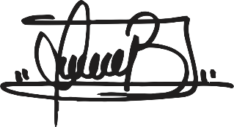
Name of Authors Signature Date
_________________________________ ____________________________ ________________________
Víctor Julio Balanta Martínez 1.117.506.336

Yolanda Cuellar Medina 40.769.640

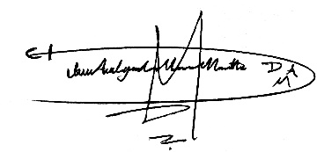
Dúber Alejandro Mora Motta 1.006.460.093
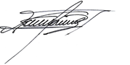

Gustavo Adolfo Celis Parra 17.648.997

