**AUTHOR DECLARATION FORM**

**(Journal of the Indonesian Tropical Animal Agriculture)**

We, the undersigned authors of the manuscript entitled: “Analysis of CSN2 Exon 7 Gene Diversity and Its Association with Sapera Goat Milk Composition”hereby declare the authors responsibility, source of funding and copy right statement in order to publish the article in Journal of the Indonesian Tropical Animal Agriculture (JITAA).

1. Authors Responsibility

* The manuscript is not previously published or is not being considered for publication elsewhere.
* We have approved the content of the manuscript.

|  |
| --- |
| * We follow the format of JITAA (see Guide for Authors and Template for Manuscript) * The corresponding author is responsible for publication fee. |

2. Source of Funding

The source of funding for study (contract number and year of funding):

Self-funded

3. Copyright Statement Agreement

The copyright of an article is transferred to the Journal of the Indonesian Tropical Animal Agriculture (JITAA), when the article is accepted for publication.

Name of Authors Signature Date

_________________________________ ____________________________ ________________________

Gisela Deviandini May 02, 2023



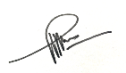

Ronny Rachman Noor May 09, 2023

Epi Taufik May 03, 2023

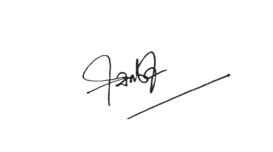

Santiananda Arta Asmarasari May 11, 2023