AUTHOR DECLARATION FORM
(Journal of the Indonesian Tropical Animal Agriculture)

We, the undersigned authors of the manuscript entitled: Conditioned Medium versus DMSO for Cryopreservation of Bovine Adipose Tissue-Derived Mesenchymal Stem Cells . . . . . . . . . . . . . . . . . . . . . . . . . . . . . . . . . . . . . . . . . . . . . . . . . . . . . . . . . . . . . . . . . . . . . . . . . . . . . . . . . . . . . . . . . . . . . . . . . . . . . . . . . . . . . . . . . . . . . . . . . . . . . . .. . . . . . . . . . . . . . . . . . . . . . . . . . . . . . . . . . . . . . . . . . . . . . . . . . . . . . . . . . . . . . . . . . . . . . . . . . . . . . . . . .. . . . . . . . . . . . . . . . . . . . . . . . . . . . . . . . . . . . . . . . . . . . . . . . . . . . . . . . . . . . . . . . .
hereby declare the authors responsibility, source of funding and copy right statement in order to publish the article in Journal of the Indonesian Tropical Animal Agriculture (JITAA).

1. Authors Responsibility
- The manuscript is not previously published or is not being considered for publication elsewhere.
- We have approved the content of the manuscript.
- We follow the format of JITAA (see Guide for Authors and Template for Manuscript)
- The corresponding author is responsible for publication fee.

2. Source of Funding
The source of funding for study (contract number and year of funding):
Contract number: 9/III.11/HK/2023 and Year of funding: 2023. . . . . . . . . . . . . . . . . . . . . . . . . . . . . . . . . . . . . . . . . . . . . . . . . . . . . . . . . . . . . . . . . . . . . . . . . . .

3. Copyright Statement Agreement
The copyright of an article is transferred to the Journal of the Indonesian Tropical Animal Agriculture (JITAA), when the article is accepted for publication.

No | Name of Authors | Signature | Date
1 | Saad Irfan |  | 29 April 2024
2 | Hamzah Zulfiqar | 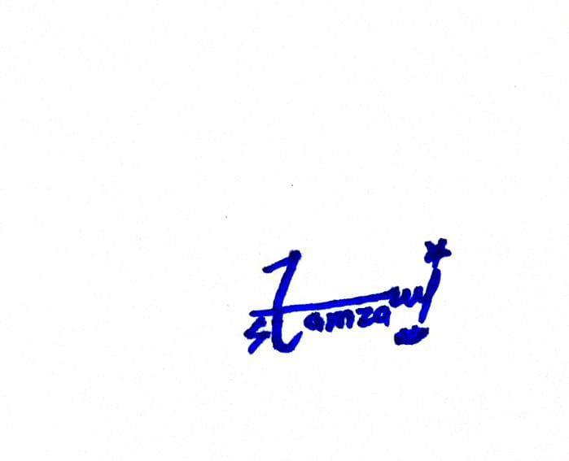 | 29 April 2024
3 | Dela Ayu Lestari |  | 29 April 2024

4 | Anita Hafid | 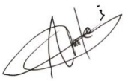 | 29 April 2024
5 | Tatan Kostaman |  | 29 April 2024
6 | Herdis | 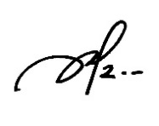 | 29 April 2024
7 | Tri Puji Prayitno |    | 29 April 2024
8 | Pradita Iustitia Sitaresmi |  | 29 April 2024
9 | M. Firdaus Hudaya |  | 29 April 2024
10 | F. B.I.Lupitasari |  | 29 April 2024
11 | Mulyoto Pangestu | 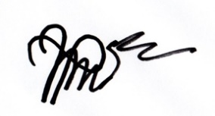 | 29 April 2024
12 | Suyatno |  | 29 April 2024

