Analysis of G-Protein Coupled Receptor gene of Capripoxvirus
from Sheep in Saudi Arabia

M. M. Abdellatif, Y. H. Ali; K. S. Intisar and M. H. El-Sayed
Department of Biology, College of Science and Arts-Rafha, Northern Border University, Arar, Saudi Arabia
Corrsponding e-mail: muazm20@gmail.com
ABSTRACT
Capripox is a highly infectious, often fatal, illness that results in severe losses; it is caused by Capripoxvirus (CaPVs) of the Poxviridae. It is challenging to distinguish between members of the CaPVs, even if the infection may be diagnosed based on the clinical picture. The study aimed to analyze the G-protein-coupled receptors (GPRC) gene sequence from Sheep in Saudi Arabia. Nine viruses were identified using GPCR-based PCR from skin scabs. Sequence alignment revealed multiple substitutions in the nucleotides and their deduced amino acids. Identity of the GPRC gene sequence among local strains was estimated to be 96.7-100%, whereas homology among selected CaPVs was found to be 88.0-100%. Evolutionary divergence analysis showed the discrepancy of 0.0 to 0.03% among local viruses and 0.0 up to 0.94% related to homologous CaPVs included. Phylogeny displayed CaPVs into three groups; local strains scattered into four branches together with other SPPVs from Saudi Arabia, while the second clustered SPPVs from Saudi Arabia, Iraq and Nigeria and the third includes GTPVs and LSDVs. Analysis showed that at least four variants of CaPVs are circulating among sheep in the region. Molecular analysis will help to identify the involved strains to adopt effective preventive measures.

Keywords: Capripoxvirus, GPRC gene, Sheep. Saudi Arabia

Corresponding Author
Dr. Muaz Magzob Abdellatif, PhD, Department of Biology (Microbiology), Faculty of Arts and Science, Northern Border University, Saudi Arabia; Email: muazm20@gmail.com.

INTRODUCTION
Capripoxvirus (CaPV) caused a highly infectious often fatal disease in ruminants, manifested by local or systemic cutaneous eruption, induced by a double-stranded DNA virus classified in the Chordopoxvirinae of the Poxviridae (Kitching, 2007). Losses are due to increased mortality rates, reduced production and weight, damage to wool and hides, immunization campaigns, and limitations on exportation of livestock and their products, along with restrictions on animal movements (Sawarkar et al., 2000; Yadin et al., 2007; Venter et al., 2017; Munyanduki et al., 2021). It is a notifiable disease in Africa, Middle East, and several counties in Asia (OIE, 2017). The disease was reported in different parts of Kingdom of Saudi Arabia (Housawi et al., 2003; Truong et al., 2015; Al-Ali et al., 2020). Although tentative diagnosis mainly based on the clinical picture, it’s difficult to differentiate members of the CaPVs, despite previous literature indicates host-virus specificity (Afonso et al., 2002; Bowden et al., 2009). Certain sheeppox and goatpox strains have been reported to infect sheep and cause fatal diseases (Davies, 1976; Bhat et al., 1989). Identification of CaPVs cannot be reached by antigen-antibody reactions as a result of the antigenic similarity and the presence of one serotype (Hammond et al., 1986; Bhat et al., 1989). Since, literature on mixed infection and natural susceptibility of sheep to goatpox and vice versa are contradictory; molecular methods emerge as a proper tool to identify the viruses implicated in epidemics (Hammond et al., 1986; Gershon and Black, 1988; Bhat et al., 1989; Gershon et al., 1995; Afonso et al., 2002). G-Protein Coupled Chemokine Receptor gene (GPRC), have been involved in virulence, cell stimulation, replication, antibody neutralization reaction as well as responses to antiviral medications of viruses, is thought to be a reliable approach for differentiating between sheeppox virus (SPPV), goatpox virus (GTPV), and lumpy skin disease virus (LSDV) (Chensue, 2001; Seet and McFadden, 2002; Lamien, et al., 2009; Lelenta et al., 2011). A very scares work on characterization of sheeppox virus in Eastern Saudi Arabia was reported (Seet and McFadden, 2002; Al-Hizab et al., 2017). No data were so far available on the molecular biology of SPPVs in Northern border of the country.
Molecular characterization of the circulating strains will help to implement effective measures to manage disease outbreaks. This work was designed to analyze the nucleotide sequence of GPRC gene extracted from field CaPVs from sheep in Rafha. Saudi Arabia.
MATERIALS AND METHODS
Collection of Samples
Skin scabs (n=10) were collected from infected sheep in Rafha, Saudi Arabia. Samples were suspended in 0.01M phosphate buffer saline (PBS), pH 7.4, homogenized, preserved at -20ºC till examined.
Extraction of DNA
Tissue suspension was centrifuged for 10min at 664g, then the nucleic acid was purified using PUREGENE®DNA extraction kit (Gentra System, Minneapolis, USA) following the manufacturer's procedure, kept at ‒20°C till used.
PCR
The GPCR gene-based PCR was completed as described by (Jia et al., 2015), using forward (GPCR-F: 5'-TTT ATC AGC ACT AGG TCA TTA TCT-3'), and reverse primers (GPCR-R: 5'-TATCAC TCC CTT CCA TTT TTA T-3'); The reaction mix (50µl) includes 1µl purified DNA, 5µl 10X PCR buffer, 0.3µl Taq DNA polymerase (5U/mL) (Invitrogen), 4µl 2.5mM dNTPs, and 0.75µl of each primer (10mM), with the following reaction condition: denaturation for 4min at 98°C, then 35 cycles of denaturation for 30s at 95°C, annealing for 30s at 49.5°C, extension for 120s at 72°C, and a final elongation for 10min at 72°C. Amplicons were visualized on ethidium bromide stained agarose gel (1%).
Sequencing of GPCR gene
The PCR products (5μl) were added to 2μl of ExoASP-IT® (usb). After 15min at 37°C, ExoSAP-IT was deactivated by 15min at 80°C. Purified amplicons were sequenced using a BigDye terminator v3.1 Cycle Sequencing Kit and an ABI PRISM 3730XL Analyzer. Nucleotide sequences were determined on both strands of the gene at Macrogen sequencing facility (Macrogen Inc., Seoul, Korea). Sequences were deposited in the GenBank under the following accession numbers MT025822, MT025823, MT025824, MT025825, MT025826, MN934941, MN934942, MN934943 and MN967001 (Table 1).
Sequence alignment

Homologous sequences (n=15) were obtained via Blastn search using a nucleotide query on the National Center for Biotechnology Information (NCBI) database (Table 1). Nucleotides as well as their deduced amino acid sequence alignments were performed using ClustalW in SeqMan within Lasergene (version 7.1.0, DNASTAR, Inc, Madison, WI, USA).
Evolutionary analysis
The nucleotide substitutions per site among sequences were computed. All ambiguous positions were removed for each sequence pair (pairwise deletion option). The evolution was predicted using a matrix of pairwise similarities calculated by Maximum Composite Likelihood approach (MCL) (Tamura and Nei 1993). The investigation was carried out using Molecular Evolutionary Genetics Analysis (MEGA X).
Phylogenetic analysis

The phylogenetic tree was built utilizing neighbor-joining method in MEGAX. Bootstrap analysis was used to test the topology of the trees with 1000 replicates (Sanderson and Wojciechowski 2000).
RESULTS
PCR
Nine out of ten samples tested gave positive results for GPCR gene-based PCR (Image not shown).
Sequence alignment
Nucleotide sequence alignment of the GPRC gene amplified from nine field sheep poxviruses revealed multiple substitutions. Likewise, deduced amino acids alignment displayed multiple substitutions in the translated peptide (Figure 1,2).
Estimates of Identity
Nucleotide sequence homology of the GPRC gene among Rafha strains was estimated to be 96.7-100%, whereas identity between selected CaPVs was found to be 88.0-100% (Figure 3).
Evolutionary Divergence
Analysis showed the discrepancy of 0.0 to 0.03 among local sheep pox strains and 0.00 up to 0.94 related to homologous viruses included in the study (Table 2).

Phylogenetic analysis
The tree based on GPRC gene showed that CaPVs strains studied were divided into three groups. One grouped local strains scattered into four branches, together with other SPPVs from Saudi Arabia (MG232393 and MG232391), whereas the second clustered SPPVs from Saudi Arabia, Iraq and Nigeria and the third includes GTPV from India, China, Vietnam, Turkey and Iran and LSDV from Russia, South Africa, China, Bangladesh and Nigeria (Fig 4).
DISCUSSION
Capripoxvirus infections are endemic in several countries throughout the world. Since they restrict the expansion of the intense pasture system in small ruminants sectors and lower their productive capacity, they are classified as category A livestock diseases (Yune and Abdela, 2017). G-Protein Coupled Receptors (GPRC) gene which plays a role in defending during the immune response's overwhelming attack (Seet and McFadden, 2002; Yune and Abdela, 2017), has been selected for differentiation between members of CaPVs (Lamien et al., 2009; Lelenta et al., 2011). Nine CaPVs were identified by PCR from sheep displaying pox lesions. Sequence alignment revealed multiple substitutions in the nucleotides and their deduced amino acids. Previous reports found that several field LSDV strains included alterations in the GPCR gene, either nucleotide sequence changes or amino acid mutations, such as deletion or insertion (Santhamani et al., 2014; El-tholoth and El-kenawy, 2016; Cetre-sossah et al., 2017). Based on the nucleotide and amino acid sequence of the GPCR gene protein, investigations conducted in Russia in 2017 identify LSDV strain as a novel vaccine-like LSDV strain in cows (Kononov et al., 2019).
Analysis of GPRC gene sequence showed that the identity among field strains is 100-98.9% and 90.51 to 98.21% when compared to homologous strains downloaded from the GenBank databases. Similarity among Huining and Zhangye strains exhibited 95.0-99.7 and 93.0-100% (Jia et al., 2015). Chinese sheeppox varied from 99.4% to 99.6% and 95.0 ~ 99.8% with other strains of CaPVs (Jia et al., 2012). Previous work showed that all LSDV isolates are closely related to each other with a nucleotide and AA identity ranged from 99% to 100% (Bazid et al., 2019). Tran et al (2024) found that the sequence of the GPCR of Vietnam strain of LSDV were 99.91% similar to the Xinjiang/2019 strain, 99.65% comparable to two vaccination strains, and 98.87% related to the Saratov/2017 strain. Evolutionary Divergence analysis revealed a low amount of divergence between CaPVs included in the study.
Phylogenetic analysis revealed that the selected CaPVs strains could be divided into three groups. One grouped local viruses scattered into four branches together with other SPPVs from Saudi Arabia, whereas the second clustered SPPVs from Saudi Arabia, Iraq and Nigeria and the third includes GTPV from India, China, Vietnam, Turkey and Iran and LSDV from Russia, South Africa, China, Bangladesh and Nigeria. Likewise, previous research presented a tree comprised of three closely similar genetic clusters including the strains causing lumpy skin disease, sheep pox, and goat pox (Lamien et al., 2009; Bazid et al., 2019). There is inconsistency in the viral-host nomenclature; for instance, a virus identified in sheep is gathered with the goat poxvirus strains, and vice versa (Lamien et al., 2009). Notably, GTPV/Saudi Arabia/1993 and the GTPVs originating from Sudan and Oman are grouped separately, in alignment with their original host (Lamien et al., 2009). However, it disagrees with reports which presented six CaPVs from Saudi Arabia into two separate clades: SPPVs and GTPVs. While SPPV/Saudi Arabia 4/2017, SPPV/Saudi Arabia 5/2016, in addition to SPPV/Saudi Arabia 6/2016 are closely related to one another, SPPV/Saudi Arabia 3/2013 and SPPV/Saudi Arabia 1/2014 are not (Housawi et al., 2003; Truong et al., 2015; Al-Hizab et al., 2017; Al-Ali et al., 2020). GTPV Saudi Arabia 2/2017 is clustered with GTPVs from India, China and Bangladesh in the GTPV group. Other data, displayed five strains organized into two groups, Chinese SPPVs as they are grouped together. Turkey/98 Van2 (SPPV Turkey) is relatively similar to Chinese strains compared to other Turkish SPPV TU-V02127 and another SPPVs from African countries (Jia et al., 2012). The tree revealed that at least four distinct strains of CaPVs have been detected among sheep in the northern region of Saudi Arabia, suggesting that sequencing of GPCR gene is a promising approach for subgrouping. However, Tran et al. (2024) identify two different LSDV strains exist in Vietnam.
CONCLUSION
Sequence alignment and phylogenetic analysis based on GPRC gene revealed genetic discrepancy with multiple substitutions in the nucleotides and their deduced amino acids among local SPPV strains. Analysis showed that at least four variants of CaPVs are circulating among sheep in the region. The results of this research will help in identifying SPPVs, especially in Northern Border of the country, to implement effective preventive measures to control the virus.
ACKNOWLEDGEMENTS
The authors extend their appreciation to the Deanship of Scientific Research at Northern Border University, Arar, KSA, for funding this research work through the project number “NBU–FFR–2024–377–02”.
CONFLICT OF INTEREST
We are declaring that they have no conflict of interest.

REFERENCES
Abu-Elzein, E., F. Housawi, O. Ramadan, A. Gameel, A. Al-Afaleq and O. Al-Gundi. 2003. Observations on natural and experimental infection of sheep and goats with a virulent field Capripoxvirus with high affinity to goats. Vet. Arh. 73(3): 119-131.
Babiuk, S., T. R. Bowden, G. Parkyn, B. Dalman, D. M. Hoa, N. T. Long, P. P. Vu, D. X. Bieu, J. Copps and D. B. Boyle. 2009. Yemen and Vietnam capripoxviruses demonstrate a distinct host preference for goats compared with sheep. J. Gen. Virol. 90(1): 105-114.
Biswas, S., R. S. Noyce, L. A. Babiuk, O. Lung, D. M. Bulach, T. R. Bowden, D. B. Boyle, S. Babiuk and D. H. Evans. 2020. Extended sequencing of vaccine and wild‐type capripoxvirus isolates provides insights into genes modulating virulence and host range. Transbound. Emerg Dis. 67(1): 80-97.
Black, D., J. Hammond and R. Kitching. 1986. "Genomic relationship between capripoxviruses. Virus. Res. 5(2): 277-292.
Boshra, H., T. Truong, S. Babiuk and M. G. Hemida. 2015. Seroprevalence of sheep and goat pox, peste des petits ruminants and Rift Valley fever in Saudi Arabia. PLoS. One. 10(10): e0140328.
Cao, J. X., P. D. Gershon and D. N. Black. 1995. Sequence analysis of HindIII Q2 fragment of capripoxvirus reveals a putative gene encoding a G-protein-coupled chemokine receptor homologue. Virology. 209(1): 207-212.
Chensue, S. W. 2001. Molecular machinations: chemokine signals in host-pathogen interactions. Clin. Microbiol. Rev. 14(4): 821-835.
Davies, F. 1976. Characteristics of a virus causing a pox disease in sheep and goats in Kenya, with observations on the epidemiology and control. Epidemiol. Infect. 76(2): 163-171.
Flannery, J., B. Shih, I. R. Haga, M. Ashby, A. Corla, S. King, G. Freimanis, N. Polo, A. C. n. Tse and C. J. Brackman. 2022. A novel strain of lumpy skin disease virus causes clinical disease in cattle in Hong Kong. Transbound. Emerg. Dis. 69(4): e336-e343.
Garner, M., S. Sawarkar, E. Brett, J. Edwards, V. Kulkarni, D. Boyle and S. Singh. 2000. The extent and impact of sheep pox and goat pox in the state of Maharashtra, India. Trop. Anim. Health. Prod. 32: 205-223.
Gershon, P. D. and D. N. Black. 1988. "A comparison of the genomes of capripoxvirus isolates of sheep, goats, and cattle. Virology. 164(2): 341-349.
Hamdi, J., H. Munyanduki, K. Omari Tadlaoui, M. El Harrak and O. Fassi Fihri. 2021. Capripoxvirus infections in ruminants: a review. Microorganisms. 9(5): 902.
Hamouda, M., F. Al-Hizab and I. El-Sabagh. 2017. Clinical, pathological and molecular diagnosis of Sheeppox virus in Saudi Arabia. JAPS: 27(1): 91-97.
Ibrahim, M., A. M. Al-Ali, M. A. Salem, H. A. Al-Wsaibei, A. M. Al-Butayan and F. M. Housawi. 2020. "Phylogenetic analysis of sheep pox and goat pox virus strains in Saudi Arabia. JAPS. 30(3): 586-594.
Kitching, R., P. Bhat and D. Black. 1989. The characterization of African strains of capripoxvirus.Epidemiol. Infect. 102(2): 335-343.
Kitching, R., J. Hammond and D. Black. 1986. Studies on the major common precipitating antigen of capripoxvirus. J. Gen. Virol. 67(1): 139-148.
Kitching, R. P. 2007. Sheep Pox. Diseases of Sheep. 1st Ed I.D. Aitken OBE, BVMS, PhD, CBiol, FIBiol, DVM&S h.c. (Edinburgh), FRAgS, MRCVS.P. 302-306.
Lamien, C. E., M. Lelenta, W. Goger, R. Silber, E. Tuppurainen, M. Matijevic, A. G. Luckins and A. Diallo. 2011. Real time PCR method for simultaneous detection, quantitation and differentiation of capripoxviruses. J. Virol. Methods. 171(1): 134-140.
Le Goff, C., C. E. Lamien, E. Fakhfakh, A. Chadeyras, E. Aba-Adulugba, G. Libeau, E. Tuppurainen, D. B. Wallace, T. Adam and R. Silber. 2009. Capripoxvirus G-protein-coupled chemokine receptor: a host-range gene suitable for virus animal origin discrimination. J. Gen. Virol. 90(8): 1967-1977.
Mathijs, E., F. Vandenbussche, A. Haegeman, A. Al-Majali, K. De Clercq and S. Van Borm. 2016. Complete genome sequence of the goatpox virus strain Gorgan obtained directly from a commercial live attenuated vaccine. Genome. Announc. 4(5): 01113-01116.
OIE 2017. Organization for Animal Health, Sheep pox and goat pox, OIE Paris.
Parvin, R., E. H. Chowdhury, M. T. Islam, J. A. Begum, M. Nooruzzaman, A. Globig, K. Dietze, B. Hoffmann and E. Tuppurainen. 2022. Clinical Epidemiology, Pathology, and Molecular Investigation of Lumpy Skin Disease Outbreaks in Bangladesh during 2020–2021 Indicate the Re-Emergence of an Old African Strain. Viruses. 14(11): 2529.
Rouby, S. R., A.-H. Bazid, M. Wasfy and M. El-Sayed. 2019. Capripoxviruses: Exploring the genetic relatedness between field and vaccine strains from Egypt. Vet. World. 12(12): 1924.
Sanderson, M. J. and M. F. Wojciechowski. 2000. Improved bootstrap confidence limits in large-scale phylogenies, with an example from Neo-Astragalus (Leguminosae). Syst. Biol. 49(4): 671-685.
Seet, B. T. and G. McFadden. 2002. Viral chemokine-binding proteins. J. Leukoc. Biol. 72(1): 24-34.
Sprygin, A., A. Van Schalkwyk, I. Shumilova, A. Nesterov, S. Kononova, P. Prutnikov, O. Byadovskaya and A. Kononov. 2020. "Full-length genome characterization of a novel recombinant vaccine-like lumpy skin disease virus strain detected during the climatic winter in Russia, 2019. Arch. Virol. 165(11): 2675-2677.
Su, H., H. Jia, C. Yin, Z. Jing, X. Luo and Y. Chen. 2015. Phylogenetic analysis of Gansu sheeppox virus isolates based on P32, GPCR, and RPO30 genes. Genet. Mol. Res. 14(1): 1887-1898.
Tamura, K. and M. Nei (1993). Estimation of the number of nucleotide substitutions in the control region of mitochondrial DNA in humans and chimpanzees. Mol. Biol. Evol. 10(3): 512-526.
Tulman, E., C. Afonso, Z. Lu, L. Zsak, J.-H. Sur, N. Sandybaev, U. Kerembekova, V. Zaitsev, G. Kutish and D. Rock. 2002. The genomes of sheeppox and goatpox viruses. J. Virol. 76(12): 6054-6061.
Tuppurainen, E., E. H. Venter, J. Shisler, G. Gari, G. Mekonnen, N. Juleff, N. Lyons, K. De Clercq, C. Upton and T. Bowden. 2017. Capripoxvirus diseases: current status and opportunities for control. Transbound. Emerg. Dis. 64(3): 729-745.
Van Schalkwyk, A., P. Kara and L. Heath. 2022. Phylogenomic characterization of historic lumpy skin disease virus isolates from South Africa. Arch. Virol. 167(10): 2063-2070.
Wolff, J., E. Tuppurainen, A. Adedeji, C. Meseko, O. Asala, J. Adole, R. Atai, B. Dogonyaro, A. Globig and D. Hoffmann. 2021. Characterization of a Nigerian lumpy skin disease virus isolate after experimental infection of cattle. Pathogens. 11(1): 16.
Yeruham, I., H. Yadin, M. Van Ham, V. Bumbarov, A. Soham and S. Perl. 2007. Economic and epidemiological aspects of an outbreak of sheeppox in a dairy sheep flock. Vet. Rec. 160(7): 236.
Yune, N. and N. Abdela. 2017. "Epidemiology and economic importance of sheep and goat pox: a review on past and current aspects. J. Vet. Sci. Technol. 8(2): 1-5.
Zhou, T., H. Jia, G. Chen, X. He, Y. Fang, X. Wang, Q. Guan, S. Zeng, Q. Cui and Z. Jing. 2012. "Phylogenetic analysis of Chinese sheeppox and goatpox virus isolates. Virol. J. 9: 1-8.

Table 1. Dataset used for the analysis. Accession number, virus species, virus strain, host, country, percent of identity and reference for each sequence.
NO | Accession NO | Virus species | Virus Strain | Host | Country | Reference
1 | MT025823 | SPPV | Rafhapox030 | Sheep | Saudi Arabia | This study
2 | MT025822 | SPPV | Rafhapox030 | Sheep | Saudi Arabia | This study
3 | MT025824 | SPPV | Rafhapox032 | Sheep | Saudi Arabia | This study
4 | MN934942 | SPPV | Rafhapox002 | Sheep | Saudi Arabia | This study
5 | MN934941 | SPPV | Rafhapox001 | Sheep | Saudi Arabia | This study
6 | MT025826 | SPPV | Rafhapox034 | Sheep | Saudi Arabia | This study
7 | MN967001 | SPPV | Rafhapox303 | Sheep | Saudi Arabia | This study
8 | MN934943 | SPPV | Rafhapox003 | Sheep | Saudi Arabia | This study
9 | MT025825 | SPPV | Rafhapox033 | Sheep | Saudi Arabia | This study
10 | MN072630 | SPPV | Saudi Arabia | Sheep | Saudi Arabia | (Biswas, Noyce et al. 2020)
11 | MN072628 | SPPV | Nigeria | Sheep | Nigeria | (Biswas, Noyce et al. 2020)
12 | MN072626 | SPPV | Abu Gharib | Sheep | Iraq | (Biswas, Noyce et al. 2020)
13 | MG232393 | SPPV | SPPV/SA6/2016 | Sheep | Saudi Arabia | (Ibrahim, Al-Ali et al. 2020)
14 | MG232391 | SPPV | SPPV/SA4/2017 | Sheep | Saudi Arabia | (Ibrahim, Al-Ali et al. 2020)
15 | MN072620 | GTPV | India | Goat | India | (Biswas, Noyce et al. 2020)
16 | MH381810 | GTPV | AV41 | Goat | China | Unpublished
17 | MN072621 | GTPV | Vietnam | Goat | Vietnam | (Biswas, Noyce et al. 2020)
18 | MN072622 | GTPV | Goatpox virus isolate Turkey | Goat | Turkey | (Biswas, Noyce et al. 2020)
19 | KX576657 | GTPV | Gorgan | Goat | Iran | (Mathijs, Vandenbussche et al. 2016)
20 | MT134042 | LSDV | LSDV/Russia/Udmurtiya/2019 | Cattle | Russia | (Sprygin, Van Schalkwyk et al. 2020)
21 | OM793604 | LSDV | LSDV_33-KZN_RSA_1977 | Cattle | South Africa | (van Schalkwyk, Kara et al. 2022)
22 | MW732649 | LSDV | LSDV/HongKong/2020 | Cattle | China | (Flannery, Shih et al. 2022)
23 | OP688128 | LSDV | V392.1 | Cattle | Bangladesh | (Parvin, Chowdhury et al. 2022)
24 | OK318001 | LSDV | V281 | Cattle | Nigeria | (Wolff, Tuppurainen et al. 2021)

Table 2. Base substitutions per site of GPCR gene identified from CaPVs sequences (local viruses are underlined).

SN | Virus strain |  | 1 |  | 2 |  | 3 |  | 4 |  | 5 |  | 6 |  | 7 |  | 8 |  | 9 |  | 10 |  | 11 |  | 12 |  | 13 |  | 14 |  | 15 |  | 16 |  | 17 |  | 18 |  | 19 |  | 20 |  | 21 |  | 22 |  | 23
1 |  | SPPV_MT025826
2 |  | SPPV_MT025825 |  | 0.01
3 |  | SPPV_MT025824 |  | 0.02 |  | 0.03
4 |  | SPPV_MT025823 |  | 0.02 |  | 0.03 |  | 0.00
5 |  | SPPV_MT025822 |  | 0.02 |  | 0.03 |  | 0.00 |  | 0.00
6 |  | SPPV_MN967001 |  | 0.01 |  | 0.01 |  | 0.02 |  | 0.02 |  | 0.02
7 |  | SPPV_MN934943 |  | 0.01 |  | 0.02 |  | 0.02 |  | 0.02 |  | 0.02 |  | 0.01
8 |  | SPPV_MN934942 |  | 0.01 |  | 0.02 |  | 0.01 |  | 0.01 |  | 0.01 |  | 0.01 |  | 0.01
9 |  | SPPV_MN934941 |  | 0.01 |  | 0.02 |  | 0.01 |  | 0.01 |  | 0.01 |  | 0.01 |  | 0.01 |  | 0.00
10 |  | SPPV_MN072630 |  | 0.82 |  | 0.83 |  | 0.77 |  | 0.79 |  | 0.79 |  | 0.81 |  | 0.77 |  | 0.76 |  | 0.76
11 |  | SPPV_MN072628 |  | 0.82 |  | 0.83 |  | 0.77 |  | 0.79 |  | 0.79 |  | 0.81 |  | 0.77 |  | 0.76 |  | 0.76 |  | 0.00
12 |  | SPPV_MN072626 |  | 0.82 |  | 0.83 |  | 0.77 |  | 0.79 |  | 0.79 |  | 0.81 |  | 0.77 |  | 0.76 |  | 0.76 |  | 0.00 |  | 0.00
13 |  | SPPV_MG232393 |  | 0.01 |  | 0.03 |  | 0.01 |  | 0.01 |  | 0.01 |  | 0.01 |  | 0.02 |  | 0.01 |  | 0.01 |  | 0.91 |  | 0.91 |  | 0.91
14 |  | SPPV_MG232391 |  | 0.02 |  | 0.03 |  | 0.02 |  | 0.01 |  | 0.01 |  | 0.02 |  | 0.02 |  | 0.01 |  | 0.01 |  | 0.91 |  | 0.91 |  | 0.91 |  | 0.00
15 |  | LSDV_OP688128 |  | 0.84 |  | 0.85 |  | 0.78 |  | 0.80 |  | 0.80 |  | 0.83 |  | 0.78 |  | 0.77 |  | 0.77 |  | 0.03 |  | 0.03 |  | 0.03 |  | 0.93 |  | 0.93
16 |  | LSDV_OM793604 |  | 0.82 |  | 0.84 |  | 0.75 |  | 0.77 |  | 0.77 |  | 0.81 |  | 0.76 |  | 0.75 |  | 0.75 |  | 0.03 |  | 0.03 |  | 0.03 |  | 0.93 |  | 0.94 |  | 0.02
17 |  | LSDV_OK318001 |  | 0.84 |  | 0.85 |  | 0.78 |  | 0.80 |  | 0.80 |  | 0.83 |  | 0.78 |  | 0.77 |  | 0.77 |  | 0.03 |  | 0.03 |  | 0.03 |  | 0.92 |  | 0.93 |  | 0.00 |  | 0.02
18 |  | LSDV_MW732649 |  | 0.82 |  | 0.84 |  | 0.76 |  | 0.78 |  | 0.78 |  | 0.81 |  | 0.76 |  | 0.75 |  | 0.75 |  | 0.03 |  | 0.03 |  | 0.03 |  | 0.92 |  | 0.93 |  | 0.01 |  | 0.01 |  | 0.01
19 |  | LSDV_MT134042 |  | 0.82 |  | 0.84 |  | 0.75 |  | 0.77 |  | 0.77 |  | 0.81 |  | 0.76 |  | 0.75 |  | 0.75 |  | 0.03 |  | 0.03 |  | 0.03 |  | 0.93 |  | 0.94 |  | 0.02 |  | 0.00 |  | 0.02 |  | 0.01
20 |  | GTPV_MN072622 |  | 0.85 |  | 0.86 |  | 0.79 |  | 0.81 |  | 0.81 |  | 0.84 |  | 0.79 |  | 0.78 |  | 0.78 |  | 0.04 |  | 0.03 |  | 0.04 |  | 0.94 |  | 0.94 |  | 0.03 |  | 0.03 |  | 0.03 |  | 0.03 |  | 0.03
21 |  | GTPV_MN072621 |  | 0.85 |  | 0.86 |  | 0.79 |  | 0.81 |  | 0.81 |  | 0.84 |  | 0.80 |  | 0.78 |  | 0.78 |  | 0.04 |  | 0.03 |  | 0.04 |  | 0.93 |  | 0.93 |  | 0.03 |  | 0.03 |  | 0.03 |  | 0.03 |  | 0.03 |  | 0.00
22 |  | GTPV_MN072620 |  | 0.85 |  | 0.86 |  | 0.79 |  | 0.81 |  | 0.81 |  | 0.84 |  | 0.80 |  | 0.78 |  | 0.78 |  | 0.04 |  | 0.03 |  | 0.04 |  | 0.93 |  | 0.93 |  | 0.03 |  | 0.03 |  | 0.03 |  | 0.03 |  | 0.03 |  | 0.00 |  | 0.00
23 |  | GTPV_MH381810 |  | 0.85 |  | 0.86 |  | 0.79 |  | 0.81 |  | 0.81 |  | 0.84 |  | 0.80 |  | 0.78 |  | 0.78 |  | 0.04 |  | 0.03 |  | 0.04 |  | 0.93 |  | 0.93 |  | 0.03 |  | 0.03 |  | 0.03 |  | 0.03 |  | 0.03 |  | 0.00 |  | 0.00 |  | 0.00
24 |  | GTPV_KX576657 |  | 0.85 |  | 0.86 |  | 0.79 |  | 0.81 |  | 0.81 |  | 0.84 |  | 0.80 |  | 0.78 |  | 0.78 |  | 0.03 |  | 0.03 |  | 0.03 |  | 0.94 |  | 0.94 |  | 0.03 |  | 0.03 |  | 0.03 |  | 0.03 |  | 0.03 |  | 0.00 |  | 0.00 |  | 0.00 |  | 0.00

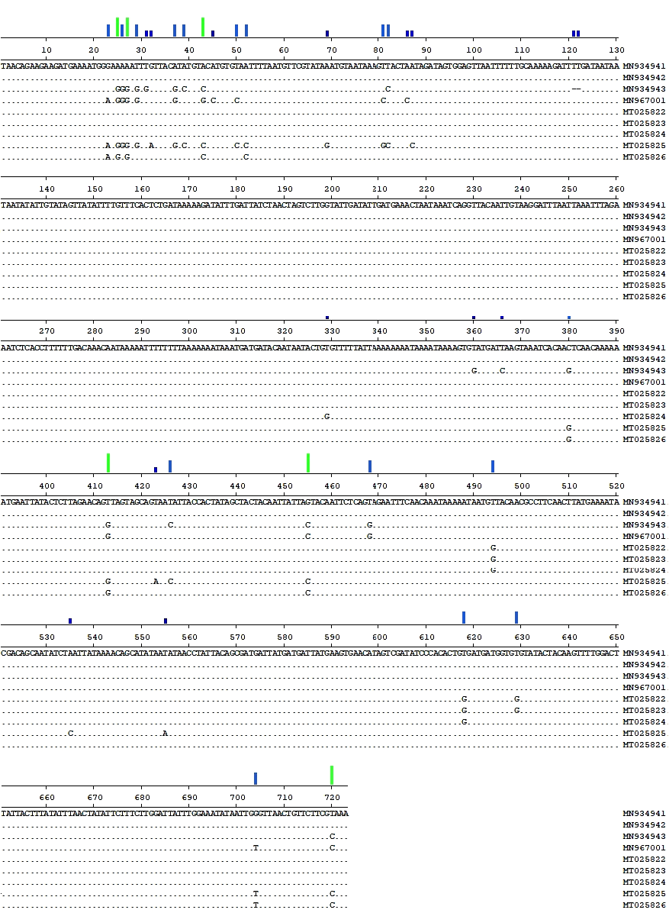

Figure 1. Sequence alignments of partial GPRC gene extracted from field sheep poxviruses of this study.

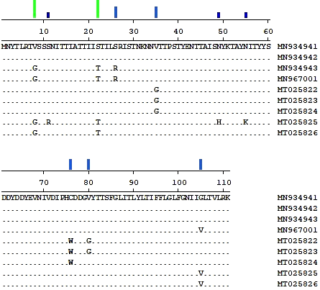

Figure 2. Deduced amino acid sequence alignments in partial G-Protein Coupled Receptors (GPRC) protein.

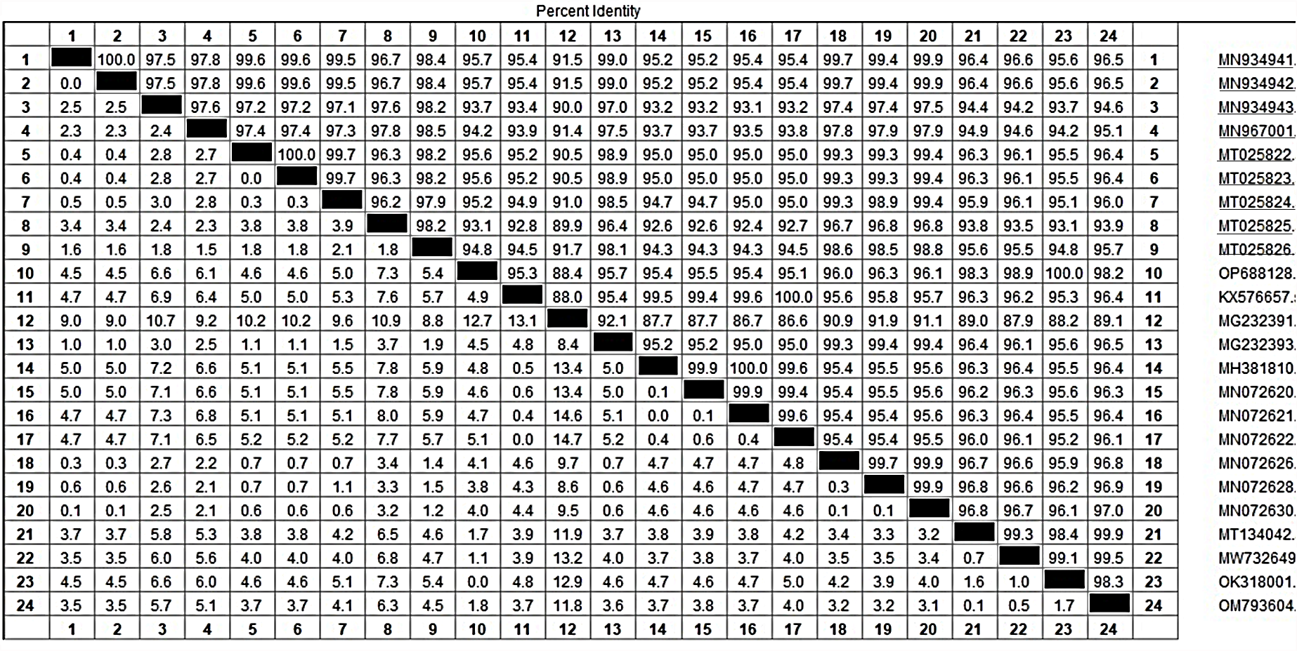
Figure 3. Percent identity of GPRC gene sequence among local strains (underlined) and CaPVs downloaded from GenBank.

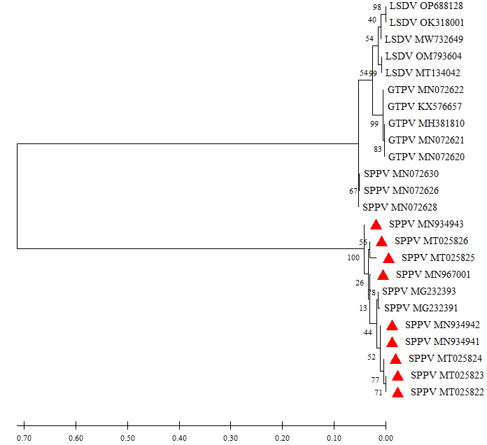
Group 1
Group 3

Subgroup 1
Subgroup 2

Subgroup 3

Subgroup 4

Subgroup 5

Subgroup 1

Subgroup 2

Group 2
Figure 4. Phylogeny of CaPVs based on partial GPCR gene sequence.

