**AUTHOR DECLARATION FORM**

**(Journal of the Indonesian Tropical Animal Agriculture)**

We, the undersigned authors of the manuscript entitled: **Performance and Digestive Organ Profile of** **Wandering Whistling Duck Fed Different Protein Levels**

hereby declare the authors responsibility, source of funding and copy right statement in order to publish the article in Journal of the Indonesian Tropical Animal Agriculture (JITAA).

1. Authors Responsibility

* The manuscript is not previously published or is not being considered for publication elsewhere.
* We have approved the content of the manuscript.

|  |
| --- |
| * We follow the format of JITAA (see Guide for Authors and Template for Manuscript) * The corresponding author is responsible for publication fee. |

2. Source of Funding

The source of funding for study (contract number and year of funding):

Beasiswa Pendidikan Indonesia (BPI) / The Indonesian Education Scholarship Program (202101121554) by Puslapdik Kemdikbud (Center for Education Financial Services, Ministry of Education, Culture, Research and Technology) and LPDP (Indonesian Endowment Fund for Education) .

3. Copyright Statement Agreement

The copyright of an article is transferred to the Journal of the Indonesian Tropical Animal Agriculture (JITAA), when the article is accepted for publication.

Name of Authors Signature Date

_________________________________ ____________________________ ________________________

Jamilah 30 Desember 2024



Luthfi Djauhari Mahfudz 30 Desember 2024

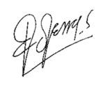

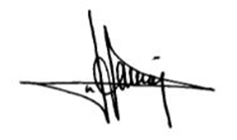Edjeng Suprijatna 30 Desember 2024

Hanny Indrat Wahyuni 30 Desember 2024