**AUTHOR DECLARATION FORM**

**(Journal of the Indonesian Tropical Animal Agriculture)**

We, the undersigned authors of the manuscript entitled:

IMPROVED IMMUNE STATUS OF FMT MEDIATED GUT MICROBIOTA PROFILING OF LATE LACTATION FRIESIAN HOLSTEIN COW IN LOWLAND INDONESIA

hereby declare the authors responsibility, source of funding and copy right statement in order to publish the article in Journal of the Indonesian Tropical Animal Agriculture (JITAA).

1. Authors Responsibility

* The manuscript is not previously published or is not being considered for publication elsewhere.
* We have approved the content of the manuscript.

|  |
| --- |
| * We follow the format of JITAA (see Guide for Authors and Template for Manuscript) * The corresponding author is responsible for publication fee. |

2. Source of Funding

The source of funding for study (contract number and year of funding):

Riset dan Inovasi untuk Indonesia Maju (RIIM) 2nd Year, Contract: 13/IV/KS/05/2023 dan 01/PKS/Bumi.Yasa.Svarga/V/2023.

3. Copyright Statement Agreement

The copyright of an article is transferred to the Journal of the Indonesian Tropical Animal Agriculture (JITAA), when the article is accepted for publication.

Name of Authors Signature Date

_________________________________ ____________________________ ________________________

Annisa Dhea Lathifa . . . . . . 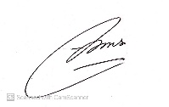. . . 31, January 2025

Nuruliarizki Shinta Pandupuspitasari ... 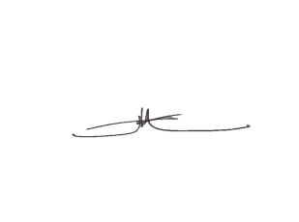. . . . . 31, January 2025

Faheem Ahmed Khan . . . . . 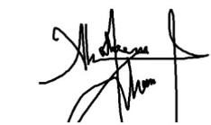. . 31, January 2025

Azhar Ali . . . . 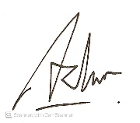. . …… … 31, January 2025

Bambang Waluyo Hadi Eko Prasetiyono . . 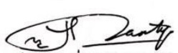. . . . 31, January 2025