**AUTHOR DECLARATION FORM**

**(Journal of the Indonesian Tropical Animal Agriculture)**

We, the undersigned authors of the manuscript entitled:

**“Intermittent administration of *Spirulina platensis*: effects on post-peak laying hens performance, protein digestibility, physiological responses, and egg quality”**

hereby declare the authors responsibility, source of funding and copy right statement in order to publish the article in Journal of the Indonesian Tropical Animal Agriculture (JITAA).

1. Authors Responsibility

* The manuscript is not previously published or is not being considered for publication elsewhere.
* We have approved the content of the manuscript.

|  |
| --- |
| * We follow the format of JITAA (see Guide for Authors and Template for Manuscript) * The corresponding author is responsible for publication fee. |

2. Source of Funding

The source of funding for study (contract number and year of funding):

Universitas Diponegoro (Faculty of Animal and Agricultural Sciences), contract number (No. 4/UN.7.F5/HK/III/2023)

3. Copyright Statement Agreement

The copyright of an article is transferred to the Journal of the Indonesian Tropical Animal Agriculture (JITAA), when the article is accepted for publication.

Name of Authors Signature Date

_________________________________ ____________________________ ________________________

Ikania Agusetyaningsih July, 31st 2025

Fakhriansyah Luthfian July, 31st 2025

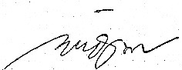

Endang Widiastuti July, 31st 2025

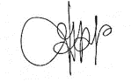

Dinda Ayu Permata Sari July, 31st 2025

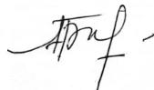Turrini Yudiarti July, 31st 2025

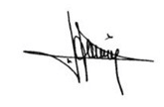

Hanny Indrat Wahyuni July, 31st 2025

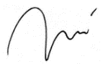

Sugiharto Sugiharto July, 31st 2025