AUTHOR DECLARATION FORM
(Journal of the Indonesian Tropical Animal Agriculture)

We, the undersigned authors of the manuscript entitled: Immunohistochemical Analysis of HSP-70 and IL-6 Expression in Rooster Testes Treated with Cucurbita moschata Seed Extract under Heat Stress Conditions.

hereby declare the authors responsibility, source of funding and copy right statement in order to publish the article in Journal of the Indonesian Tropical Animal Agriculture (JITAA).

1. Authors Responsibility
- The manuscript is not previously published or is not being considered for publication elsewhere.
- We have approved the content of the manuscript.
- We follow the format of JITAA (see Guide for Authors and Template for Manuscript)
- The corresponding author is responsible for publication fee.

2. Source of Funding
The source of funding for study (contract number and year of funding):
Faculty of Vocational Studies, Universitas Airlangga, Surabaya, Indonesia, for supporting this study through Grant No: 2475/UN3.FV/PT.01.03/2024.

3. Copyright Statement Agreement
The copyright of an article is transferred to the Journal of the Indonesian Tropical Animal Agriculture (JITAA), when the article is accepted for publication.

Name of Authors Signature Date
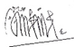
_________________________________ ____________________________ ________________________
Siti Eliana Rochmi 07-08-2025

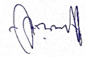
Miyayu Soneta Sofyan 07-08-2025

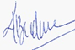
Agung Budianto Achmad 07-08-2025

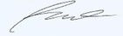
Herinda Pertiwi 07-08-2025

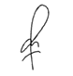
Gretania Residiwati 07-08-2025

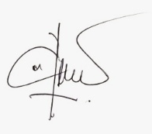
Igo Syaiful Ihsan 07-08-2025

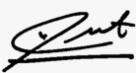
Habib Syaiful Arif Tuska 07-08-2025

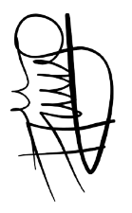

Supriyadi 07-08-2025

