AUTHOR DECLARATION FORM
(Journal of the Indonesian Tropical Animal Agriculture)

We, the undersigned authors of the manuscript entitled: Genetic Parameters of Milk Yield and Reproductive Performance Traits in Holstein-Friesian Dairy Cattle
hereby declare the authors responsibility, source of funding and copy right statement in order to publish the article in Journal of the Indonesian Tropical Animal Agriculture (JITAA).

1. Authors Responsibility
- The manuscript is not previously published or is not being considered for publication elsewhere.
- We have approved the content of the manuscript.
- We follow the format of JITAA (see Guide for Authors and Template for Manuscript)
- The corresponding author is responsible for publication fee.

2. Source of Funding
The source of funding for study (contract number and year of funding):
EQUITY Program (Contract No. 4303/ B3/DT.03.08/2025 and 3927/UN6. RKT/HK.07.00/2025).

3. Copyright Statement Agreement
The copyright of an article is transferred to the Journal of the Indonesian Tropical Animal Agriculture (JITAA), when the article is accepted for publication.

Name of Authors Signature Date


_________________________________ ____________________________ ________________________

Asep Anang . . . . . . . . . . . . . . . . . . . . . . . . . . . . . . . . . . . . . . .
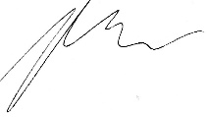
Didin Supriat Tasripin . . . . . . . . . . . . . . . . . . . . . May, 9th 2026

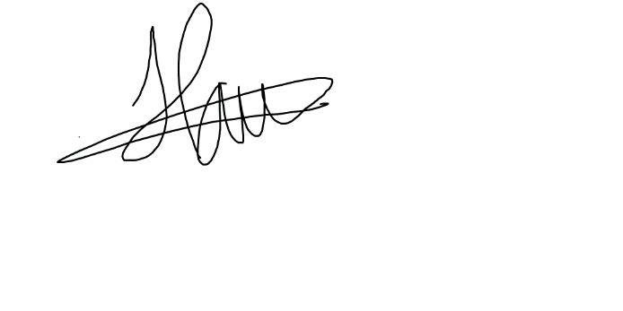
`Heni Indrijani . . . . . . . . . . . . . . . . . . . . . May, 9th 2026

Mochammad Hafizh Zulkarnaen . . . . . . . . . . . . . . . . . . . . . May, 9th 2026

