The Correlation Between Depression Symptoms and Physical Activity Among University Students

Zidni Imanurrohmah Lubis¹⁾, Alfidah Idnu Fadilallah¹⁾, Anita Faradilla Rahim¹⁾, Syiar Aprilla Tanazza²⁾
¹⁾ Physiotherapy Department, Faculty of Health Science, Universitas Muhammadiyah Malang, Malang, East Java, Indonesia
²⁾ Master students, Sports Medicine Department, College of Medicine, Kaohsiung Medical University, Taiwan (R.O.C)
ABSTRACT
Background: Depression represents a critical public health concern among university students, with prevalence rates in Indonesia reaching 50.76%. While physical activity is known to benefit mental health, the relationship between depression symptoms and physical activity among Indonesian university students remains poorly understood, with previous studies showing mixed findings. This study aims to examine the relationship between depression symptoms and physical activity among university students across multiple academic disciplines at Muhammadiyah University of Malang.
Method: This cross-sectional study involved 383 undergraduate students from the class of 2023 across ten faculties. The depression symptoms were assessed using the Patient Health Questionnaire-9 (PHQ-9), while the physical activity was measured using the International Physical Activity Questionnaire-Short Form (IPAQ-SF). Random sampling was employed with inclusion criteria of students aged 18-25 years. The data were analyzed using descriptive statistics and Spearman's rho correlation test with a significance level set at α=0.05.
Result: The mean depression symptoms score was 10.45 (SD=5.596), indicating moderate depression symptoms. Then, the mean physical activity level was 1812.93 MET-minutes/week (SD=1766.542). Spearman's rho analysis revealed a statistically significant negative correlation between depression symptoms and physical activity (r=-0.135, p=0.008). This result indicated that the higher depression levels were associated with reduced physical activity, and the weak correlation was caused by other factors that impacted the level of depression in relation to physical activity, such as social support, access to sports facilities, academic workload, and motivation. The female students comprised 69.7% of respondents, with most aged 20-21 years (73.4%). The results of this study showed that depression symptoms and physical activity had a significant inverse relationship among university students. Thus, routine depression symptoms screening using PHQ-9 should be integrated into student health assessments, and physical activity interventions should employ low-barrier, flexible approaches starting with modest achievable goals to address depression-related barriers.
Keywords: depression symptoms, physical activity, university students, mental health, biopsychosocial model

INTRODUCTION
Mental health challenges among university students have emerged as a critical public health concern, with depression being one of the most prevalent conditions. Depression is characterized by persistent sadness, loss of interest, feelings of guilt, disturbed sleep or appetite, and poor concentration (1). It differs from normal mood fluctuations in persistence and intensity (2), often lasting longer without direct relation to specific life events (3).
In fact, university students face unique stressors, including living away from home, peer pressure, and adaptation needs (4). This transitional period involves identity formation, academic pressures, and the establishment of new social networks (5). Prolonged stress impacts students holistically as mental and physical health are interconnected (6). Inability to manage academic demands produces psychological pressure manifesting as depression, anxiety, and stress (7). Research found 57.4% experienced moderate stress (8), and unaddressed stress can progress to depression (9).
In Indonesia, depression rates reached 6.2% for ages 15-24 years (10), with university students showing higher prevalence at 50.76% (11). Studies found 26.9% experienced mild, 18.5% moderate, and 9.3% severe depression (12). Among nursing students, 48.3% experienced mild, 21.5% moderate, and 8.1% severe depression (3).
Furthermore, one crucial factor in mental health research is physical activity. Physical activity, defined as bodily movement requiring energy expenditure (13), maintains fitness (14) and supports psychological well-being (15). Regular activity reduces depression risks and prevents cognitive decline (16). WHO recommends 150-300 minutes of moderate or 75-150 minutes of vigorous activity weekly (13). However, only 33.5% of Indonesians meet the recommendations (17), and 61.7% of students show low activity (18). This discrepancy raises important questions about the depression and physical activity relationship.
The depression and physical activity relationship operates through multiple mechanisms. Depression causes dysregulation of serotonin, norepinephrine, and dopamine (19), reducing pleasure during activity (20). It decreases motivation and causes anhedonia (21), activates the HPA axis, causing fatigue (22), and leads individuals to avoid physical effort (23). Students find it difficult to maintain activity routines (24). This creates a vicious cycle where depression reduces activity while reduced activity worsens depressive symptoms.
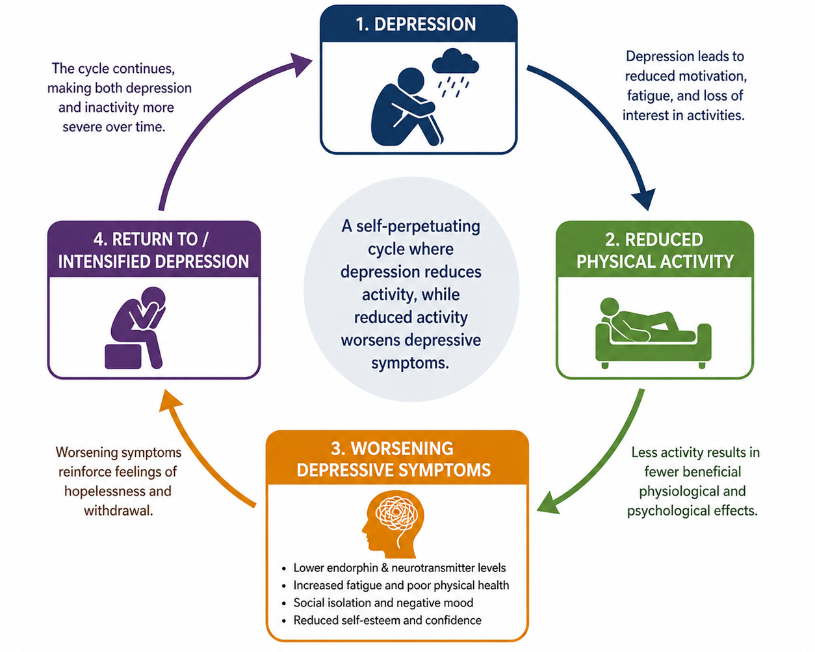
Figure 1. Cycle between Depression symptoms and Physical Inactivity

In addition, international research shows that more severe depression correlates with lower activity (25), with physical activity protecting against depression (23). However, Indonesian studies show mixed findings; one found 29.6% with low activity experienced moderate-severe depression without statistical significance (24), while another found no correlation despite 61.7% having low activity (18).
Obviously, these findings highlighted critical gaps. Most research occurred in Western populations with limited Southeast Asian examination, where cultural attitudes differ. Women are more vulnerable to mood disorders (26) and have lower activity due to societal norms (27). Previous Indonesian studies focused on single faculties, limiting generalizability. Engineering students face complex coursework (4), while medical students encounter clinical stressors (28). These demands may differentially impact depression and physical activity capacity.
Given these gaps and the escalating mental health crisis, comprehensive research across diverse disciplines is needed. Understanding this relationship is essential for evidence-based interventions addressing mental health and healthy behaviors. From physiotherapy perspectives, research can inform approaches to overcoming psychological barriers (6). Therefore, this study aims to examine the relationship between depression level and physical activity among students at Universitas Muhammadiyah Malang across multiple faculties. Then, the hypothesis was that higher depression would negatively associate with physical activity, consistent with biopsychosocial models.

METHOD
This study used a quantitative observational analytical method with a cross-sectional study design. Then, this study used depression level as the independent variable and physical activity as the dependent variable. By using this method, all of the data of this study were collected at one specific point in time, without requiring extended observation periods.
Clearly, the data collection was conducted from September to October 2025 at Universitas Muhammadiyah Malang. The study utilized a quantitative observational analytic approach with a cross-sectional design to examine the relationship between depression symptoms and physical activity among undergraduate students at Universitas Muhammadiyah Malang, cohort 2023. The study employed a random sampling technique to recruit the participants from the target population. The total population consisted of 4,348 first-year undergraduate students (the class of 2023) from Universitas Muhammadiyah Malang. The sample size was calculated using Slovin's formula with a 5% margin of error. Therefore, the sample chosen was 383 undergraduate students aged 18-25 years with the inclusion criteria. Exclusion criteria in this study were vocational students at Universitas Muhammadiyah Malang. The students who met the exclusion criteria had a history of consultation with a psychologist/psychiatrist during the last 6 months, and those who were unwilling to be respondents.
In addition, two validated self-report questionnaires were administered to collect the data from participants. The first instrument was the Patient Health Questionnaire-9 (PHQ-9), which was used to assess depression symptoms among participants. This instrument consisted of nine items that evaluated respondents' conditions over the past 14 days. Each item was scored on a scale ranging from 0 to 4, where 0 indicated "not at all" and 4 indicated "always." The total depression score ranged from 0 to 36 points, with the higher scores indicating more severe depression. The validity of the Indonesian version of the PHQ-9 has been examined, yielding a statistical result in the form of an Eta correlation coefficient of r = 0.527. This result indicated a positive correlation within the Indonesian version of the PHQ-9. Then, the internal consistency was assessed using Cronbach's alpha, which yielded a value of 0.873, falling within the acceptable range of 0.7 to 0.95, thereby confirming the reliability of the scale (29).
Moreover, the second instrument was the International Physical Activity Questionnaire-Short Form (IPAQ-SF), which was used to measure physical activity levels. This questionnaire consisted of seven questions assessing participants' physical activity over the past seven days, evaluating three types of activities: walking, moderate-intensity activities, and vigorous-intensity activities. The physical activity scores were calculated using Metabolic Equivalent of Task (MET) values, where walking equals 3.3 METs, moderate-intensity activity equals 4.0 METs, and vigorous-intensity activity equals 8.0 METs. Physical activity levels were categorized into three groups: low activity (<600 MET-minutes/week), moderate activity (600-3000 MET-minutes/week), and high activity (>3000 MET-minutes/week). The IPAQ-SF was administered using the validated Indonesian version, as adapted and validated by Dharmansyah and Budiana (2021) (30).
Furthermore, the data analysis was performed using IBM SPSS Statistics, a univariate analysis which involved calculating descriptive statistics, including frequency distributions and percentages for categorical variables (age, gender, faculty). For bivariate analysis, the Kolmogorov-Smirnov test was first performed to assess the data distribution normality, with a significance level set at α = 0.05. This study used Spearman's rho correlation test to examine the relationship between depression symptoms and physical activity as a non-parametric statistical methods.
However, the study protocol was reviewed and approved by the Research Ethics Committee of the Faculty of Health Sciences, Universitas Muhammadiyah Malang, with ethical clearance number E.4.d/095/KEPK/FIKES-UMM/VIII/2025.

RESULT AND DISCUSSION
This study involved 383 undergraduate students from Universitas Muhammadiyah Malang, the class of 2023. The demographic characteristics of respondents are presented in the following sections.
Table 1. Respondent Characteristics
Respondent Characteristics | n | %
Age
18 | 3 | 0.8
19 | 63 | 16.4
20 | 183 | 47.8
21 | 98 | 25.6
22 | 28 | 7.3
23 | 5 | 1.3
24 | 2 | 0.5
25 | 1 | 0.3
Sex
Male | 116 | 30.3
Female | 267 | 69.7
Faculty
Islamic Studies | 19 | 5
Teacher Training and Education | 30 | 7.8
Social and Political Sciences | 53 | 13.8
Law | 29 | 7.6
Economics and Business | 57 | 14.9
Psychology | 34 | 8.9
Agriculture and Animal Science | 30 | 7.8
Engineering | 79 | 20.6
Medicine | 12 | 3.1
Health Sciences | 40 | 10.4
Total | 383 | 100

This study involved 383 undergraduate students from Universitas Muhammadiyah Malang, the class of 2023. The age distribution of respondents ranged from 18 to 25 years, falling within the early adulthood category. The majority of respondents were 20 years old, accounting for 47.8% (183 respondents), followed by 21 years old at 25.6% (98 respondents), 19 years old at 16.4% (63 respondents), 22 years old at 7.3% (28 respondents), 23 years old at 1.3% (5 respondents), 18 years old at 0.8% (3 respondents), 24 years old at 0.5% (2 respondents), and 25 years old at 0.3% (1 respondent). Respondents aged 20-21 (73.4%) represented a critical period where depression can establish sedentary patterns persisting into later life. Diverse faculty representation highlights discipline-specific stressors across engineering, medical, and social science programs (4,28,31).

Table 2. Gender Differences in Depression Symptoms and Physical Activity: Mann-Whitney U Test Results
Variabel | Gender | N | Mean Rank | p | α
Depression symptoms | Male  Female | 116  267 | 186.80  194.26 | 0.544 | 0.05
Physical Activity | Male  Female | 116  267 | 200.04  188.51 | 0.349 | 0.05
Note : U = Mann-Whitney U value; p = significance value (2-tailed); significance level α = 0.05

The gender distribution of the sample is presented in Table 2 above, with further details described as follows. The predominance of female respondents was consistent with findings from previous studies. It is suggested that women tend to be more open and willing to discuss mental health issues compared to men (32). Female predominance (69.7%) reflected documented gender differences; women experience depression at twice men's rate due to hormonal and psychosocial factors (33), and engage in less physical activity due to cultural norms and safety concerns (27). However, the supplementary analysis using the Mann-Whitney U test revealed no statistically significant differences in depression symptoms (p = 0.544) or physical activity levels (p =0.349) between male and female respondents. This result suggested that the predominance of female participants did not introduce gender bias and that the results may be generalized across genders.
Clearly, the respondents were distributed across ten faculties at Universitas Muhammadiyah Malang. The Faculty of Engineering had the highest representation with 20.6% (79 respondents), followed by the Faculty of Economics and Business at 14.9% (57 respondents), Faculty of Social and Political Sciences at 13.8% (53 respondents), Faculty of Health Sciences at 10.4% (40 respondents), Faculty of Psychology at 8.9% (34 respondents), Faculty of Agriculture and Animal Husbandry and Faculty of Teacher Training and Education each at 7.8% (30 respondents), Faculty of Law at 7.6% (29 respondents), Faculty of Islamic Studies at 5.0% (19 respondents), and Faculty of Medicine at 3.1% (12 respondents). This diverse faculty representation ensured that the study findings reflected the students’ experiences across various academic disciplines with different academic demands and stress levels.
In addition to the gender distribution, the sample was also characterized by a relatively high proportion of students from the Faculty of Engineering. This influenced the findings, as engineering students were often engaged in academically demanding and sedentary activities, such as prolonged computer use, laboratory work, and project-based assignments(34). Such patterns may contribute to lower levels of physical activity, which in turn could amplify the observed relationship between physical inactivity and depressive symptoms(35). Therefore, the results should be interpreted with caution, as the sample composition may limit generalizability to student populations with more diverse activity patterns.

Table 3. Descriptive Statistics of Depression symptoms and Physical Activity among Students
Category | n | Mean | St. Dev
Depression symptoms | 383 | 10.45 (0-27) | 5.596
Physical Activity | 383 | 1812.93 (0-12.852) | 1766.542

The descriptive statistics revealed considerable variability in both depression symptoms and physical activity among respondents. For depression symptoms, the mean score of 10.45 (SD = 5.596) indicated that on average, the students experienced moderate depression symptoms. The scores ranged from 0 (no depression) to 27 (severe depression), demonstrating the wide spectrum of mental health conditions among the student population.
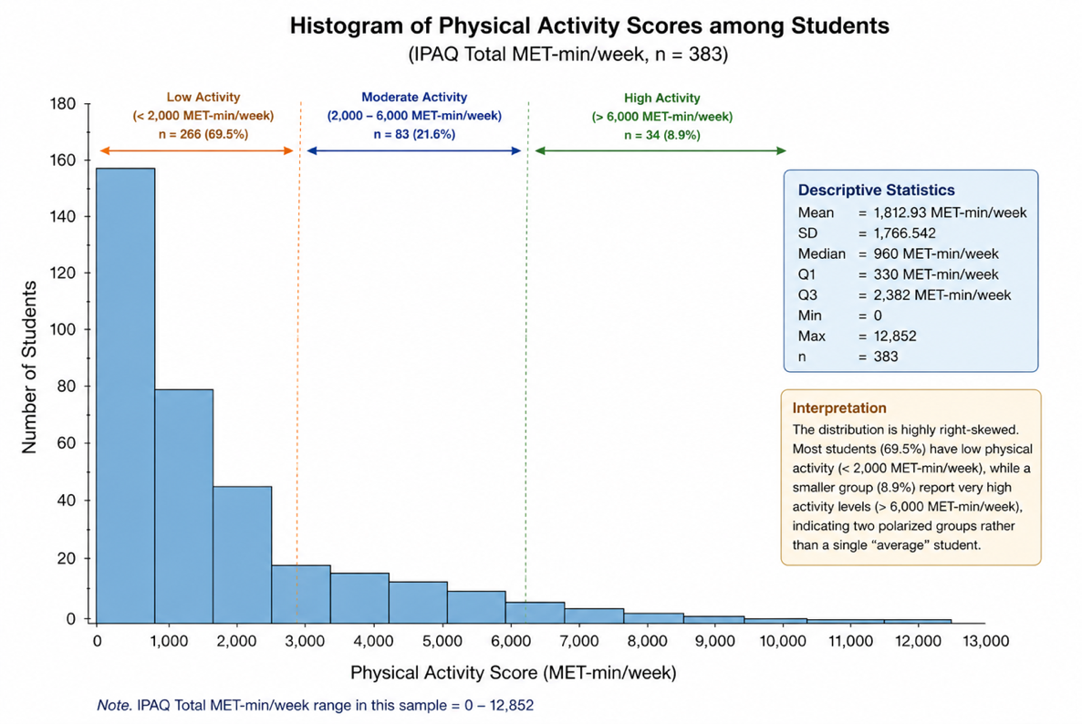
Figure 2. Histogram of Physical Activity Scores among Students
Physical activity levels showed even greater variability, with a mean of 1812.93 MET-minutes/week (SD = 1766.542) and a range from 0 to 12,852 MET-minutes/week. This wide range indicated extremely diverse physical activity patterns, with some students engaging in no physical activity whatsoever, while others maintained very high levels of physical activity. The mean value of 1812.93 MET-minutes/week placed the average student in the moderate physical activity category (600-3000 MET-minutes/week).
The extreme variability in physical activity (0 to 12,852 MET-minutes/week, mean = 1812.93, SD = 1766.542) revealed stark disparities. While the mean met WHO recommendations, the large standard deviation indicated distinct subpopulations of highly active and completely sedentary students. Complete inactivity was concerning, given associations with cardiovascular disease and worsening mental health (36). The Riskesdas 2018 found that only 33.5% of Indonesians met activity recommendations. These patterns reflect broader societal trends (17).

Table 4. Normality Analysis
Variabel | N | p | α
Depression symptoms | 383 | 0.000 | 0.05
Physical Activity | 383 | 0.000 | 0.05
Note : Kolmogorov-Smirnov analysis ; N = Respondent ; p = Significant value; α = Significance level

The Kolmogorov-Smirnov test was conducted to assess the normality of data distribution for both variables. The results indicated that both depression symptoms (p = 0.000) and physical activity (p = 0.000) were not normally distributed, as the p-values were below the significance threshold of 0.05. The non-normal distribution of depression scores reflected the skewed nature of mental health conditions in the general student population, where most students experienced low to moderate levels of depression, with fewer cases of severe depression. Similarly, the non-normal distribution of physical activity scores suggested that physical activity patterns did not follow a bell-shaped curve, possibly due to distinct subgroups of students (sedentary vs. active).

Table 5. Correlation Between Depression symptoms and Physical Activity Among University Students
Variable | N | Mean | p | r | α
Depression symptoms | 383 | 10.45 | 0.008* | -0.135 | 0.05
Physical Activity | 383 | 1812.93 | 0.008* | -0.135 | 0.05
Note : Spearman’s rho analysis ; N = Respondent ; Mean = Average value ; * = Correlation ; p = Significant value ; r = Correlation value ; α = Significance level
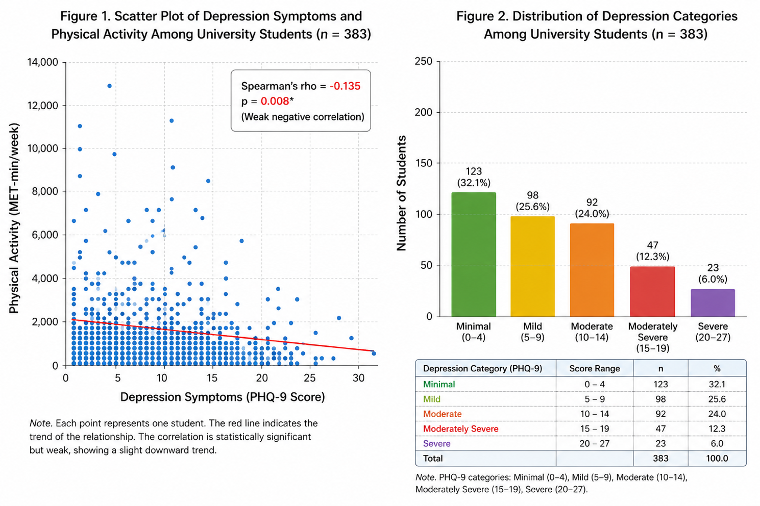

Figure 3. Scatter Plot of Depression Symptoms and Physical Activity Among University Student (n=383)

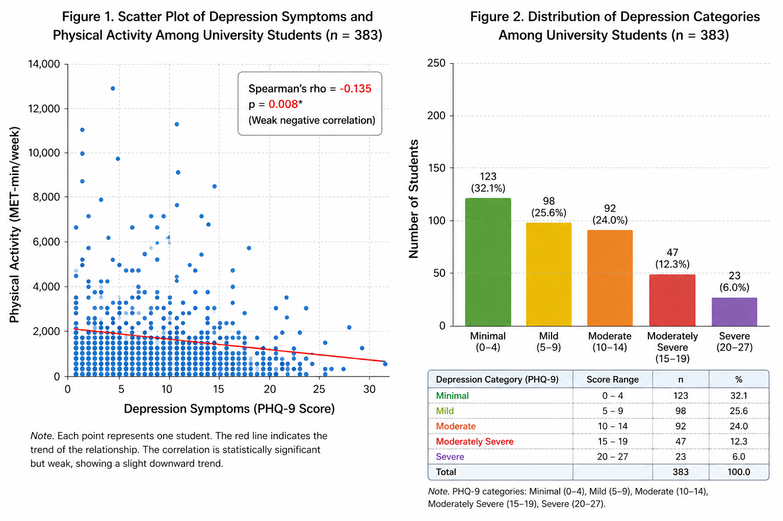

Figure 4. Distribution of Depression Categories Among University Student (n=383)

The Spearman's rho correlation analysis revealed a statistically significant negative correlation between depression symptoms and physical activity among students (r = -0.135, p = 0.008). The negative correlation coefficient indicated an inverse relationship between the two variables: as depression symptoms increase, physical activity levels tend to decrease. Although the correlation coefficient of -0.135 indicated a weak relationship according to conventional interpretation guidelines, the statistical significance (p = 0.008 < 0.05) confirmed that this relationship was unlikely to have occurred by chance. This finding supported the alternative hypothesis (H₁) that there was a significant relationship between depression symptoms and physical activity among students, while the null hypothesis (H₀) was rejected.
This study showed a statistically significant negative correlation between depression symptoms and physical activity among university students (r = -0.135, p = 0.008). This result indicated that higher depression symptoms were associated with reduced physical activity. While the correlation was weak, its statistical significance confirmed a meaningful relationship consistent with biopsychosocial models of mental health. The mean depression score of 10.45 placed the students in the moderate depression category, aligning with Setyanto's (2023) findings among Indonesian university students (12). This transitional period of university life, characterized by academic pressures and identity formation, creates vulnerability for mental health difficulties (4).
Although the correlation between depression symptoms and physical activity was statistically significant (r = -0.135, p = 0.008), the magnitude of the association was weak. This suggests that while biological and psychological mechanisms linking depression and reduced physical activity are well established, these internal factors may not be the primary determinants of physical activity behavior in this population.
In the context of Indonesian university students, external and environmental factors are likely to play a more dominant role in shaping activity patterns. For instance, the tropical climate with high temperatures and humidity may discourage outdoor physical activity, particularly among students with limited access to climate-controlled facilities. In addition, inadequate pedestrian infrastructure and limited campus walkability may reduce opportunities for incidental physical activity(37,38). Academic demands, including prolonged sedentary study, laboratory work, and screen-based tasks, may further constrain students’ time and motivation for exercise(35,39). These contextual constraints may attenuate the strength of the relationship between depression and physical activity, resulting in a statistically significant but weak correlation. Therefore, physical activity behavior in this population appears to be influenced by a complex interplay of psychological, biological, and environmental factors, with external barriers potentially overriding internal motivational processes(39,40).
The depression and physical activity relationship operated through multiple mechanisms. Neurobiologically, depression involves dysregulation of serotonin, norepinephrine, and dopamine, neurotransmitters crucial for motivation and energy (19). Impaired dopaminergic systems cause anhedonia making exercise unrewarding (41). Depression activates the HPA axis, elevating cortisol and causing fatigue that hinders physical activity (42). This creates a vicious cycle, depression reduces activity biologically, while reduced activity exacerbates depression by limiting endorphin and BDNF production (23). Psychologically, learned helplessness and negative thought patterns undermine self-efficacy for sustaining activity (20).
The negative correlation observed (r = -0.135, p = 0.008) was consistent with Kim et al. (2021), who found Korean university students with low physical activity experienced significantly higher depression and poorer interpersonal relationships (25). Their study showed a dose-dependent relationship, with moderate and high activity groups showing progressively better mental health outcomes. Similarly, Rifki & Tjandra (2024) found Indonesian medical students with minimal activity were more likely to experience moderate to severe depression, though they did not find statistical significance using different analytical approaches.
These findings have important practical implications. First, routine depression screening using PHQ-9 should be integrated into student health assessments. Second, physical activity interventions for students with depressive symptoms should move beyond general recommendations toward structured approaches such as Physical Activity on Prescription (PAP). In this model, campus health services do not merely advise students to “be more active,” but provide individualized, low-barrier activity prescriptions tailored to students’ psychological and contextual constraints. For instance, considering the presence of anhedonia and low motivation identified in this study, interventions may include simple and achievable programs such as 10–15-minute guided campus walking groups, scheduled at flexible times and integrated into students’ daily routines. These structured yet accessible activities may help reduce psychological barriers to initiation, gradually building adherence and restoring motivation for physical activity.
However, the study strengths include adequate sample size (n=383), diverse faculty representation, and validated instruments (PHQ-9, IPAQ). Limitations include a cross-sectional design precluding causal inference, self-report biases, weak correlation indicating numerous unmeasured factors (social support, facility access, sleep quality) substantially influence physical activity, female predominance (69.7%), limiting generalizability to males, and a single-university restriction.

CONCLUSION
This study showed that the students at Universitas Muhammadiyah Malang had an average depression score of 10.45. This result indicated moderate symptoms of depression, while their physical activity levels varied, with an average of 1812.93 MET-minutes/week, with the majority falling into the moderate to low category and not meeting WHO recommendations. Then, the analysis results revealed a significant negative correlation between depression symptoms and physical activity. It means that the higher the students' depression symptoms, the lower their physical activity. Thus, it requires serious attention to improve students' mental and physical well-being.

REFERENCES
1. Organization WH. Depressive Disorder (Depression) [Internet]. 2025. Available from: https://www.who.int/news-room/fact-sheets/detail/depression
2. Bowen R. Moods in clinical depression are more unstable than severe normal sadness. Vol. 8. 2017;8(April):1–6. doi:https://doi.org/10.3389/fpsyt.2017.00056
3. Kusuma MDS, Nuryanto IK, Sutrisna IPG. Tingkat gejala depresi pada mahasiswa program studi sarjana keperawatan di Institut Teknologi dan Kesehatan (ITEKES) BALI. Jurnal Riset Kesehatan Nasional. 2021;5(1):29–34. PubMed PMID: 25246403.
4. Wilson SA, Wright CJ, Miller ME, Hargis LE, Usher EL, Hammer JH, et al. Identifying common perceived stressors and stress-relief strategies among undergraduate engineering students. ASEE Annual Conference and Exposition, Conference Proceedings. 2022. doi:https://doi.org/10.18260/1-2--41009
5. Hamidah ND, Priasmoro DP, Nurmayunita H. Krisis Seperempat Baya (Quarter Life Crisis) Pada mahasiswa tingkat akhir keperawatan Di ITSK Rs. Dr. Soepraoen Malang Quarter. Jurnal Penelitian Keperawatan. 2024;10:201–20. doi:https://doi.org/10.32660/jpk.v10i2.764
6. Husni M, Asnuriyati W, Mawarni T. Hubungan antara kesehatan mental dan kualitas hidup pada individu dengan penyakit kronis. Vol. 7. 2024;7:11385–92. doi:https://doi.org/10.31004/jrpp.v7i3.32553
7. Mutasimbillah F, Matang. Kesehatan mental mahasiswa dan pengaruhnya terhadap peran mahasiswa dalam bermasyarakat berbangsa dan bernegara oleh Maha Widya Bhuwana. 2024;7(1).
8. Ambarwati PD, Pinilih SS, Astuti RT. Gambaran tingkat stres mahasiswa. Jurnal Keperawatan Jiwa. 2019;5(1):40. doi:10.26714/jkj.5.1.2017.40-47
9. Khare S. The impact of chemical changes in the brain caused by chronic stress can trigger depression. Vol. 9. 2021;9(4). doi:10.25215/0904.032
10. Kesehatan K. Depression Among Young People in Indonesia [Internet]. 2023. p. 1–2. Available from: https://repository.badankebijakan.kemkes.go.id/id/eprint/5527/1/03 Factsheet Keswa 24april_English.pdf
11. Malahayati U. Menelusuri jejak depresi di kalangan mahasiswa: sebuah eksplorasi gejala khas. MagnaSalus: Jurnal Keunggulan Kesehatan. 2024;06(3):44–51.
12. Setyanto AT. Deteksi dini prevalensi gangguan kesehatan mental mahasiswa di perguruan tinggi. Wacana. 2023;15(1):66. doi:10.20961/wacana.v15i1.69548
13. Organization WH. Who guidelines on physical activity and sedentary behaviour. 2020.
14. Wicaksono A. Buku Aktivitas Fisik dan Kesehatan. 2021. 32–36 p.
15. Kanahaya D, Khaerunisa H, Hakiki IN, Iskandar NM, Prasetyo T. Menyelaraskan tubuh dan pikiran: manfaat kognitif memasukkan senam ke dalam pendidikan jasmani. Karimah Tauhid. 2024;3(3):3669–84. doi:10.30997/karimahtauhid.v3i3.12644
16. Pearce M, Garcia L, Abbas A, Strain T, Schuch FB, Golubic R, et al. Association between physical activity and risk of depression. A Systematic Review and Meta-analysis. Vol. 79. 2022;79(6):550–9. doi:10.1001/jamapsychiatry.2022.0609
17. Widyawati M. Kurang Aktivitas Fisik Berpotensi Alami Penyakit Tidak Menular [Internet]. 2019. Available from: https://kemkes.go.id/id/ kurang-aktivitas-fisik-berpotensi-alami-penyakit-tidak-menular
18. Agoes IF, Atzmardina Z. Hubungan aktivitas fisik terhadap prestasi akademik pada mahasiswa FK UNTAR angkatan 2022 / 2023. Vol. 5. 2024;5(September):6810–4.
19. Nasution HN, Firdausi H. Pendekatan diagnosis dan tatalaksana gangguan mood pada usia lanjut. jurnal kedokteran. 2021;06(02):1–80. doi:http://dx.doi.org/10.36679/kedokteran.v6i2.333
20. Munirah I, Utami HN, Rahma J, Mukhlisatunnafsi L, Adni A. Studi literatur: penggunaan media sosial sebagai faktor risiko terjadinya depresi. JMH: Jurnal Medika Hutami. 2024;05(02):3842–53.
21. Oktavia SA, Setiawan AIB. Penerimaan diri pada mahasiswa dengan anhedonia. PSYCOMEDIA : Jurnal Psikologi. 2024;3(2):68–76. doi:10.35316/psycomedia.2024.v3i2.68-76
22. Rosyanti L, Devianti R, Hadi I, Syahrianti S. kajian teoritis: hubunggan antara depresi dengan sistem neuroimun (SITOKIN-HPA AKSIS) “Psikoneuroimunoologi.” Health Information : Jurnal Penelitian. 2017;9(2):35–52. doi:10.36990/hijp.v9i2.104
23. Schuch FB, Vancampfort D, Firth J, Rosenbaum S, Ward PB, Silva ES, et al. Physical activity and incident depression: A meta-analysis of prospective cohort studies. American Journal of Psychiatry. 2018;175(7):631–48. doi:10.1176/appi.ajp.2018.17111194 PubMed PMID: 29690792.
24. Rifki M, Tjandra O. Hubungan aktivitas fisik dengan depresi pada mahasiswa kedokteran Universitas Tarumanagara. Tarumanagara Medical Journal. 2024;6(1):109–14. doi:10.24912/tmj.v6i1.31373
25. Kim C, Song Y, Jeon YJ. The effect of college students’ physical activity level on depression and personal relationships. Healthcare (Switzerland). 2021;9(5):1–11. doi:10.3390/healthcare9050526
26. Arrieta PPM de, Arenaza JG. Affective disorders and gender differences. 611–38. doi:10.1007/978-3-030-15179-9
27. Suarjana IWG, Manopo JE, Pongoh LL, Supit ASA. Perbedaan aktivitas fisik berdasarkan karakteristik individu pada masyarakat Minahasa Selatan. Jurnal Ilmu Olahraga dan Kesehatan. 2023;12(2):414–26.
28. Hediaty S, Herlambang, Natasha Ayu Shafira N. Gambaran tingkat stres mahasiswa kedokteran berdasarkan medical student stresor questionnaire di fakultas dan ilmu kesehatan Universitas Jambi. Joms. 2022;2(2):61–70. doi:https://doi.org/10.22437/joms.v2i2.23252
29. Lee EH, Kang EH, Kang HJ, Lee HY. Measurement invariance of the patient health questionnaire-9 depression scale in a nationally representative population-based sample. Frontiers in Psychology. 2023;14(August):1–11. doi:10.3389/fpsyg.2023.1217038
30. Dharmansyah D, Budiana D. Indonesian adaptation of the international physical activity questionnaire (IPAQ): psychometric properties. Jurnal Pendidikan Keperawatan Indonesia. 2021;7(2):159–63. doi:10.17509/jpki.v7i2.39351
31. Hassem T, de Andrade V, Laher S, Bemath N, Bain K. Postgraduate Psychology Students’ Mental Health and Coping during COVID-19: Lessons learnt. Journal of Student Affairs in Africa. 2024;12(1):47–67. doi:10.24085/jsaa.v12i1.4338
32. Gulland A. women have higher rates of mental disorders than men, NHS survey finds. Vol. 5320. 2016;5320(September):5320. doi:10.1136/bmj.i5320
33. Dirgayunita A. Depresi: Ciri, Penyebab dan Penangannya. Journal An-Nafs: Kajian Penelitian Psikologi. 2016;1(1):1–14. doi:10.33367/psi.v1i1.235
34. Aziz FA, Hafidz NAA. The prevalence of musculoskeletal disorders symptoms and ergonomics risk amongst engineering, science, and technology students. In. 2024. p. 377–87. doi:10.1007/978-981-99-8819-8_30
35. Karol M, Koseska K, Borowicz J, Górecki B, Kloch K, Romaniuk P, et al. Sedentary lifestyle and academic stress as risk factors for health disorders in young adults. Journal of Education, Health and Sport. 2026 Jan 12;87:67461. doi:10.12775/JEHS.2026.87.67461
36. Faigenbaum AD, MacDonald JP, Stracciolini A, Rebullido TR. Making a strong case for prioritizing muscular fitness in youth physical activity guidelines. Current Sports Medicine Reports. 2020;19(12):530–6. doi:10.1249/JSR.0000000000000784 PubMed PMID: 33306516.
37. Yastinawati A, Safrudin S. Faktor-faktor yang berhubungan dengan budaya sedentari pada mahasiswa tingkat akhir di Universitas Bhayangkara Jakarta Raya tahun 2025. Health Promotion and Community Engagement Journal. 2025 Jul 25;3(2):109–16. doi:10.70041/hpcej.v3i2.168
38. Sarah AS, Pahria T, Shalahuddin I. Dampak Pandemi Covid-19 terhadap aktivitas fisik pada mahasiswa fakultas keperawatan Universitas Padjadjaran. Malahayati Nursing Journal. 2023 Jan 1;5(1):203–17. doi:10.33024/mnj.v5i1.7261
39. Yu F, Fernandez R, Chidarikire S, Mackay L, Smith M. Associated factors, barriers, and interventions to promote physical activity and reduce sedentary time in academics: a systematic review. BMC Public Health. 2025 Aug 13;25(1):2753. doi:10.1186/s12889-025-24092-2
40. Aung MN, Somboonwong J, Jaroonvanichkul V, Wannakrairot P. Possible link between medical students’ motivation for academic work and time engaged in physical exercise. Mind, Brain, and Education. 2016 Dec 2;10(4):264–71. doi:10.1111/mbe.12121
41. Roy S, Biswas AK, Sharma M. Stress, anxiety, and depression as psychological distress among college and undergraduate students: a scoping review of reviews guided by the socio-ecological model. Healthcare (Switzerland). 2025;13(16):1–20. doi:10.3390/healthcare13161948
42. Kandola A, Ashdown-franks G, Hendrikse J, Sabiston CM, Stubbs B. Physical activity and depression: Towards understanding the antidepressant mechanisms of physical activity. Neuroscience and Biobehavioral Reviews. 2019. doi:10.1016/j.neubiorev.2019.09.040

