Analysis Summary

Date and Time
Date: 18 April 2017
Time: 7:09:51

Title
tambah hipotesis: 18 April 2017 7:09

Notes for Group (Group number 1)
The model is recursive.
Sample size = 102

Observations farthest from the centroid (Mahalanobis distance) (Group number 1)
Observation number | Mahalanobis d-squared | p1 | p2
102 | 30,192 | ,003 | ,234
88 | 25,897 | ,011 | ,313
99 | 25,816 | ,011 | ,111
49 | 23,925 | ,021 | ,164
87 | 23,673 | ,023 | ,081
100 | 22,989 | ,028 | ,066
101 | 22,951 | ,028 | ,025
46 | 21,235 | ,047 | ,108
98 | 20,919 | ,052 | ,081
40 | 20,053 | ,066 | ,137
48 | 19,805 | ,071 | ,108
4 | 19,360 | ,080 | ,116
36 | 19,347 | ,080 | ,066
25 | 18,641 | ,098 | ,121
85 | 18,476 | ,102 | ,094
83 | 18,125 | ,112 | ,104
50 | 18,069 | ,114 | ,068
37 | 17,579 | ,129 | ,104
82 | 17,270 | ,140 | ,115
21 | 17,209 | ,142 | ,081
81 | 16,347 | ,176 | ,248
68 | 15,813 | ,200 | ,383
45 | 15,493 | ,216 | ,442
51 | 15,445 | ,218 | ,373
13 | 15,240 | ,229 | ,383
60 | 15,014 | ,241 | ,406
96 | 14,763 | ,255 | ,445
94 | 14,752 | ,255 | ,364
57 | 14,236 | ,286 | ,551
27 | 14,167 | ,290 | ,502
56 | 14,147 | ,291 | ,427
79 | 13,982 | ,302 | ,434
28 | 13,658 | ,323 | ,533
74 | 13,567 | ,329 | ,502
84 | 13,406 | ,340 | ,512
91 | 13,333 | ,345 | ,472
55 | 13,176 | ,356 | ,484
65 | 13,054 | ,365 | ,475
67 | 12,857 | ,380 | ,514
62 | 12,793 | ,384 | ,472
80 | 12,452 | ,410 | ,603
69 | 12,183 | ,431 | ,688
41 | 12,138 | ,435 | ,642
54 | 11,956 | ,449 | ,677
61 | 11,929 | ,451 | ,619
73 | 11,862 | ,457 | ,585
66 | 11,747 | ,466 | ,582
52 | 11,617 | ,477 | ,589
76 | 11,584 | ,480 | ,533
20 | 11,576 | ,480 | ,459
89 | 11,441 | ,492 | ,472
86 | 11,405 | ,495 | ,417
53 | 11,169 | ,514 | ,499
71 | 11,145 | ,517 | ,436
77 | 11,142 | ,517 | ,362
2 | 11,095 | ,521 | ,319
92 | 11,014 | ,528 | ,299
18 | 10,809 | ,545 | ,356
17 | 10,542 | ,569 | ,461
44 | 10,496 | ,572 | ,414
42 | 10,217 | ,597 | ,534
70 | 9,428 | ,666 | ,910
12 | 9,348 | ,673 | ,901
64 | 9,213 | ,685 | ,910
14 | 8,985 | ,704 | ,942
63 | 8,807 | ,719 | ,956
78 | 8,708 | ,728 | ,954
95 | 8,614 | ,735 | ,952
11 | 8,568 | ,739 | ,938
9 | 8,554 | ,740 | ,911
6 | 8,450 | ,749 | ,909
35 | 8,307 | ,761 | ,919
31 | 8,074 | ,779 | ,949
59 | 7,965 | ,788 | ,948
15 | 7,942 | ,790 | ,926
22 | 7,869 | ,795 | ,913
5 | 7,835 | ,798 | ,884
8 | 7,769 | ,803 | ,862
16 | 7,526 | ,821 | ,909
19 | 7,184 | ,845 | ,962
47 | 6,842 | ,868 | ,987
34 | 6,828 | ,869 | ,977
72 | 6,768 | ,873 | ,968
32 | 6,610 | ,882 | ,971
97 | 6,357 | ,897 | ,984
33 | 6,298 | ,900 | ,976
39 | 6,258 | ,903 | ,962
26 | 6,098 | ,911 | ,964
43 | 6,018 | ,915 | ,950
93 | 5,948 | ,919 | ,930
38 | 5,857 | ,923 | ,908
24 | 5,703 | ,930 | ,901
30 | 5,600 | ,935 | ,872
23 | 5,282 | ,948 | ,915
58 | 5,086 | ,955 | ,911
29 | 4,974 | ,959 | ,872
10 | 4,582 | ,971 | ,918
90 | 4,281 | ,978 | ,923
1 | 4,193 | ,980 | ,846
7 | 3,341 | ,993 | ,960

Computation of degrees of freedom (Default model)
Number of distinct sample moments: | 78
Number of distinct parameters to be estimated: | 30
Degrees of freedom (78 - 30): | 48

Result (Default model)
Minimum was achieved
Chi-square = 67,203
Degrees of freedom = 48
Probability level = ,035

Assessment of normality (Group number 1)
Variable | min | max | skew | c.r. | kurtosis | c.r.
X6 | 2,000 | 9,000 | -,617 | -2,544 | ,384 | ,792
X3 | 4,000 | 10,000 | ,232 | ,957 | -,199 | -,410
X12 | 4,000 | 9,000 | -,328 | -1,352 | -,289 | -,597
X11 | 4,000 | 9,000 | -,166 | -,685 | -,508 | -1,046
X9 | 3,000 | 10,000 | -,085 | -,349 | ,010 | ,021
X10 | 3,000 | 10,000 | -,316 | -1,304 | -,450 | -,927
X8 | 3,000 | 9,000 | -,258 | -1,065 | ,421 | ,868
X7 | 3,000 | 9,000 | -,304 | -1,252 | ,221 | ,455
X4 | 3,000 | 9,000 | -,597 | -2,460 | ,321 | ,661
X5 | 3,000 | 9,000 | -,534 | -2,200 | ,169 | ,349
X2 | 4,000 | 10,000 | ,198 | ,816 | -,172 | -,354
X1 | 3,000 | 10,000 | -,380 | -1,566 | ,660 | 1,360
Multivariate |  |  |  |  | 11,301 | 3,113

The result analysis Full Models Modified
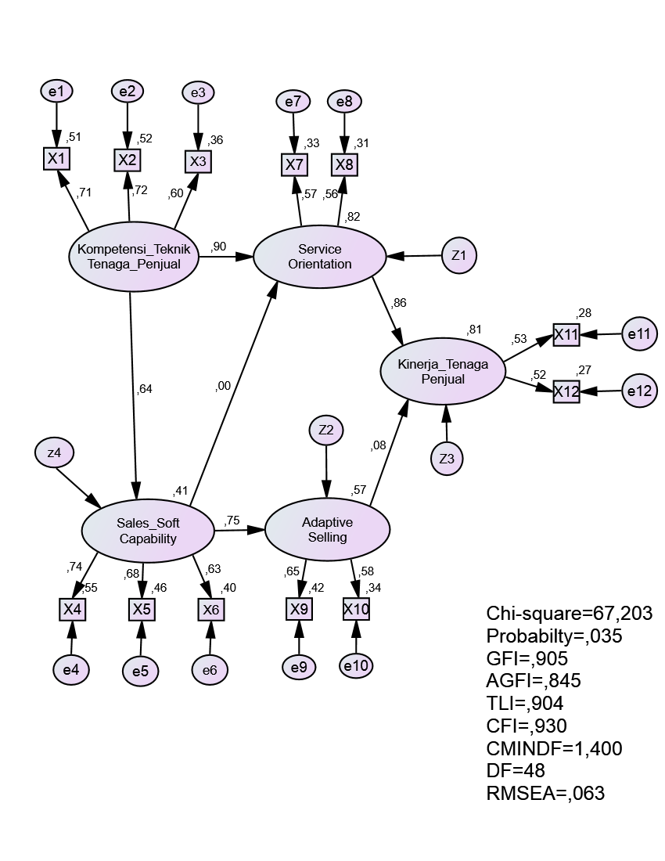

Sample Covariances (Group number 1)
X6 X3 X12 X11 X9 X10 X8 X7 X4 X5 X2 X1
X6 2,238
X3 ,259 1,524
X12 ,059 ,252 1,273
X11 ,102 ,408 ,357 1,321
X9 ,494 ,626 ,261 ,464 1,820
X10 ,605 ,466 ,441 -,004 ,742 2,140
X8 ,204 ,491 ,384 ,288 ,355 ,345 1,092
X7 ,307 ,428 ,248 ,405 ,706 ,320 ,480 1,614
X4 1,148 ,324 ,329 ,361 ,630 ,656 ,205 ,487 1,940
X5 ,868 ,498 ,485 ,411 ,485 ,563 ,262 ,402 ,876 1,772
X2 ,437 ,752 ,566 ,498 ,520 ,357 ,358 ,542 ,624 ,702 1,662
X1 ,380 ,650 ,435 ,460 ,750 ,306 ,532 ,742 ,513 ,621 ,870 1,754

Condition number = 14,388
Eigenvalues
7,101 2,666 1,892 1,545 1,202 1,120 ,958 ,906 ,866 ,735 ,666 ,494
Determinant of sample covariance matrix = 13,522

Standardized Residual Covariances (Group number 1 - Default model)

X6 X3 X12 X11 X9 X10 X8 X7 X4 X5 X2 X1
X6 ,000
X3 -1,005 ,000
X12 -1,477 -,719 ,016
X11 -1,264 ,281 ,022 ,016
X9 -,607 1,871 ,182 1,426 ,000
X10 -,007 ,892 1,287 -1,418 ,009 ,000
 |  |  | Estimate | S.E. | C.R. | P | Label
Sales_Soft_Capability | <--- | Kompetensi_Teknik_Tenaga_Penjual | ,610 | ,161 | 3,794 | *** | par_13
Adaptive_Selling | <--- | Sales_Soft_Capability | ,729 | ,185 | 3,932 | *** | par_3
Service_Orientation | <--- | Sales_Soft_Capability | ,000 | ,173 | ,001 | ,999 | par_6
Service_Orientation | <--- | Kompetensi_Teknik_Tenaga_Penjual | ,700 | ,197 | 3,552 | *** | par_7
Kinerja_Tenaga_Penjual | <--- | Adaptive_Selling | ,058 | ,176 | ,329 | ,742 | par_4
Kinerja_Tenaga_Penjual | <--- | Service_Orientation | ,713 | ,258 | 2,764 | ,006 | par_5
X8 | <--- | Service_Orientation | ,803 | ,199 | 4,037 | *** | par_1
X11 | <--- | Kinerja_Tenaga_Penjual | 1,000
X12 | <--- | Kinerja_Tenaga_Penjual | ,967 | ,288 | 3,364 | *** | par_2
X1 | <--- | Kompetensi_Teknik_Tenaga_Penjual | 1,000
X7 | <--- | Service_Orientation | 1,000
X10 | <--- | Adaptive_Selling | ,976 | ,273 | 3,577 | *** | par_8
X9 | <--- | Adaptive_Selling | 1,000
X2 | <--- | Kompetensi_Teknik_Tenaga_Penjual | ,990 | ,170 | 5,819 | *** | par_9
X5 | <--- | Sales_Soft_Capability | 1,000
X4 | <--- | Sales_Soft_Capability | 1,145 | ,218 | 5,247 | *** | par_10
X3 | <--- | Kompetensi_Teknik_Tenaga_Penjual | ,786 | ,156 | 5,033 | *** | par_11
X6 | <--- | Sales_Soft_Capability | 1,054 | ,216 | 4,871 | *** | par_12
X8 -,739 ,730 ,633 -,243 ,931 ,831 ,000

X7 -,482 -,374 -,911 ,063 2,482 ,267 ,381 ,000
X4 ,754 -,922 -,054 ,071 -,226 -,013 -,971 ,286 ,000
X5 ,076 ,426 1,250 ,686 -,553 -,058 -,300 ,129 -,238 ,000
X2 -,644 ,347 ,787 ,232 ,725 -,133 -,961 -,423 ,047 ,922 ,000
X1 -,934 -,275 -,108 -,046 1,947 -,409 ,217 ,668 -,561 ,425 -,055 ,000

Regression Weights: (Group number 1 - Default model)

Standardized Regression Weights: (Group number 1 - Default model)
 |  |  | Estimate
Sales_Soft_Capability | <--- | Kompetensi_Teknik_Tenaga_Penjual | ,640
Adaptive_Selling | <--- | Sales_Soft_Capability | ,753
Service_Orientation | <--- | Sales_Soft_Capability | ,000
Service_Orientation | <--- | Kompetensi_Teknik_Tenaga_Penjual | ,904
Kinerja_Tenaga_Penjual | <--- | Adaptive_Selling | ,083
Kinerja_Tenaga_Penjual | <--- | Service_Orientation | ,860
X8 | <--- | Service_Orientation | ,561
X11 | <--- | Kinerja_Tenaga_Penjual | ,527
X12 | <--- | Kinerja_Tenaga_Penjual | ,520
X1 | <--- | Kompetensi_Teknik_Tenaga_Penjual | ,712
X7 | <--- | Service_Orientation | ,574
X10 | <--- | Adaptive_Selling | ,581
X9 | <--- | Adaptive_Selling | ,645
X2 | <--- | Kompetensi_Teknik_Tenaga_Penjual | ,724
X5 | <--- | Sales_Soft_Capability | ,675
X4 | <--- | Sales_Soft_Capability | ,739
X3 | <--- | Kompetensi_Teknik_Tenaga_Penjual | ,600
X6 | <--- | Sales_Soft_Capability | ,633

Variances: (Group number 1 - Default model)
 |  |  | Estimate | S.E. | C.R. | P | Label
Kompetensi_Teknik_Tenaga_Penjual |  |  | ,890 | ,243 | 3,659 | *** | par_14
z4 |  |  | ,477 | ,160 | 2,977 | ,003 | par_15
Z1 |  |  | ,097 | ,103 | ,937 | ,349 | par_16
Z2 |  |  | ,328 | ,204 | 1,612 | ,107 | par_17
Z3 |  |  | ,070 | ,120 | ,584 | ,559 | par_18
e1 |  |  | ,864 | ,167 | 5,182 | *** | par_19
e2 |  |  | ,790 | ,161 | 4,915 | *** | par_20
e5 |  |  | ,964 | ,183 | 5,256 | *** | par_21
e4 |  |  | ,880 | ,199 | 4,430 | *** | par_22
e7 |  |  | 1,082 | ,187 | 5,780 | *** | par_23
e8 |  |  | ,749 | ,132 | 5,660 | *** | par_24
e10 |  |  | 1,418 | ,279 | 5,092 | *** | par_25
e9 |  |  | 1,062 | ,253 | 4,202 | *** | par_26
e11 |  |  | ,952 | ,180 | 5,300 | *** | par_27
e12 |  |  | ,927 | ,172 | 5,394 | *** | par_28
e3 |  |  | ,975 | ,161 | 6,056 | *** | par_29
e6 |  |  | 1,340 | ,240 | 5,577 | *** | par_30

