Disclosure Statement
we hereby certify that, to the best of our knowledge, no aspect of our current personal or professional circumstance places us in the position of having a conflict of interest with this article.

we hereby certify that, to the best of our knowledge, neither we (including any member of our immediate family) nor any individual or entity with whom or with which we have a significant working relationship have (has) received something of value from a commercial party related directly or indirectly to the subject of this article.

The foregoing statements are true without exception.

The foregoing statements are true this article is our work with personal funding.

While an interest or affiliation with a below of study in institution (Bandung institute of technology) does not prevent you from making an article, the relationship must be made known to attendees. Failure to complete and return this form will require to identify a replacement for your article.

Bandung, 29 July 2021
Correspondent of article

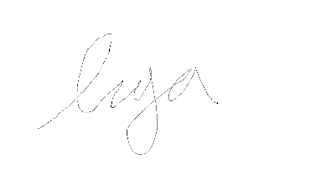

(Ligasyah Arnanda Primadana)

