- Purchase Decision* AND“ Brand Image” AND “Price”=ada 41 jurnal=10

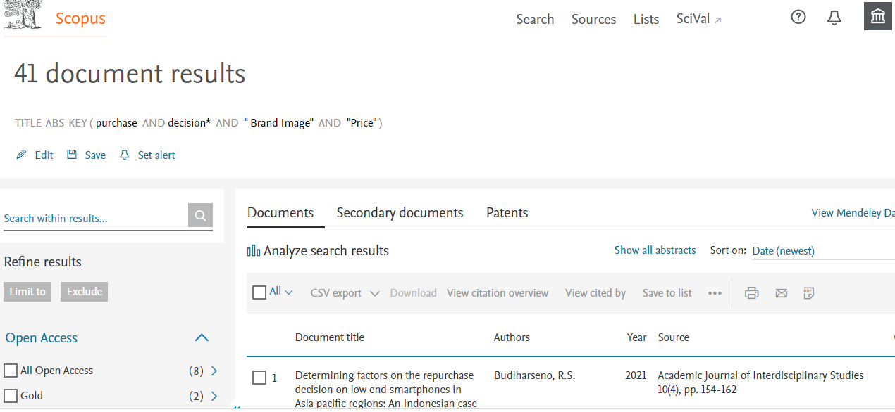
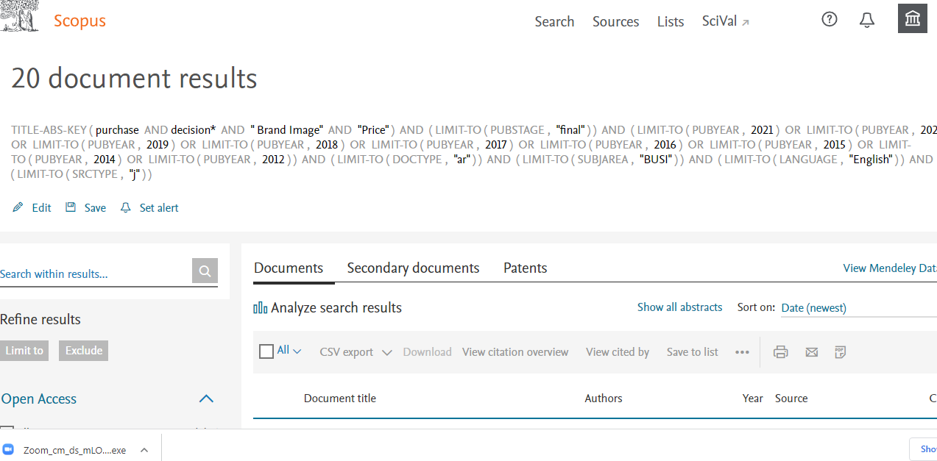

- (“buying decision” OR “Purchase Decision”) AND “product quality” AND “price” AND “brand image”
////2012-2021=2021 (2) 2019 (1) 2004 (1)= 4 jurnal jadi 2
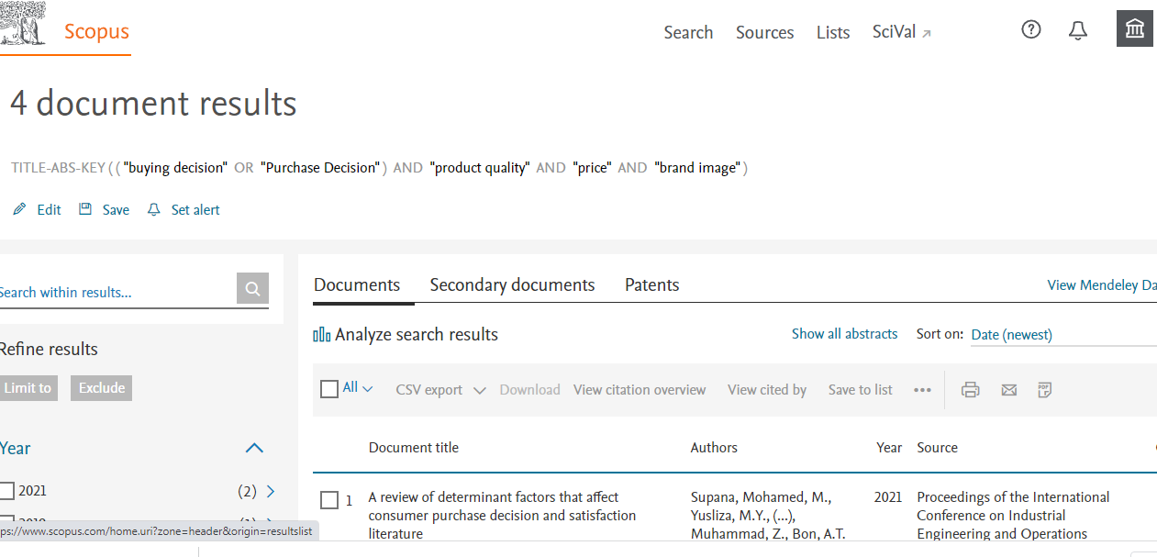
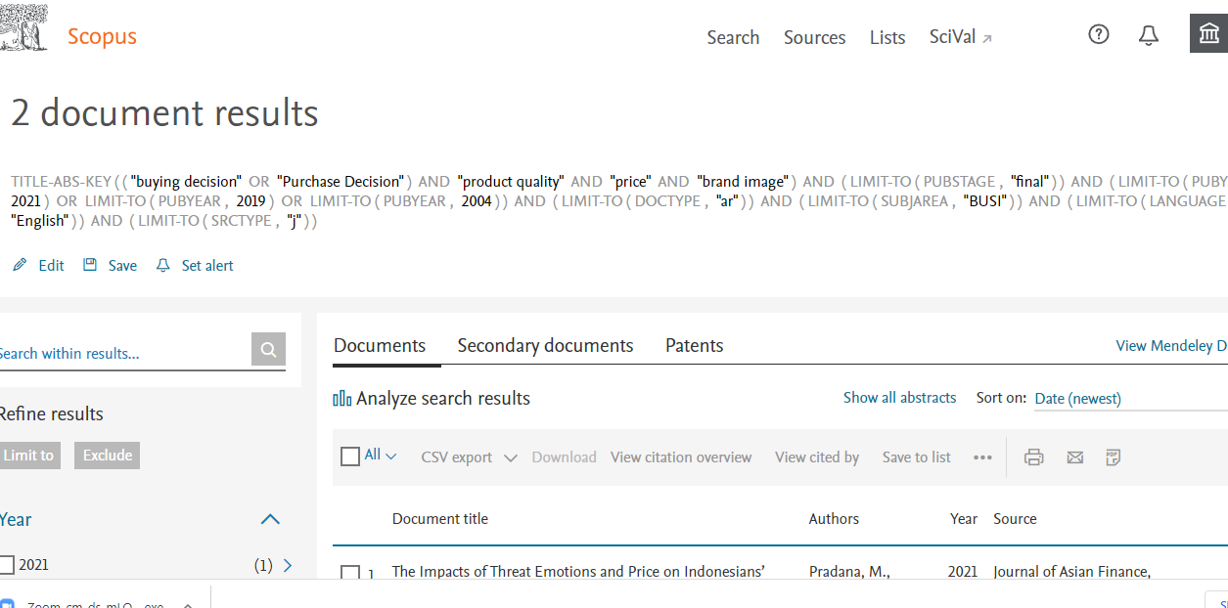

- purchase decision* AND “price” AND “product quality” =124= 24
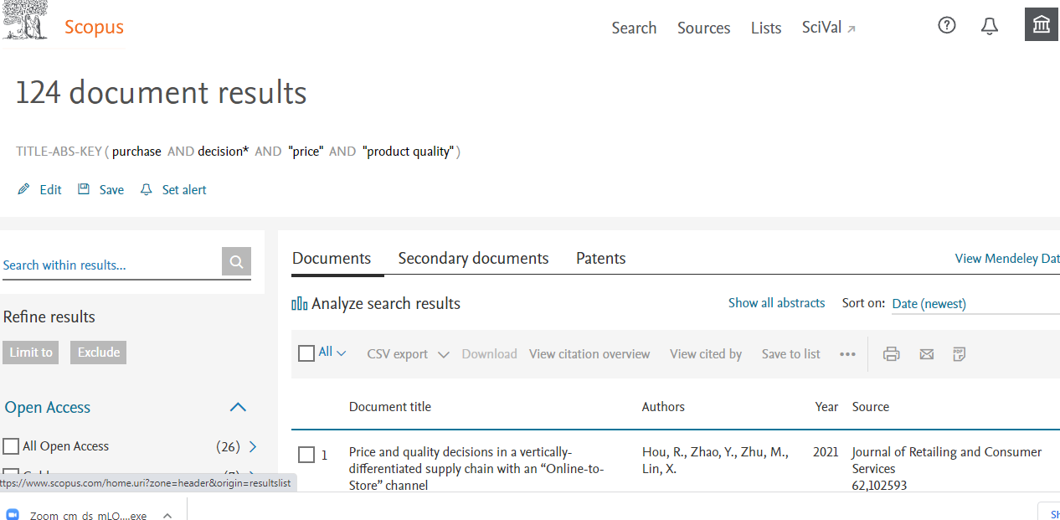
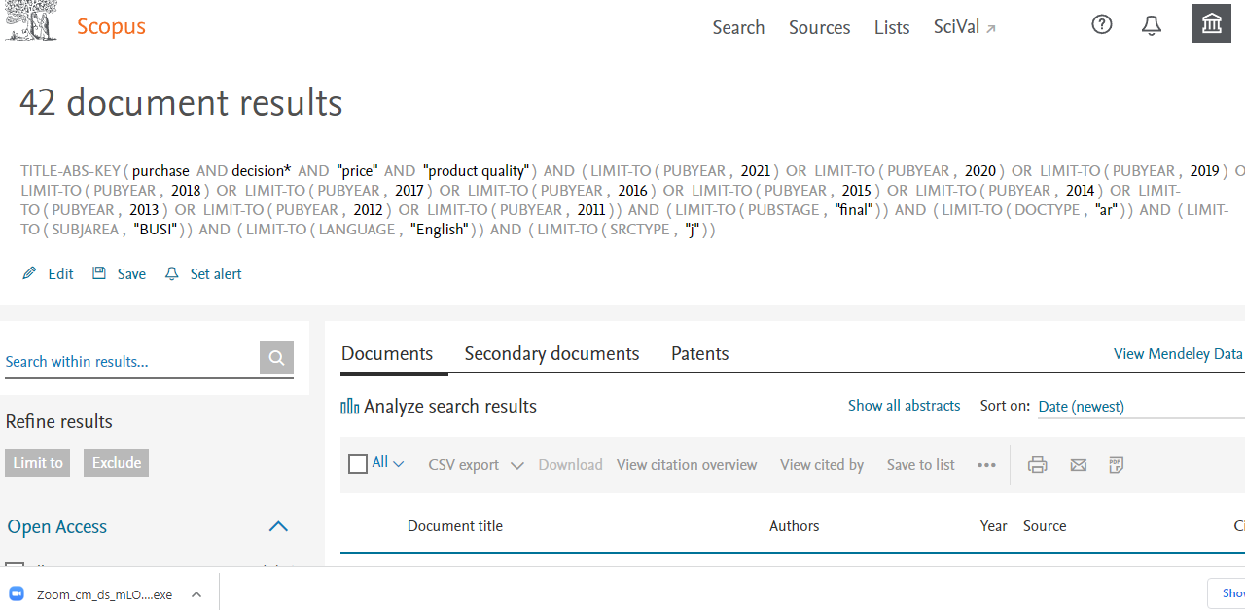

- Brand image* AND “Price” AND “product quality” AND “purchase decision”=
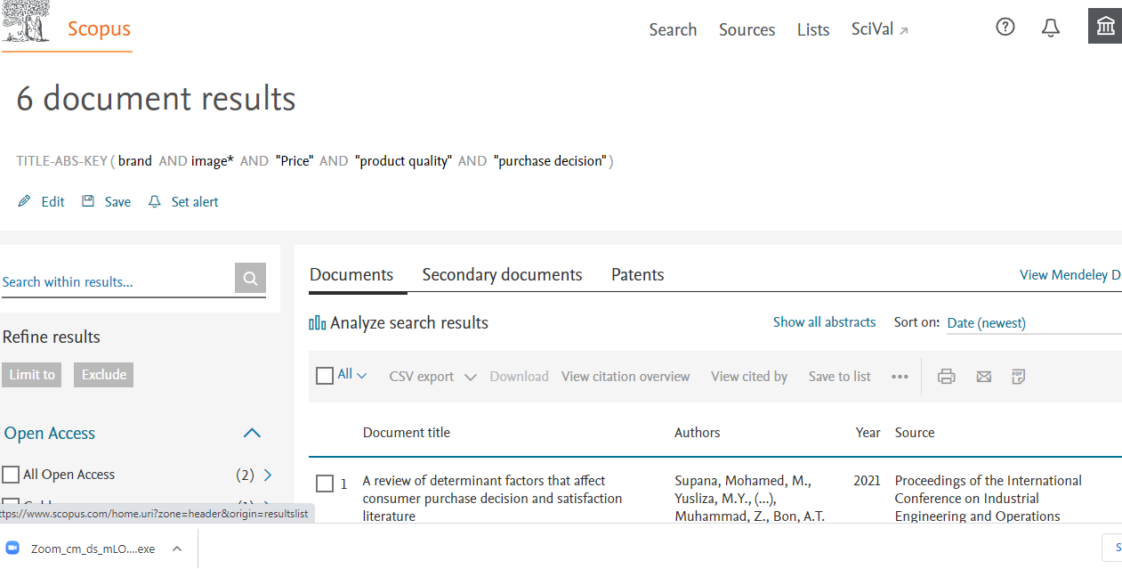
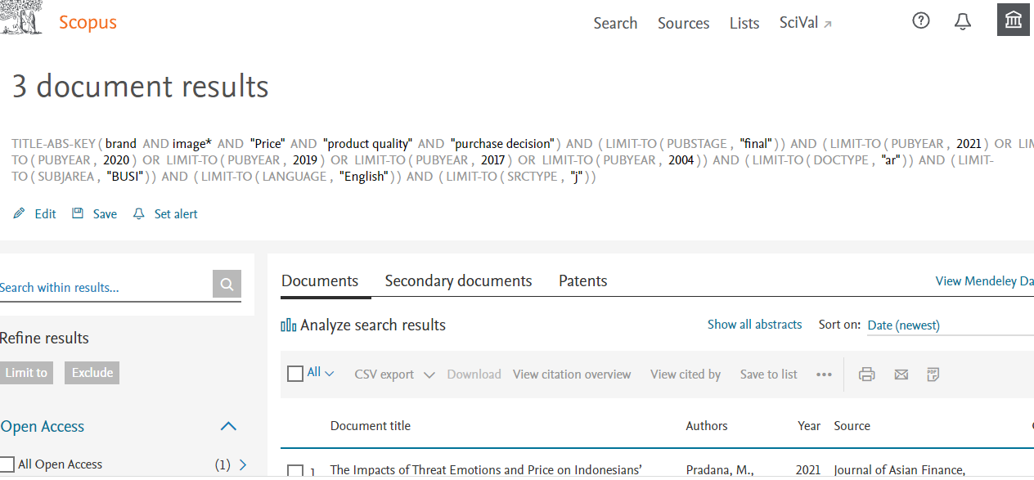

- purchase decision* AND “product quality” AND “brand image”
